Notes for lec #2 neurology ghaidaa abuzahra
Slide 48 page 24
- reflex arc :at level of spinal cord( without thinking )
- sensory neuron synapse directly with motor neuron OR indirectly via interneuron
- CNS & spinal cord are the integration system
- Notice that the sensory receptors for pain ( indirectly via interneuron)

S.50 P.25
Eg. Sensory afferent neuron stimulated by pain→post.horn of gray matter →interneuron →ant.horn → motor neuron → effector like biceps muscle
S.52 p. 26
-Differentiate between sulcus – fissure – and commissures
- 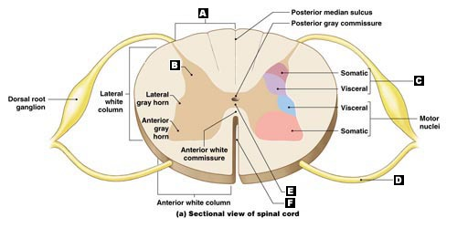central canal contains CSF
S.53 P.27
Lateral horn extend from T1-L2 NOT from T1-L3
S.55 P.28
Alpha efferent ( extrafusal ),gamma afferent (intrafusal)
S.57 P.29
Substantia gelatinosa at the apex of pos. horn , golgi tyoe 2 ( short )
Any localized neuron must be short
Supraspinal level : NOT from spinal cord BUT from brain
S.58 P.29
Bulk of cells : have large nucleus
S.59 P.30
Both are located at the base of post . horn of Gary matter
S.62 P.31
BE alert plzzzzzzzz
Cerebral cortex =cerebrum = conscious level
Cerebellum =unconscious level
General sensation ( conscious +unconscious )
S.63 P.32
These are the ascending tracts
S.66 P.33
Post. White column ( gracilis –G- ) and (cuneatus _C_)
If we take a section in spinal cord at any level we will see gracilis coz it existits at all levels of spinal cord
While cuneatus only exists at cervical segments and upper 6 thoracic segments
S.67P.34
Descending = motor
Eg. Of descending tracts :corticospinal tract
S. 70 P.35
Mother cell exist in cortex →spinal ( corticospinal descending )
The Crossing (motor decussation) will happen in medulla oblongata
S.71 p.36
Descending tracts direct synapse with ventral
Upper motor neuron (descending tracts ) their axon in form of tracts and their cell bodies exist in cortex
Lower motor neuron ( LMN) :cell bodies in ventral horn and axon in form of nerves

From extra slides

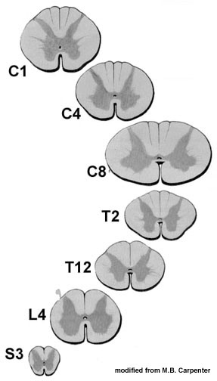

When we move from CERVICLE CORD to SACRAL OR COCCYGEAL CORD the gray matter increases (up to down )
movment from down to up( the gray matter decreases while white matter increase )

