Local Anesthesia in Endodontics

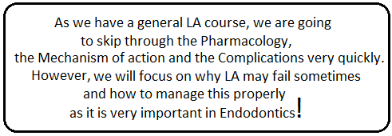
Lecture outline:
- Definitions
- Pharmacology of LA
- Mechanism of action of LA
- Complications of LA
- Failure of LA
- Management of LA failure

- Definitions:
To start with, we need to define pain. Pain: is "An unpleasant sensory and emotional experience associated with actual or potential tissue damage – as defined by the International association for the study of pain IASP.
We have to deal with pain in dentistry; it is not acceptable for our patients to suffer from pain and the way we control pain during our procedure is by LA. Therefore, effective local anesthesia is the bedrock of pain control in Endodontics.
The term "local anesthesia" needs to be revised; as it implies the total loss of all kinds of sensation including touch, pressure, temperature and pain. While what we actually do is "local analgesia" which means localized loss of pain sensation only – meaning the patient can still feel whatever touch, pressure and temperature but they do not feel pain.

- Pharmacology of Local Anesthetics:

Local anesthetics are basically either esters or amides;

- Amino-esters:
They are not popular these days. They include Procaine, Benzocaine and Cocaine.
These are metabolized in plasma by the enzyme pseudocholinesterase.
- Amino-amides:
They are the more common ones. They include Lidocaine, Articaine, Prilocaine, Mepivacaine and Bupivacaine. These are metabolized in liver excreted in the kidneys.
- Note: Articaine has both groups.

- Mechanism of Action of LA:

Local anesthetics need to diffuse through the nerve cell to work; by blocking the sodium channels.
The LA is present in two forms;
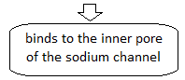
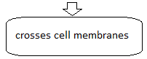
either uncharged which is the basic form OR charged which is the acidic form!

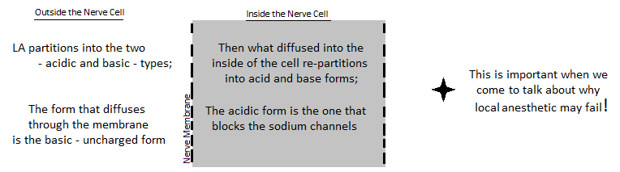

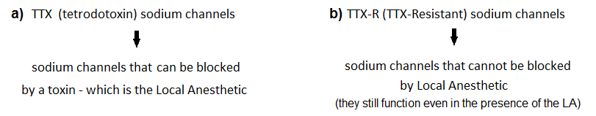
Not all sodium channels are the same. We have at least 9 subtypes of voltage-gated sodium channels (VGSCs), but we broadly divide them into:

- Note: TTX-R channels are primarily found on nociceptors.

- VGSCs consist of an alpha and a beta subunit;

- The alpha subunit – which is part of the sodium channel - serves as a voltage sensor, so if you transmit an electric current they open the sodium channels and the nerve starts firing
(Channels get activated and sodium ions pass when the channel detects an electrical field).

- This is the biologic basis behind electrical pulp tester; the generation of a small electrical field across the dental pulp that can activate VGSCs.

- In cases of inflammation we have release of prostaglandins and these prostaglandins can active the TTX-R channels; so this sensitization of TTX-R channels lowers the activation threshold and increases the firing and the amount of sodium ions that flow through the channel.

This may explain the increased responsiveness to electrical pulp testing seen in patients with irreversible pulpitis.

Effects of Systemic Disease on LA Selection:

There are systemic diseases or conditions that may affect our selection of the local anesthetic;

- Several systemic disorders may require modification of LA dosage – in general; patients who are not well or patients with serious medical conditions, like:

- Unstable angina pectoris
- Recent History of MI or stroke (within the past 6 months)
- Severe hypertension
- Uncontrolled congestive heart failure
- Heart transplant

It will be wise to choose a LA without adrenaline - they should not receive a local anesthetic containing a vasoconstrictor and they should consult their physicians before undergoing endodontic treatment.

- Alcoholism:

Alcoholics in general do not respond to local anesthetics as readily as normal patients, but we have to define alcoholics; people who pathologically consume alcohol (not anyone who consumes a drink containing alcohol is an alcoholic).

Several clinicians have reported that alcoholics appear to be more resistant to local anesthetics. However, in comparison with pulpal responsiveness to electrical stimulation of a maxillary lateral incisor, no differences were noted between recovering alcoholics (mean 113 days in recovery) and age- and gender-matched controls.

- Pregnancy: (An important issue)

A lot of pregnant ladies visit the clinic and the dentist declines any treatment only because she is pregnant… He is afraid of taking x-rays and giving her LA - this is so inappropriate!

If it is an elective procedure it can be delayed until after conception and then after delivery BUT if it is an emergency treatment, it HAS to be done; because it is more worth for the pregnant lady to suffer from pain or infection because we refuse to do root canal, than the risk she may suffer from giving her LA.
(i.e., the risk of giving a pregnant lady LA is much less than the damage that may be caused by pain or infection if left without treatment)

Therefore, the most important aspect of care with pregnant patients is to eliminate the source of pain by performing the indicated endodontic treatment because this reduces the need for systemic medications.

In general, any of the commonly available (popular) local anesthetics are safe for use in pregnant or lactating patients.

The only issue of concern is that; in the past the Prilocaine used to come with felypressin as a vasoconstrictor. Felypressin is a synthetic form of the vasopressin hormone and is very similar to oxytocin that can lead to uterus contraction, so in concentrated amounts this may cause a problem. But now Prilocaine is rarely found!

- Note: Vasopressin is a hormone that is naturally produced from the posterior lobe of the pituitary gland with two primary functions; retention of water and constriction of blood vessels.

- Interaction with other medications:

A thorough review of the patient's medical history is an absolute requirement.
Local anesthetics may interact with other medication, in particular any medication that causes CNS depression (e.g.: Tri-cyclic antidepressant). (We need to know about this!)

Also, potential drug-drug interactions occur primarily with the vasoconstrictors in local anesthetic formulations therefore judicious use of local anesthetic solutions without vasoconstrictions (e.g.: 3% mepivacaine) is a reasonable alternative.

- Complications of LA:

- Psychogenic: vasovagal attack

Patients, who are mostly females, get afraid once they see the needle!
It is easy to manage; position the patient flat with head below the level of legs and cover the needle.

- Toxicity ( related to over-dosage): (This is important)

Often is the result of a cumulative large dose (e.g., repeated injections) OR inadvertent Intravascular administration causing rapid systemic spread that may lead to toxicity.

Early signs are usually reversible, such as; Light headedness, excitability (المريض بكون برج), circumoral paraesthesia of the mouth and muscle twitching.

More serious signs where we need to call an ambulance include: convulsions, loss of consciousness, respiratory depression and cardiovascular collapse.

Although systemic effects from LA are rare, if we insist on causing toxicity by repeated injections we will cause it and we will be in trouble - they can include:
- An initial excitatory phase: Muscle twitching, tremors, grand mal convulsions
- A subsequent depressive phase: sedation, hypotension and respiratory arrest

Toxicity (over-dosage) is related to the plasma level of LA which is dependent on:

  - Patient's age, weight, and state of health
E.g.: a 150-kg patient can receive more dose than a 40-kg patient
  - Other medication taken: TCA, phenytoin… can reduce the plasma proteins available for binding: increased levels of LA in plasma
  - Speed of injection
E.g.: You rush giving the LA, the needle enters into a blood vessel instead, you inject the whole carpool within 10 seconds – you end up with higher risk of causing toxicity!
  - Intravascular injection

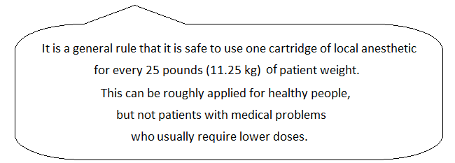
Moore's rule of 25:

- Intra-muscular injection:

It happens many times - to give the injection inside the muscle instead of giving an ID block.
The problem here is related to the type of adrenergic receptors found in the skeletal muscles.

LA contains vasoconstrictor whose function is vasoconstriction, as indicated by its name. However, the response is dependent on the type of adrenergic receptor found at the injection site; either:

- Vasoconstriction response is achieved by interaction of the adrenaline with adrenergic receptors of alpha type which are found in the rest of the tissues all over the body

OR

- Vasodilatation response is achieved by interaction of the adrenaline with adrenergic receptors of beta type which are found in skeletal muscles – which may result in:

- Temporary and reversible myo-toxicity
- Hematoma and Trismus
- Affecting the airways – in more serious cases

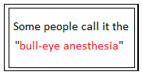
- Temporary or Permanent Nerve Damage:

Caused by hitting the nerve during giving ID block, leading to damage that usually comes in the form of temporary paresthesia.

The Articaine in particular is associated with five-fold higher incidence of paresthesia compared with Lidocaine, because its concentration is 4%.
It is not allowed to give an ID block using Articaine in England, but the only anesthetic they have here is Articaine.

- Facial Palsy:

If we inject deep in the parotid gland we will temporarily anesthetize the facial nerve - which is a motor nerve, therefore we end up with facial palsy (temporary facial paralysis)!

It is a scary scenario if it happens – the patient comes for dental treatment and ends up feeling paralyzed.
Therefore, reassurance can go a long way and the most important thing is to cover the eye for few hours until the patient recovers because the patent loses the ability to close his/her eye which may become dry or injured if the weather is windy.

- Allergic reaction:

Not very common - especially with the amide type of LA!
There are some reported cases of allergy due to the preservatives. But if we stick to the amide type we should be okay.

- True hypersensitivity to LA is extremely rare (less than 1% of reactions)
- Other components (preservatives) can cause allergic reactions
- Higher risk in the ester group than the amide
- The amide local anesthetics appear to have little immunogenicity and therefore have an extremely low rate of allergic reactions

- Cardiovascular reactions:

Tachycardia after injection is not uncommon as a result of alpha adrenoceptor stimulation by systemic distribution of the vasoconstrictor throughout the vascular compartment.

The patient may also report heart palpitations associated with anxiety or fear may experience transient tachycardia and changes in blood pressure.

I.e.: the vasoconstrictor if given in large doses may cause tachycardia, hypertension and palpitations – we need to know about these.

To reduce the risk, the clinician should make sure to:
- Avoid intravascular injection by always aspirating before making the injection
- Inject slowly
- Use dosages within accepted guidelines (within limits)

Methods of Confirming Anesthesia:

After giving the ID block, the first thing we do is
- Asking the patient "Is your lip numb?" – as this is the first sign of anesthesia
Then, using the probe we
- Test the Soft-tissue if is anesthetized
If we want more confirmation, we can do vitality testing
- By applying a cold refrigerant (ethyl chloride) or by using an electric pulp tester
Or
- Simply begin our treatment and see if the patient feels any pain!

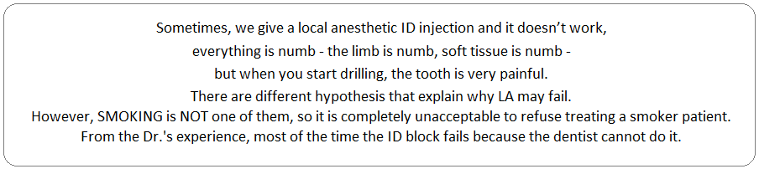
- Failure of LA:

Statistically, IDB are successful in 75-90% of the times in patients with normal healthy pulps.
In patients with irreversible pulpitis: success rate is 20-70% (8-fold failure rate) – (can get to as low as 20%)
So there is a massive discrepancy!

Hypotheses for Local Anesthesia Failure:
- 1) Anatomic factors:

- Difficult technique:

The technique is difficult but it is one of the basic techniques that we need to master!
Different people use different techniques but ideally we should practice as much as we can.

We need to hit or be around the Mandibular foramen and deposit the LA in a sufficient quantity in order for it to work. However, if you locate your needle somewhere far away from where you want and only tiny little amount reaches the Inferior alveolar nerve, you may still partially anesthetize soft tissues at healthy pulps, but for an inflamed pulp you need a bigger amount - so this explains why the lip and soft tissues may be numb (the A-alpha fibers), but not an inflamed pulp (inflamed C-fibers).

- Accessory innervation: N. to Myelohyoid?

Sometimes, the N. to Myelohyoid gives accessory innervation to the pulps. We can simply block it with lingual infiltration. If it was the Myelohyoid nerve causing the problem, the lingual infiltration should solve the problem.

- Note: Please refer to the slides to locate the nerve, as we need to be familiar with it.

- 2) Effect of inflammation on:

(Inflammation has so many effects)

- Local tissue pH:

Let's get back to ionic and non-ionic, basic and acidic forms
Local anesthetic agents are preserved in ionic form (acidic pH 3-4). Once injected, it repartitions into acid and base forms depending on the tissue pH and the drug pKa (which determine the distribution of the LA between the acid and base forms) according to the Henderson – Hasselbalch equation: pKa – pH = Log (base/acid) – (we do not need to know the equation).

We need the uncharged (basic) proportion of the drug to diffuse across the cell membrane. Once inside the cell, the drug repartitions into acid and base forms again and the acid form is what blocks the sodium channels.

In cases of inflammation, tissue acidosis is induced. This can cause ion-trapping in LA (i.e.: trapped in the charged (acidic) ionic form, therefore unable to cross cell membranes), meaning there is no basic form of the LA to diffuse through the membrane (That's a good theory!).

The thing about this theory is that not all local anesthetics have the same pKa (i.e.: tissue pH does not equally ion-trap LA agents as they differ in their pKa). For example, you can use Mepivacaine since it has a lower pKa value and therefore less susceptible to ion trapping, even in cases of tissue acidosis there is still enough uncharged form of it to give us sufficient anesthesia. So, more effective in endodontic pain control.

Tissue pH may be adjusted to augment clinical anesthesia; Alkalinazation (elevation of tissue pH a little bit) is done with sodium bicarbonate.

Against this theory:

- Injection site is distant to the inflamed site in IANB – most convincing point. E.g.: an inflamed lower 6 is far away from the injection site and therefore it is unlikely to get tissue acidosis at the injection site
- Tissue acidosis is only minor in magnitude
- Inflammed tissues have a greater buffering capacity

- Effect of inflammation on blood flow:

Peripheral vasodilatation induced by inflammatory mediators would reduce the concentrations of LA by increasing absorption rate. Based on this theory, the use of adrenaline 1:50,000 should be more effective in endodontic pain patients.
(i.e.: Inflammation increases blood flow so it is only normal to expect that LA will not last as long as in healthy individuals)

- Activation of the LA resistant sodium channels (TTX-resistant):

During inflammation, prostaglandins and other inflammatory mediators can activate the resting sodium pumps that do not function in healthy pulps (i.e.: inflammation evokes an increase in the anesthetic-resistant subpopulation of sodium channels that exist on pain neurons).
This results in a barrage of electrical signals from the peripheral nerves to the brain so that increases the input.

- Effect of inflammation on nociceptors: (This is very important)

- The first image from the left shows a nociceptive nerve terminal in a healthy pulp. (Please refer to the slide on page 8)

- In cases of inflammation, the inflammatory mediators (e.g.: Bradykinin and PGE2) activate and sensitize nociceptors neurons leading to sprouting of the nerve terminals which increases the receptive field (increases the area of response and therefore increases the input and the signals that are transmitted to the brain) – as shown in the second image.

- The exact same thing happens with the potatoes, when left for a while they sprout (درنات) – as shown in the third image.

We have activation of the dormant TTX-resistant sodium channels, so inflammatory mediators (PGE2 and Bradykinin) reduce the threshold for firing of the nociceptive neurons. And this results in a barrage of neuronal impulses.

One explanation of the throbbing pain that we get during irreversible inflammation is related to the threshold of action potential in nerve physiology. The threshold is the critical level to which the membrane potential must be depolarized in order to initiate an action potential; so any stimulus that doesn’t reach the threshold won't lead to any nerve stimulation, but anything above the threshold will cause nerve to fire.

If the threshold is lowered to a level where the heart beat can cause nerve to fire, we get throbbing pain!

- Effect of inflammation on central sensitization:

The continuous afferent barrage of electrical impulses sent to the trigeminal nucleus and brain results in central sensitization, so any -noxious stimulus becomes noxious in cases of inflammation (hyper-excitability of central neurons).

- 3) Tachyphylaxis of LA: (Not a very strong theory)

Administration of receptor agonist drugs repeatedly lead to reduced responsiveness to a subsequent administration of the drug – the sodium channels become somehow resistant.
(i.e.: We anesthetize, anesthesia works, when the anesthesia duration is over, we give another anesthesia it does not work).

No evidence from clinical studies!

However, our problem usually is not with repeated injections, most of the time it is failing to achieve LA at the first injection (which should be sufficient for us to remove the pulp).

There are so many things against this theory – most important of which is the fact that chronic pain patients are treated with multiple administrations of LA over many years. Yet no tachyphylaxis cases have been reported (they do not suffer from tachyphylaxis).

- 4) The core theory:

As the ID nerve travels from the posterior area towards the anterior area, the peripheral fibers of the IAN innervate the mandibular molars, and then as we go forward the core innervates the premolars and anterior teeth.

Local anesthetic administration may not penetrate the IAN deep enough to anesthetize the core fibers especially if the anesthesia amount is not sufficient.

This may only explains failure of LA in anterior and premolar teeth but not the molars – so it is
NOT a very strong theory.

- 5) Psychological factors: (This is very important)

Patients are anxious and apprehensive, therefore they have reduced pain thresholds – anything hurts them!

- Management of LA failure:

- Identify patients who are likely to pose such a problem first:

- Signs and symptoms of irreversible pulpitis – it is much easier to anesthetize someone with a necrotic tooth than irreversible pulpitis.

- History of experiencing inadequate LA – the patient tells you that the Dr. anesthetized him 4 times but it didn’t work. This patient is a red flag.

- High level of anxiety – a scared patient is a red flag.

- Use supplemental LA: (something other than ID block)

- Simply increase the dose:
Exposes a greater length of the IAN

- Use anesthetic with a lower pKa:
e.g.: 3% Mepivacaine to decrease the potential for ion trapping

- Use a different technique. Deliver the 2nd LA cartridge higher in the pterygomandibular space – we have two famous techniques (although the Dr does not usually use them):
    - Gow-Gates,
    - Varizani – Akinosi

In order to: Increase the length of the exposed IAN
Block the N. to Myelohyoid

- The Gow-Gates technique: (Please refer to the slide on page 10)

- Target area
The medial anterior aspect of the condyle just below the insertion of the lateral pterygoid muscle
- Extra-oral landmarks
Draw a line from the tragus of the ear to the labial commissure. Our syringe should be parallel to this line.
- We need to hit bone – very similar to an ID block; if we do not hit bone, we you are probably too deep in the tissues and we are at risk of injecting in the parotid gland

- The Varizani – Akinosi technique: (Please refer to the slide on page 10)

- This is a closed mouth technique (an advantage)
- Using a long 30 mm needle, half of the needle should stop just at the upper second molar, parallel to the muco-gingival junction.

- Use different routes:

- Intra-ligamentary
- Intra-osseous
- Intra-pulpal
- Buccal/lingual infiltration (will sometimes do the trick)

- Intra-ligamentary injection: (Please refer to the slide on page 10)

- Deposit LA in the periodontal ligament space.

- There are three points that need to be considered;
- it is a very painful technique
- it needs to be done very slowly because the resistance is massive
- sometimes there is risk of inducing infection (if the patient has very poor oral hygiene, the plaque and bacteria found in the sulcus can be transmitted to the bone)

- The Wand:

The Want is a fancy (3,000 JOD) computer-assisted LA delivery system that can be used to administer intra-ligamentary injections. It looks like Harry Potter's magic stick.
It accommodates a standard local anesthetic cartridge that is linked by sterile micro-tubing to a disposable, pen-like handpiece with a Luer-Lok needle.
The device is activated by a foot control, which automates the infusion of LA solution at a controlled rate; fast rate: 1.4 ml/min used for Buccal and Lingual infiltration
slow rate: 1.4 ml/ 4 min 45 sec for intra-ligamentary injection

- The intra-osseous route:

- The intra-osseous is a VERY useful technique in cases of irreversible pulpitis. Sometimes it is the only thing that can get you out of jail.
- We perforate the buccal plate and insert our needle to deliver the LA solution directly inside the cancellous bone adjacent to the tooth to be anesthetized.
- It gives us IMMEDIATE onset of anesthesia but short duration.
- Needs to be used with caution as it has risk of causing palpitations and other cardiovascular complications.

- Two intra-osseous systems have been studied clinically and are available in the market:

- The Stabident system (Fairfax Dental, Miami, FL)
- The X-tip system (Dentsply, York, PA).

- The Stabident system:

The Stabident system is composed of:

- A slow-speed handpiece-driven perforator: a solid 27-gauge wire with a beveled end that drills a small hole through the cortical plate.
(i.e.: a hollow needle that fits on a slow-speed handpiece)

- The injector needle: placed into the hole made by the perforator to deliver the LA solution directly into the cancellous bone.

So, what you do is drill a small hole into the bone, remove the perforator and insert the injector needle to deliver the LA solution. It may sound easy, but good luck trying to find the hole that you created in the bone. So it is tricky and needs lots of practice.

The new Stabident system, like the X-tip system, consists of 2 parts that can be detached from each other. After the buccal bone plate has been perforated, the two parts are separated leaving the perforator tip inserted into the bone and removing the latched part of the perforator together with the handpiece. A long needle can then be inserted into the perforator tip and the anesthetic is injected intra-bony.

- Note: The Dr. recommends these techniques if we struggle with LA.

- The intra-pulpal route:

- In about 5% to 10% of mandibular posterior teeth with irreversible pulpitis, supplemental injections, even when repeated, do not produce profound anesthesia and pain persists when the pulp is entered.
- This is an indication for an intra-pulpal injection; injection of LA solution inside the pulp that gives immediate anesthesia sufficient for us to exacerbate the pulp although very short-lived.

- Drawbacks:

- The pulp needs to be already exposed to allow direct injection, so this can be severely painful (therefore not very useful in that sense). Should be given only after all other supplemental techniques have failed as a last source.
- Short duration of pulpal anesthesia.
- Needs to be given under pressure (depositing the anesthetic solution passively into the chamber is insufficient because the solution will not diffuse throughout the pulp), so we need to stick the needle and push it in – which is what makes it very painful.

- Advantages:

- Produces profound anesthesia if given under back-pressure.
- The onset of anesthesia is immediate.
- No special syringes or needles are required (doesn’t need any fancy equipment).
- Resulted LA is MULTIFACTORIAL – mainly due to pressure but the LA works too.

- Miles a dentally trained neurophysiologist who needed endodontic treatment, reported to the Journal of Endodontics about his intense pain when the intra-pulpal injection was administered (after his endodontist could not numb his tooth he, had to give him intra-pulpal injection). He reported that although it was successful, success was achieved at a price. He stated that he felt a diminished confidence in the endodontist and increased apprehension.

- Topical anesthesia:

- They are indicated for desensitizing the mucosa to needle pricks before local infiltration. They can be found in all different forms (gel, ointment or spray). Ice sticks can also be used (as shown in the slide on page 13 to numb the palatal mucosa before injection).
- Lidocaine – most common (5% ointment, 10% spray), Benzocaine – not very popular (7.5 – 20% gel)
- It does have a positive psychological effect on the patients (placebo effect).

- Use adjunctive drugs and techniques:

- The 2 main events in LA failure as implicated by the theories seem to be:

- The effects of inflammation on peripheral nociceptors (so it makes sense to use anti-inflammatory medications before we start our treatment in order to reduce the amount of PGE2 and other inflammatory mediators – the simplest drug to prescribe is the ibuprofen).

- The central nervous system processing of pain signals (the brain is tired of the continuous nerve signals so we use something to suppress this).

- Therefore:

- Use anti-inflammatory drugs; NSAIDs, steroids
- Reduce anxiety :
- Caring manner (being nice and friendly) and confident approach (our confidence and professional attitude have massive psychological effect on the patients)
- Sublingual trizolam (oral sedation)
- Nitrous oxide (inhalation sedation)

- Please refer to the slides for illustrations.
- Good luck

