microbiology Sheet no: 22
Refer to slide no : 13 & 14
Written by: Razan al-laham & Aleen al-nawafleh
Corrected by: Aleen al-nawafleh & Razan al-laham

** The genera Mycobacterium and Nocardia have been grouped into the family mycobacteriaceae

1-Mycobacteria
We will continue talking about mycobacterium.
We mentioned in the last lecture that:
- We can isolate the organism from the sputum and when we culture it ( in Lowenstein-Jensen medium ) we have to wait for a long time (6-8 weeks) to make sure that there is no growth (this is an indication that the disease that is caused by this bacteria is chronic)
- and we said that it has a long doubling time (18 hours)
- and that we can stain the sputum for the mycobacterium by ziehl neelsen stain ; that’s why they are called acid fast bacilli , then we can use the PPD procedure which can give us an indication , the problem is that if the person has been vaccinated then he will become PPD positive (the PPD here has no use) , but if somebody has never had the PCG vaccination and the PPD procedure turned out to be positive this means one of two things : either he has been vaccinated or infected (this has been mentioned in more details in the previous lecture)
*** But we conclude from all of this is that the PPD cannot distinguish between past or recent infection.

Treatment:
- The disease can be treated by taking several drugs for 5-6 months . its very important that the patients finish the medicine , taking the drugs exactly as prescribed. If they stop taking the drugs too soon , they can become sick again; if they don’t take the drugs correctly, the bacteria that are still alive may become resistant to those drugs .(We use more than one antibiotic, we use two or three antibiotics at the same time; so that the bacteria will not become resistant to the drugs, if we use just one drug then the bacteria will become resistant to it , so we start with at least three drugs and we decrease the number of medications gradually with time to two drugs. the whole duration of treatment takes around 5-6 months and it may last to years because the bacteria is very slow growing ; that’s why we treat the disease for a long time)
- and when we treat the patients , compliance is very important
***compliance : adherence to taking the tablets everyday regularly as its prescribed otherwise the bacteria will become resistant to the drugs (in other words : a patient’s adherence to a recommended course of treatment)
- The patients should be isolated if they are producing cough which has sputum , blood stain and bacterial agent (or in other words , they should be isolated if they are exporting mycobacteria) ; otherwise they will pass the mycobacteria to other people
- Direct observe therapy we should ask them to swallow the tablet in front of us; some patients are awkward (some have mental issues or they don’t like to take medication so they would put the tablet under their tongue and when we turn around they would spit it out)
Now we finished talking about tuberculous mycobacteria. And now we are going to talk about another mycobacteria that is related to them , they are known as non-tubercolous myccobacteria.

Non-tuberculous Mycobacteria
they are different from tuberculous mycobacteria ; they don’t produce tuberculosis , sometimes they can produce skin infection or they can produce lung infection , they are more fast growing (if we culture them , it takes 3 or 4 days for the culture to appear (production of colonies) but in tuberculous mycobacteria we have to wait weeks for the colonies to appear) , another distinction feature is wither they produce pigments or not , some of them are non-pigment producers (non-chromogens) and some are pigment producers.
Now, the pigment producers ; they either produce pigments in the presence of light ,they are called photochromogens , or they produce pigments in the absence of light (in the darkness) and they are known as scotochromogens.
***disseminated infection is usually limited to immunocompromised patients, particularly ئHIV-infected individuals (AIDS). (HIV patients they are susceptible to the non-tubercoulous mycobacteria and they become disseminated in their bodies)

Mycobacterium leprae (hansen’s bacilli)
Another mycobacteria is mycobacterium leprae
- It’s an Acid fast bacillus .
- unlike mycobacterium tuberculosis which we can grow them in Lowenstein-jensen medium, this bacillus (mycobacterium leprae) can’t be cultured in normal conditions , they have never been cultured in any medium at all , but we can grow them in some animals ( like in the foot of a mouse or in the armidello )
- It causes the disease leprosy (الجذام) , and this disease has two varieties (the disease depends on the immune response of the body ; according to the immune response we get one of these two varieties) :
- Lepromatous leprosy
- Tuberculoid leprosy
In Lepromatous leprosy , there is a diffuse spread of the disease in lesions , it affects the skin , the nerves (leads to contraction in wrists , hands , knees and ankles ) , it leads to destruction of tissues and sometimes they have a hole instead of their nose ( they don’t have a nose)
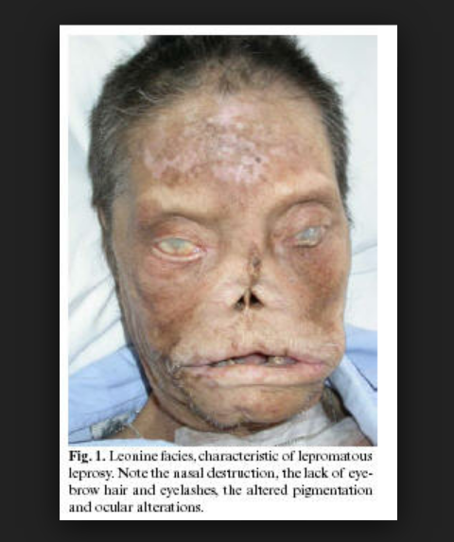
(sorry for the picture)
***In the old days they used to put a bell around the neck of the patients of lepromatous leprosy so they can hear that the patients are coming; they were afraid to get infected.
Its infectious but it has a very very low infectivity (you have to live with them ‘the patients’ for 3-4 years before you catch the disease)
The way of transmition is unknown but probably its by touch
***There are a lot of antibodies produced against mycobacterium leprae but they are not affective because the organism is intracellular and this is really due to an immune deviation of the immune response.
(When we have an immune response , helper T lymphocyte(Th0) are activated , when they are activated they either become TH1 which are cell mediated or TH2 which are antibody mediated)
Th1 and Th2 produce different sets of cytokines . (immune deviation is explained in immunology)
Again , we have 2 varieties of leprosy , if you have an immune deviation toward TH2 response you will get the lepromatous variety which is more serious ; because it spreads , there are lots of antibodies but they are not affective because they are intracellular organism .

the other variety is the tuberculoid , the patients will get tubercles (granulomas) in the skin or in the nerves producing disfigurement and nerve deficiencies, its the same as lepromatous but less serious and less spread ; because we have a cell mediated immunity which controls the spread of these organisms (the number of organisms here are going to be less).

Treatment
We treat them with dapsone or rifampin and sometimes the treatment is carried on for the rest of the life of the patient .

2-nocardia
they are gram positive bacteria , intracellular organism , they grow in filaments and they are weakly acid fast bacilli.
***Actenomycins (they are not acid fast) , nocardia and mycobacteria all grow in filaments resembling fungi.
Nocardia are present in the environment.
They rarely cause clinical disease except in immunocompromised individuals , they either cause a lung infection or an ischemia infection.

Spirochetes
Three genera cause human disease; Treponema, Borrelia, and Leptospira.
They are thin , spiral organism, motile ; they have a flagella that are warped around the bacteria itself within the outer membrane ( the flagella are between the inner and the outer membrane , that’s why we find that the lumen is spiral ), so we conclude that spirochetes are different from other motile bacteria , these flagella don’t protrude into the surrounding medium but are enclosed within the bacterial outer membrane .

they are related to gram negative bacteria but they don’t stain by gram stain , when we say that they related to gram negative bacteria we mean that they have an outer membrane (the outer membrane here is slightly different from the other standard gram negative bacteria ).
Generally spirochetes are difficult to stain but we can stain some of them (like borrelia and leptospiral) with aniline dyes.

treponima can be only seen by one of these ways :
- dark field illumination ; we use a special microscope and when we look by it everything looks dark except for the spirochete looks white as if it’s an empty space
- stain it with silver stain (they will look black under the microscope)
- or immune fluorescents (we use antibodies that have been labeled with immuno florescent onto the bacteria and we use immune florescent microscope to see it)

1-treponema pallidum
in the old days , it caused a very severe illness that used to kill people very easily ; that’s why they used to call it large pox or big pox , but now it’s not fatal.
Again it can’t be stained with gram stain or aniline dyes .
Pathogenic mechanisms employed by spirochetes are poorly understood , there is no special toxin , exotoxin or entero toxin but still they produce pathology and tissue destruction , and the damage that is caused by them is a type of hypersensitivity reaction (type 4) ; it’s an allergy to the organs . (the same as mycobacteria , it doesn’t have any special toxin)
** Treponema species pathogenic to humans include:
A- The causative agent of venereal syphilis ‘’ which is a sexually transmitted disease ‘STD’ ‘’
B- The non venereal treponematoses yaws, bejel and pinta ‘’ diseases that are present in Africa , they are similar to syphilis but they are not really sexually contact , they are transmitted within families probable by contact and nothing else ‘’
Now the treponema is the one that causes the disease syphilis and syphilis itself is transmitted sexually , and usually disease manifested in three stages:
- Primary
- Secondary
- Tertiary

Primary stage
-Actually appears after about 2-3 weeks from sexually contact , and usually goes to the skin .
-So usually the initial lesion\ulcer\chancer , it’s usually appears either in the lips or it’s can appear on the glands of penis or in the cervix of uterus because these are the place where the bacteria actually goes inside the body .
- it’s appear as induration ‘’ مثل الزر بتكون يابسة تحت الجلد ‘’ under skin , then it ulcerate
- it’s painless ( doesn’t harm ) , but usually the regional lymph nodes is enlarge ( submandibular lymph node )
- and this lesion become full of spirochetes , so any body become in contact with it , then become infected .
- after about 2-3 weeks or 4 weeks the lesion heal by itself .
- but after about 2-3 months from healing you will get appearance of secondary stage .
Secondary stage
- ill , Fever , malaise , doesn’t feel well , rash on skin which is very dark in color , there’s sparky present in the blood and there is ulcer that appear around anal opening known as condylomata lata , all of these are symptoms of the secondary stage .
- second stage can last onset , or can come back for few years and then every thing is fine منيح هاي الجملة مش متأكدة منها 100% ما قدرت اسمعها

Tertiary stage
The last stage of the disease , maybe occur after 5-10 years “ long time upward ‘’ And this manifest as granuloma or GUMMA , this granuloma destructive the destroyed tissue , and they are mainly confined to three areas: 1-heart ( which destroy the valve ) 2- brain ( or CNS can cause general paralysis and this late complication of syphilis ) 3- it can appear anywhere else in the body like skin or bone .

Does the syphilis is always progress to the tertiary stage ?
No , some people become cure without any treatment , usually have primary stage and then become cure , or they can go to the secondary stage and become cure spontaneously ‘’ no body know why ‘’ . but some people unfortunately the disease not cure and then they progress to the tertiary stage.
-it’s not inherited , but it can pass to the fetus ( it’s not only sexually acquired ) , the mother if she get the syphilis she can pass disease ‘’ syphilis ‘’ in to her baby , and that why prenatal screening for any pregnant women is needed … so any pregnant women should go through prenatal and follow up “ check for syphilis for every pregnant women ‘’ , in order to sure that she doesn’t has the disease . if she has the disease , it can pass it to the baby that’s lead to congenital syphilis , which very serious , it’s can lead to abortion and death of the fetus , or the baby will born with very sever malformation .
** we can use antibiotic , it’s very easy to cure syphilis if it’s diagnosis , very simple by penicillin .
**people who have been infected they can have antibody against treponema and if they don’t show the symptoms of the syphilis they must cure themselves .
( look at the pictures ) : These are primary syphilis show ulcer with raise edge which is very hard … you have very lesion one in the penis , one in the tongue ,one in the cervix , one at the finger “ respectively ‘’
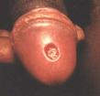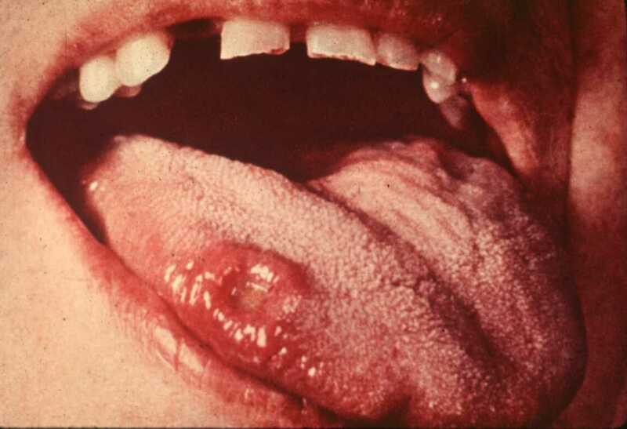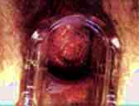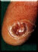

This picture shows the secondary stage : increase in the rash all over the body and it’s very cupreous “ نحاسي “

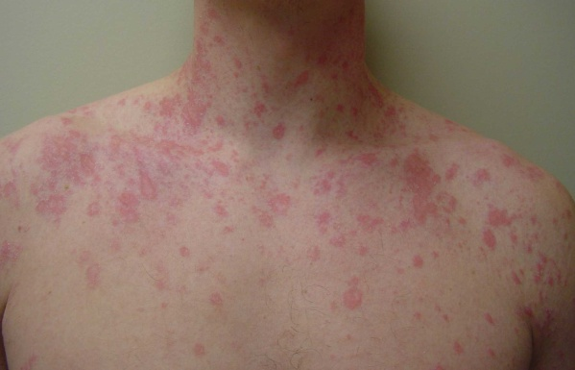
** we can treat syphilis in the secondary stage , but once it reach to the tertiary stage it’s useless , because we don’t see any organism in the body ( no antigen or few antigen and that cause hypersensitivity for granuloma )

CONGENITSAL SYPHILIS
You can have many problem with congenital syphilis , you can have : 1- hole in the palate 2- runny nose “ discharge “ 3- saddle nose ‘’ bridge of the nose collapses ‘’ 4- Hutchinson teeth … as we can see in these pictures
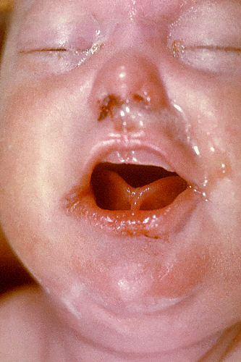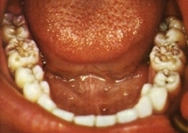
Hutchinson teeth : notch in the teeth , mulberry teeth‘’ زي شكل التوت ‘’, well know complication of congenital syphilis .

** serology
Two variety of antibody they can appear during infection with syphilis : antibody which is not specific ( called : anticardiolipin test ) , this appear in people with syphilis , but it can also appear in people who are normal , that’s mean it can be present in all people , and present in people who have immune disease .
VDRL\RBR : the real disease research lab test these test use the cardiolipin as antigen for present of these antibodies , so these antibodies are good for ( screening )
- But positive VDRL doesn’t mean that this person have syphilis defiantly , but may have syphilis
- So this test known as non-treponema test , use for screening , if non-treponema test is positive , then we do treponema test , where treponema test create antigen of treponema itself and look for presence of antibody in that patient , if they are present and treponema test is positive that mean “ yes “ he has the disease .
- So non-treponema tests : they are non specific ( just for screening ) once these test are positive we want to confer with treponema test , if treponema test is negative that mean “ don’t have syphilis “ maybe have lupes , ما سمعتهم منيح حكاهم بسرعة :\, something else .
- If treponema test is positive that mean “ have syphilis “
- Penicillin is very effective in treat it .

2-Borrelia
- They causes relapsing fever “ الحمة المنتكسة ‘’
Two types :
A- burrella recurrentis : causes recurrent fever , usually has two type:
1- endemic : pass by tick ( tick is insect live in wild )
2- epidemic : pass by louse ‘’ قملة :P “
-what you have actually is fever , and the patient gets better after few days , and then after few days , he gets the fever again then gets better , then gets fever again and so on and on , it might take about 15 time , that’s why called relapsing fever this happen because the borrelia change their antigen ‘’ when you get the borrelia recurrent , you produce antibody against it and you clear it , but some borrelia change their antigen on the surface and they produce again fever and you will bring antibody against it and so on and on .
- Borrelia burgdorferi : causes by tick ( insect ) , you will get a lesion , rash , and this rash get bigger and bigger and bigger !! .. this disease very common in USA .

3-Leptospira
- Leptospira interrogans : Thin coiled with a hook at one ends. “ curved from the top “ like question mark sign ?
- Leptospira biflexia : Thin coiled with a hook at both ends. “curved from the top and bottom .
- Mainly they are disease of rats , present in sewerage “ بالمجاري “ and they can pass into people through rat urine , it can enter into open skin and cause inflammation in the kidneys and liver , also the patient may die !
- The sever aspect of disease known as ‘’ Weil's disease’’ or ‘’leptospira icterohaemorrhagiae’’ .

Special thanks for Ala’a atef

