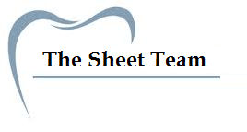

***Title of Lecture: control of microbial growth & Antibacterial agents.***

***Date of Lecture: 12th, October***

***Sheet no: 8***

***Refer to slide no. : 4, 5 (no need)***

***Written by: Seema Salam Daradkeh***

* **Alkylating Agents**

What they do: Substitute alkyl groups for the hydrogen of reactive groups of enzymes (they dissolve the enzymes into: nucleic acids and proteins)

**Main alkylating agent, which is a gas:**

* **Ethylene oxide** 
  1. Chemosterilizer (or sterilizer: kills bacteria, viruses, and spores)
  2. Very effective
  3. Colorless, soluble in water and common organic solvents.
  4. main disadvantage: Explosive if mixed with air or O2 that’s why it’s usually mixed with CO2 or N2 as inert gases to prevent explosion )
  5. Toxic: so before you use the instruments you sterilized with ethylene oxide, you have to make sure you dissipate all the ethylene oxide to avoid toxicity)
  6. Slow action influenced by concentration of gas, relative humidity, time of exposure, and temperature (4 hours at 50-56°C and 6-12 hours at RT). These are all controllable so, we can control the time in which sterilization process happens properly.
  7. Optimum humidity is 30%.
  8. Used to sterilize heat sensitive items. Ex: medical equipment that can’t stand the temperature of the autoclave, ex: hemodialysis machine and Heart-Lung machines.
  9. Gas must be dissipated before the item can be used (24 hours).
  10. Exposure time is reduced by 50% for each doubling of ETO concentration.
  11. likewise the activity of ETO doubles with each T° increase of 10°C.
  12. **BetaPropiolactone**: Fumigant. (carcinogen)
* **Aldehydes**

1. Include some of the most effective antimicrobials.
2. Inactivate proteins by forming covalent crosslinks with several functional groups.
3. **Formaldehyde gas**
4. Excellent disinfectant.
5. Can dissolve in water, to become Formalin. Which is Commonly used, 37% aqueous solution.
6. Formalin was used for preserving cadavers, fixing slides for pathological stage observation, in wool industry (because, wool has anthrax spores, and formalin can kill spores), disinfecting hospital rooms, extensively to preserve biological specimens and inactivate viruses and bacteria in vaccines; commonly known as toxoids (harmless, ex: diphtheria, tetanus, whooping cough), which are inactivated toxins, and their antigenicity is maintained)
7. some people say it’s carcinogenic but it’s not common.
8. Irritates mucous membranes, eyes, skin, strong odor. (this is why people wear labcoats, gloves, goggles when they use it..)

**B. Glutaraldehyde**

1. Less irritating and more effective than formaldehyde, also, doesn’t last long (it’s half-life isn’t long) and it’s more expensive.
2. One of the few chemical disinfectants that is a **sterilizing** **agent**.
3. Used for medical\hospital equipment that can’t withstand autoclaving. Ex: fibro-optic instruments like gastro-scopes and endoscopes.
4. A 2% solution of glutaraldehyde (Cidex) is Bactericidal, tuberculocidal, and viricidal in 10 minutes but sporicidal in 3 to 10 hours. (Affects: bacteria, viruses, tubercles and spores.)
5. It’s toxic, so once you sterilize the instruments you should rinse them with distilled water to get rid of any residual glutaraldehyde, you don’t want to harm people with instruments still have traces of it.
6. Commonly used to disinfect hospital instruments.

* **Heavy Metals**

1. Include copper, selenium, mercury, silver, and zinc.
2. **Oligodynamic action**: Very tiny amounts are effective.
3. **harmfull to microorganisms, not extesivly used on people, because it can be harmfull to us as well**
4. **Nevertheless, they have some uses:**

**A. Silver:**

* Mostly used as: 1% silver nitrate used to protect infants against gonorrheal eye infections, installed into babies eyes right after birth. until recently, before 1925 (before discovery of antibiotics), mothers would get gonorrheal infection, and the baby will get ***gonococcus*** in their eyes causing ophthalmitis (ophthalmia neonatorum) which could lead to blindness, so silver nitrate was used to heal it, without hurting the baby. It’s not used anymore because now they treat it with antibiotics.

**B. Mercury**

* Organic mercury compounds like merthiolate and mercurochrome are used to disinfect skin wounds, it’s also poisonous.

**C. Copper**

* Copper sulfate is used to kill algae in pools and fish tanks. It isn’t used in technical practice.

**D. Selenium**

* Kills fungi and their spores. Used for fungal infections.
* Also used in dandruff (which is a fungi) shampoos.

**E. Zinc**

* Zinc chloride is used in mouthwashes.
* Zinc oxide is used as antifungal agent in paints.
* **Oxidizing Agents**

1. Oxidize cellular components of treated microbes.
2. Disrupt membranes and proteins.

**A. Ozone (O3) :**

1. Highly reactive form of oxygen.
2. Made by exposing oxygen to electricity or UV light.
3. Less irritant, and more expensive than Chlorine.
4. Used along with chlorine to disinfect water.
5. Helps neutralize unpleasant tastes and odors.
6. More effective killing agent than chlorine, but less stable and more expensive, lasts less time.

**B. Hydrogen Peroxide (H2O2)**

1. Used as an antiseptic.
2. Used on skin but, not good for open wounds because it is quickly broken down by catalase present in human cells and tissues, so it becomes useless.
3. The active Oxidant is the free hydroxyl radical
4. Effective in disinfection (3-6%) of inanimate objects.
5. Sporicidal (10-25%) at higher temperatures.
6. Used by food industry and to disinfect plastic implants, contact lenses, and surgical prostheses.
7. **Plasma Gas:** Vaporization of H2O2 with the generation of microwave or radiofrequency energy. It is a sterilant. More expensive.

**C. Benzoyl Peroxide**

1. Used in acne medications.

**D. Peracetic Acid**

1. One of the most effective sporicidal liquid available.
2. Doesn’t generate anything toxic. It Generates (broken down into: ) acetic acid and Oxygen, both of which are nontoxic.
3. **Sterilant**
   * + - 1. Kills bacteria and fungi in less than 5 minutes.
         2. Kills endospores and viruses within 30 minutes.
4. Used widely in disinfection of food and medical instruments because it does not leave toxic residues.

* **Chlorhexidine**
  1. Antiseptic at 4%
  2. Used for surgical scrub and hand washing.
  3. Types: Hibiclens, Hibitane.
* **Parachlorometaxylenol** (PCMX)
  1. Disinfectant, Active against gram positive bacteria.
* **Triclosan**

1. Active against bacteria. It is a common antiseptic in deodorant soap.  
     
   **we have 3 levels of disinfection:

* **High-Level disinfectants**

1. Used for items involved with invasive procedure that cannot withstand sterilization procedure because it’s really equivalent to sterilization. (certain types of endoscopes, surgical instruments with plastic or other components that cannot be autoclaved).
2. Disinfection of these and other items is most effective if treatment is preceded by cleaning the surface to remove organic matter.
3. Examples of high level disinfectants include treatment with moist heat, glutaraldehyde, hydrogen peroxide, peracetic acid, chlorine dioxide, and other chlorine compounds.

* **Intermediate Level disinfectants**

1. Alcohols, iodophors, and phenolics are used to clean surfaces or instruments in which contamination with bacterial spores and other highly resilient organisms is unlikely. And for hands, syringes.. (used for semicritical items. it doesn’t kill everything, but removes most of them).
2. Examples of items treated include flexible fiberoptic endoscopes, laryngoscopes, vaginal specula, anesthesia breathing circuits, and others.

* **Low-Level disinfectants**

1. Quaternary ammonium compounds are used to treat noncritical instrument and devices such as blood pressure cuffs, ECG electrodes, and stethoscopes.
2. Although these items come into contact with patients, they do not penetrate through mucosal surfaces into sterile tissues.

**Antibacterial Agents**

We said that we have antiseptics to kill microorganisms outside the body, but if we have an infection in the body, it means that we need something to really work inside the body, go into blood and kill microorganisms in the body itself.

These chemicals that we use are known as Antibacterial agents, or Antibiotics. Some people name them, chemotherapeutic agents or chemotherapy, but; chemotherapy really has nothing to do with antibiotics, it’s only restricted to treating cancer. After all, antibiotics are chemicals, nonetheless we cannot use the term “chemotherapy” we use antibiotics or antimicrobial agents.

Now, drugs for treatment of infection had been used for a long time, for example: Malaria used to be treated with Quinine. And quinine grows near water swamps, which are the perfect place for mosquitoes, so the disease and the treatment are found in the same place. It was used to treat malaria for a long time.

* Drugs have been used for the treatment of infectious diseases since the 17th century (e.g. quinine for malaria, emetine for amebiasis)
* Chemotherapy as a science began with Paul Ehrlich in the first decade of the 20th century.
* He formulated the principles of selective toxicity and recognized the specific chemical relationships between pathogens and drugs, the development of drug resistance, and the role of combined therapy.
* Ehrlich's experiments led to the Arsphenamines for syphilis (a serious disease in old days, used to be called, great pox, so in the early 20th centuray the started using arsphenamines to treat it), the first planned chemotherapy.
* The real era of antimicrobial chemotherapy began in 1935, with the discovery of sulfonamides (The first antibiotics to be used) they are really aniline dyes and they found it to protect mice, against infections by bacteria and then they tried to produce it, and found it effective.
* Although antiseptics had been applied topically to prevent the growth of microorganisms, systemic bacterial infections had not as yet responded to any existing agents.
* In this year, the red azo dye protosil was shown to protect mice against systemic streptococcal infections and to be curative in patients suffering from such infections.
* It was soon found that protosil was cleaved in the body to release p-aminobenzene sulfonamide, or sulfanilamide.
* Compounds (antibiotics) produced by microorganisms were eventually discovered to inhibit the growth of microorganisms (penicillin, streptomycin, tetracycline, … etc).
* Penicillin was discovered by Fleming, which is produced by fungus and this has a killing activity against bacteria.
* Despite the rapidity with which new chemotherapeutic agents are introduced, bacteria have shown a remarkable ability to develop resistance to these agents.
* 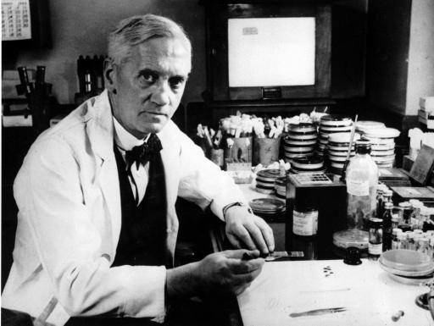Thus antibiotic therapy will not be the predicted magical cure for all infections, rather it is only one weapon, albeit an important one, against infectious diseases

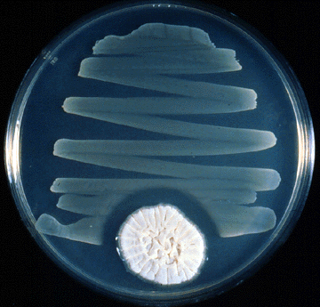

**Fleming and Penicillin**  
this is a culture media, and a Petri dish  
notice the streaking of bacteria, where the fungus is growing is surrounded by a clear area from bacteria. Why? Because, this penicillium fungus, suppresses the role of bacteria. That’s how he really discovered penicillin, by accident: he was growing bacteria, and the culture was contaminated by fungus.

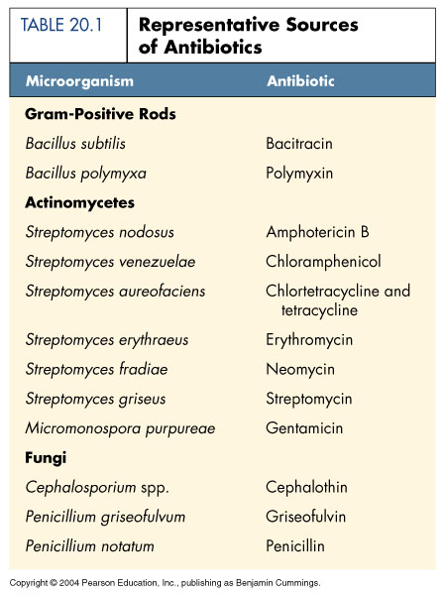

* Microbial Sources of Antibiotics (mostly from bacteria and fungi)

1. Gram +ve bacteria, which produce Bacitracin & Polymixin, these are toxic and only used topically.

2. actinomyocetes is actually bacteria, there are many species of them.

3. Fungi, they also produce important antibiotics like penicillin.

* Definitions:

1. **Selective toxicity:** on the bacteria, there are antibiotics that are active against some bacteria but not all bacteria.
2. **Antimicrobial agents :**Antibiotics Vs chemotherapeutic agents
3. **Antibacterial spectrum**: range of activity (Broad vs. Narrow)
   * 1. Broad: some can be active against gram +ve and gram –ve bacteria at the same time.
     2. Narrow: only active against gram +ve bacteria for example.
4. **Bacteriostatic Vs bactericidal**:
5. Bacteriostatic: antibiotic that when you apply it on bacteria, it will stop it from growing and dividing, it doesn’t kill.
6. Bactericidal: it kills the bacteria.
7. **Combination therapy (aka cocktail therapy)** you use more than one antibiotic together: Synergism vs. Antagonism:
8. Synergism: the combination works together to produce a better effect ex: sulfonamides and Trimethoprim each alone is a bacteriostatic, together they are bacteriocidal.
9. Antagonism: tetracycline with penicillin doesn’t work because tetracycline is bacteriostatic and penicillin is bacteriocidal so in order for penicillin to work it needs to have growing bacteria, so it will lead to antagonism.
10. **MIC VS MBC**:
11. MIC (minimal inhibitory concentration; the lowest concentration of an antibiotic that leads to inhibition of bacteria growth)
12. MBC (minimum bacteriocidal concentration; the minimum concentration of that antibiotic that actually kills the bacteria)

* **Mechanisms of Action: it depends on the morphology of the bacteria.(prokaryote vs. eukaryote):**

1. **Inhibition of cell wall synthesis**:
2. this will harm the bacteria, but not the human cells because bacterial cells have glycopeptides this is one way in which the antibiotics work
3. Ex: Beta lactams, Vancomysin, Teicoplanin, Bacitracin, Isoniazid, Ethambutol, and Cycloserine.
4. **Alteration of cell membrane function**
5. these can be toxic, that’s why they’re used topically, if you take the parental they will injure the kidney or liver, etc..
6. Ex: Polymyxins, Amphotericin B, Imidazoles, Triazoles, Polyenes.
7. **Inhibition of protein synthesis:**
8. can kill the bacteria and spare the mammalian cell, attacking the ribosomes, because of the different structures of the ribosomes, we can have antibiotics that will harm only bacteria and spare those of humans
9. These will stop synthesis of proteins or cause premature release of proteins thus we don’t have proteins working properly and the bacteria cannot live without its own proteins or enzymes that are important for it.
10. Chloramphenicol, Erythromycin, Lincomycins, Tetracycline, Aminoglycosides.
11. **Inhibition of nucleic acid synthesis:**
12. Rifampin, Quinolones, Metronidazole, Sulfonamides, Trimethoprim.

Although we treat infections with antibiotics, It’s not the antibiotic that irradiates the infection, it’s the immune system, and really antibiotics check the multiplication of the bacteria, by killing them, and by stopping them from growing and then eventually the immune system actually is the one that eliminates the infection, that’s why people who are immunedeficient, they can take antibiotics but their response ability is less than normal people who have normal immune system.