Title of Lecture: Antibacterial agents, & Gram positive bacteria

Date of Lecture: 26 Oct. 2014

Sheet no: 11

Refer to slide no. : 5: 49-60
6: 1-8
Written by: Seema Salam Daradkeh

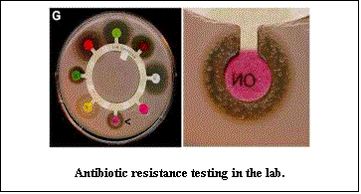
Measuring Antimicrobial Sensitivity: Disk Diffusion
When we take a sample from a site of infection, and take it to the lab we ask for a C&S (Culture and sensitivity test)
In the lab they will culture the bacteria accordingly, in order to get the information needed, and after that we will get a pure culture, showing which organism is causing the infection.
Then, they’ll do a sensitivity study on the medium (agar) and you can see a measured diameter of suppression or growth around the bacteria, done by antibiotic, so you can decide wither it’s Sensitive, Medium or Resistant according to the antibiotic. And then the laboratory will send the report back to the doctor to choose the suitable antibiotic.
The lab, should carry on the susceptibility studies.

Measuring Antimicrobial Sensitivity
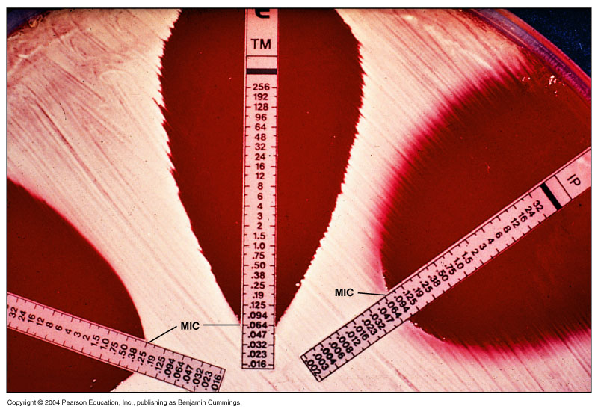
- E Test is done to determine the MIC.
- MIC: Minimal inhibitory concentration
- These strips have variant concentration of a drug, for ex: in the picture, at the top we have high concentration of the antibiotic and decrease as you go down.
- The area where there is suppression of growth is the MIC area. This is the minimal inhibitory concentration of the antibiotic, as you go more up the suppression increases because the concentration of the antibiotic actually increases, that is what we mean with MIC.
Antimicrobial Resistance
- Relative or complete lack of effect of antimicrobial against a previously susceptible microbe
- Increase in MIC
Mechanisms of Antibiotic Resistance
(how the bacteria resists the antibiotic)
- Enzymatic destruction of drug
- Prevention of penetration of drug
- Alteration of drug's target site
- Rapid ejection of the drug

Antibiotic Selection for Resistant Bacteria
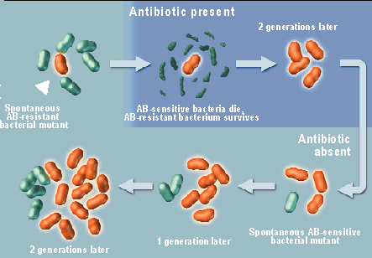
The bad habit of using antibiotics in an inappropriate way, actually increase the chance of having resistance, if you have one which is red, and the other ones are green (the green ones are sensitive to the antibiotic, and the red bacteria is resistant to the antibiotic) so this antibiotic is not used properly, because you’ll give the antibiotic it will kill the sensitive bacteria, but the resistant bacteria will carry on multiplying, so you’ll end up with population of the red bacteria, and that’s how resistant strains of bacteria are chosen and carries to grow, especially if you don’t choose a strong drug.
What Factors Promote Antimicrobial Resistance?
- Exposure to sub-optimal levels of antimicrobial(Antibiotic) : antibiotics should be taken at the right dose and not skip doses.
- Exposure to microbes carrying resistance genes : because resistance gene can be transferred from one bacteria to another by plasmids for example.
Inappropriate Antimicrobial Use
- Prescription not taken correctly: the patient should take the medicine correctly, this is known as compliance which means the adherence of the patient in taking the antibiotic as it has been prescribed, unfortunately most people don’t do that. This is really very encouraging for growing bacterial resistance, and very important in cases of TB.
Treatment of TB should be continued for 6 months, sometime the patients won’t take the antibiotic continuously.
- Antibiotics for viral infections: Unfortunetly this isn’t the case, because sometime a patient goes to the doctor with sore throat, and mostly sore throat can be of viral infection, here, the antibiotic will kill the bacteria which are sensitive (Normal Flora) and encourage the resistant bacteria to grow
- Antibiotics sold without medical supervision
- Spread of resistant microbes in hospitals due to lack of hygiene
- Inappropriate Antimicrobial Use
- Lack of quality control in manufacture or outdated antimicrobial : That’s why any drug manufactured should be under observation, and monitored not to be out of date or having less dosage of the active antibiotic.
- Inadequate surveillance or defective susceptibility assays
- Poverty or war
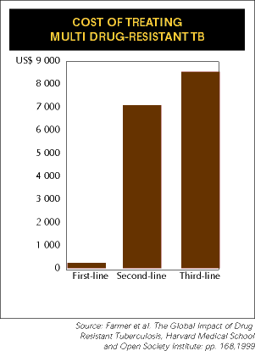
- Use of antibiotics in foods
Consequences of Antimicrobial Resistance
- Infections resistant to available antibiotics
- Increased cost of treatment, if the bacteria is more resistant.
- So the first line of antibiotics are the cheapest, if the bacteria becomes resistant to the first line, the cost increases and other drugs (2nd line or 3rd line) are used.
Unnecessary prescriptions: sometimes, antibiotics are given when they’re not required:
- Ear infections : 30% of antibiotic infections are not necessary because it could be viral infection
- Common cold: 100% viral, so antibiotic are not necessary at all.
- Bronchitis : 80% of antibiotics prescriptions are not necessary because it’s a mixed grow anyway, and if you take a sample, they cannot isolate a pure culture.
- Sore throat: 50%
- Sinusitis: 50%
Considerations before giving antibiotics:
- Choose the coast: choose the cheap antibiotic as the first drug.
- Administration: choose the easiest for the patient, Orally instead of injections
- Avoid drugs with serious side effects: Some drugs have side effects on the 8th nerve for example.
- If the patient was a child: give the drug as syrup.
- Don’t use multiple antibiotics.
Proposals to Combat Antimicrobial Resistance (if you want to develop new antibiotic)
- Speed development of new antibiotics
- Track resistance data worldwide
- Restrict antimicrobial use
- Direct observed dosing (TB): to make sure that the medicine is really taken
- Use more narrow spectrum antibiotics: like if you can use penicillin to treat an infection, why use Clindmycin because for example an infection by streptococcus group A, penicillin or any other narrow range antibiotic does the job, but if you use a broad range antibiotic it will kill the bacteria and will also kill other normal flora, and encourage growth of resistant bacteria.
- Use antimicrobial cocktails: not recommended unless you have good additive synergistic effect.
Gram positive bacteria:
- Gram +ve cocci
- Gram +Bacilli
- We will talk about Gram +ve cocci, and especially Staphylococcus.
- INTRODUCTION:
- Staphyloccocci - derived from Greek “staphyle” (bunch of grapes), and “coccus” because it’s spherical.
- Species: there are about +30 species, but only 3 are important:
    - Staphylococcus aureus: Produces a gold pigment.
    - Staphylococcus epidermidis: It grows on the skin
    - Staphylococcus saprophyticus.
-the later two actually don’t cause disease very often, and they are not serious as the Staphylococcus aureus, they are associated with plastic implants in the body, like a cannula or a catheter or naso-gastic tube they tend to stick to plastics and rubber and establish infection, but the most common infection with Staphylococcus is actually due to Staphylococcus aureus.
- Gram positive cocci are arranged in clusters
- Hardy organisms surviving many non physiologic conditions (easily grown)
- Include a major human pathogen and skin commensals
- They look like clumps, they are Gram +ve, their color is Bluish-purplish.

- Staphylococci
- Nonmotile, facultative anaerobes (can survive with or without O2) and strongly catalase positive (They can protect themselves against free oxygen radicals, which normally kills bacteria, by transforming H2O2 into H2 and H2O) .
- They grow in 10% NaCl and at a very wide temperature of 18° to 40°C.
- They normally grow on: human skin and mucous membranes (nares), and occasionally in the intestine as normal flora.
- They are opportunistic (they cause infection if they can get into blood stream or inside the body)
- 32 species belong to the genus, 16 of which have been associated with human disease.
- These are divided into coagulase-negative (All the other staphylococcus) and coagulase positive (Staphylococcus aureus).
-Coagulase is actually an enzyme that converts Fibrinogen into Fibrin, causing clumping of bacteria together, and coagulation around them, it is believed that this coagulation around them protects them from anti-bodies and cells that are involved in immune response against infection.
- Coagulation is a pathogenicity factor.
*Coagulase itself could be secreted or cell-bound. The cell-bound: allows the bacteria to clump on each other. And the secreted: allows them to actually surround themselves by fibrinogen to protect itself from attack by immune system.
- Structure of Staphylococci
- Capsule (Slime): a Pathogenicity factor. Sometimes can be very well marked like a halo of polysacharide, and sometimes it’s in the shape of a slime.
- Teichoic acid : a Pathogenicity factor. adherence factor to the tissues where it’s present. Used for binding of staphylococci to fibronectin.
- Protein A On Staphylococcus aureus only. A Pathogenicity factor. and it is covalently linked to peptidoglycan. It has a unique affinity for binding to FC of IgG. So it makes the antibody attacking it useless by binding to the FC portion.
- Clumping Factor (cell-bound coagulase) a Pathogenicity factor. Present on most strains of Staphylococcus aureus. It binds fibrinogen converting it to fibrin causing staphylococci to clump or aggregate.
- Grouping for Clinical Purposes
1. Coagulase positive Staphylococci
-Staphylococcus aureus
2. Coagulase negative Staphylococci
-Staphylococcus epidermidis
-Staphylococcus saprophyticus
- Staphylococcus aureus
- Bacteria commonly carried on the skin or in the nose(nares)
- 25-30% population is colonized with “staph”
- Cause of infections:
- Minor infections: something on the outside of the body (skin and soft tissue)
- Major infections (blood, pneumonia, surgical site and actual surgical wounds)
- Staph is the most common cause of skin infections, because it is most likely to be present on skin.
- Source of Staphylococcus infection:
- The patient himself, from his normal flora
- The people dealing with the patient (ex: manipulating wounds without gloves, you are contaminating the wound with your staphylococcus)
- Epidemiology
- Present in most environments frequented by humans
- Readily isolated from fomites
- Carriage rate for healthy adults is 20-60%
- Carriage is mostly in anterior nares, skin, nasopharynx, intestine
- Predisposition to infection include: poor hygiene and nutrition, tissue injury, preexisting primary infection, diabetes, immunodeficiency
- Increase in community acquired methicillin resistance – MRSA: the staphylococci change their penicillin binding proteins and they became resistant to methicillin. MRSA: methicillin resistant Staphylococcus aureus. And the only antibiotic effective against them is vancomycin.

