This is related to the last sheet .
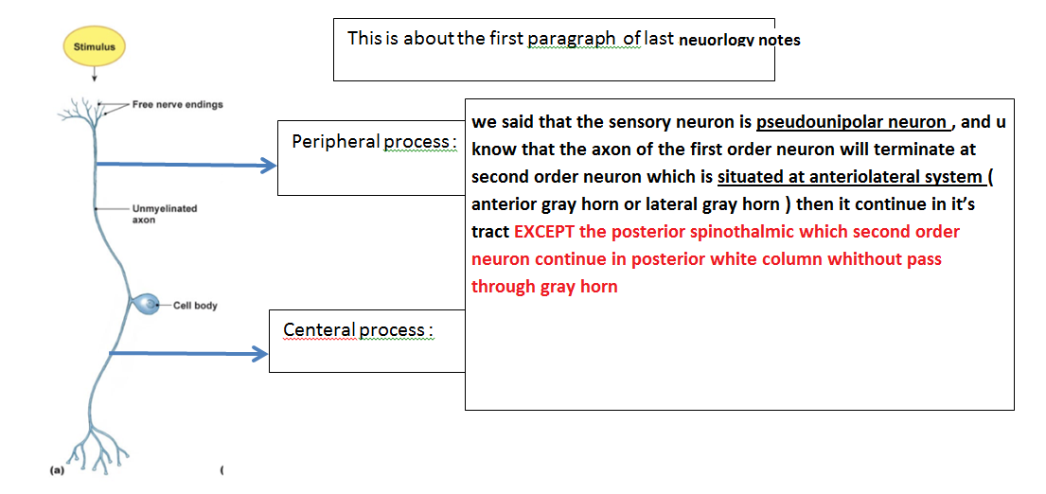
Lab 4
For exam : U should be able to identify each section of the medulla oblongata , at which level , and identify some structure in that section
3 section :
- At caudal level : there will be motor decussation >> corticospinal tract
- At middle level : there will be sensory decussation >> fasciculus gracilies and cuneatus
- At upper part : level of olive , there will be cranial nuclei >>
Slide 2 & 3: The difference between the motor decussation level and sensory decussation level :
The motor “ the corticospinal tract ” , the fiber come from the anterior gray mater and decussate to the other side and form the pyramids , but at the sensory decussation level the fiber come from the posterior white matter and cross the median plane and continue as Medial leminiscus

** in the middle section , u can notice the beginning of the Olivary nuclei but not maximum
appearance
Slide 4 : The third section : the level of olive :
-There is group of nuclei present at upper part of medulla , and it responsible for controlling the voluntary movement

-There is no decussation here
- ICP : fiber that connect the cerebellum and medulla oblongata
- 4th ventricle : the central canal converted into 4th ventricle ; it is a cavity inside brain and filled
with CSF.
-Medial leminiscus : it should appear in this section
- reticular formation : a group of nuclei , to control some activity in the body ( e.g ,to keep alertness and conscious level
- nuclei of cranial nerve
- the hypoglussal nuclei :beside the midline
- Dorsal vagal nucleus : gives the parasympathetic to the vagus nerve .
- Solitary nucleus : control the taste .
- nucleus ambiguous : gives the larynx , pharynx and soft palate .
-7th 9th 10th >> the number of cranial nerve which control taste .
-9th 10th 11th >> pharyngeal plexus .
-The most lateral nuclei : nuclei of vestibuloccular nerve .
- olivary nucleus : control voluntary muscle movement .
- Medial longitudinal fasciculus “ MLF” :situated on each side of the midline , inferior to the
floor of the 4th ventricle , it responsible for connect the cranial nerve with each other(which
is third, fourth and sixth “for the movement of eye ball” with 8th with vestibularcochlear) >>
so it adjust the movement of eye ball with position of the head .
- the cavity of 4th ventricle is present in this section
The cavities of the hollow human brain are called ventricles , There are four ventricles in the human brain: two lateral ventricles in the cerebrum , the third ventricle and the fourth ventricle in the medulla . CSF flows from the lateral ventricle to the third ventricle through foramen of Monro. The third ventricle and fourth ventricle are connected to each other by the cerebral aqueduct .

Ask me if there is any problem .

