orthodontic dental materials

Today we are going to talk about properties of orthodontic dental materials used in removable and fixed appliances .

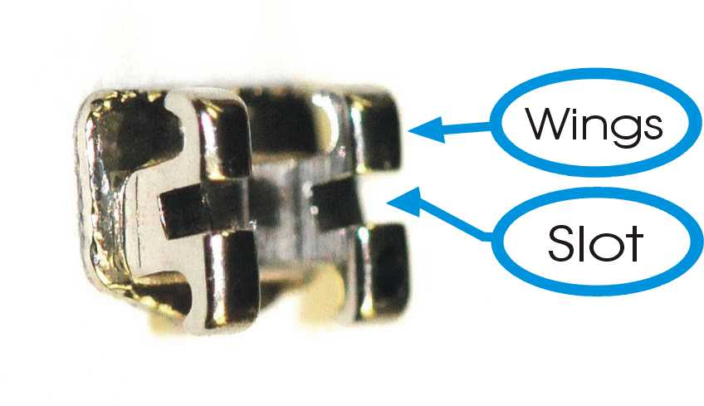Fixed appliance components :
- ligatures: toe the arch wires to the brackets.
- arch wires .
- metal bands .
- brackets
- elastomeric modulus .
Brackets : the component that transfer the force .
Consists of four main parts:
1- slot 2- stem 3- base 4- hock .
* bond to the tooth structure to achieve the tooth movement .
- according to the material used , there are 3 types of brackets :
1- Metal brackets ( conventional ) .
2- polymers brackets .
3- ceramic brackets .
Metal brackets :
there are 3 main types :
1- Stainless steal brackets :
( most common used ) , cheap and effective .
>> manufactured from 18:8 steel
18% chromium for corrosion resisitance ( form a layer that prevent the corrosion ) .
8% nickel to improve the flexibility of the arch wire .
Mainly composed of iron 71%
2% of carbon .
** AISI : American Iron Institution give a number that depends on the content of the alloy ; the more alloy content the more the number the more the hardness of the bracket .
- the one that used in orthodontics brackets is # 314 .
* the only disadvantage is the allergy to the Ni .
2- Co\Cr brackets : much less Ni content than S.s
3- Ti brackets : most biocombatable , No Ni at all .
* Note : if the patient has an extra oral nickel sensitivity , not necessary to have an intra oral Ni sensitivity ! why ? :
because :
1- the skin is more sensitive to Ni than intraoral environment .
2- the saliva play a rule in decreasing the sensitivity .
3- there is no direct contact with the Ni In the oral cavity , so less amount of release .
- to be sure that the ptn is not allergic to Ni :
put only 2 brackets (on the 4 and 5 ) and ask the ptn to go home and come the next day , examin the gingiva for swellings or whitish discoloration .
* how to manufacture the S.s brackets :
1- Meld : very expensive , computerized ( if manual , high percentage of errors ) , sometimes it’s inactive with metals .
2 – casted : wax up of each bracket then casting , time consuming technique .
3- injected mold : mold with 10 or 20 brackets wax up . ( most accurate way ) .
*how to bond the metal brackets to the tooth structure ?
- by composite rely on the mechanical retention .
-to increase the mechanical retention , the surface area must be increased .
_we can increase the surface area by :
>> mesh base : make the base of the bracket like a mesh ( شبكه )
>> make slots ,grooves or holes in the base by laser itching to increase the mechanical retention and the bond strength .
Polymers brackets :
- made of polyurethane or polycarbonate .
- color : white or transparent .
Advantage : esthetics
Disadvantages : 1- discoloration of the brackets after one month .
2- low fracture resistance
3- lack of stiffness and strength
* the bracket should be stiff to hold the tooth movement , if flexible it will bend with wire and we get 50% of the wanted tooth movement .
Ceramic brackets :
1- monocrystaline aluminum oxide :
* more transparent than the poly crystalline , manufacturing by milling of one block.
* more expensive , more esthetic , less friction .
2- poly crystalline aluminum oxide :
* ceramic material + saline , mix and inject them to the mold and then burn the mixture in order to let the saline to come out .
advantage : esthetics .
disadvantages :
1- low bond strength because the aluminum oxide inhibit the setting reaction of the composite , so we use saline coupling agent instead . (modulating a strong chemical bond btw the bonding agent of the composite and the aluminum oxide ) but this will lead to difficult debonding of the bracket from the tooth structure .
to overcome the debonding problem , dentists rely on the mechanical retention and stop using the saline coupling agent any more .
2-high friction : to overcome , they manufacture ceramic bracket with metal slot . so the touch between the brackets and the wires is from stainless steel >> less friction.
3- brittleness : easy to fracture .
4- hardness : porcaline harder then enamel causing iatrogenic enamel wear to the apposing teeth especially the palatal surface of the upper incisors .
to overcome : - open the bite
– put metal brackets or poly carbonate brackets on the lower arch .
- low profile bracket : bevel on the lower bracket to prevent the occlusion with the
opposing .
5.The debonding: because of it’s brittleness we will have difficulties during removing the brackets , we use the de bonding plier to remove the brackets, However it will break and half of the bracket will be still attached to the tooth, in this situation we don’t have any grip to use the pliers any more so we have to use burs in order to remove it… so the debonding will take two hours instead of 5 minutes!! .. so this is a big problem.
- Nowadays we have more than one technique of debounding like using special debonding plier or the ultrasonic technique.
The most common way is patency?????? 25:20 which made a stress release inside the bracket it’s like a groove inside the bracket so when we squeeze it the bracket will break exactly from the groove which mean the two halves will get out. (you are not supposed to know about it ).

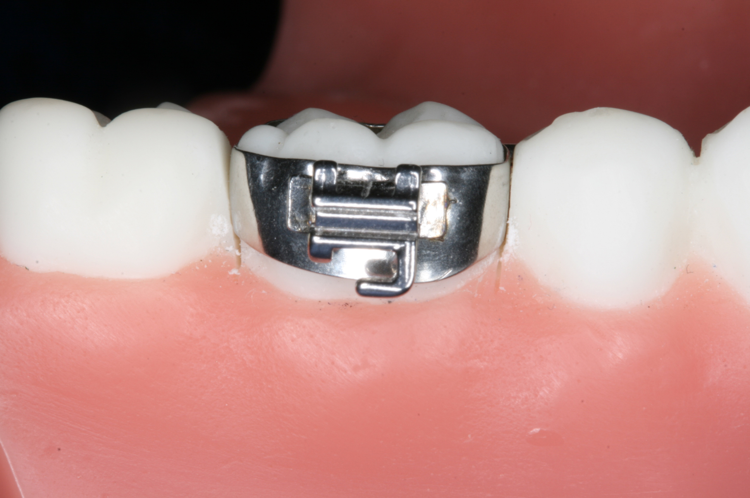*The band:
Mainly it’s made from stainless steel. they have different sizes with slot on it just like the slots of the brackets but here they are soldered to the band.
In the past before the bonding techniques were exist they used the band on each and every tooth on the arch (band on the canine the laterals and so on) but after the developing of bonding technology and the composite we don’t do this any more.
So why we still use bands on the 6’s ?!
Simply because the mastication there will be continuous causing deboning of the brackets or the tubes , another thing that we need this band to put anchorage components .
*How to insert the band:
First of all we need a space between teeth, so we use something called elastomeric separator they are rubber and flexible so we can easily insert them between teeth and they will create a space for the metal band. Usually we put this separator for a week inside the patient’s mouth.
Then we need to bond the band to the tooth (banding) and stick the bracket on it( bonding).. we have four main categories of the bonging materials :
*Diacrylate: which is BISS gamma and we only use it for bonding we don’t use it for banding, it is the regular composite that we use.
It composed of (15-80)% fillers, the nanotechnology increased the % of the fillers.
Why the fillers are important in composite? They reduced the polymerisation shrinkage.
What is the difference between the orthodontic composite and the composite that we use for restorations? It is a little bit more flowy, because we don’t want it to be thick underneath the brackets.
We have two types of composite:
* Chemical cure: either two tubes or sandwich technique.
The sandwich technique: instead of having two tubes, they put the accelerator (initiator) inside the bonding agent , so we itch the tooth structure then we put the bonding agent on it then we put the bonding agent on the bracket then we put the composite , so the composite is sandwiched between the two bonding agents.
*Light cured composite: can we use it under the metal bracket ?! yes, we have a phenomena called trans elimination which is when you put the light cure on the incisor edges we can see the light going through the enamel prisms, because of this phenomena we still have curing with the metal brackets.

>> glass ionomer: we can’t use it for bonding only for banding.
Advantages:
-chemically bonds to the tooth structure
- Achieves to the steal as well
-Release fluoride so it’s kind of an ideal material to use because
the posterior teeth are more prone to caries .
Disadvantage: the bitter taste and it is a moisture sensitive material.

1-Resin modified glass ionomer: same as GI, but we have hydoxymethylmethacylate, this will give us more bond strength compared to the conventional GI cement.
2-Compomer: same as RMGI ( I think he meant composite) , however the filler percentage in it is higher (30-35)%. It’s a light cure we do acid etching then bonding. Recently they made a study and it showed that the bond strength of the composite and compomer are the same on brackets, but we still have one advantage of compomer over composite which is releasing fluoride. However, until now we still using composite we didn’t switched to compomers.
Enamel preparation before bonding:
Before the acid etch and the bonding we do polishing to the tooth structure.
If we are using phosphoric acid we don’t need polishing, but if we are using the fifth generation ????????? we have to do polishing.

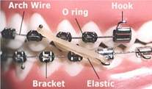
*The arch wires:

It’s the component used to connect the brackets and the bands together.

- Stainless steel arch wire: same components and manufacturing way as SS brackets , made from stainless steel 18,18. The main advantage that it is stiff (rigid).
Properties: it doesn’t have flexibility like nickel-titanium. It’s formable (I can bend it).it is wieldable (b2dar al7emo) Low friction which is very important, environmental stable, low cost.

- Nickle-titanium arch wire (NiTi) : it comes in three types:
- Martensitic stable: composed of 52 % Ni ,43% Ti,
main characteristics: not stiff, more flexible , we can’t do welding wala soldering, high friction resistance, doesn’t have shape memory or superelasticity.
Stress-strain curve ???????
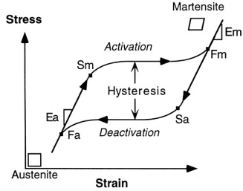

- Martensitic active
- Austenitic active: super elasticity and shape memory
To understand these forms we have to know that Ni-Ti comes in two forms or phases : martensitic and austenitic and they depend on the arrangement of the Ni-Ti atoms and the material can move between the austenitic and martensitic if it’s active , but If it was stable then it cant.
The martensitic is more flexible and it exist on lower temperature and the austenitic is less flexible and its found on higher temperatures .
- Titanium ??????? alloy (TNA): the only advantage of it that its formable, so we use it in the last stage when we need to move one teeth only

