Sheet no: 20.
Refer to slide no: hardcopy only. (PROVISION OF SPACE IN ORTHODONTICS)
Date: 20/3/2015
Dr: Iyad Al-Omari
Written and corrected by: lubna Marmori
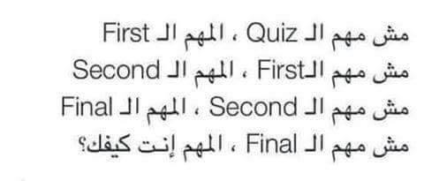

هذه المحاضرة عبارة شرح بسيط عن الطرق الي بنقدر من خلالها تزويد الفك بفراغ او مساحة لحتى نقدر نحرك الاسنان .
- بدخل المريض
- Treatment plan
- Is there any crowding?
- Decide extraction or non extraction
- Means of providing space.
- … Continue in last lectures.

Sheet 20
PROVISION OF SPACE IN ORTHODONTIC
HOW DID WE DO TO PROVIDE SPACE?
We have series of lectures to be able at the end of this semester to come with treatment plan. Treatment plan is step by step so it is very important to examine the patient.
First, you see the ptn and examine him. Then you decide if you want extra investigation (records such as study model, photograph, x-ray), then you start analyzing this records.
One of the important records to the patient is the Study model, which help us in Space analyses.
(Here we talk briefly, there was whole lecture talked about this subject.)
Why space analysis is important?
The most common problem in Jordan (50% of Jordanian) is the crowding, so here we need space (provide space).
Records (study model), do space analysis. So once you analyze the space you come with result (here you can know your ptn have which type of space).
Type of space:
- Adequate space
- short space : known as crowding
- Excessive space: known as spacing.
When we have crowding we should deal with MEANS OF PROVIDING SPACE, and this is the subject of this lecture.
MEANS OF PROVIDING SPACE IN ORTHODONTIC.
It divides into 2 parts:
- non extraction
- extraction (tooth , teeth)
There is a whole lecture about extraction phase.
Now we will talk about non- extraction methods.
To make it simple, we usually extract premolar (= 7 mm width per side), so as a rule:
IF WE HAVE, A CROWDING 3.5 PER QUADRENT OR MORE WE GO FOR EXTRACTION.
IN OTHER WORDS:
IF WE NEED SPACE MOERE THEN HALF UNIE PER QUADRENT WE GO FOR EXTRACTION.
If the space requirement less than 3.5 we go to non-extraction phase.
So why do we need to provide space? Basically, to correct crowding.
Other indication : to provide space.
- Camouflage skeletal problem. ( to correct incisal and molar relationships )
Comoflage = patient has skeletal problem, and we want to correct the occlusion. We correct the occlusion but ignore the skeletal problem (المريض بيتقبلها) and not dealing with it. So only correct the occlusion problem.
** So ptn come with skeletal class 2, and you know that he has increased overjet and we should decrease the overjet by providing space.
** The same thing if ptn come with skeletal class 3
…………………………………………..
REMEMBER:
THE OPTIONS IN ORTHODONTIC IS
- ACCEPT
- COMOUFLAGE
- GROWTH MODIFICATION
- SURGURY
So again we do charting of teeth then space analysis then we decide (extraction vs non-extraction) {3.5 or more per quadrant > extraction} . After that we decide what is the type of teeth movement we need (bodily vs tipping). Therefore, it is systematically to get best treatment.
This was an introduction, and now the lecture will start:
The reason for provision of space in orthodontics:
- crowding
- Compensate for skeletal discrepancy; Camouflage skeletal problem. ( correcting occlusion in upper and lower incisors & molar relationship without skeletal discrepancy )
Crowding again: (there is also a lecture about crowding) but it is basically short of space. According to categories it may divide into mild, moderate, sever ((there are a lot of categories that divide it into other division. the simplest category divide crowding into mild , moderate ,severe)) .
Sever means more than one unit per quadrant (More than 7 mm). ((in jordan ))
Moderate means 3-4 mm per quadrant.
Mild means 2-3mm per quadrant.
We want to straighten the teeth to get space
Remember ** more than 3.5 > extraction.
Clinical tips:
- We have to decide if it is extraction or not?
- If we decide extraction, we go for arch expansion:
A- PROVIDING SPACE.
B- EXPAND THE ARCHES TRANSVERSLY
- Arch lengthening:
A - EXPAND THE ARCHES ANTERIO-POSTERIORLY.
B- PROCLINATION OF ANTERIOR TEETH.
- UPRIGHT OF TEETH:
Six keys of normal occlusion: teeth not 100% perpendiculars on occlusal plane, all teeth are tip mesially.
- IPR : interproximal reduction
- Correction of posterior teeth rotation.
- Combination of any or all of the above.

- ARCH EXPANSION
Can we do that for the ptn ?
Yes, we can. But only when it is indicated.
INDICATION:
- Unilateral cross bite with displacement
crossbite indicates that there is constriction so we try to expand.
What is the reason of cross bite with displacement? Constriction of upper arch. ( (narrow space)).
With constriction of upper arch. When the ptn bite.. Shift to the mandible that’s why we expand bilaterally.(as treatment).
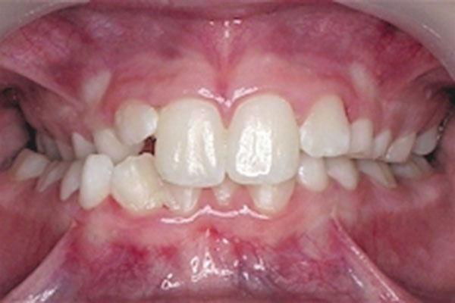
Here :
We have constriction in this side.
Usually when there is symmetrical constriction in upper arch it leads to cross bite.
So ptn when bite, there will be occlusal interference, there will be adaptation to get better function and this happen with shifting to the mandible. So mandible will move to right and left.
Therefore, the treatment is to EXPAND BILATERALLY.

- Bilateral crossbite with crowding. Sometime we accept bilateral crossbite, because it is accepted esthetically and no harm on occlusion. However, in cases WITH CROWDING, we have to expand to relief crowding and to treat cross bite. (يعني بنروح المريض بندون ما نعمله اشي بس الا اذا كان فيه تزاحم بين الاسنان)
- Distalizing upper posterior teeth.
- Preparation for a bone graft in cleft.
Now how to treat ?
We talked previously about function appliance, which help in expansion and movement of mandible forward.
dr discuss a photo for ptn has unilateral crossbite posteriorly , we don’t expand only the right side but also the left one . Therefore, when we do expansion we will get the space that we need.
How do we achieve expansion?
- Using removable appliance. Advantage: open of the bite.
- Fixed appliance. (As: quadhelix , rapid maxillary expansion(next lecture) ).
- Functional appliance. (As: Frankel appliance > passive expansion) but remember we don’t use functional appliance for expansion, but only when indicated. This is common mistake. So it is not the first choice to relief cross bite.
How much did it give space?
Usually all mesially provisional space gives 2-3 mm maximum. (I do not know if is it for arch or for quadrant? dr didn’t mention it here.)
Ex. Ptn has 5 mm per arch crowding >> so per quadrant 2.5mm, so expansion not appropriate choice.
What is about retention?
We should think about retention when we use removable appliance. Because sometime expansion leads to displacement, (all expansion will relapse with time). (ومرات تفك من ثم المريض) .and don’t forget to open bite.
Open bite >> Facilitate movement.
Example
- Upper removable appliance: we need 1- expansion screw 2- adequate retention 3- posterior biteplane (not always used).
- Coffin spring: expand bilaterally, advantage: not depend on ptn cooperation.
- Quadhelix: fixed appliance. Fix the band and it has four (quad) coils.
- Rapid maxillary expansion. (there is a lecture about this subject).
- Function appliance : as we talked in previous lecture; passive means it depend on the effect of Buccinator , so the tongue will push the teeth to the side .
REMEMBER: PTN HAS CLASS 1 AND BILATERAL CROSS BITE, WE NEVER USE FUNTION APPLIANCE. ((Ptn should has skeletal problem AND bilateral cross bite)).
So EXPANSION:
- Cross bite
- 2-3 mm maximum per side
Other means of providing space is ARCH LENGTHENING.
2- Arch lengthening.
What is the meaning of arch Lengthening? We talk about anteriposteriorly.
Anterior > incisors
Posterior > distalize posteriorly.
Anterior teeth:
- Proclination of upper incisors :
- It just for upper arch, because it is stable.
- We cannot change the lower incisors position. (dr said : we can change them, but they will relapse as soon as possible.)
- So it use when the upper incisor is retroclined (class 3 and class 2 div 2).
- Therefore, we correct the incisors relationship.
- We move the teeth labially.
- For each mm you move it, you need 2 mm within the arch.
- Ex. If we want to نرجع incisors 1 mm we need 2 mm within arch ( 1 mm from each side.)
- Ex. We move incisors 2 mm, how much did we create space? 4 mm per arch (so 2 mm for every side.)
How do we achieve it ?
- Removable appliance
A- (screws): * advantage: Retention (why is the screw better than z spring? retention.
B- Z springs ( if it was only one incisors or 2 ,BUT if it was more than this , we can’t use z spring (مش منطق نحط اربعه ) , there is palatal spring (cross over spring ) which is the best to be used in these situation.
- Fixed appliance
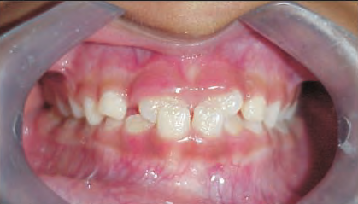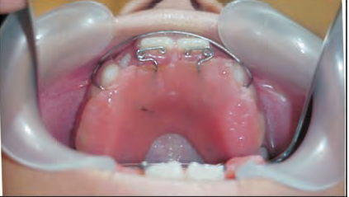
- Ptn come with class 3 or anterior cross bite , we use z spring and
- 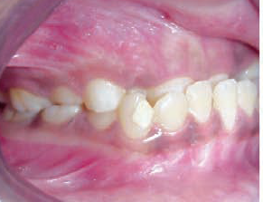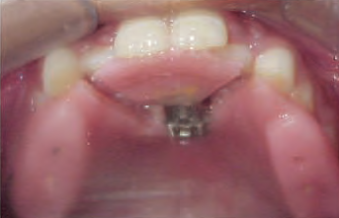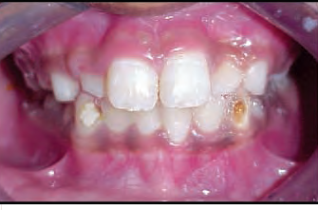
- Ptn come with class 3 or anterior cross bite and treated with 3-d screw.
- هون في حد سأل سؤال والدكتور جاوب .. أنا لا فهمت السؤال ولا فهمت الجواب .. ابصر عن شو كانوا بيحكوا
- Another example for ptn has crossover and we use palatal spring. that used when there are more than two teeth.
- 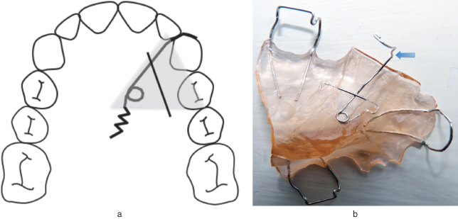
Can we do proclination for lower incisors?
NO, but we have 2 exception.
Exception:
- Thumb sucking.( because if we remove the effect we can procline them).
- Class 2 div 2. (Because the effect of lower lip on upper incisors> bimaxillary retroclination.
THE THIRD MEANS:
3- moving posterior teeth
Simple only we move upper or lower posterior teeth posteriorly.
Indication:
- Distal movement for upper or lower arch.
- To correct molar relationship.
- Molar in class 2 > so distalize them lead to create space and to correct the relationship.
- (الدكتور حكى بس كلاس 2 بس ب السلايد ذاكرين كلاس 1 و كلاس 2 .. فاي دونت نو )
- How much do we get space? quarter unit ( it is impossible to get full unit )
(quarter unit= 2-3 mm).
Method:
We need headgear with removable appliance or fixed appliance.
Headgear for two purposes:
- Active movement is Distal movement for posterior teeth(6+7+8 * remember number of roots and its effect on how much force and the suitable anchorage). So its side effect: reaction force is high. If we do not use suitable anchorage it leads to proclination of upper incisors. And this is the side effect of all distalizers , which is huge problem.
Head gear disadvantage:
has hazard; It has splint may it تفك then lead to Eye injury > blind. Blind caused by Infection > but It is very rare.
Nudger: the most commonly used; we use a band instead of Adams clasp because it is not that much strong so we use a band.
please read lip bumper in page 6 in slide. Dr didn’t add any comment.
REMEMBER:
THE MOST USEFUL METHD IN PROVISION OF SPACE IS 1- DISTALIZASTION 2- EXPANSION
- DISTALIZATION > CLASS2 (NOT ALL CLASS 2 , BUT ONLY HALF UNIT OR LESS ** DR MENTIONED US THAT IT INCLUDE QUARTER )
4 - UPRIGHT OF TEETH:
Just correct the angulations. Very small space.
ONLY FIXED APPLIANCE.
5- IPR interproximal stripping:
- .5 mm removed from the tooth. (.25mm from each side).
- Anterior teeth .3 mm per contact.
- Posterior teeth .5 mm.
- Maximum up to 3mm per arch , but we can’t do it for all teeth, we go for certain teeth so usually we can’t get this result (3mm) .
Only certain teeth.
How to did it ?
- Manual > difficult
- Low speed disk
- Bur
Side effect: theory only.
- Effect Interproximal bone lead to Pocket
- Study on ptn >> after 30 years , they have Increased caries.

Interporoximal stripping , interpoximl reduction.
All these terms > IPR
- Correction of premolar and molar relationship :
- Posterior teeth.
- but when talk about anterior teeth > occupy less space. In this case we need space. Should provide space.
- Very minimal space given.
- Rotation > fixed appliance دائما
Dr : Very simple lecture.
Just do it systemically :
- Is there crowding?
- Is there cross bite ? overbite?
- Can I distalize molar ?
- Don’t play with molar relationship if it was perfect.
- Can I rotate ?
- Can I do IPR?
- Avoid extraction.
The inserted pictures to understand the concept only.
Thank you ..
lubna
أيُّها العَابِسونَ فيْ -2 ..

