Orthodontics
Sheet: # 21
Date of lec: 27/3/2016
Written by: Ala’a Abukhader
Extra oral traction and anchorage
Today we will talk about:
- Types of extra oral appliances.
- The Principles of the applied force.
- Safety aspect of these appliances.
Anchorage:
It’s a resistance to unwanted tooth movement.( Newton’s third law of motion )
The source of resistance to the forces generated in retraction to action components of an appliance.
Source of these anchorage can be either intra-orally(teeth ,soft tissue ,and implants ) or extra-orally.
We will talk about extra-orally anchorages (HEAD GEAR)
Types of head gear (we have three main types):
- Head gear (mainly use it in pt with class I & class II)
- Face mask (Reverse pull head gear /protractions head gear mainly use it in class III
- chin cap (the principle is to restrict growth of the mandible)
Head gear:
It’s an extra –oral appliance making use of cervical (neck area) or cranial (head area )an anchorage to apply forces to the jaw and teeth with the purpose of growth modification & tooth movement.
The source of the applied force either the neck area or the cranial area (back of the head).
Why we use it?
We use it for (purposes):
1) Tooth movement:
- Extra- oral anchorage:
It’s a method of increasing the anchorage to prevent forward movement of anchorage teeth." الهدف منو انو الاسنان المثبته ما تتحرك"
e.g.
- a case with increased over jet , we decide to extract the premolar by this we will have a space=7mm and it is exactly equal the needed space for over jet reduction
Now imagine that we are retracting the upper ant. Teeth to correct the over jet (moving the canine to take the place of Premolar ) we want all the space .
Can we afford the molars to move forward? if they move 1mm forward this means that we can’t correct the over jet completely, so we need anchorage!
We don’t want to distalise the teeth (posterior one) and in the same time we don’t want the posterior teeth to move even 1mm interiorly so, just we want to hold them in their positions.
So, we use a head gear to hold the posterior teeth exactly where they are.
- Force level: 200-250 g per side.
- Wear time: 10-12 hour (after school to the second day)

- Extra-oral traction:
Active distal movement of teeth to create space for alignment and over jet reduction.
We create space either by extraction or distalization of posterior teeth.
- Our aim is to distalise the upper arch.
- Force level: 400-500 g per side (double the force level that is needed for anchorage)
- Wear: (12-14) (+: or more) per day.
- Distal movement of upper molar:
*when do we distalise the upper arch?
1- When the patient has well aligned lower teeth (if there is crowding in the lower arch and we want to extract usually we have to extract from the upper arch as well)
2- When there is crowding or over jet in upper arch.
3- When the Molar relationship is half unit class two or less (if we need 3.5mm or less).
Unit=7mm (Premolar width)
If it is more than half unit class two then we need more than 3.5mm so we can’t do distalization(it doesn’t work).
- While Extraction of upper 4 doesn’t give sufficient space for complete alignment or over jet reduction, we need more than a unit, so in this case we might distalise in addition to extraction.

- Crowded upper arch with median diastema
So, we can utilize the diastema in addition to distalization.

5-Where prognosis for stability of over jet reduction is doubtful we start with distalization; we don’t do extraction if the possibility of relapse is high and when the case can go either with or without extraction.

Case:
Missing lateral incisors ,Molar relationship is half unit class 2 ,her profile is indicated for opining the space of laterals ,so we want to open space for lateral incisor we don’t want to close the space.
Tx: we use head gear attached to RA , we can use it attached to fixed appliance.
At the end: Molar relationship is class 1 and we provide the needed space.
- The difference between extra-oral anchorages &extra-oral traction (same appliance)
1) Force level.
2) Wear time.
2) Growth modification: (Orthopedic effect)
To restrict growth of maxillary to prevent anterior/vertically growth of maxillary

- to restrain vertical maxillary growth (gummy smile) and when the maxilla is growing downward
- Force should pass through the center of resistance of maxilla to make proper protrusion. (H.W)
- Big force is needed more than the one for tooth movement( 500 + g per side)

Head Gear Components:
- Part connected to the teeth.
- face bow (the most common)
- J-hook (not used nowadays)
2- Strap or head cap attached to neck:
-head cap
-neck strap
-vertical pull
3- Elastic part or spring mechanism which pulls teeth.
- Face Bow
Components:
Rigid wire >> transfers extra-oral force to maxilla and teeth.
Inner bow >> attached to teeth
In fixed appliance we insert it in tube attached to molar band
In RA (Removable Appliance) we either put it in acrylic (the pt. Should remove the whole appliance) or in head gear tube soldered to Adam’s .
Outer bow >> connected to the other part (elastic). 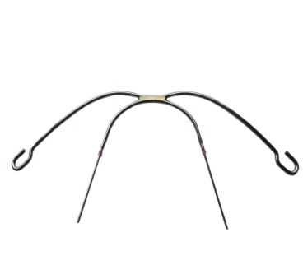
Inner bow
Outer bow
- J- hook (not used nowadays)
It connects interiorly to fixed appliance to protrude the upper anterior teeth in cases with deep over bite. (intrusion of incisors) .
Which can be directly attached onto the arch-wire in FA or attached to hooks soldered onto the labial bow of RA.
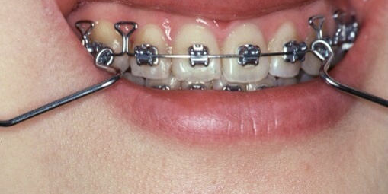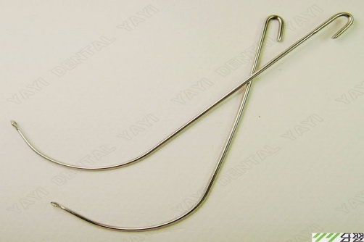

- Neck Strap
Spring mechanism from both side pull the outer face-bow toward the neck and it is a source of anchorage to distalize the teeth.
So, it distributes and transfers the reactionary force to neck area.
- Head Cap:
It is connected to the cranium.
It distributes and transfers the reactionary force to the cranium.
Types of head gears according to their components:
- Low Pull or Cervical head gear \\ if it contains only Neck Strap.
- High Pull or Occipital head gear \\ if it contains only Head Cap
- Straight Pull head gear \\ if it contains both Neck Strap and Head Cap.
- Variable Pull head gear \\ consists of head cap variety of positions for application of force (the direction (Not used nowadays).

2
1

4
3

- Spring Mechanism
-Connect the two other components (the head cap or neck strap to the outer face bow).
-Control the magnitude of the force.
- The more you pull it the more force it will give.
2) Face Mask (Reverse Pull Head Gear /Protraction Head Gear)
- Used with young patient 8-10 years, class 3.
- Is used to try and move teeth mesially to close up excess spacing or in class III malocclusion in an attempt to move the maxilla forward .
- Used in cases with maxillary retrusion and we want to protrude the maxilla.
- Utilizes rests on the chin and forehead as source of anchorage, in between them there is a frame for elastic traction that pull the teeth and hopefully the maxilla forward.
- Used either with RA or fixed appliance (soldered on it like rapid maxillary expansion appliance).
- The elastics pull the maxilla and maxillary teeth forward.
As a result of this pull we will end with the following:
~ Protrusion of maxilla.(to pull the maxilla forward ) mainly effect
~ Proclination of upper anterior teeth
~ It could retrocline the lower Incisors.
~ Posterior growth rotation of mandible(down/backward growth rotation) >> reduced over bite.

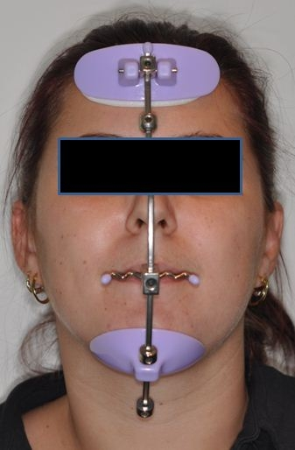
- Chin Cap

- The least one that has evidence.
- The evidence mainly No effect on skeletal ,the main effect on dental .
- used with mandible protrusion cases.(class3)
- It follows the old theory that said that” the condoyle is a growth center” and when you apply this force you prevent the growth of the condoyle.
- But with recent theory which said that “the condoyle is a growth site”, it redirects the growth of the mandible by applying force.
- As a result of this applied force we will end with the following:
~ Retroclination of lower Incisors.
- To move the mandible down/backward .(it doesn’t actually restrict the growth of the mandible .
~ Posterior growth rotation of mandible >> reduced over bite.
- Mechanical Principle
- Magnitude of force.
--- Extra-oral anchorage = 200 -250 g/side
--- Extra-oral traction = 400-500 g/side
--- Orthopedic = 500 or more g/side

- Duration of force.

--- Extra-oral anchorage = 10-12 hour/day
--- Extra-oral traction = 14 hour/day
--- Orthopedic = more than 14 hour/day

- Center of Resistance (CR): a point on which the application of single force will produce bodily movement in the same amount and direction of the force.
- If the distalizing force passes through the center of resistance of the molars this will produce Bodily movement which means that the crown and root will move in the same direction and amount without any rotation.
- In molars it is in tri-furcation area.

- Center of Rotation: the point around which rotation occurred when the tooth is being moved.
- All head gears distalize the molars but what we have to control will it intrude or extrude the molars, will it rotate the molars or not.
- Rotational molars >> if the distalizing force doesn’t pass through CR (Center of Resistance), this will produce tipping movement (rotation).

But, How much would it tip? This depends on:
1- The distance between the applied force and CR
(The closer we are to the CR the less tendency for tipping).
- Close to center of resistance =bodily movement
- Away from center of resistance = rotation
- The force magnitude.
- if the perpendicular distance increase(from line of the force to center of resistance lead to rotation )
- Each tooth has only one center of resistance and many center of rotation

- Again,Direction of force
*The direction of tooth in which it rotates depend whither the line of the force passes gingivally or coronally to the center of resistance.
- if the force doesn’t pass through the CR the tooth will tip but how would it tip ( the crown will tip distally or the root will tip distally) this depends on the direction of the force whither it is coronally or gingivally to the CR.
- If the applied force is Gingival (apical) to CR the root tip will tip backward.
- If the applied force is Coronal to CR the crown will rotate distally.

- Would it Intrude or extrude?
The direction of the force applied to tooth is splints to vertical and horizontal.(the force direction related to the occlusal plane )
--The Horizontal force includes distalization
--The Vertical force includes both depending on its direction with the occlusal plane ; we can determine the relation between the force and occlusal plane by :
1- The type of head gear.
- The length of outer bow.
- The outer bow angulation.

- TYPES OF HEAD GEAR:

- 1/ Low Pull Head Gear
>The direction of applied force is below the occlusal plane this means that we will end up with Extrusion of the posterior teeth and distalization.
>We use it in cases with short face (reduced vertical dimensions, anterior rotation of the mandible) and deep over bite.

- 2/ High Pull Head Gear
>The direction of applied force is above the occlusal plane this means that we will end up with Intrusion, distalization and control the eruption of molars (prevents them from eruption)
>We use it in cases with long face (increased vertical dimensions) and reduced over bite.
>It rotates the mandible counter o’clock (forward) to correct the over bite and vertical dimensions.
- 3/ Straight Pull Head Gear
>There is NO vertical component; the applied force is passing along the occlusal plane.
>We use it in cases with normal over bite and normal skeletal pattern, we don’t want to intrude, we don’t want to extrude.
The net of the forces in the middle so there is neither intrusion nor extrusion, only distalization.

- Problems of Head Gear
- Eye trauma ( more sever one ) (the inner bow distance exactly equal the distance between two eyes)
It can cause blindness if it affects one eye and if it causes infection in one eye this infection can be transmitted to the second eye.
- Intra-oral trauma( injury to the teeth or gingiva)
- 3rd party trauma ( patient’s friends and family)

- Safety Method
- Patient education, in addition we have to educate his parents and we should give them instructions (written /verbal) about the appliance; the benefit and the possible harm.
- Use fixed appliance because it prevents both disengagement and recoil damage.

**How to prevent accidental disengagement?
We use:
- Rigid neck strap ( Rigid should be present)
- Locking mechanism; metal or elastic from backward hooks around the distal part of band.

** How to prevent recoil injuries?
We use:
- Anti-recoil device; the rubber get out plastic if it is pulled rapidly while the pt. removing the appliance.
- Rigid neck strap.
--The inner bow end should be round (safe end)

In RA (Removable Appliance):
The inner face bow enter the acrylic or tube attached to a very retentive Adam’s
We use it only with High Pull Head Gear.
We don’t use low pull HG.

- --There is something called Correx Gauge which used to measure the force.
- --There is a special type of pillows for the patients who used these appliances but actually we advise the patient to sleep on his back.
Good luck

