Ortho lec #3
Added information and corrected by fatmeh alabbasi and sanaa bentareef
Last lecture we talked about concepts and terminologies.
Reference is chapter 4 from laura and chapter 2 from the proffit
Note : Calvarium means the cranial bone , That part of the scull that covers the brain.
This lecture we will focus on anatomy : cranial bones, cranial base, maxilla and mandible
Cranial bones:
That part of the scull that covers the brain
The cranial bone consist of different pieces of bones :
- The Frontal bone .
- Squamous part of the temporal bone
- The parietal bone
- Squamous part of the Occipital bone

We took before that we have two types of ossification :
- Intramembranous ossification.
- Endochondral ossification.
The ossification of the cranial bones starts 8 weeks intrauterine.
The type of ossification is intramembranous so we don’t need the presence of cartilage.
So only the soft tissue that is covering the brain will get invaded by blood vessels, bone formation happens then the formation of islands of calcification.
The outer membrane of the brain is called exominates??? that is where the first activity happens
These islands grow bigger (and the surrounding soft tissue will become smaller) forming the cranial bones.
At birth , these bones are not fused, they are separated by soft tissues called “fontanels”
We have 6 fontanels at birth which are :
- Anterior fontanel
- Posterior fontanel
- 2 Sphenoid fontanels
- 2 Mastoid fontanels

## why aren’t they fused ?
To make the infant head smaller during birth , thus having easier delivery.
After 18 month of birth , fontanels will be replaced by fibrous tissue called “ sutures”
Sutures are osteo-fibrous contact areas between adjacent flat skull bones , where majority of the blood invading occur.
## what happens to the brain after birth ?
It will keep on growing.

The type of growth is neural growth, which is determined by the growth of the brain along with the calvarium.
First we have rapid growth in early years then slows until 7 to 8 years of age when growth is complete (completion of calvarium growth).
Since the calvarium is covering the cranial bones , and bone is getting bigger, the islands of bones will keep pushing apart because sutures are not calcified yet fused and these areas after pushing apart will be filled with bone.
So we will have bone formation at the sutures area and bone remodeling at the outside (deposition) and inside (resorption) surface bone deposition and bone resorption “ active process” (why?) to accommodate the new shape and size of bone.

## what type of movement does the calvarium do ?
It’s primary movement , active translation. “ primary not caused by other factors”
And as we said the pattern of growth of the calvarium is closely following the neural path of growth .

Cranial base:
It’s the part of the skull where the brain rests.
Consist of :
- Ethmoid.
- Sphenoid.
- Occipital.
The ossification starts 4 months intrauterine.
It’s the last part of skull to calcify .
the type of ossification is endochondral.
- So a long line of cartilage ( formed form the membrane covering the brain at its lower surface which is called the ectomeric?? which will start to have an activity of formation of chondrocytes, chondrocytes will start forming cartilage, we will have a piece of cartilage extended from the nasal septum to the foramen magnum, and then we will have active areas of bone formation and we will have more islands of bone) these centers will get wider and wider, cartilage areas will get smaller and then replaced by bone.
- We will end up with main islands of bone: ethmoid, sphenoid, occipital bones.
- We will have remnants of cartilage in between them called “synchondroses” primary cartilage (primary: because it is the centre of growth ) , continuous growth , hyaline type and it’s androcentric.
- The remnants of cartilage will turn into bone.
Synchondroses exists as :
- Spheno-ethmoidal synchondroses
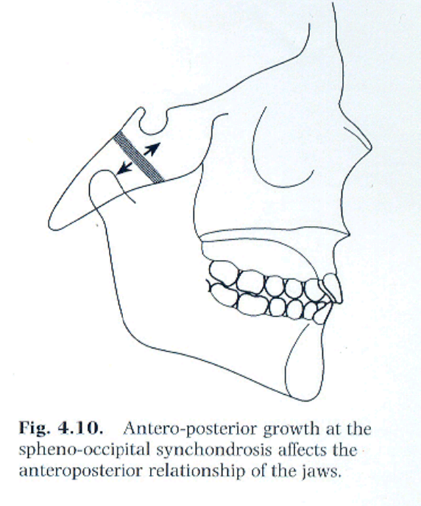
- Intersphenoidal synchondroses.
- Spheno-occipital synchondroses.
- Then the cranial base will grow (active bone formation by endochondral ossification at the synchondroses) longer( why?) because of active bone formation "not the remodeling" in the synchondroses. At the same time we have remodeling to accommodate the shape of the brain, spaces and according to the structures surrounding it.
- Before birth the inter-sphenoidal synchondroses will be closed.
- Around 6 years of age , the spheno-ethmoidal synchondroses closes , after the brain finishes its neural growth.
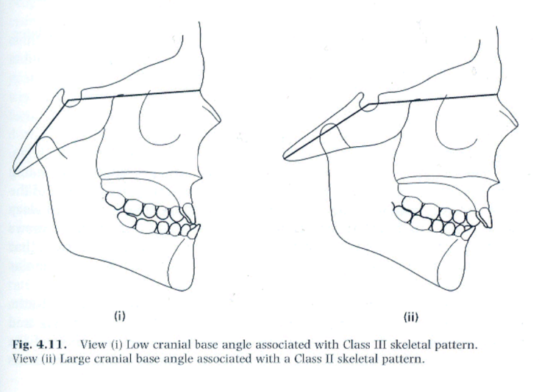
- After the growth spurt (13-15 female , 15-17 male ) , the spheno-occipital synchondroses starts to close reaching ossification at almost 20 . (why?) because it’s attached to the temporal bone, where we have TMJ which holds the mandible, so when the spheno-occipital synchodroses keep growing and elongating it will affect the mandible as well, so it affects the mandible position effecting the skeletal pattern of the patient.
We will end up having a cranial base angle, we call it sometimes “suddle angel” which has an average of 124
## if this angle becomes acute or the basal bone grows shorter the mandible will grow forward and we will have class 3 and small posterior facial height . (protrognotic mandible )
## the angle becomes obtuse or the basal bone grows longer the mandible will grow backward and we will have class 2 occlusion “ clinically looks like small mandible but it’s not” (retrognotic mandible )
So the length and shape of the basal bones will affect the position of the mandible .
Nasian to the sella torsica ((forms the horizontal line of suddle angle)) and the the articulary " an imaginary line between the condyle and the zygomatic bone" ((form the vertical line of the suddle angle))………..the suddle angle is an imaginary angle.
Maxilla :
it started calcification 7 weeks intrauterine. So it’s the third bone to calcify ; we have first the clavicle and then the mandible then the maxilla
The type of ossification is intramembranous ossification so we don’t need cartilage.
It is start to calcify lateral to the nasal septum "nasal cartilage" where we have condensation to mesenchymal cells , and then this condensation will be invaded by blood vessels and then we have bone secretion and calcification …,but we have to remember that nasal cartilage by itself doesn’t contribute much to the maxillary growth or development it only guides it.
- After birth : the whole soft tissues that the maxilla is embedded in will grow downward and forward and that will CREATE MORE GAPS (sutures) needs bone to be closed ,This type of movement is primary, active translation (active bone formation by the maxilla), so the movement of the maxilla downward and forward will enhance the active bone formation at the sutures.
- We can see the shaping of the baby maxilla “ very small”
- Gradually we will have bone resorption at the anterior part, and bone addition at the posterior part (maxillary tuberosity) of the maxilla giving space for the molars to erupt as if it's moving backwards ( but the other factors will sum up the movements and we will end up with a forward movement of the maxilla ) bone remodeling process.
The fact that the maxilla is part of the cranial bones and we know that cranial bones and the base are getting longer, carrying the maxilla with it forward this movement of the maxilla is secondary “ secondary translation” (why?) because it’s cause by cranial bones growth “ external cause”

## so we have primary and secondary movement in the maxilla :
- Primary movement :downward and forward
- Secondary movement: forward.

- Bone remodeling is done in the same direction in the palate, resorption at the base of the nasal cavity , bone deposition at the roof of oral cavity as if bone remodeling is moving downward and as part of the maxilla it will also move forward , downward .
- In the midline suture of the palate it will be pushed apart by the transverse development ((an active bone formation will happen in the middle of the palate "the suture region" )) >>> so we can see the palate growing wider.
- This will start to slow down and stop at 15 f .m/17 m and it accelerates at the pubertal stage .
Why is this important ?
because if i am planning for a surgery I should wait after the growth finishes and if i am willing to do growth modification it should be done at the growth spurt time not before nor after .

Mandible:
First signs of ossification starts 6 weeks intrauterine.
Second bone to calcify.
Here we have both types of ossification , intramembranous and endochondral.
- Here we have meckel’s cartilage though it doesn’t have a part in the mandible bone formation its only a guidance ( remnants of it will form the small bones of the middle ear), mesenchymal condensation happens , then blood invade , centers of ossification forms, and here we have intramembranous ossification and formation of islands of bones .

So we have intramembranous ossification for the body of the mandible , islands are growing larger, meckel’s cartilage contribute some bone “ conductive ossicles” which has nothing to do with the mandible.
- We have the condyles separated from the mandible and later fuse.
- Condyles start condensation from cartilage type of the cartilage is secondary (growth site ) which means growth is sideways not centric (so not primary).
- 10 weeks intrauterine we will have replacement of this cartilage with bone.

So the body of the mandible intramembranous
The condyle and the ramusendochondral.
- Then they will fuse and the mandible forms, and remnants of cartilage will contribute to the TMJ capsule formation.
- After birth we will still have endochondral ossification ( at the condyle area ) of the mandible but the majority of the activity will be bone resorption bone remodeling

## so maxilla we have only intramembranous ossification, cartilage only involved in development not growth.
## mandible has both types of ossification , cartilage contribute to the formation of condyles.
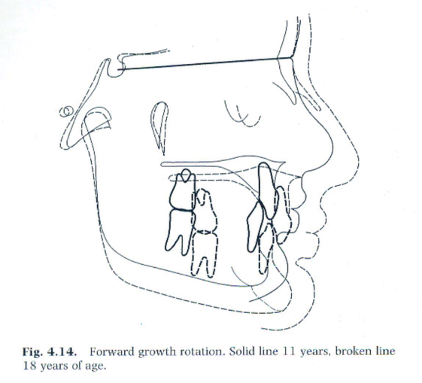
- the mandible is embedded in the soft tissues which aids in movement, speech, swallowing ,eating and growth at the same time.
- When soft tissues move downward and forward, the head of the condyle moves downward away from the joint thus enhancing bone formation and endochondral ossification in that area.
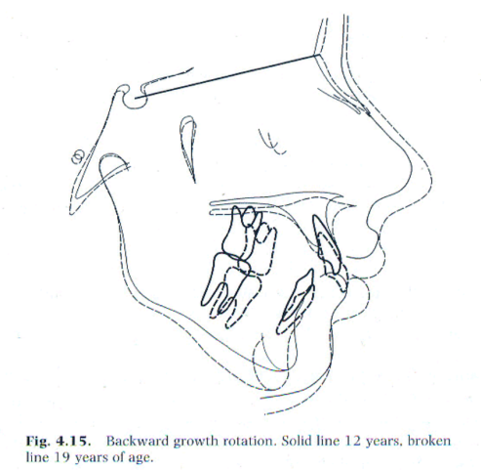
- The ramus is going to increase in height by active bone formation primary displacement (why?) because there is active bone formation at the condylar end .in response to the surrounding tissues and structures.
## the dr. showed some pics of small mandible : after birth bone remodeling, this part which is used to be part of the condyle , later will be part of middle of the ramus, and later part of the anterior part of the ramus, and because of active process of remodeling , body of the mandible will grow longer to accommodate more teeth.
- In the transverse section we see deposition of the outer surface making mandible wider.
- The chin is inactive in early time.
- Remodeling brings ramus backward.
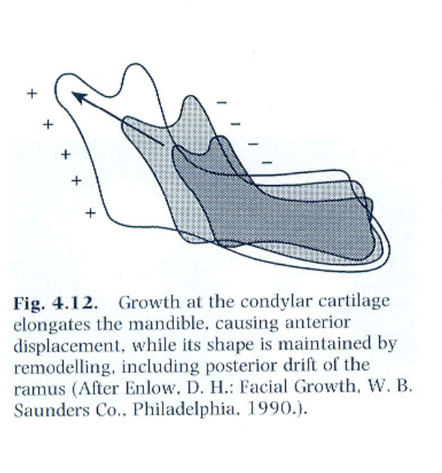

- This pic shows you how the mandible is getting higher in ramous and longer in the body region by displacement of the soft tissue , also you can notice active bone remolding where there is bone resorption at the anterior margin of the ramus and bone formation posteriorly so the mandible is getting wider

- We have another mechanism to move the mandible which is : when the cranial base (spheno-occipital synchondroses) is getting wider and moving backward, the mandible will move backward also this type of movement is called secondary translation .
- The area of the chin is inactive, and due to the downward forward movement of the mandible it will become prominent and this is a sign of maturing in the child.
- the ramus become longer by endochondral ossification and the body will become longer by bone formation and the mandible become wider by bone remodeling this how the mandible gain its new size and shape during developmentso at the end of this the mandible become forward and downward (why?) because it fixed there " forward and downward"…….the same happen to the maxilla, BUT THE DIFFERENCE IS the growth of the maxilla stops first and the mandible growth further (2 years in average) according to the sephalo-codal gradian of growth "differential growth" , AND this will affect the developing malocclusion or correction malocclusion if you interfere at the right time.
- Before puberty we have increase in height of ramus 1-2 mm/year and increase in the length of the body by 2-3mm/year , AT THE PUBERTY (the growth spirit) these quantities might double ((this is very valuable if you planning to modify growth of the mandible)).
- We reach the maximum size of the mandible at 17 years in girls and 19 in boys, so if a surgeon planning for a surgery to the mandible he/she will wait after these ages, although some surgeons prefers to wait further because these measurements are average.
- IF we look to the curve of the growth pattern, we'll notice that the pattern of the growth of the maxilla is closer to the neural growth, BUT the growth of the mandible is closer to the general growth.
- We also have the vertical growth; the ant. And post. Height. The differential change in the posterior and anterior facial height is what we called ROTATION.
- We have forward growth rotation (more posterior growth or less anterior growth) and backward growth rotation (less posterior growth or more anterior growth).
- In the MAXILLA we have rotation but it is very minimal and it almost completely masked by bone remodeling so it does not affect the overall pattern of skeletal development BUT in the MANDIBLE it is significant (80% of population has forward growth rotation and some will have a backward growth rotation).
- Posterior growth rotation it is the post. Growth height , it is affected by endochondral ossification of the condyle , the (spheno-occipital synchondroses bone formation) and the soft tissues "the muscles that inserted to the ramus",,, these 3 factors will determine the final post. Height. The anterior height on the other hand will be affected by development and eruption of teeth "occlusion" , the fascia, and the muscles "the suprahyoid muscles; their insertion is the spinal column" ; so it will be affected by the growth of the spinal column.
- THE RATIO BETWEEN the post. Growth height and the ant. Growth height in the sagittal plane (the differential growth) will determine the rotation.
- If a patient has a lot of forward growth rotation, the ant. Facial height will be reduced so the overbite will increase (deep overbite) .
- If a patient has a lot of backward growth rotation , the ant. Facial height will be increased so the overbite will decrease (an open bite will result).
Craniofacial growth in the adult
When does it stop??
The dr. want us to refer to table 4.1.3 to read about the craniofacial growth in the adult, she said ''if we do not have it she will give it to us''.
The control of craniofacial growth, where are the factors and where are the genes that affect the final size and the position of bone in the maxilla, mandible, cranial bones… There are 3 theories:
- Some found that these factors are in the suture (in the bone itself): they try to take the calvarium away of the brain, it does not develop by itself, there is no active bone formation at the sutures isolated from the rest of soft tissue and the cartilage and the rest of structure , this theory is a little bit poor; it doesn't explain the growth of the craniofacial growth…. Some ptns. Have a lot of spinal fluids so the calvarium will be large (so this theory is weak cause it does not consider the soft tissues effect!).
- The cartilage is controls the craniofacial structures: like the cartilage in the cranial base "which is a primary cartilage; so it can explain it there", but the meckel's cartilage in the mandible does not contribute , the condylar cartilage is a secondary cartilage and the cartilage of the septal nose does not contribute the growth of the maxilla>>> so it is a weak theory cause it doesn't explain the growth fully.
- A functional based theory bone the soft tissues where the bone are embedded is control the growth of "maxilla, mandible, cranial base….ect" : growth of the soft tissues and its functional demand will determine and affect the growth of maxilla..mandible..cranial base..ect…
How we will be sure about this theory?
Some patients have mouth breathing "cannot breath from the nose" and they will develop (long face syndrome) , others have difficulty of swallowing, have weak muscles or very strong muscles, they will affect the developing bone and developing malocclusion….. studies said that the ptn my breath from his mouth because of a weak muscle (so it is a result not a reaction)…we do not know which is the result and which is the cause.
So this theory explains a lot but it does not explain everything.
We cannot predict growth, but if we want to do an effective treatment concerning the growth and the development, we must do it after the spurt of growth (as we said)!.
قل للعيون إذا تساقط دمعها........الله أكبر من همي و أحزاني
قل للفؤاد إذا تعاظم كربه.......... ربُّ الفؤاد بلطفه يرعاني

