The development of normal occlusion

Reference: Chapter 3 – textbook for orthodontics

Tooth development and eruption:
(you should memorize these numbers)
 | Calcification (mIU) | Crown completion (m) | Eruption (m)
Incisors | 4 | 1.5-3 | 6-9
Canine | 4-5 | 9 | 18-20
First molar | 4-5 | 6 | 12-15
Second molar | 4-6 | 12 | 25-36

-If you look in a new born mouth, you will see edentulous gum pads
-Eruption begins at any time during first year
-Primary is completed by 2.5-3 years (reassure parent)
-There is no significant data and differences between males and females. Females’ teeth don’t erupt quicker than males
-deciduous teeth are smaller, whiter and more upright than the permanent teeth.
-Upright: in relation to the maxilla and mandible, they are more vertical, they look very straight, they appear to be at right angle with the lower mandible.
-Epithelial pearls: calcified nodules that appear on the gum and those don’t require any treatment.
-Natal teeth: sometimes the baby is born with teeth.
Usually these teeth are the mandibular incisors.
These teeth are not supernumerary or extra teeth; they are the original teeth but erupted very early.
Sometimes they cause problems during breast feeding; in this case you should remove them. But if they don’t cause problems during feeding, you should retain them.
Feature of the primary dentition:
A. The distal surface of the primary second molar can be either:
1)Straight/flush
2)mesial step
3)distal step
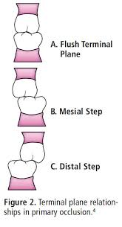
Normal primary dentition is either a straight/flush or a mesial step.
B. Incisor spacing
if you have a child with crowded deciduous teeth this means that the permanent teeth will definitely be more crowded, therefore there should be a space
C. Anthropoid (Primate) space
Distal to the lower canine and mesial to the upper canine.
Primates are origin of mammals, and most of the mammals have this space
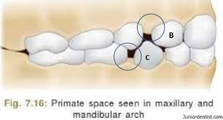

Primary dentition from 3-6 years:
1) Primary teeth are whiter that permanent teeth.
Why?
-Organization of enamel prisms is different
-the light scan is different
-enamel is less translucent
But the main reason is due to: higher inorganic content, there is more calcium, the enamel is more calcified, more hydroxyapatite
2) Attrition
attrition is more in primary, because they are thinner buccolingually, you should not give the patient night guard.
3) Reduction in overjet and overbite
overjet: is the extent of horizontal overlap of the upper teeth over the lower teeth
overbite: is the vertical extent
4) Edge to edge relation
-As we said, deciduous teeth should have space, or else we will have crowding in the permanent dentition. And even if you got spaced deciduous incisors, that doesn’t guarantee that there will be no crowding, unless the space is more than 6mm (Leighton 1971)

Eruption of first permanent molar:
-at 6 years
-commonly mistaken by parents as primary molar, so they give the permission to their child to eat sweets as much as he wants since they think it’s a primary molar and will be replaced by a permanent one.
-Dental students also get confused between the:
1) Lower first permanent molar as primary molar
2) Lower permanent canine and primary canine
**You should count number of teeth
Class 1 molar relationship:
The mesio-buccal cusp of upper 6 occludes to the buccal groove of the lower 6
Class 1 molar relationship is achieved in 3 ways:
- Directly on eruption if there is a mesial step
- By closure of anthropoid space
- By the use of the lee-way space

Lee-way space:
Sum of the width of the primary canines, first and second molars is greater than their successors (permanent teeth)
On average:
- 1.5 mm per side in the maxilla
- 2.5 mm per side in the mandible
This difference mainly came from the large size of E’s.
The E is larger in the lower arch than the upper arch.
Growth:
For the first molars to erupt; the mandible and the maxilla should grow posteriorly to provide space
Upper 6 will develop in the maxillary tuberosity
Lower 6 will develop in the anterior border of ascending ramus of the mandible
Thus; resorption will take place in the anterior border of ascending ramus, the mandible length will increase, the edentulous part of the mandible will increase.

Permanent incisors:
After all the 6’s come, the permanent incisors will start to erupt.
Permanent incisors are much larger than deciduous incisors
Space between incisors is provided in 3 ways:
1. Space between deciduous incisors
2. Labial inclination of permanent incisors
3. Alveolar bone growth (increase in intra-canine width)
Eruption:
-Right and left incisors are symmetrical in eruption, they erupt together.
The upper incisors eruption is from 6-8 years for both (right and left), and it needs about 3 months to reach the occlusal plane.
Delay in one side should be investigated by radiographs
Possible causes for delay in eruption of one of the incisors:
- Supernumerary (dentin, pulp and enamel are mixed together)
- Dilaceraton following trauma of overlying primary tooth
after the age of 4, if the child was exposed to trauma for the primary incisor, it will be transmitted to the permanent incisor.
How it happens?
The calcified part will move, and the non-calcified part won’t move. We will end up with a bended tooth
Trauma usually due to kickboxing.
Usually we have a gap between the two central incisors, laterals incisors will look funny.
This stage is called the ugly duckling stage, and it’s normal.
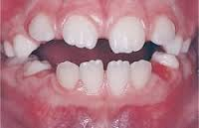

When permanent canines erupt, they use the distal surface of the lateral incisors as a guide for them to erupt and close the space.
Sometimes we do provide treatment during the ugly duckling stage, early orthodontic treatment.
Why to provide a treatment for something normal?
- Because some children are teased at school, and his mother comes to the dentist asking for a treatment.
Some studies showed that early orthodontic treatment improves child’s self-esteem during this period (ugly duckling stage), but later on, both (who had the treatment and who hadn’t) will share the same self-esteem
At the end it matters only through these 2-3 years (ugly duckling stage)
- Esthetics
The doctor does not prefer early orthodontic treatment just due to esthetics
- Proclined or protruded teeth
increase in overjet
If the overjet is more than 6mm, it will increase the risk of trauma by 50%
Problems during eruption:
-low frenal attachment (because of the diastema)
-delayed in eruption of one incisor
-lack of space
Eruption of premolars and molars:
-Starts around 7 years and completes at 12 years
-C D E are larger than 3 4 5 – lee way space
-Lower E is 2mm larger than lower 5, so most of the lee-way space comes from the lower E
-Upper E is 1.5mm larger than upper 5
-Lower D is 0.5 mm larger than lower 4
-Lower 6 will move more mesially than upper 6
Lee-way space on average:
- 2.5mm per side in mandible
- 1.5mm per side in maxilla

Eruption sequence:
- Centrals and molars
- Lower 3, 4, 5
- Upper 4 then 3,5
- 7’s from 12-14 years
- 8’s from 16-20 years
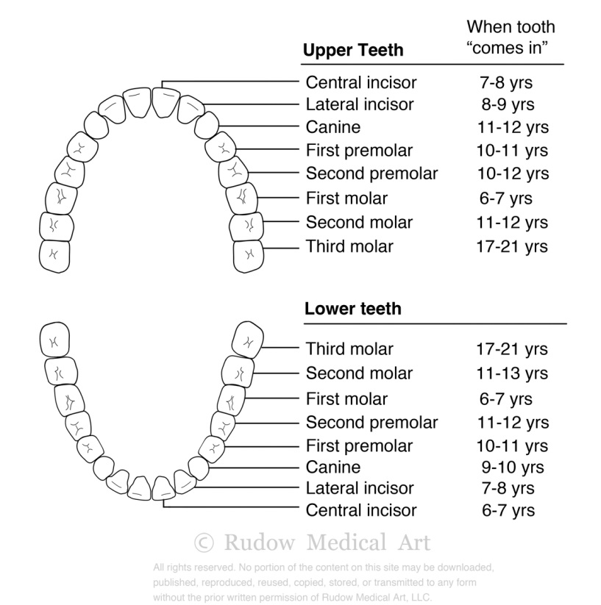

Curve of Monson:
Created by the upper buccal cusps, and lingual lower cusps

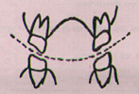

Curve of spee:
Created by the occlusal plane.
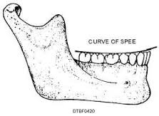
**Please do NOT depend only on these notes. Check the book for better understanding.
Written by: Linda Morgan
Corrected by: Mohammed Gara
GOOD LUCK

