Sheet no. : 8
Done by : Tala Qutachi , Dima Kilani
Etiology of malocclusion (local factors)
The dr. said that he will give a slide and a sheet (handout) for this lecture including all necessary information.
what does etiology mean ?
Etiology means cause. In order to treat a patient with malocclusion I need to know the cause (etiology).
-What are the causes (etiology) of malocclusion?
1- skeletal causes
a patient with anterior open bite , reverse overjet and class 3 incisal relationship, extraorally the chin is protruded. (as shown in the slide )
this patient has skeletal cause of malocclusion.
2- soft tissue causes
like when the lower lip is behind upper incisors that’s called ‘’ lip trapping ‘’ which causes proclination of upper incisors and retroclination of lower incisors, resulting in overjet
3-dental /local causes
interceptive treatment means intervening to reduce the severity of the developing malocclusion (and we usually intervene to treat dental/local reasons ) the dr. will explain “ interceptive treatment “ later.
local factors of malocclusion :
1-variation in tooth number
2-variation in tooth size 3- variation in tooth position
(1,2,3) are the main categories , but the dr. mentioned another category to summarize them called “ retained primary tooth “ , will be explained later .
________________________________________________________________
first : variation in tooth number include :
A-supernumerary teeth
B-hypodontia
c-early loss of primary teeth
A-SUPERNUMERARY TEETH :
additional( extra ) teeth most commonly present in the anterior maxilla and they are more common in males than females
-Types of supernumerary teeth:
1-conical teeth
characteristics : small in size , conical (cylindrical ) in shape , sometimes it can have a root , might erupt to the oral cavity , generally conical teeth does NOT prevent the eruption of permanent teeth but what is does is spacing , diastema , eruption to oral cavity.
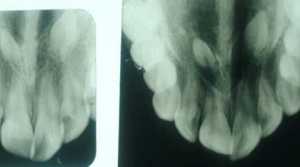. 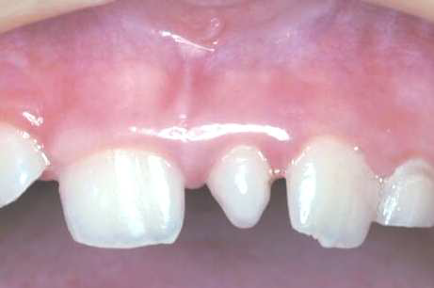
2-tuberculate teeth 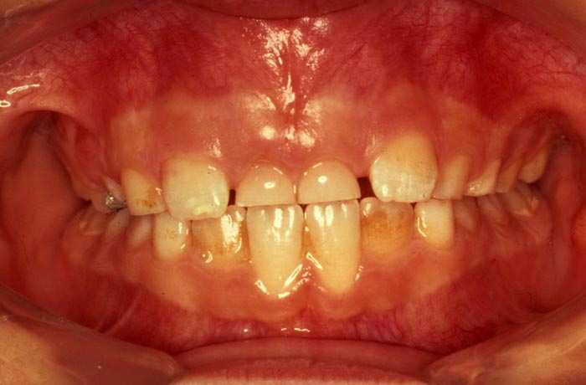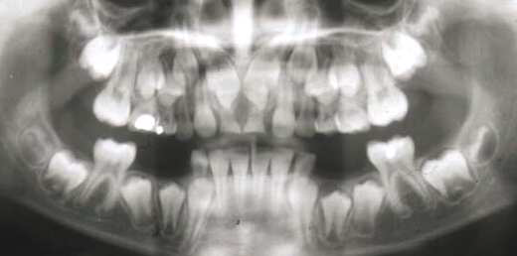
Note : Sequence of eruption is very important to know , eg: usually centrals develop before laterals , in the slide the picture shows that permanent lateral erupted with primary centrals not replaced yet , this indicates abnormality since the primary centrals should be replaced before laterals , in this case I have to investigate by taking x ray , panorama is preferred over periapical why? To know if the ptn have more than one supernumerary , also periapical might not show everything needed, I might need above periapical area so its not enough. So the best options are panorama or Anterior occlusion x ray , so in this case when we took opg for that ptn we found two supernumerary, those 2 supernumerary were different, they looked like barrels , they are called tuberculate .
it's a barrel shaped tooth with no roots and it's usually paired.
-tuberculate cause impaction (prevent eruption)
3-supplemental teeth : 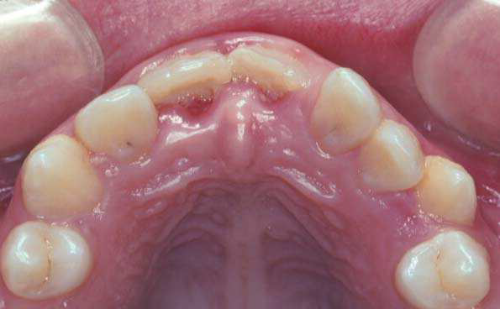
additional teeth with normal teeth shape and they can cause crowding if the arch is small , its managed by extraction.
4-odontome: it can prevent eruption.
. 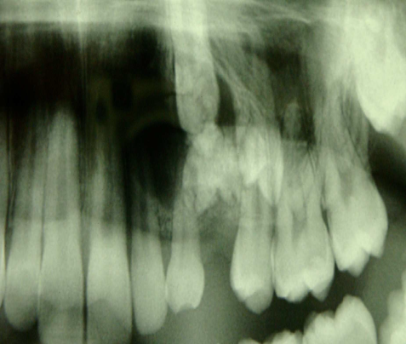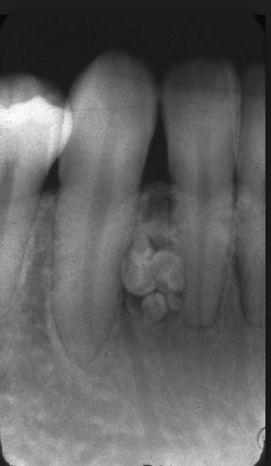
Note : prevention of erupted is most common in 1- tuberculate then 2- odontome / very rare in conical .
Odontome is 2 types:
I-compound: distinct mass, more common
II-complex: one mass , prevent eruption of teeth more than compound but their less common
management : removal at the right time , if a 15 year old child came with a supernumerary that prevented eruption of central incisor ( that’s a disaster ) because I need to remove the supernumerary , put a gold chain , do retraction , needing two to three years of treatment and surgery is very likely , while if the dentist recognized that soon enough and removed the supernumerary at 9-10 the tooth will erupt alone , or at least I will not need to put the gold chain high up .
Note : if the odontome doesn’t interfere with eruption or later in ortho treatment (when teeth are moved ) , or with roots no need to remove it but should be kept on observation.
Note : there is a table in the handout that summarizes those points ….
-Clinical signs that indicate there is a supernumerary : 1- presence of an extra tooth 2- eruption of primary dentition and delay in eruption of permanent dentition 3-“median diastema” if in midline , if not in midline” spacing” 4- asymmetrical eruption( eg : if odontome on one side only one central incisor erupted and the other incisor didn’t erupt ) .
B- Hypodontia: congenitally missing teeth (did not develop at all )
-usually hypodontia comes in association with microdontia (not always)
-hypodontia present in ectodermal dysplasia and cleft lip and palate
-hypodontia usually causes spacing (not always)
an example of interceptive treatment, the dentist recognized a patient with missing lateral , removed B,C early so the canine when it erupted it replaced the lateral place . Interceptive treatment will be explained in 2 lectures at the end of the year, Will this affect molar relationship ? yes it will ,the answer will be explained in details later but usually if 1 unit is lost in upper arch molar relation will be class 2 which is fine (acceptable).
Slide 30 In the picture , there are:
- missing lower centrals ( how did we know they're missing ? because of the sequence of eruption , they're supposed to erupt before upper centrals and lower laterals so we concluded that they are missing (retained primary tooth) the cause is unkown until x ray is taken but mostly it will be because of hypodontia .
- upper laterals are missing too, why ? because there was no primary laterals (B) , always when primary are missing permanent are definitely missing too .
- Lower first premolar is missing because the D is infra-occluded
What happens is that when 5 they is missing (most commonly) or 4 the Ds and Es won't exfoliate on time and the neighboring teeth would start tipping toward them ,and become infra occluded
Infra-occluded teeth usually happens in case of:
- missing permanent 5 or 4 tipping movement of neighboring teeth
- or the primary teeth been ankylosed to the bone " and the permanent is present" no vertical development
You have to take an x-ray to make sure which case you are dealing with
Slide 34
We are going to talk about individual missing teeth
First: lateral incisors:
Here we have a typical missing lateral case.
Start charting the teeth : (begin with the right side )
Pig shaped lateral central incisor central incisor canine 1st PM 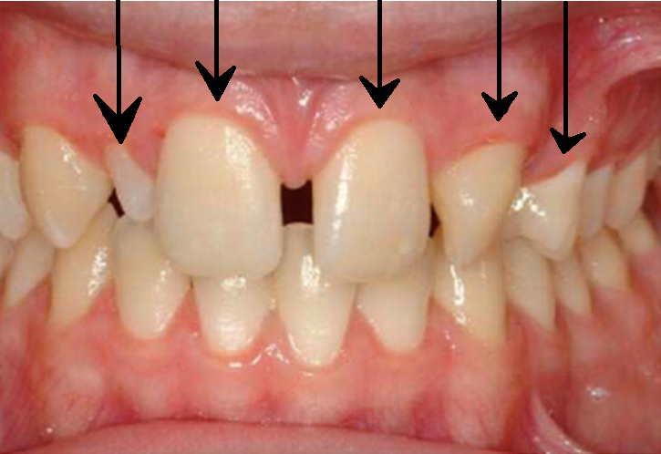
You notice missing left lateral incisor
Most of the cases when we have a unilateral missing lateral we have pig shaped lateral on the opposite side
slide 35-36
guidance theory: stats that the distal surface of lateral incisor root guide the eruption of the canine.
In case of a missing lateral the canine would lose its guidance which would lead to impaction – but not in all cases
Guidance theory came out of an observation that most of canine impactions are accompanied with missing lateral incisors so in case of a missing lateral dentist must undergo early investigations on canine position
Slide 37
Which is most commonly missing tooth ? PM or Lateral incisor?
It depends on the study sample. Our book is based on british samples so missing second PM is more prevalent than missing lateral
In Chinese community missing lower central incisor is the most common. ( far east)
In Jordan, based on the dr observation, the lateral incisor is most commonly missing – or most commonly complained from
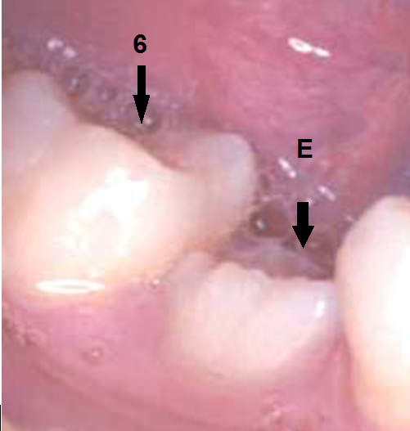
Slide 38
Infra-occlusion is more clear here
When all teeth are developing vertically while E is retained in its place the neighboring teeth would start tipping. (when the primary E is not developing vertically as well, an open contact would result and the primary tooth couldn't prevent neighboring teeth from tipping towards it and usually accompanied of over eruption of the opposed upper tooth)
This occur in most cases of missing PM-- but not all of them
Management will be discussed in next lectures.
- Now the dr is talking about a case I can't find in the slides of a missing lower central incisor
It’s the most common tooth to be missed in the Far East communities, this case present missing either central or lateral incisor we cant know for sure because both of them look similar, it's either the central is missing and the lateral gone drifting or the lateral is missing and canine is drifted
Results of missing central :
- Midline shift
- Either incisors would tip lingually to close the space which would increase the overjet (most common)
- Or the molars would drift anteriorly changing the molar relationship
So in this case the patient lateral outer view you would think he is class I or mild class II
But when we checked his teeth relationship he had a huge overjet due to the missing central
This doesn't always happen. The dr showed another case of missing lower incisor with a normal overjet , because posterior teeth moved forward
Slide 40 3. Early loss of primary teeth :
The dr included this as a category in variation of tooth no. because its affect on the developing occlusion
Primary tooth works as a natural space retainer.
In this case : start charting
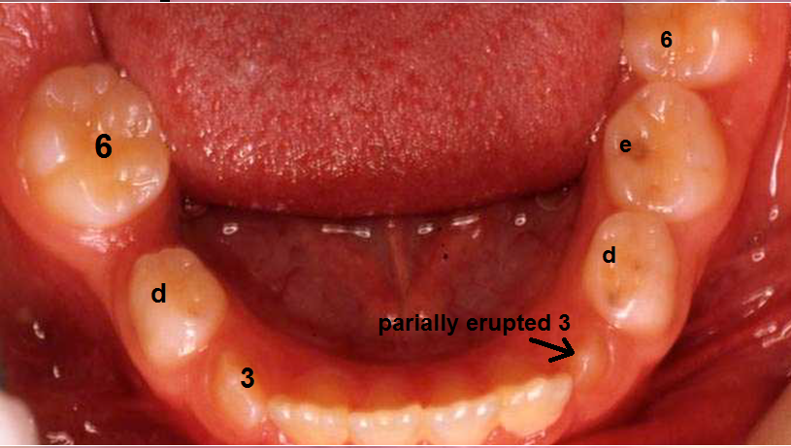
Notice missing right E
Compare 6 position in both sides
Right 6 is mesial drifted which would result in the loss of tooth space effecting the eruption of second PM bcoz it's the last tooth to erupt
Last tooth to erupt is always the most affected in the early loss of teeth, in lower arch is 2nd PM and in upper arch is canine which would lead to their impaction
Slide 41 is an OPG of a similar case
The dr should've applied a space retainer in order to avoid the mesial drifting – but yet again not all cases we put space retainer
Early loss effects depends on multiple questions:
- Which tooth is extracted ?
- When ? effects differ whether the patient lost an E at 18 yrs old or when he was 8 for example
- Amount of crowding ? spaced or crowded ? the more crowding the bigger the effect
Early loss of incisors have a very little impact, the only problem is esthetic – leads to bullying and teasing of the child
We have two terminologies :
1) compensating extraction 2) balancing extraction
Compensating extraction : I extract in the opposing arch; meaning that if I made an extraction in the lower I extract the opposing tooth on the upper to maintain the molar relationship
Balancing extraction : if I extracted on one side I should extract on the opposing side to avoid midline shift
In case of early loss of:
- incisors I don't need balancing nor compensating extractions
- canine: in case of unilateral loss on one side + crowding midline shift would result so I need to undergo balancing extraction
in this case :
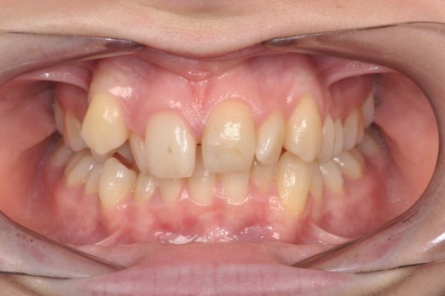
The lower midline is correct but the upper is shifted to the right due to early loss of right lower canine.
What happened is the right primary C was lost early while left C stayed in its place when the permanent incisors started to erupt in had little space because this is a crowded arch, They started to spread in order to get aligned so they shifted to the right –causing midline shift- to get well aligned to prevent being severly crowded and became mildly crowded
Again, they took the space of the canine, and since canine is the last tooth to be erupted in the upper arch it didn't have any space so right canine erupted buccally.
The dr will bring this photo in the exam asking about the main etiology of the malocclusion the answer is early loss of primary canine
Why canine ? because it's the last tooth to erupt

Finally early loss of first and second primary molars :
- 2nd molar (E) : leads to mesial drifting of 6 impaction of 5. Minimal effect on the midline unless the arch is extremely crowded
- 1st molar (D): it would effect the molar relationship a little bit and midline shift a little bit

