DR.Awni AL –KAYEDE
Prof. Conservative Dentistry
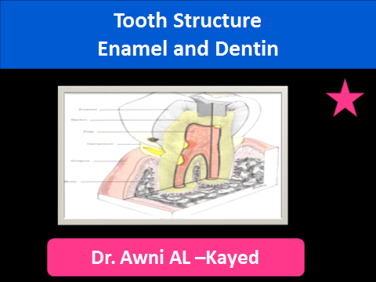
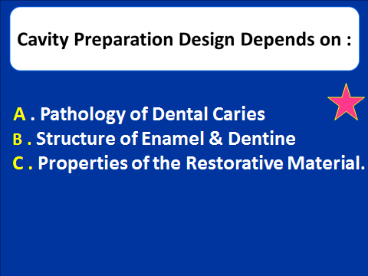
In the previous Lecture we Discuss the Dental Caries process and This Lecture will be Revision of Tooth Structure : Enamel & Dentine.
Enamel : = Enamel formed by Calles called AMELOBLASTS Which Originate from the Embryonic Germ Layer known as Ectoderm.
= Enamel Varies in Thickness in Different areas of the Tooth Crown, &
- The Enamel Thickness Varies from one Class of tooth to another
- Enamel is Thicker at the Incisal and Occlusal Surfaces and Becomes Progressively Thinner Toward the CEJ.
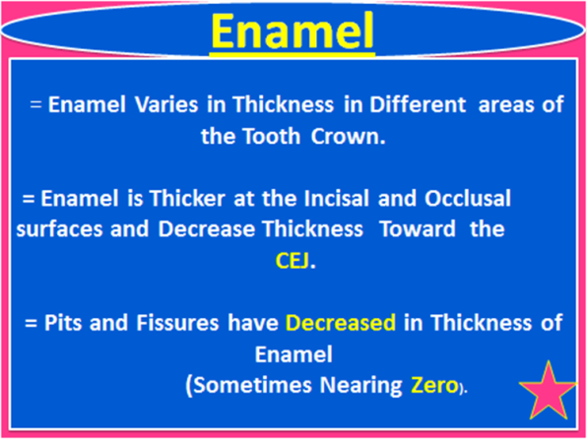
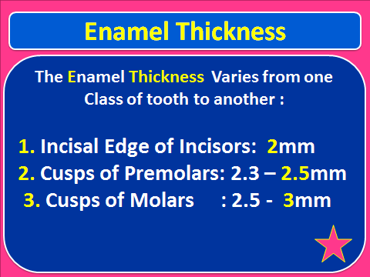
Enamel is the hardest structure in the human body.
Hydroxyapatite, in the form of a crystalline lattice, is the largest mineral constituent and is present 90% to 92% by volume. Other minerals and trace elements are contained in smaller amounts. = The tensile bond strength of enamel is as low as 11.4 MPa.
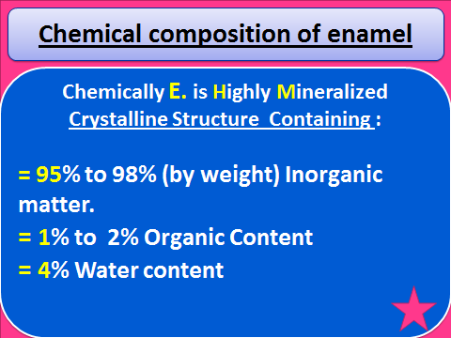
Structurally, enamel is composed of Millions of Enamel Rods or prisms, which are the largest structural components, as well as rod sheaths and a cementing inter-rod substance in some areas.
- In general the Enamel Rods are aligned Perpendicularly to both the DEJ and the tooth surface in the primary and permanent dentitions, except in the cervical region of permanent teeth where they are oriented outward in a slightly apical direction.
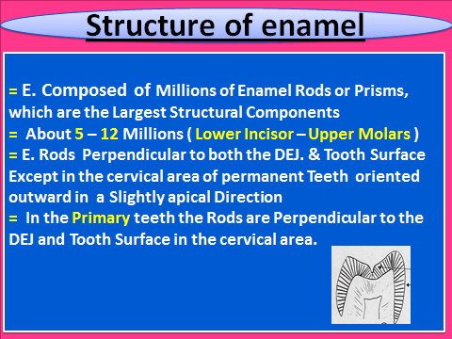
= Lower Incisor 5 millions ER.
= Upper Molars 12 millions ER.
=In Transverse Sections Enamel Rods are Shaped with a Rounded Head section and a Tail Section. The head is generally oriented in the occlusal/incisal direction and the tail in the apical direction.
Each of the Enamel Rods is formed from Millions of Small, elongated hydroxyapatite crystals. These crystals are hexagonal in shape.
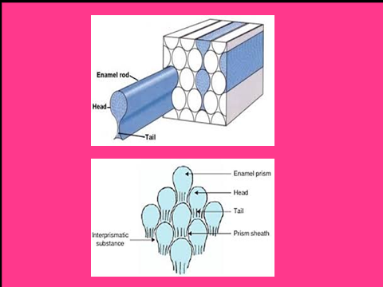
= From the External Surface to the DEJ. There are three things that Decreas :
1= Diameter of E. Rods at the outer surface is about 8 µm and at the DEJ of about 4 Microns.
2 = E. Hardness may vary over the external tooth surface area, it Decrease inward, Being Less Hard at the DEJ.
3 = the Density ( كثافة ) of Enamel Decrease fro the Surface th the DEJ.
ثلاث خواص في الميناء تقل كلما دخلنا الى الداخل
DEJ.
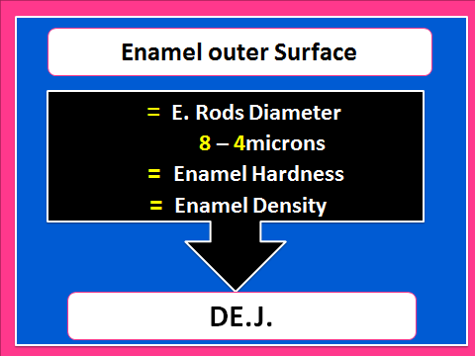
But the Solubility increases too.
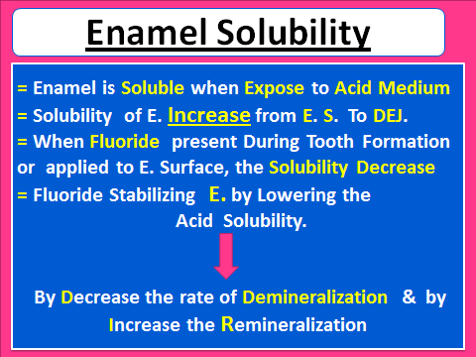
= Fluoride play important Role in Caries Prevention Especially when it is in the ideal Level of Concentration in the Drinking water 0.8 – 1.2 ppm
More than 1.2ppm concentration Cause Discoloration , And when it is Below the ideal Level of 0.7ppm Increase the Caries Incidence.
Enamel Color : = Enamel is Semi Translucent. It reflects the Color of the underlying Dentin.
= Thickness of the Enamel and Degree of Enamel Calcification plays a Role in Enamel’s Color
= Extrinsic Staining Café , Tea, Smoking, Caries,
= Intrinsic Staining : Fluorosis, tetracycline Staining, Amelogenesis Imperfecta, Enamel Opacities, Trauma
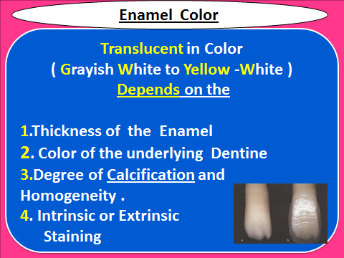

= When isolating a Tooth Completely from Oral Cavity, Enamel Becomes Whiter than the Rest of Teeth, Because of Loosing of Saliva ( Humidity ) so the 4% water Evaporate and seem whiter.
= If you want to Choose the Color of Composite or the Color of Esthetic Restorative Material, we Choose it when the Tooth is Moist not Dry
= Dehydration Causes a change in Color of Enamel due to the Temporary Loss of Loosely Bound Water Particles (<1% by weight)
= So Shade Selection must Performed Before Isolation or before Acid Etching.
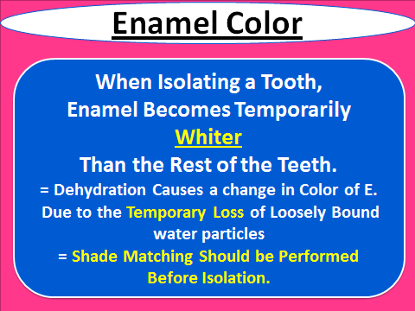
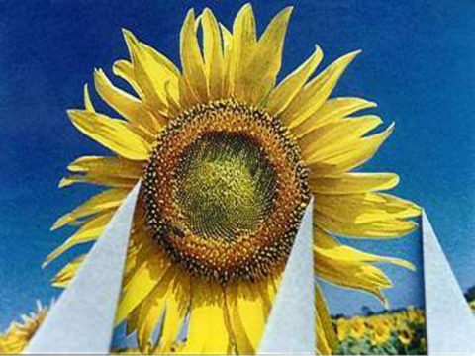
= Dentin :
It is Scalloped or wavy in outline, with the Crest of the waves Penetrating toward the Enamel. The rounded projections of Enamel Fit into the Shallow Depressions of Dentin. This interdigitation seems to Contribute to a Firm Attachment Between Dentin and Enamel.
= The DEJ is also a Hypermineralized Zone about 30 µm Thick.
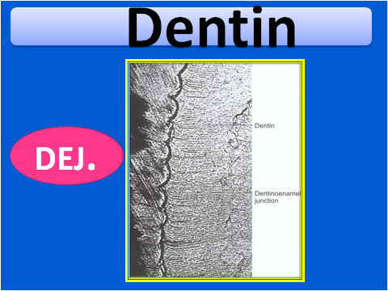
= Dentin forms the Largest Portion of the Tooth Structure
- Externally Dentin is Covered by E. On the anatomical Crown, & Cementum in the anatomic Root .
- Internally Dentin forms the walls of the Pulp Cavity ( Pulp Champer & Pulp Canals )
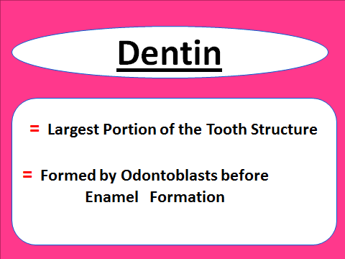

Odontoblasts considered Part of the Pulp & Dentin Because
1.- The Cell Bodies in the Pulp and
2. The Cell Processes Extended in the Dentinal Tubules in the Mineralized Dentin
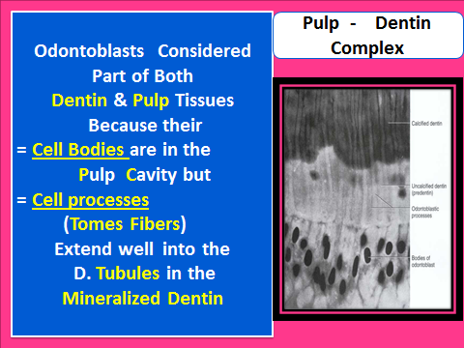
= IN CONTRACT to Enamel Dentin formation continues throughout Life , and that what makes Dentin a Living Tissue.
= Dentin formation begins next to Cusp Tips or Incisal Edges and Continues toward the Apex of the Root.
= Dentin is Softer than Enamel (about 1/5 hardness of enamel), but it is harder than bone and cementum.
= It is more Elastic than Enamel, which helps support the more Brittle Enamel.
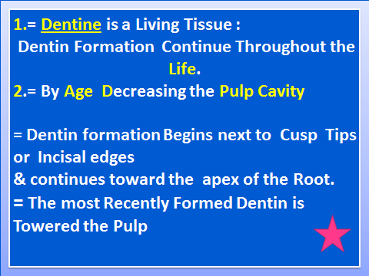

=Dentin is Softer than Enamel (about 1/5 hardness of enamel), but it is Harder than Bone and Cementum.
= It is more Elastic than Enamel, which helps support the more Brittle Enamel. ( Dentin is a hard, Mineralized tissue, its Flexible, with Modulus elasticity of 1.67x10psi. This Flexibility helps support the more brittle nonresilient Enamel ).
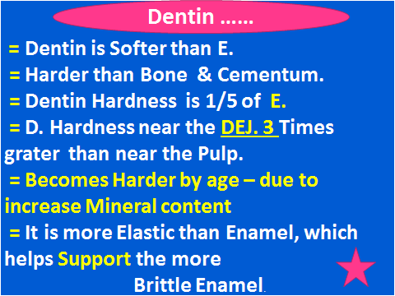
= Human Dentin Contain 75% inorganic Material, 20% Organic Material and 5% Water
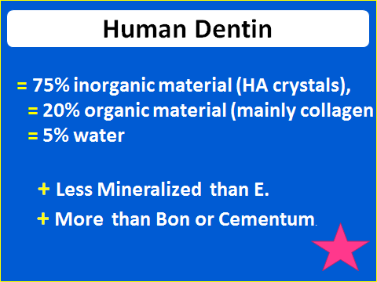
+ The Dentinal Matrix Contains Dental Tubules
= The Dentinal Tubules are Small Canals that Extend Across the Entire Width of Dentin, Extend from the DEJ or DCJ junction to the Pulp.
= Each Tubule Contains Cell Process (Tomes fiber) .

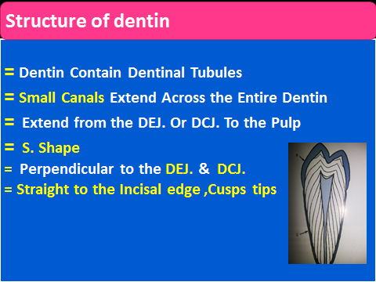
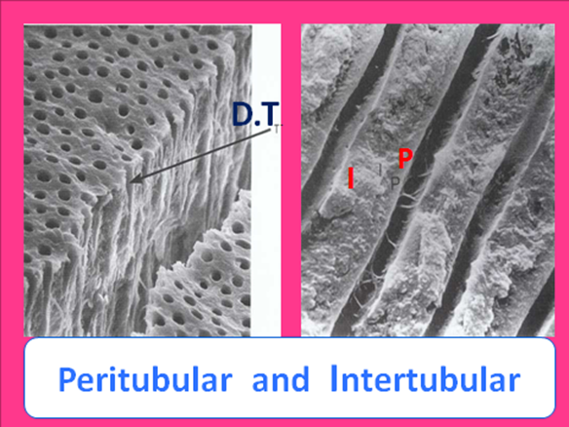
= Each Dentinal tubule is lined with a layer of Peritubular dentin, which is much more Mineralized than the surrounding Intertubular dentin.
- Number of Tubules/mm2 and Size of Tubules Increase Toward the Pulp. That has a Relationship of Increased Sensitivity of Deep Dentin.
Although the Dentinal Tubules are Functional in Forming and Maintaining Dentin, Open dentinal Tubules Compromise its Function as a Protective Barrier.
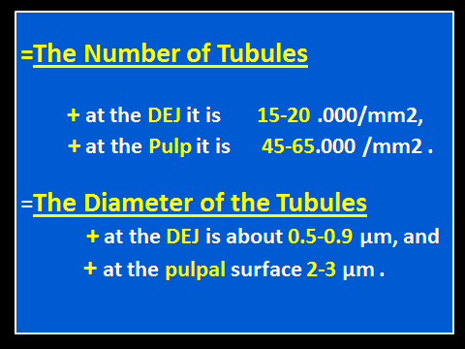
= As the Surface area of Dentin at the DEJ is much Larger than that at the Pulp, the Dentinal Tubules are Forced Closer to Each other Toward the Pulp.
=The number of tubules
at the DEJ is between 15-20 thousand/mm2,
and at the Pulp it is 45-65 thousand/mm2 .
=The diameter of the tubules
at the DEJ is about 0.5-0.9 µm, and
at the Pulpal surface 2-3 µm .
Dentin Color :
During Cavity Praparation ,Dentin usually is Distinguished from enamel by:
1.= Dentin is yellow-white. Enamel is translucent, reflecting the color of the dentin.
2.= Dentin is opaque and dull, reflects less light than enamel. Enamel is shiny.
3.Dentin is Softer than Enamel & provide Greater yield to the pressure of sharp explorer tin, which tends to catch & hold in Dentin
Hardness is related to the degree of mineralization.
Sound is also related to hardness.
4.= Because Enamel is harder it provides a higher-pitched sound than dentin when you move a sharp instrument over it.
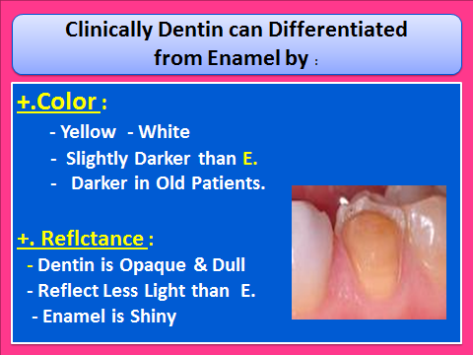
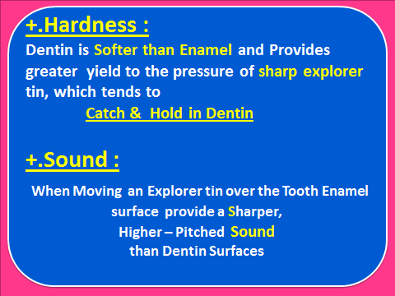
SHARPER SOUND IN ENAMEL رنين
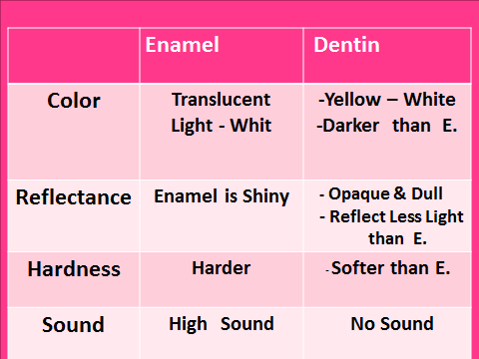

Sensitivity:
The most accepted theory of Pain Transmission is the Hydrodynamic Theory which account for the Pain Transmission through Small,Rapid Movements of Fluid that Occur within the Dentinal Tubules
. It was proposed by Branstrom. The dentin is not innervated nor vascular, except for about 20% of Dentinal Tubules that have Penetrating Nerve Fibers by no more than few microns in the deep dentin.
Fluid Movements in the Tubules account for the pain transmission.
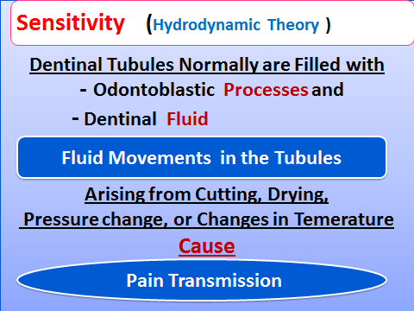

= Dentin must be Protected During Cavity Preparation and Restoration to avoid Cause Trauma to Dentin and Pulp
- AVOID use the Hand Pieces without Air-Water Spray to avoid Heat the Bur and Cause Trauma to Dentin and Pulp
- Avoid Dehydrate Dentin and keep it in Normal fluid content. ( Aspiration of odontoblasts PROCESS )
- Protect Dentin By intermediate materials : Liner, Base,Dentin Bonding AGENT , Non TOXIC Filling Materials
- Proper seal the wall and margin During cavity preparation or During restoration and make good seal.
Prepare Smooth Cavity wall and Margin
- Make good adaptation and seal the Filling material to cavity walls and margins.
- Avoid overfilling the cavity margin , and avoid under filling the cavity
+ Excessive Drying of tooth preparation can Cause Odontoblasts to be aspirated into Dentinal Tubules.
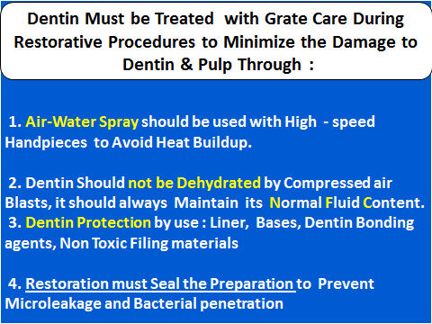

Primary Dentin : In contrast to Enamel Dentin Formation Continues after Tooth eruption & through the life of the Pulp.
The Dentin Forming the Initial Shape of the Tooth is Called Primary Dentin & is usually Completed 3 years after Tooth Eruption
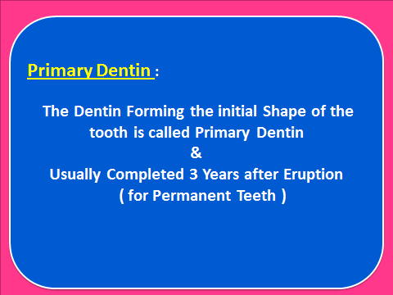

Reparative Dentin ( Tertiary Dentin ):
Reparative Dentin ( Tertiary Dentin )
1. = Formed by Replacement Odontoblasts ( secondary Odontoblasts ) in response to Moderate – Level Irritants
- Non-caries injuries
- Moderate rate Dental Caries
- Operative Procedures
2. Its appear as a Localized Dentin Deposit on the wall of the pulp cavity immediately subjacent to the area on the tooth that has received the injury.
3. Repartive Dentin usually is Formed when teeth are mechanically prepared to within 1,5mm to the Pulp.
4.In about 15 days, New odontoblasts are differentiated from mesenchhymal cells of the pulp, & these replacement Odontoblasts lay down the Reparative Dentin.
5. Reparative Dentin become Microscopically appearing about 1 MONTH from the Stimulus.
6. Structurally & Chemically Different from primary & Secondary Dentin & being atubular.
7. When Moderate – Level Stimuli are applied to Dentin, such as moderate – rate caries or attrition, the affected odontonlasts process may Die with the associated odontoblasts.
These ara of Dentin are called Dead Tracts
- The Tubules are empty.
- Appear Black when Ground sections of Dentin are viewed micriscopicaly.
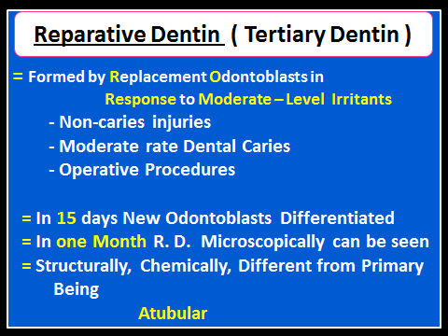
Sclerotic Dentin :
= Result From Aging or mild irritation ( Slowly advancing Caries ) cause a changes in the composition of primary Dentin.
=The per tubular Dentine becomes Wider
- Gradually filling the tubules with calcified material
- - The area are Harder, Denser , Less Sensitive & more protective to the Pulp.
- - Sclerotic Dentin resulting from aging is
physiologic Dentin Sclerosis
- Sclerotic Dentin resulting from a mild irritation is
Reactive Dentin Sclerosis.
- Reactive Dentin Sclerosis can be seen Radio graphically in the form of a More Radiopaque ( Lighter ) area in the S shape Dental Tubules.
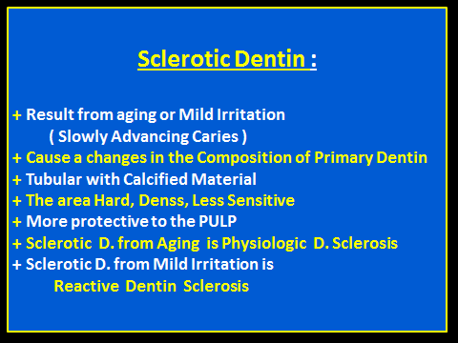

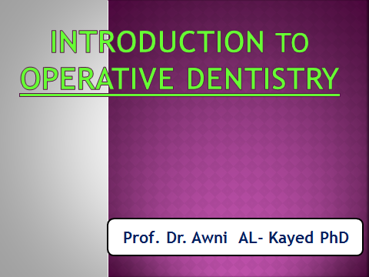
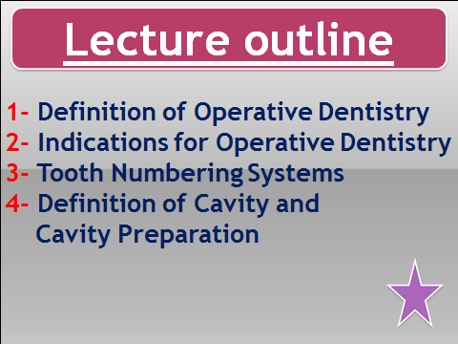
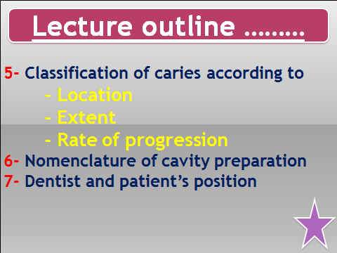

1- Operative Dentistry is Recognized as the foundation of dentistry and
the Base from which most other aspects of Dentistry evolved.
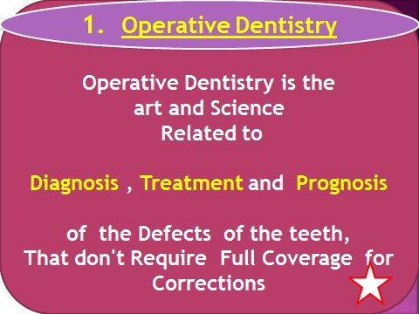
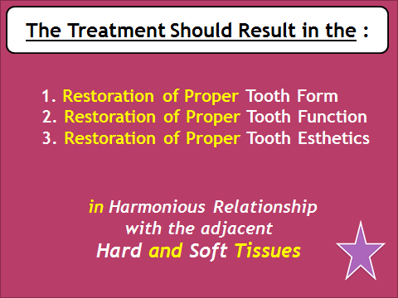
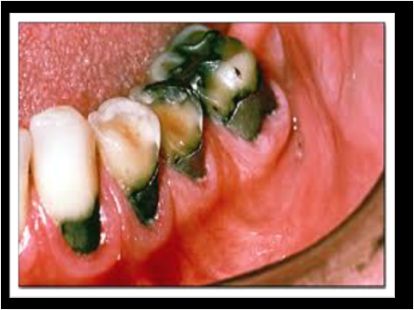
2. Dental Caries
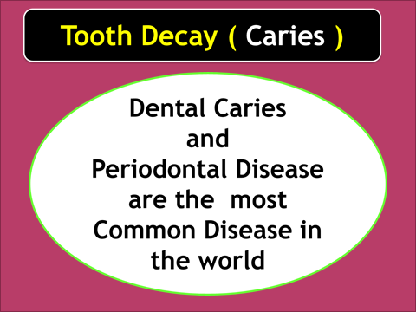
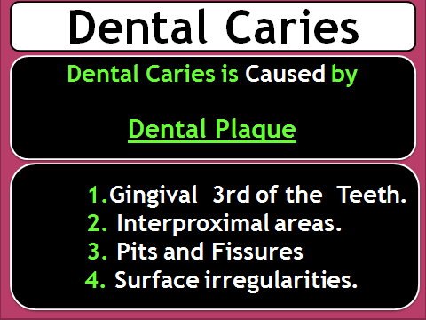
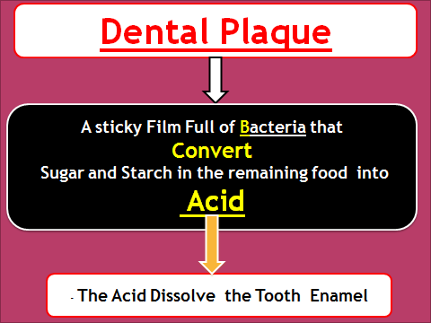
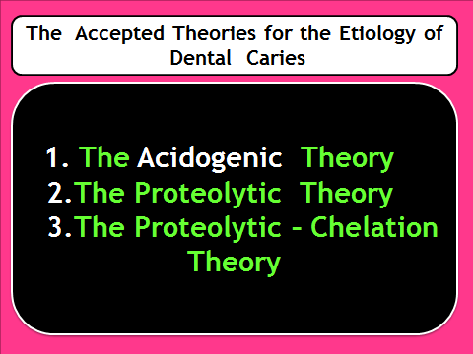
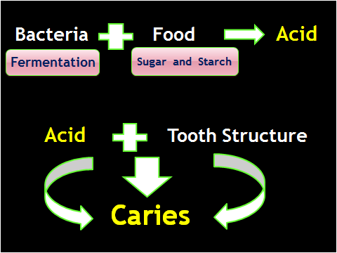
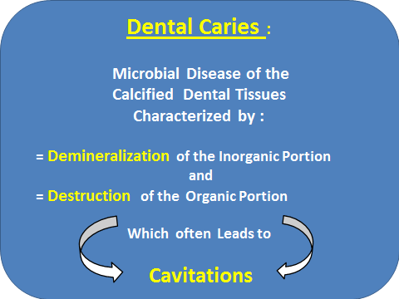

Dental Plaque can found in : 1.Gingival 3rd of the Teeth. 2. Interproximal areas. 3. Pits and Fissures 4. Surface irregularities.
Caries from Food acid if not stopped, can progress through the Enamel Down into Dentine, and if not treated the caries can reach the Pulp and Can cause throbbing pain. When the pulp will become involved, infection will invaded and set up inflammation, which will kill the pulp and often by involving the periodontal membrane produce an acute alveolar abscess
-In the initial Enamel caries there is no pain we can observe that through clinical examination or patient observe the Black Color or due to unsupported enamel the Patient feel cavitation as a result of fracture the unsupported Enamel during mastication
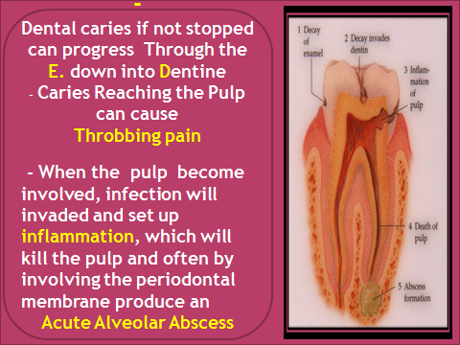
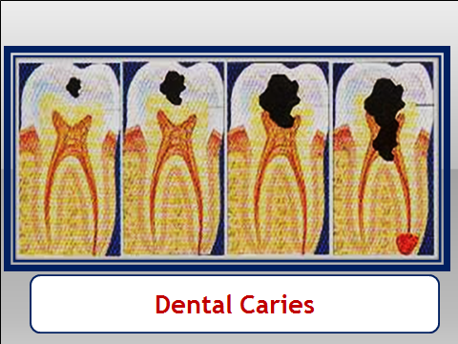

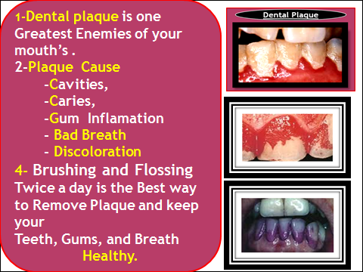
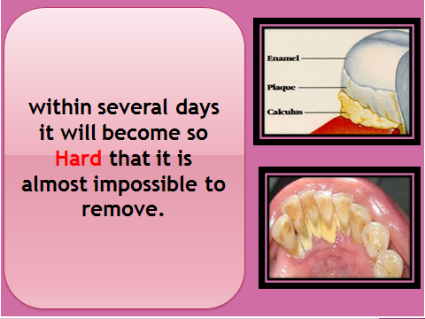
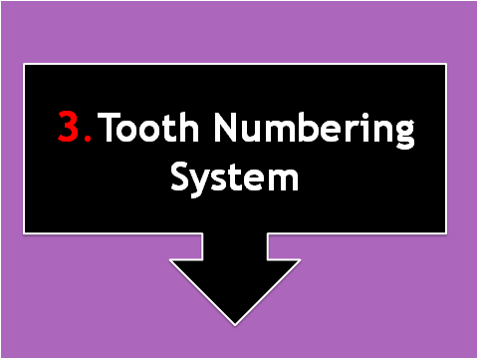

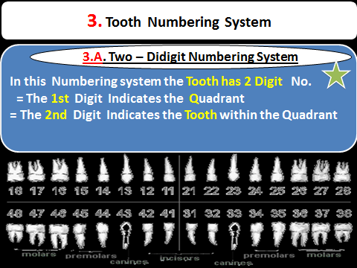
2. Palmer Numbering System : known as the Military Tooth Numbering System. Although supposedly superseded by the FDI World Dental Federation notation, it overwhelmingly continues to be the Preferred Method used by Dental Students and Practitioners in the United Kingdom, and at the UJ.
In this system, the Mouth is Divided into Quadrants. The Numbers 1 through 8 and a unique symbol are used to identify the Teeth in each quadrant. The numbering runs from the center of the mouth to the back.
The numbers sit inside an L-shaped symbol used to identify the Tooth within the quadrant.
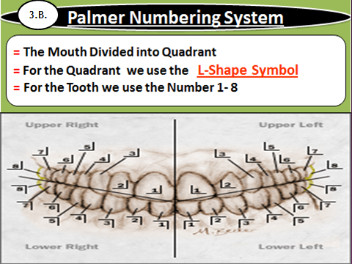
3. Universal Numbering System : We use only NOs From 1 to 32
( as the total Numbers of permanent teeth is 32 ) we start from the upper right 3rd molar given No 1 through the upper teeth to the 3rd upper left third molar given No 16, and then to the Lower left 3rd molar given No 17 , and finally to the lower right 3rd molar given No 32 through all the Lower teeth.
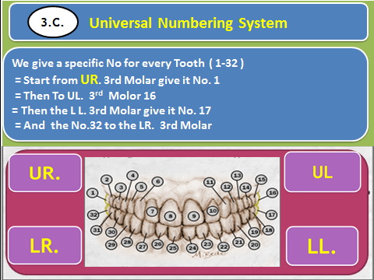
= Definition of Cavity and Cavity Preparation
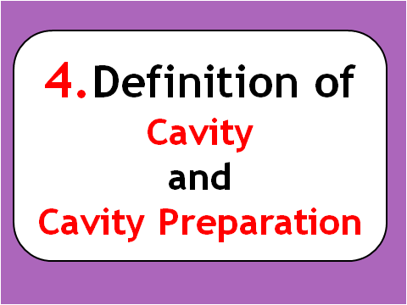
= Cavity :
- Cavity refers to a Defect in Enamel and Dentin, Resulting from the Pathologic Process of Dental Caries.
- Once the lesion has progressed sufficiently to Produce Frank Cavitation, the only Treatment is Complete Removal of the Infected Tissue.
- The Lost Tooth Structure is Replaced by a Material that is Durable and Compatible with the Remaining Tooth Structure and Supporting Tissues.
- Cavity or Lost Tooth structure may Due to Caries, Fracture, 2ndry Caries, Non Caries injuries.
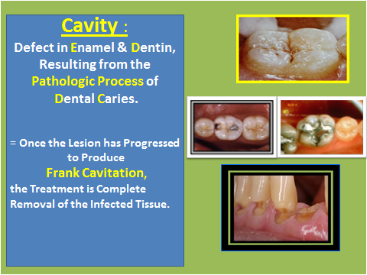
= Cavity Preparation :
Cavity preparation is the performance of Dental Surgical Procedures Required to Expose and Remove the Infected Tissue, and Shape the Remaining Enamel and Dentin to Receive a and Retain the Permanent Filling Material.
- Both rotary and hand cutting instruments are used in cavity preparation. The prepared cavity is ready to receive the restorative dental material.
Dental Excavator
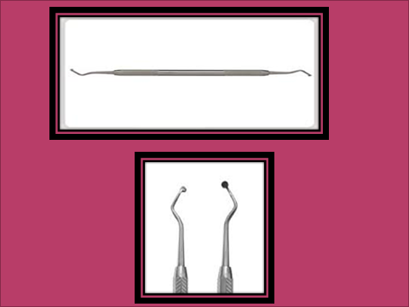

= Caries Terminology : Caries can be Described According to the
1.Location
2.Extent
3.Rate of progression

- Type of Dental Caries Location of Caries
1.Pit and Fissure Caries: Pits & Fissures results from incomplete Coalescence of the Enamel During Odotinogenesis ( Tooth Formation ).
. =Enamel rods are oriented perpendicular to the external surface of the tooth. If the enamel rods do not coalesce on the surface, this results in the presence of pits and fissures. = .These are areas where bacteria become trapped. = .The bacteria produce acids which breakdown the enamel by the process of Demineralization.
=. Because of the orientation of enamel rods, a pattern of Caries is seen in Enamel which is Cone Shaped, with the apex at the tooth surface and the base in contact with the dentin.
= .Dentin is a tissue which is less mineralized than enamel, when the acids attack the dentine, the decay tends to spread laterally along the EDJ. = .The pattern of Caries in Dentine is a Cone Shape with the Base also at the EDJ and Apex Toward the pulp.
=Dentine Caries : Dentin Less mineralized than Enamel, The process of caries is more rapidly then Enamel.( Dentinal Tubules),
The Numbers of Dentinal tubules near the DEJ About 70.000 – 90.000 and Between 30.000 -75000 near the pulp
The Diameter is about 1-2 mm in outer surface and 3-4 mm at its Pulpal side

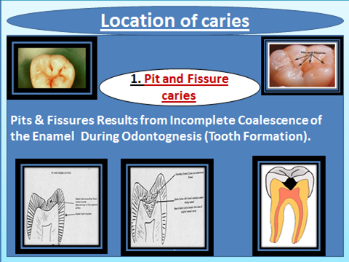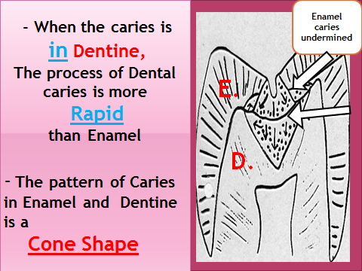

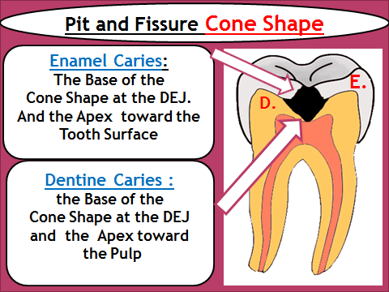

2. Smooth Surface caries:
The enamel rods are oriented differently on the smooth surfaces (diverging outwards), as a result, their pattern of decay differs from that of pit and fissure decay. The demineralization of the smooth surface enamel results in a cone shaped lesion with the apex at the EDJ and the base on the external surface. The lesion in dentine is the same as above. The base is at the EDJ and the apex toward the pulp.
- Smooth Surface Caries Found in := Cervical area ( Buccaly) = Proximal Surfaces
- ( Mesial and Distal Surface ) = Lingual surfaces rarely get carious because of the Tongue and Saliva

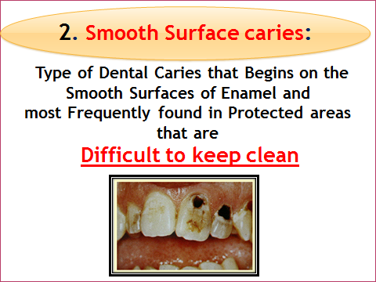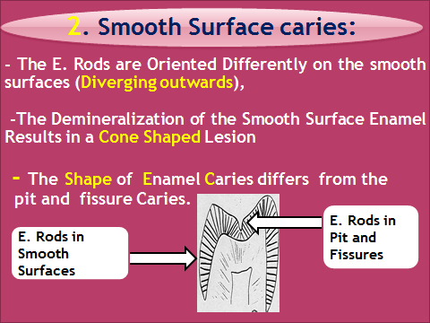
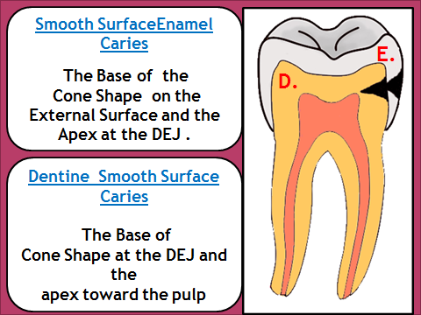

3. Root caries ; Occure on the roots that expose to oral cavity, due to gum resection, its observed more in old patients, the roots caries is more rapid than other forms of caries

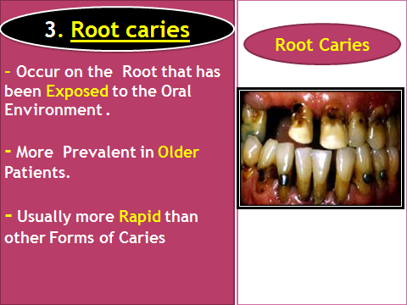

- Type of Caries according to the Extent :
Reversible and Irreversible ( Cavitaed Caries)
-Reversible caries in intially observed as white spots. The surface color may appear brown color due to absorption staining from the oral cavity
= INITIALY white spot lesion is seen ,and due to improve oral hygiene and fluoride application and or missing the adjacent tooth , remeneralization occur
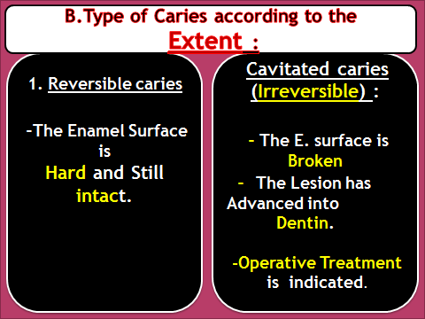
- Type of Caries according to the Rate of Progression :
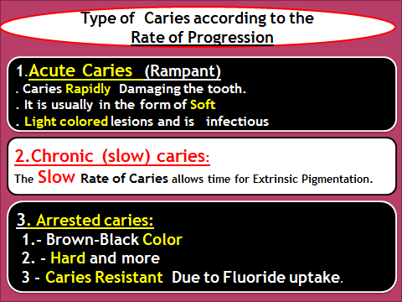
Related Caries Terminology :
Primary caries: is the Original Carious Lesion of the tooth.
Residual caries: Caries that Remains in The cavity after Completed Tooth Restoration, whether by Operator’s intention or by accident.
Secondary (Recurrent) caries: Occurs at the Junction of the Tooth and restoration and may Progress under the Restoration.
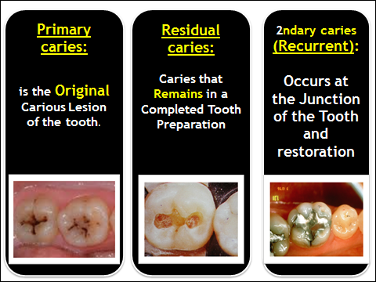

Cavity Classifying According to their Location ( G.V. Black
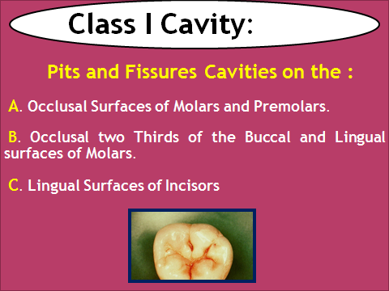
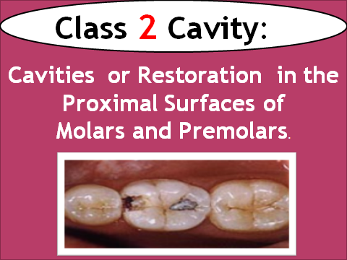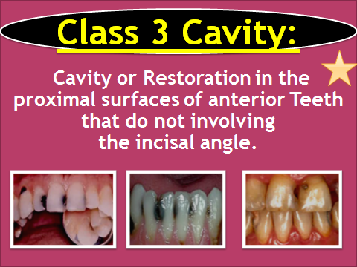

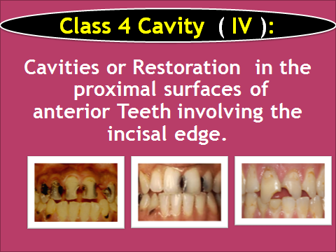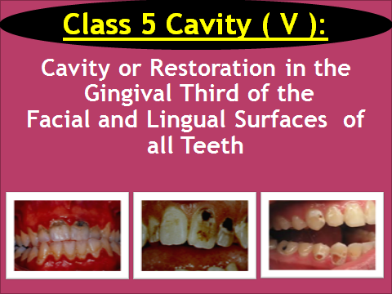

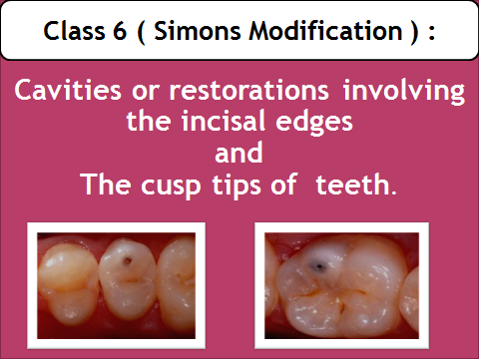

= Cavity Classification :
According to the Number of Surfaces involved

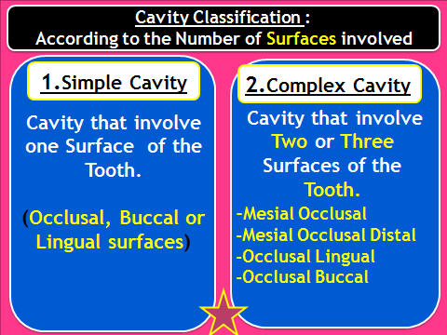

A simple Method of writing this would be using the First Letter of the Surface. O.B.L. or MO,DO, MOD, OL, OB.

