Sheet no. : 6

Refer to slide no. : Examination of TMJ (Slide #2)

Written by: Ola Abu Zir, Haya Hasweh
Corrected by: Ola Abu Zir, Haya Hasweh

EXAMINATION OF THE TEMPRO-MANDIBULAR JOINT AND RELATED MUSCLES

- Before you start the examination
- The simple cases you can handle it, but the complicated cases should be turn to a surgeon.
- The medical, dental, social, financial backgrounds of the patient play a big role in examination of the patient TMJ ….. so a complete medical and dental history should be taken (70-80% of the diagnoses).
- The history should be taken with the patient sitting upright in a quiet, relaxed atmosphere, ideally away from the treatment room.
- Use a questionnaire …... it’s important in order to have a record about the case and the complications that may happen after the treatment.
Its care about the dental history, medical history, social, financial, carrier,…..
- Eye contact and a friendly, interested demeanor on the part of the clinician promote body language that will enhance nonverbal communication.
- The most important thing in patient data: chief complaint & history complain.
- When the chief complaint is esthetic ….. then the history it’s not that important
- But when the chief complaint is pain ….. then you have to ask the patient about:
  - Location
  - Behavior (sharp, dull, chronic, acute, stabbing)
  - When it start? From a month/ year/ absent from years and then return
  - Duration (minutes / seconds)
  - Because of cold / hot
  - If he takes a treatment for it or not.
  - Quality
  - Degree
- The more vaguely a patient localizes the pain, the more specific the examiner's inquiry must be. (If the patient can’t determine where the pain is I have to help and lead him.)
- Report patient’s expectations (especially esthetic treatment)….. you have to explain what you are going to do to the patient and what the result will be.
Ex.: when a dentist makes a composite filling for an access cavity that doesn’t have enamel (only dentine), here he should tell the patient that the filling may fall (the bonding of the composite with the dentine is less than enamel so we may have debonding)
- Report the social history of the patient.

- Critical questions to be asked!
- Seven critical questions as defined in the ADA (American Dental Association) President’s Conference on Temporomandibular Disorders:
- Difficulty in mouth opening? (the most important question)
- Pain or clicking in the jaw joint?
- Pain on chewing, yawning or wide opening?
- Pain in or about the ears or cheeks?
- A bite that feels “uncomfortable” or “unusual”?
- A jaw that “locks” , “gets stuck” or “goes out”?
- Noises in or from the jaw joints?

- Also report…
- History of previous treatment
- Other associated symptoms
Ex.: when the patient told you that he made a filling or bridge before week of pain appearance …. the problem here is high point or fault occlusion.
*** Social events play a big role in TMJ disorders (pregnant lady, someone have family problems, bride, someone fired from his job).

- Clinical examination
- Aims to detect masticatory dysfunction through examining:
- The muscles (it’s very important to know the origin, insertion, function & how to examine the muscles of mastication)
- The joints
- The teeth
- Pain of the TMJ may be related to:
- Teeth (high restoration or fault occlusion)….so the muscle will become tension.
- The patient may have kick in his face …. So the pain originated from the muscle itself.
- Joint (arthritis,…)
…… and all these will appear on the joint and muscles.

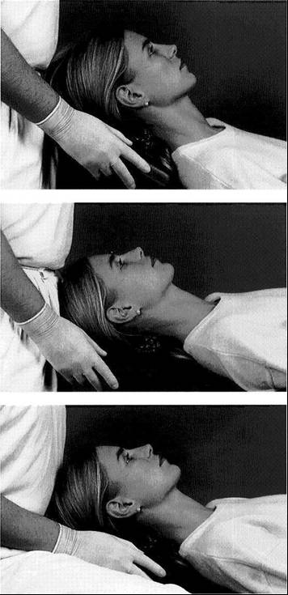
- Patient positioning for the examination
- The patient should be either setting or lying & the dentist should be standing behind the patient to compare and determine the asymmetry (hypertrophy of muscle or different movement).

- Neuromuscular examination
- The muscles can be examined by palpation or functional manipulation.
- The main mastication muscles that we examine are:
- Masseter (by palpation)
- Temporalis (by palpation)
- Lateral pterygoid (by functional manipulation)
- Medial pterygoid (by functional manipulation)
- There is no pain usually associated with the function or palpation of a healthy muscle.
- Why there is some muscles examined by palpation (masseter & temporalis) and others (lateral & medial pterygoid) by functional manipulation?
Because when we ask the patient to clench the masseter and temporalis fibers (anterior, medial, posterior) can be palpated.
But lateral pterygoid when you want to palpate it you have to enter your palm inside the mouth (intraoral) to find it in the maxillary tragus and here we always have something called False Positive (it’s mean that I think I am holding the lateral pterygoid muscle but the real thing is that I am holding the head of the medial ptergoid) ….. so why the medial & lateral pterygoid by functional manipulation? Because they give us false positive in palpation.

- Muscle palpation
- When pain is felt during muscle palpation, it can be deduced that the muscle tissue has been compromised by either trauma or fatigue.
- Accomplished by the palmer surface of the middle finger, with the index and forefinger testing the adjacent areas.
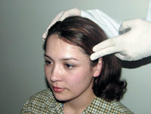
- Temporalis muscle palpation:
It’s like a fan above the ear.

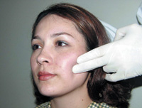
- Masseter muscle palpation:
Here we let the patient to set straight and we stand behind him to see if there is any asymmetry
- Functional manipulation
- Useful in case of muscles are difficult to palpate.
- Relies on the fact that function will induce or increase pain in fatigued or traumatized muscles.
- The only muscle that opens the mouth is the lateral pterygoid …. So to check the lateral pterygoid ….. ask the patient to open his mouth against resistance.
- To check the medial pterygoid …. ask the patient to move his mandible to the right & left against resistance.
- Medial Pterygoid palpation:
We can examine it as in the picture or intraorally or by functional manipulation, but to avoid the false positive and because it’s painful we don’t examine it intraorally or as this picture …. so we examine it by functional manipulation.

- Also palpate..
- Sometimes TMJ disorders may affect the muscles of the neck as:
- Posterior neck muscles (Trapezius)
- Sternocleidomastoid
- Sometimes the origin of TMJ problem comes from the disk or the muscles of the neck.

- TMJ evaluation
- Palpation
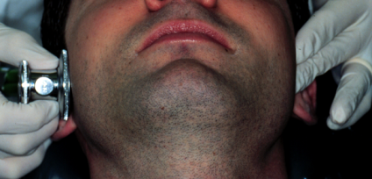
- Auscultation (used in serious cases)

- TMJ palpation
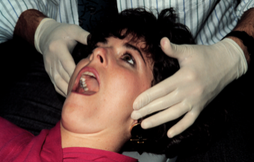
- Extrameatal

- Intrameatal
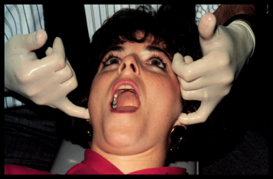
Place the palms inside and ask the patient to open and close his mouth.

- Here we have to notice two things:
- Pain
- Hear if there is clicking or crepitus

- Joint sounds
- Click "صوت طقة"
the problem is in the articular disk stuck or the muscles.

- Crepitation “friction sound”
the condyle or the disk becomes degenerative (rough surface on rough surface).
It indicates that the patient may have had a general problem in his body (rheumatoid arthritis, degenerative disease, …)

- Evaluation of mandibular movements
- Maximum opening > 40 (children also)
Female: 40-50 , Male: can reach 60
Measured by using your fingers (3 fingers or more)
- Determination of lateral excursions (approximately 10mm between the lower midline away from the upper midline)
- Determination of protrusion (5mm or >)
…… if the patient makes all these…. This will indicate that the patient has normal opening range and movements.

- Examination of the teeth and occlusion
- Common signs and symptoms:
- Tooth wear
- Tooth mobility (when there is a problem in the occlusion and the gingiva is weak)
- Pulpitis
- Determine the discrepancy between the centric occlusion (maximum inter cusption) and centric relation …. normal :1-2 mm
And determine if it go back smoothly or not.

- Supplementary diagnostic tools
- The last choice
- Used to gain additional insights especially when pathology is expected to rule out malignancy.
- Doesn’t depend only on radiograph.
- Provide information regarding:
- Morphological characteristics of the bony components of the joint.
- Certain functional relationships between the condyle and the fossa.
- If there is any abnormalities.

