Oral pathology sheet #4
Written by: yara haj \ Hind Alabbadi
Corrected by: naheelaluleimi

- Herpes zoster:
- Herpes zoster virus has two stages similar to HSV. This virus is number 3 from the same family of HSV.
- Chickenpox is 1ry infection which is not common lately because of the presence of vaccine. It is common in children that can be transported through inhalation of droplets contain the virus, then within few weeks patient will develop fever, malaise and characteristic rash. These rashes appear as macules -flat pigmented area- then there will be papules. In the papules there will be vesicles. After that, pustules, then it rupture forming ulcer then heal.
- Macula>> papule>> vesicles >> pustule>> rupture>> ulcer>> heal.
- Chickenpox virus becomes latent, the same as the HSV.
- Herpes zoster - shingles – varicella zoster this virus commonly affects chest, but we have other common sites in the head and neck.
- As a comparison with herpes labials HSV; herpes zoster is rare not frequent infection. The predisposing factors (more critical than those of HSV) are related more to reduced immunity and malignancies. So patient with herpes zoster should be checked for deficient immunity or for internal malignancies like lymphoma or leukemia.
- Prodromal symptoms of severe pain in teeth can occur in some patients before vesicles formation . Some dentists may treat that by RCT or dental extraction.
- Then rashes start to appear, the same as in chickenpox; macules, papules, vesicles, pustules and ulcer affecting one or more of branches of trigeminal nerve. Unilateral (not cross the midline) painful skin rashes with blisters.
- Note: HSV, herpes zoster and chickenpox become latent then travel in ganglia through nerves.
- Q; Recurrence in relation to age in comparison with herpes simplex?
- Intra orally: unilateral lesions on the buccal mucosa or palate (the same as HSV). How to differentiate between the HSV and HZ?

- To summarize:
- HSV:
  - latency
  - affects gingiva
  - reactivation is common
  - Mostly appear in childhood.
  - Duration is from 8-10 days
  - No complication after healing.
  - Diagnosis is clinical and confirm by using biopsy, serology and smear.
- HZV:
  - latency
  - reactivation is rare
  - mostly appear in elderly.
  - Diagnosis clinical and confirm using biopsy, serology, smear,…
  - duration>> weeks.
  - May be followed by some complications.
- Complications of HZV:
- Hyper pigmentation,
- 15% may have post herpetic neuralgia which is severe pain after healing because of the damaged ganglia of trigeminal nerve.
- Some patients may have Ramsey-Hunt syndrome when the geniculate ganglia is involved (facial and auditory nerves are affected). It is characterized by:
- peripheral facial palsy.
- pain of ear and face.
- rash on the external ear.
- manifestation of dizziness.
- changing taste sensation.
- hearing loss.
- loss of balance (affect auditory nerve).
- Herpangina
- It is painful mouth infection caused by coxsackievirus. Coxsackievirus have 6 groups, they are RNA-virus compared to DNA-virus (Herpes). It can be transmitted by fecal-oral route and may cause outbreaks at school among children.
- The manifestations usually are mild, such as; dysphagia, malaise and fever with small vesicles compared to primary gingivostomatitis. Usually these vesicles appear in the posterior part of oral cavity –oropharynx- without widespread gingivitis.
- So in order to differentiate between HSV and coxsackievirus is that:
- HSV is associated with widespread gingivitis. However coxsackievirus doesn't affect gingival.
- Site of infection whether the ulcer in anterior part of oral cavity or posterior close to oral tonsils and soft palate.
- healing needs about 7 days without complications.
- Hand-Foot-Mouth disease:
- Another infection of coxsackievirus is Hand-Foot-Mouth disease. It is also easy to diagnose. You can notice vesicles on 3 main sites; oral cavity, palm of hands and soles of feet. In addition to malaise and mild fever.
- Infectious Mononucleosis caused by Epsin-Bar-virus which is type 4 of herpes group. Infectious mononucleosis usually affects children and mostly it is subclinical. Manifestations appear when the affected pt is young adult or adolescent, present as dysphagia, loss of appetite, anorexia, fever, fatigue, sore throat and multiple lymphadenopathy. Therefore infectious mononucleosis is also called glandular fever or kissing disease (not kissed lesion).
- oral manifestations,
- Petechia (small reddish-bleeding spots) and ulcers on the junction between hard and soft palate.
- Edema and creamy tonsillar exudates in the pharynx area looks like diphtheria.
- If pt has partially impacted wisdom tooth, we can notice pericoronitis.
- Pat may have also spleenomegaly and hepatomegally.
- EBV can cause other lesions like:
- Hairy leukoplakia esp. in immuno-compromised pt's. (appear on lateral border of the tongue
- Burkitt’s lymphoma.
- Nasopharyngeal carcinoma.
- Non-Hodgkin's lymphoma.
- Measles (الحصبة) – skin rash
- How to differentiate between chickenpox rash and measles rash?
- Measles rash are macules, start as small reddish spots that might be slightly elevated. But there is no vesicles or pastules. The non-specific symptoms of measles: fever, headache, sometimes infection may spread to the lung or brain.
- The important thing related to oral cavity that rash appears in oral cavity before skin. It appears as lesions intra-orally prior to rash. Koplik'sspots which is white small papules on erythematous base on the buccal mucosa it's painless. After 1-3 days the skin rash appears.
- Chicken box more coomon than measles
- In immunocompromisedpt's or pt's with malnutrition or pt's with malaria , measles can be predisposing factor to what called "Gangrenous stomatitis" or "Noma" (bacterial infection).
- Cytomegalovirus – number 5 in the herpes group. It doesn't cause characteristic infection in oral cavity. In immunocompromisedpt's it can cause non-specific oral ulcers.
- Bacterial infections
- Although we have many types of bacteria in the oral cavity, it doesn't cause damage to mucosal tissue or soft tissue excluding gingivitis.
- The bacterial infection of gingiva that might spread to the oral mucosa is necrotizing ulcerative gingivitis or "Trench Mouth". Usually it appears in children or young adult males. It is easily diagnosed; it appears as sudden onset of ulcers on the tips of inter-dental papillae start as necrosis or ulceration covered by whitish membrane. It starts between the teeth then spread to the marginal gingival. No severe pain, but there is soreness, halitosis, bleeding of gingival and bad taste. In severe infections pt can have fever, malaise or lymphadenopathy (systemic symptoms). But usually these are absent.
- Histologicaly, no surface epithelium and the whitish membrane is composed of fibrin necroting epithelial cells and there is bacteria and RBC's with inflamed lamina propria.
- Ground stain for the whitish membrane can clarify the bacteria; spirochetes and fusiform types of bacteria. These bacteria cause the invasion to the gingival leading to infection. Trench mouth is non-contagious infection of the gum with sudden onset.
- The predisposing factors of this infection:
- Poor oral hygiene.
- Smoking.
- Fatigue.
- Immunocompromised people.
- Gingivitis + calculus.
- Stress
- Trauma.
- Malnutrition.
- If you didn't get rid of these risk factors, the infection will recur easily. If pt has malnutrition or immunodeficiency with other infections like malaria and measles, the necrosis may spread from gingival to adjacent mucosa and causes necrotizing stomatitis (noma).

Oral Infection \ Bacterial infection
Actinomycosis

Bacterial infection caused by Actinomycesspecies mostly Actinomycesisraelii.
Predisposing factors : Injury or trauma for maxilla or mandible, surgery in the area, extraction of the teeth, periapical infection, pericoronitis.
Clinical presentation: The actinomyces in the head and neck presents as Soft tissue swellings (Fig1) , you should differentiate it from other causes with such presentation. So here It's chronic swellings , very hard in the beginning but with time it become fluctuant and open with sinus or even multiple sinuses for several months then scarring will occur in that area .
So if the clinical presentation was swellings with multiple sinuses , you have to think about actinomyces.
Lymphadenopathy usually not present.
H.w :You have to think about the source of bacteria?
How to confirm your diagnosis? As we said there is opening with multiple sinuses and drainage of pus like material, so you can take this material and look on it under microscope after staining, you can see the sulfur granules = collection of the filamentous bacteria (Fig2), or if you send it to microbiology lab for culture, it will contain growth of this type of bacteria (Fig3).That's why it is called actinomyces which mean it is resembled the fungus but it is filamentous bacteria.
Histological : Granulation tissue and in the center there will be pus formation and in the pus you can find the sulfur granules. So it is granulematus type of inflammation.
Syphilis

Bacterial infection caused by Trepanomapallidum with 3 stages :
- Primary syphilis: it is Genital infection but with orogenital contact the person may present with primary syphilis in the oral cavity ; lip , tongue or floor of the mouth. After the incupation period there will be firm nodule around 0.5 cm in diameter followed by ulceration, here we call it Chancre. So the Chancre is round , shallow , painless ulcer with clean base & raised indurated edges with lymphadenopathy in the region. This will stay for few weeks and there will be healing.
-it is contagious.

Histological: Ulcerated granulation tissue with a dense CICI.

This will stay for few weeks followed by healingthen after few weeks to month there will be :
- Secondary syphilis : pt's will have non-specific signs and symptoms like mild fever, malaise, headache, sore throat with generalized lymphadenopathy and skin rash (coppery macules) تشبهلونالنحاس
Orally: the pt's will have white lesions “mucous patches” which is ulceration covered by mucoid material.
Some of these mucous patches will present like “Snail’s track ulcers” (Fig4)
Also some of pt's will have like an eruption on buccal mucosa or angle of the mouth with surface roughness we call it “Condylomatalata”
Otherept's with papules and splitting at the angles of the mouth called “Split papule” (fig5)

-it is discharging the bacteria so it is contagious as well as the primary syphilis.
- This will stay for 2-3 weeks followed by healing then after few years there will be:
- Tertiary syphilis:
It can affect any organ in the body mainly cardiovascular system (vascular syphilis) and neural system (neural syphilis).
Oral manifestations:
- Gumma: affect Palate, tongue or tonsils , Swelling ⇒ necrosis ⇒ painless, deep round ulcer with perforation that may lead to oronasal communication(Fig6)
Histological: granulomatus granulation with multinucleated giant cells. (Fig7)
- Atrophic glossitis: syphilis will cause obliterations of small blood vessels with atrophy to the mucosa like the dorsum of the tongue so we call it "Atrophic glossitis"
- Syphilitic leukoplakia : That atrophy usually followed by whitish lesion or leukoplakia so we call it syphilitic leukoplakia ,this name is not accurate because as we know leukoplakia means without known cause .
There is a risk of transformation of this lesion to squamous cell carcinoma

- Congenital syphilis: Transplacental infection with various severity which can lead to :
- Abortion .
- Hutchinson triad: blindness, deafness & dental anomalies (Hutchinson's incisors &mulberry molar )

Tuberculosis

Bacterial infection caused by Mycobacterium tuberculosis. Incidence increases after the emergence of AIDS & drugs resistance or drugs abuse.
Oral manifestations mainly seen in Immuno-compromised pt. Bacteria are present in the sputum so during the cough, bacteria may deposit in the oral cavity in the tongue or vestibules causing chronic painful, usually angular ulcer, also it may cause infection of maxilla or mandible " Chronic osteomyelitis" or chronic lymphadenopathy in the cervical region
To confirm it you have to take history, chest X ray, or by taking biopsy, so in the histopathology there is granulomatous inflammation and in the center there will be necrosis "caseating necrosis" with multinucleated giant cells “langerhans giant cells” (their nuclei are arrange at the periphery of the cytoplasm).
Remember: granulomas can be seen in deferent diseases like sarcoidosis….etc , so how to confirm that it is here TB infection ?You have to do special stain (Ziehl-Neelsen stain (Fig8)) for the bacteria in the sputum or the biopsy.
Leprosy

Bacterial infection caused by Mycobacterium leprae. Not common in our country but found more in Southeast Asia, South America & India, of 2 types :

Tuberculoid leprosy | Lepromatous leprosy
limited or localized | generalized or disseminated (more dangerous)
active cell mediated immunity ↑ | defect in cell mediated immunity ↓
defect in antibody mediated immunity ↓

Leprosy causing a lot of disfigurement to the pt in the skin, in the oral cavity you found:
- 50% of with type 2
- Nodules → ulcers → fibrosis
- Palate, gingival and tongue
- With Facial deformity

Oral Infection \ Fungal infection
-Fungal infection caused by Candida is the most common fungal infection in oral cavity.
Species: Parapsilosis, Tropicalis, Pseudotropicals,
Candida
Glabrata, Krusei, Guilliermondi, Albicans
Most common one is ….. Albicans ……
-Can present in different forms: yeast (rounded cells) Fig9A or hyphae (long branching septated, filaments like) Fig9B , The pathogenic form is the 2nd one ; i.e hyphae.
-Commensal organisms متعايشةداخلالفم 40% of healthy adult. But the chance to find Candida in the oral cavity increases more the 40% with the predisposing factors e.g. elderly pt. , pt. with systemic disease, pt. with denture .
So Predisposing factors:
Local factors | Systemic disease
trauma as a result of appliances for example, denture, smoking, frequent carbohydrates intake,xerostomia ,extreme of ages as in elderly or newborn ( Immunity ↓) ,Drugs :immunosuppressant , corticosteroids and broad spectrum antibiotic. | anaemia (iron, B12 deficiency), DM (it's important, you may help in diagnosis of diabetes during history and examination), HIV, blood dyscrasia (leukemia, lemphoma, leucopenia ….) , Endocrine( hypoparathyroidism ,hypothyroidism….), Immuno ↓

- In the oral cavity, there is Specific & nonspecific immunity against Candida.
H.w\ Candida of high or low pathogenicity? Is it superficial or deep infection? Why broad spectrum antibiotic is predisposing factor for Candida infection? What is the specific & nonspecific immunity against Candida? How Candida causes infection with damaging to the oral cavity (pathogenesis) and can it cause squamous cell carcinoma?

Candida does not cause oral ulcer.

Note

Classification:
Group 1: Primary-Confined to the oral mucosa∗ Acute: Pseudomembranous (thrush) & Erythematous (atrophic)
∗ Chronic: Pseudomembranous & Erythematous, Hyperplastic (candidal leukoplakia).
∗ Candida-associated lesions: Denture stomatitis; Angular cheilitis& Median rhomboid glossitis.
Group 2: Secondary-Oral manifestation of generalized candidiasis
∗ Systemic mucocutaneouscandidosis.
Type of cadida infection:
- Pseudomembranous (thrush):
- Erythematous candidosis:
- Chronic hyperplastic candidiasis (candidal leukoplakia):
- Candida-associated denture stomatitis
- Candida associated and other forms of Angular cheilitis:
- Chronic mucocutaneouscandidosis:

Good Luck

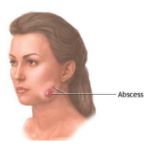
Figures
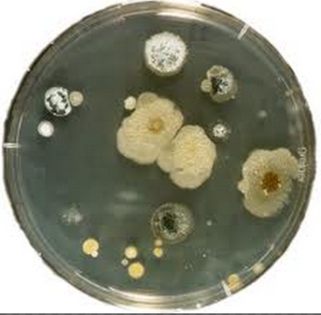
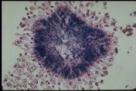

Fig3
Fig2
Fig1

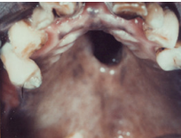
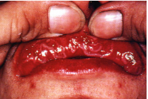
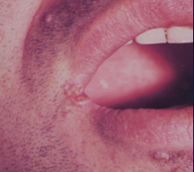

Fig6
Fig4
Fig5
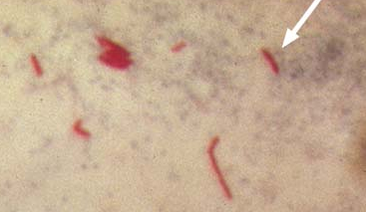
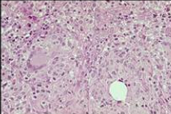
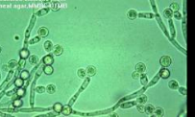

Fig9A
Fig8
Fig7

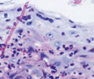
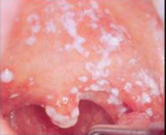
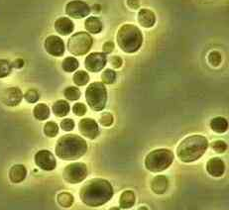

Fig10
Fig11
Fig9B

