Previously , we've talked about the skeletal causes of Malocclusion (class 2 , 3 ..) . Today's Lecture is about the Malocclusion of teeth due to Soft tissues
Lecture's Outline :
-Defenition of soft tissues .
_Importance of them
_Equilibrium theory
_etiologies & their importance in Malocclusion

_Malocclusion of teeth can be due to :
Skeletal abnormalities×
Local causes×
Soft tissues×
×Dento-Alveolar causes (the relationship between the size of the tooth & the jaw )
_Another classification :
Genetic & Environmental causes .

_Soft tissues : All the non-calcified structures which are relevant to tooth position and orthodontic treatment .
They contain : lips , Tongue , cheeks ,floor of the mouth , Muscles of mastication , Muscles of facial expression ,palate , throat , gingival , Periodontal ligaments . Freni ..

They can :
1) cause malocclusion (by being the direct cause of it )
2) make the malocclusion worse
3) be helpful (in case Dento-Alveolar compensation)
4) Be important for the stability of orthodontic treatment

_Dento-Alveolar compensation : Natural adaptive changes of dentition , which tends to mask the severity of any skeletal discrepancy that might be present between the maxilla & the mandible .
For example , A patient with class 2 , the Upper centrals are proclined & the lowers are retroclined . So , the soft tissues try to minimize the severity of that malocclusion by bringing the uppers backward (retrocline them) and the lowers more forward (procline them)
The opposite occurs with a patient having class 3 malocclusion .
This compensation doesn’t occur only on the Anterio-Postrior plane , it may also occur at the transverse & vertical planes . For example , in case of having a patient with an open bite , the upper incisors tend to over erupt to reduce the severity of the increased vertical dimension .

_Equilibrium Theory : teeth lie in a narrow zone of equilibrium (neutral zone) affected by many forces that act on them :
1)intrinsic forces : from the lips , cheeks & the tongue
2)extrinsic : habits (digit sucking habit) & orthodontic treatment
3)Occlusal forces : the anterior component of the force !
4)forces from periodontal tissue
Usually, the forces from the tongue are higher than those coming from the lips & cheeks . If we depend only on them (tongue forces) , the teeth will move forward . So , the stabilizing forces in this case are coming from the healthy periodontal tissue .
That’s why flaring in the incisors is seen in elderly patients and in patients with periodontal problems (the equilibrium is shifted more toward the tongue forces because of the unhealthy & defected periodontal tissue )
That’s why the teeth are proclined in the extreme cases of cheeks defects (for example in necrotizing cheeks )
In contrast , patients with scar tissues on the lips (more tender lips, thus retroclined teeth )
Effects of the forces on the teeth (in order to move a tooth by the force , that depends on … ) :
×level of the force ×Duration ×Direction
A (Light & long-acting) force, is more important than a( heavy & short-acting) force , in considering the etiology of malocclusion
That’s why the forces of mastication , swallowing & speech don't play that important role in causing malocclusion (they're short-acting)
When talking about the duration , 6 hours of continuous force-loading are needed to cause difference in the occlusion

** Lips :
Anterior Oral seal

Activity of the lower lip
Contour (activity of the lips)
Lip line
competence
At rest : At function :

1)lip contour: showing moderate amount of lip vermilion (everted lips : more amount is shown )
This gives an indication of the activity of the lip
Everted lips activity of the lips more proclined teeth
vertical lips activity of the lips more retroclined or normal teeth

2)lip line : the relation of the lower lip to the upper incisors (inner surface of the lip & the buccal surface of the insicors )
Normally , the lower lip covers the incisal 1\3rd of the upper incisors
-low lip line : covering less than 1\3rd of the incisors , proclined upper incisors & the lip is usually behind them and retroclined lowers .
-high lip line : the lower lip is more toward the gingival 1\3rd of the upper incisors , retroclined uppers .

3) lip competence :
Normally , lip seal is maintained with minimal muscular efforts At rest .
So , here we must have 2 things :
×minimal muscular effort
×the mandible is at rest
For example , people with proclined upper incisors , at rest , muscular activity is well-noticed trying to close their lips , and sometimes they fail ! ending up with opened mouth at rest !
Those patients also have problems in swallowing ; because during swallowing , a proper lip seal is needed to prevent the food from going outside the mouth !
-incompetent lips : when the mandible is at rest , the lips are apart , and muscular effort is required to obtain the lip seal .
In this case , lip seal is achieved by the contraction of both : Orbicularis oris & Mentalis .
-Partially competent lips : (A British concept) lips are long enough to span the space between the jaws , but are prevented from being so by the interposition of upper incisors
for example , the lips are closed and are touching EXCEPT in the area of the left upper central only ; because its proclined more .

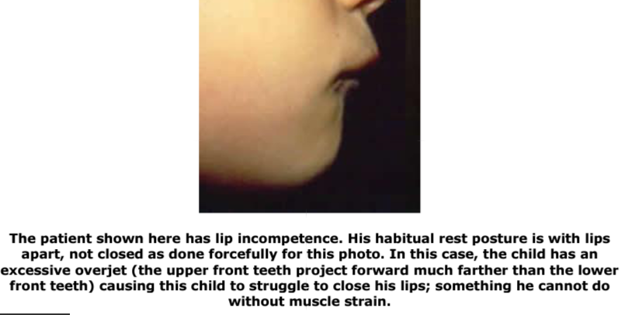
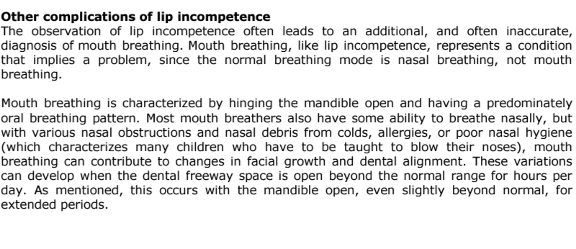
4) Anterior oral seal :
The Seal that is normally produced by the contact between the lips .
Its important in the swallowing process (lips contact with minimal efforts)

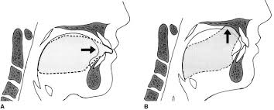
Infantile swallowing pattern :

-Tongue--lower lip seal (close
Contact between the Ton & the lower lip \ Closely related )
-little activity of the posterior part of the Tongue (the main activity is in the Anterior part )
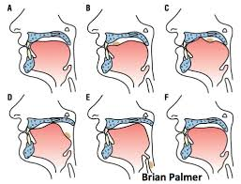
-channeling of the milk during breast-feeding (passage of the food)

Mature \ Adult swallowing pattern :

-teeth come to occlusion
-lips close together
-The tip of the Tongue comes behind the upper incisors in the Anterior palate
-More reliance on the activity of the Posterior part of the tongue
-Activity of the Muscles of the tongue to push the food in a backward direction (the Tongue does not act as a channel here )

A patient with incompetent lips . Why can't he\she achieve a normal oral seal ??
This can be Due to :
1)Skeletal causes ( skeletal class 2 , Open bite …. So, the distance between the lips increases , making it difficult to close them & to achieve the seal )
2)Dental causes (proclined incisors , thus increased distance between the lips…)
3)Soft tissues causes ( short lips "decreased lip length" )

So , How could he\she Achieve the seal ??
1)CircumOral muscular activity
When he\she swallows , extra muscular activity is done in order to close the lips together .
2)Mandibular posture
Moving the mandible forward . usually seen in mild class 2 cases .
3)The lower lip comes behind the upper incisors
Seen in severe malocclusion cases
4)Tongue--lower lip seal
Same as the infantile swallowing pattern . usually seen in Adults with open bites 5)Combination between more than one of the above-mentioned techniques .

5) Lip activity :
If the lower lip was Hyperactive , it would cause retroclination of the lower incisors with No compensation !

** Tongue another factor that may cause malocclusion
Adapted

Primary endogenous
Size

Position
At rest At function thrust

The size & position are very important ; because tongue's activity during swallowing is a short-duration activity , but if the tongue's position is always forward -specially if it is also large in size- this would cause malocclusion & proclination of the uppers .
So , Tongue's size & position are more important than its activity .

-thrust : bringing the tongue forward . Mostly its an adapted condition , meaning that having a Tongue__lower lip contact in case of having an open bite is an adapted change , and if the bite is corrected , the tongue will go backward to its original & normal position .
The same mechanism occurs in case of presence of certain habits , and once the habit is corrected , the tongue returns to its normal position .
In rare cases , there's what is known as : Primary endogenous Tongue thrust . the tongue's Function causes the malocclusion (Hyperactive tongue) by pushing the teeth more forward .

**Periodontial ligament :
It is a stabilizing factor that balances the forces between the tongue from one side & the cheeks and lips from the other side . any disturbance in the periodontial ligament support , equilibrium will be affected and spacing between the teeth will occur.

**Muscles of mastication :
Increased muscular forces may (not that much ) alter the jaw and dental arch ; patients with increased muscular tone have square faces ( small dimensions) . on the other hand , patients with decreased muscular tones have long faces . So , short vertical face dimension / height is associated with greater biting forces.

Note : masticatory muscles strength is not well-known to play an important role in determining the face height ; they might have a role but not that much!
Ok , you got confused ! since we mentioned previously that patients with short face height has higher activity of muscles , and now we are saying that the muscles strength may have a role in determining the face height and might not! It is all about قصة البيضة و الجاجة مين اجا قبل البيضة ولا الجاجة ; we still don`t know what factor of both factors ( the muscles strength and the facial height ) affects the other.

Digit sucking habit :
Usually the tongue is in a high position , so , the cheeks & the upper teeth are opposed by forces of the tongue and there is a balance between forces .
When having a sucking habit , the tongue will be in a lower position and the equilibrium in the upper part will be disturbed , the forces from the cheek side become higher than those from the tongue , leading to collapsing of the upper arch which in turn , may lead to a posterior cross bite and an open bite .
usually , this is asymmetrical & localized to anterior teeth and not extending to all posterior teeth .
As a result of suckig , upper incisors will be proclined & the lower incisors will be either proclined or retroclined.
Respiratory effect on the dentition ; Adenoids :
(اللحمية)
What`s the mechanism that affects the dentition by ?
the adenoid affects breathing ; because it causes nasal obstruction which leads to forced-mouth breathing and opening the mouth when breathing . So :
×the teeth will overerupt
×the lower facial height will increase
×the mandible will rotate backward and downward.

Usually , they have a role partly not strongly ; that`s why it is preferred when having a child with adenoids affecting his respiration to remove it .
-Researches say that chronic nasal obstruction is probably one environmental contributory cause in the long-run , but it is unlikely to be the principal cause ; because the complete nasal blockage is rare.

Common malocclusion :

A-Class 2 division 1
Upper incisors are proclined .
Etiology : 1- when the lower lip is behind the upper incisors.
2- Adapted tongue to lower lip behavior.
3- other types of swallowing behavior.
Stability :
when class 2 div. 1 is treated , one of the most important factors in stability ( in order not to get back as before ) are :
1- cessation of the habit ; for example not sucking his thumb anymore.
2-lip competence ; lips are meeting.
3-lower lip to upper incisor relationship; the lower lip should cover only the incisal 1\3rd of the upper incisors.

B-Class 2 division 2
Upper incisors are retroclined.
Those patients have high lower lip line and a hyperactive lower lip.
-note that a hyperactive lower lip can cause both class 2 div. 1 and class 2 div. 2 ; if it is associated with a low lip line , it will lead to class 2 div. 1
( Hyper active lower lip + low lip line = class2 division 1 )

if it is associated with a high lip line , it will lead to class 2 div. 2.
( Hyper active lower lip + High lip line = class2 division 2 )

C- Class 3
Usually in class 3 , the role of soft tissues is not major -unless the patient has a large tongue- that may contribute to class 3.
Soft tissues role in class 3 is to reduce the severity of the malocclusion (dentoalveolar compensation) .
In severe class 3 cases , we may have tongue--upper lip seal.

D- Bimaxillary proclination :
the excessive forward projection of both the maxilla & the mandible in relation to the cranial base.
Patients have :
×class 2 div. 1 skeletal relation
×full and everted lips (reduced activity of lips)
×sometimes , large tongue & proclined incisors ; because of the reduced activity of the lip.

-Vertical anomalies as open bite , might be from :
1- digit sucking habit.
2- chronic nasal obstruction.
3- a large tongue in abnormal position.

-Trasverse problems might be from :
1- habits.
2- patients with long faces

-Spacing problems :
Upper labial frenum in children is attached to the incisive papillae .
With age , it migrates labially . if it stays and doesn`t migrate , interruption of the periodontial ligament joining the teeth will occur leading to median diastema.
How to diagnose such a case?
- If a peri-apical x-ray is taken ,a radiolucency will be seen at that region.
- Blanch test : lift the upper lip & pull it outward and look for blanching of the soft tissues lingual to and between the central incisors.

-Clefts:
If we treat the cleft palate , a scar tissue will be formed that will prevent maxillary growing and widening , leading to a skeletal narrowing and restriction of mid-face growth.

Many thanks for ♥Ghada Abdel Hadii♥

