Ortho sheet #9
Refer to slide #3
Written & corrected by: Haya Hasweh & Ola Abu Zir
Last lecture we talked about etiology of malocclusion (causes):
1. Skeletal: a. soft tissue, b. dental
- If the patient has anterior open bite with class 3 incisor relationship (prognathic mandible), then this is a skeletal cause.
2. Soft tissue: increase overjet because of having lip trap.
3. Local factor (dental factors):
- Variation in tooth number.
- odd form or size
- variation in position
- Retained primary teeth.
- Variation in teeth number as supernumerary existence, hypodontia, early loss of primary teeth.
- Tooth of odd form or size : here is a picture of central and lateral incisors, the normal MD width if central is 8-9mm, but here its 10 (compare it with the contralateral tooth),, so we
- end up having macrodontia which will affect:
1. Esthetics.
2. Crowding and malocclusion.
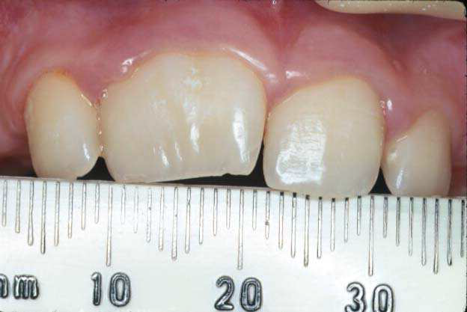
* Management: trimming (but macrodontia means that the pulp chamber also is large not only the tooth, so it’s difficult to follow the contour of tooth, maybe causing a problem to the contour of PDL ending with a ledge), so stripping from the big tooth forms a space, then we have to enlarge the contralateral width to make symmetry as well.
- opposite to macrodontia is microdontia (small teeth):
here is a picture of missing laterals.
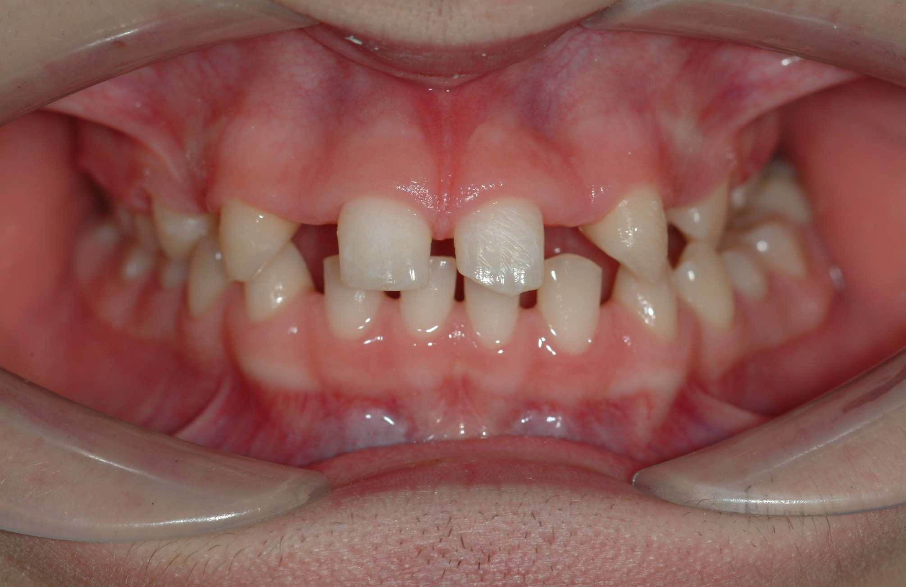

usually microdontia comes with hypodontia
- Symptoms of microdontia: spacing between teeth, so we manage it by 2 options; either by:
- crown , or
- orthodontic treatment, or
- Both (because wrong distribution of teeth and spacing between them, we have to redistribute it again, maybe veneers as well.
- teeth of odd form:
here is a picture of fusion (another term is germination), but the difference is fusion means 2 teeth buds become as 1, so number of teeth will be less, while germination means 1 tooth bud becomes 2 , so number of teeth will be the same. In this picture 1 central becomes 2, with same number of teeth.
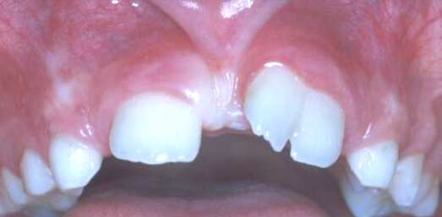
- Variation of tooth position:
Causes: 1.ectopic eruption (tooth didn’t erupt in its place)
2. Transposition
3. Failure of eruption
- most common teeth with ectopic eruption are:
1. 3rd molars (most common)
2. upper and lower canines
3. 1st permanent molars
4. upper centrals
We don’t care about 3rd molars since after eruption (18 years), surgeon would extract them, so our concern is about upper and lower canines, 1st permanent molars, upper centrals.
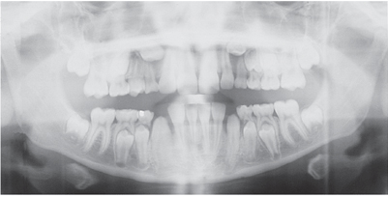
Let’s do a charting of these teeth in the picture: central, lateral, C (mandible)
- How to know its C not a canine? by its
- shape (smaller),
- color (whiter - as the color of primary enamel, or grayish- caused by loss of vitality due to caries), or by
- Attrition.
- Now, this C, how to know if it’s late or not? If it’s normal, it will erupt anyway. First, I look to the contralateral tooth, second the 2nd molar has erupted, so this canine is late because the sequence of eruption had changed.
also regarding ectopic, when seeing x-ray, we will notice that this canine has missed the path of eruption
maxilla: (central , lateral , 1st PM).
- etiology of ectopic canine:
We have to differentiate between 2 things:
1. Palatal ectopic canine: 3 hypothesis describes the causes:
    - Long path of eruption (canine erupt from base of the nose, so it will increase the chance for ectopic canine), so it has long path of eruption compared to other teeth.
    - Guidance theory: lateral incisors guide canine's eruption, so when having missing laterals, we will end up with ectopic canine.
    - genetic theory (most acceptable): signs
  - family history (brothers or sisters)
  - race (specific race of impacted canine, Jewish; most of impacted canine books come from there areas)
  - sex (f/m)
  - bilateral (genetic), but if its unilateral it’s from a local factor
2. Buccal ectopic canine (caused by crowding, why? because the impacted canine starts developing from base of the nose palatally, then it will jump buccally)

- ectopic 1st molar:
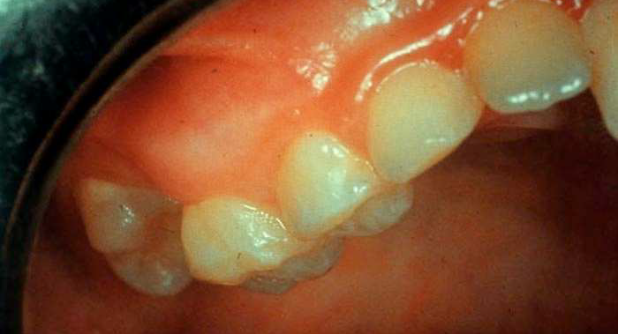
charting: C, D, E, 6
6 should be in its place, but here it erupted under E causing resorption to it
causes:
- size (big size of 6, no enough space for it), or
- mesial tipping (eruption angle of 6)-- (trapping underneath E)
- impacted 6 :
-reversible: 66% (2/3 of cases) - it would correct its position by itself
-irreversible: no space for 5, resorption in E, early loss of E or if it will still exist the patient will have irreversible pulpitis or necrosis with abscess and pain.
…..if its irreversible, we have to interfere.
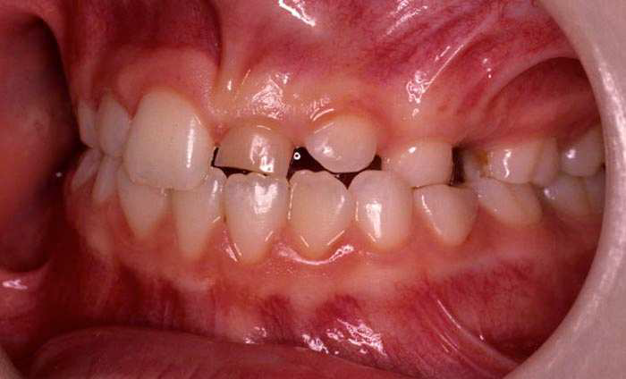
- Ectopic permanent central incisor:
Charting: central, A, 2, C
Is the eruption of central late or not?
Late because the sequence of eruption had changed.
In this pic, 1st question you have to ask your patient is: history of eruption of contralateral central, if before 1 month, its ok, but if before 1 year it’s a problem
>>>Normal contralateral eruption is 6-9 months.
- most common cause of ectopic central incisor is trauma to the primary tooth causing dilaceration
- Which trauma specifically causes dilaceration? Intrusion
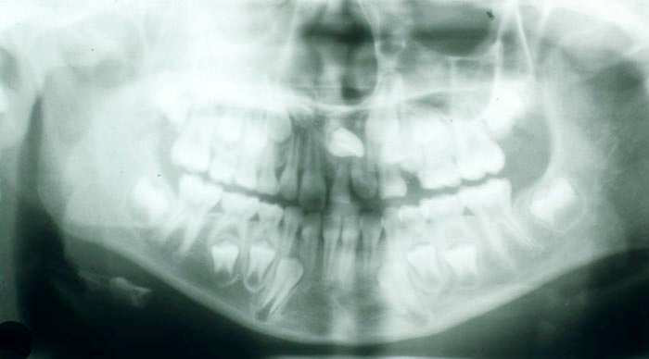
A picture of obviously necrotic tooth due to trauma.-
-An x-ray for central incisor spacing you (looking to you), so its dilacerated.
-It’s very rare for central to be like a canine having ectopic eruption without a reason, when having unerupted central, the cause would be: supernumerary tooth or dilacerations. Not like a canine.
- Why to name it as ectopic not impacted?
The difference here; ectopia has multiple causes,
While impaction means that there is something that prevents tooth from eruption (soft tissue problem, or hard tissue problem - supernumerary teeth or fibrous tissue).
- Transposition
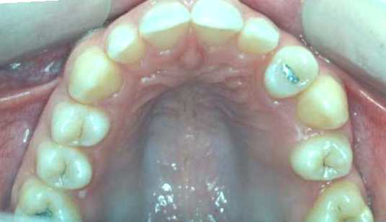
Lateral incisor
1st premolar
Canine

2nd premolar

canine is erupted in the place of the 1st premolar
*Definition: exchange eruption between the position of the teeth
*Types of transposition:
- True transposition: the tooth is completely transposed (the root and the crown)
- False transposition: the roots of the tooth is in its normal place but the crown of it is transposed (the roots will make cross) …. The teeth here will not appear at the same line of the arch (one is buccal to the another one)
>>you have to take x-ray to determine the type of the transposition.
***Exam question:
The way that we have to use to describe (name) transposition:
1st: the arch of transposition occurrence
Maxilla: Max Mandible: Mand
2nd: the transposed tooth
1st premolar: P1 2nd premolar: P2
1st molar: M1 2nd molar: M2
Central incisor: I1 lateral incisor: I2
Canine: C (pay attention that “C” here stand for the permeant canine not the primary canine)
3rd: site of transposition
e.g.: the previous picture: Mx.C.P1
- Student asked: why it’s not Mx.P1.C …depending on that premolar erupt before the canine?
No difference between these two names, we can use both of them but because the canine is the one that take the place of the lateral incisor & 1st premolar (the canine is always the cause of transposition) so we mainly use the first description.
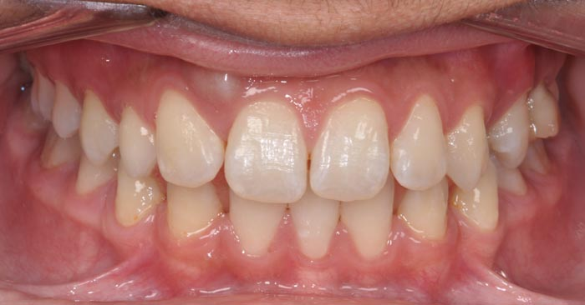
*Management:
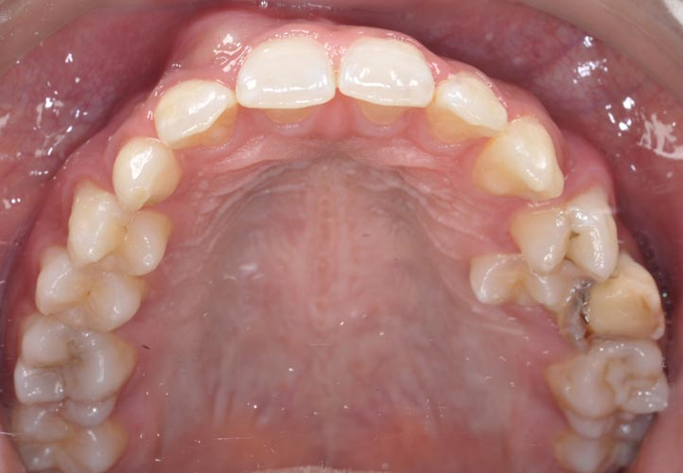
3
1
2
3
2
1
c
Canine
Primary canine
Lateral incisor

Canine

This is a true transposition (here it’s appear without x-ray) …. But you have to confirm it by x-ray.
Management options for this case:
- Reshape the tooth
- Extraction of the “c”, & then move the canine all the way back … this impossible because we can’t move it all this distance, because there is no bone, no soft tissue … and if I want to do this, I have to move the lateral incisor root palatally then move the canine and finally return the lateral incisor root back to its normal place… this is very long procedure.
- Transplantation ….. by extraction of the “c” and the permanent canine, then transplant the canine after the preparation of the socket (success rate of it if the root is not fully formed is 90%) but it’s not always work with the canine because of its long root.
- Extraction of the “c” distalize (move it distally) the lateral incisor let the canine go down reshape the canine and lateral incisor.
(This is not perfect because of the color & the neck of the canine “it’s not always nice to put the canine in the place of the lateral, but we don’t have another option”)
…… this is the option that the dentist used here.
- Failure of eruption
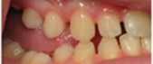
- the 6 is not fully erupted

- We don’t have any explanation why this eruption failed (no reason)
- Failure of eruption can be localized in one tooth (lucky patient) or more than one tooth that will be more severe.
- Classification:
Primary: the tooth will not erupt completely (the tooth failed to go through the gum to reach the oral cavity)
Secondary: it ceases the eruption (start to erupt then it stop) … “as in the previous picture”
- Management: it’s really difficult, because once we tried to extrude these tooth in orthodontic treatment they go and ankylosed to the bone
Sometimes we can do onlays, but in the case in the previous picture it’s very difficult to make onlay because of the huge gap.
- The primary & permanent dentitions can be affected & it can be unilateral or bilateral.
- Retained primary teeth (very important topic)

* Is the eruption of central late or not?
Late because:
  - Sequence of eruption is affected
  - Contralateral erupted tooth
*The most common cause of retained central incisor:
1- Supernumerary (most common)
>>>>The most common supernumerary is tuberculate<<<<
2- Trauma that cause dilacerations (2nd most common)
3- Hypodotia “missing teeth” (3rd cause & it’s rare)
>>> Tuberculate cause impaction
Mesiodens cause diastema
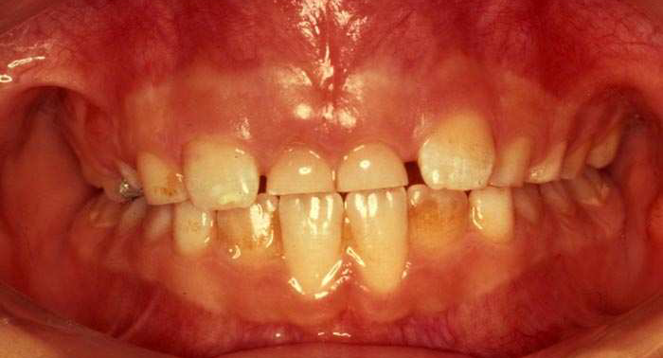

2
A
A
2

*Sequence of eruption is wrong (the lateral incisors have erupted and the central incisors still did not)
*the most common cause is: supernumerary teeth (tuberculate)
*another causes: ectopic incisor
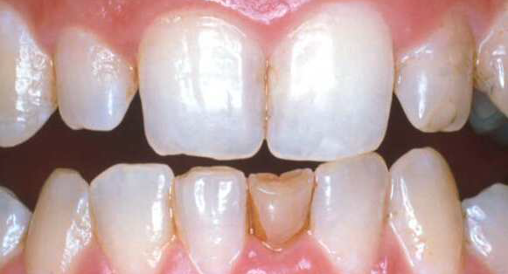

2
1
2

Is it normal to have “A”? No
Why? Sequence of eruption & contralateral tooth
Most common cause: hypodontia (mostly in Far East like Japanese and Chinese population)
Another causes but not the most common: supernumerary teeth.

c

Most common cause of the retained “C” is: impaction or ectopic canine
Another causes but not the most common cause: supernumerary or dilaceration or hypodontia.

Infra occluded primary molars
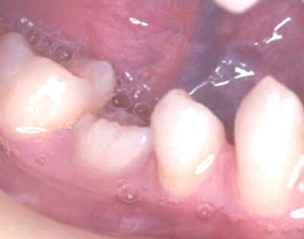
Infraoccluded “E”

*causes: 1- missing 2- ankylosis (in E we have temporary ankylosis not permeant because it come and go … so the tooth will fall by itself)
* Result: tipping
>>> so we have vertical development of the neighbor teeth and the E stay in its place, so the teeth around it will have tipping.
*management (we will take it in another lecture)
If the permanent is not missing, we usually wait & it will be self-occluded but if it’s very severe then the dentist have to intervene.
- Always we have to Check for:
- Symmetry of eruption.
- Sequence of eruption.
- Deferential diagnosis:
- Supernumerary
- Dilacerated.
- Hyodontia “missing (Rare)”

The doctor discus a case that he has treated her but he did not give us the pictures of it:
A female patient, 14 years old (her canine is partially erupted). She has missing central incisors that cause a psychological problem for here. Because of the missing central incisors the laterals have been drifting and tipping that they take the space of the central incisor. Upon x-ray they found that she has two supernumerary teeth. They cannot move the lateral incisors because if they move the roots of them will resorb because they will hit the central incisors follicle …. Treatment: extraction of supernumerary, then extraction of premolars to create space for the central incisors.
The management of this case will be very easy if started when it was 7-8 years old, by only extraction the supernumerary teeth …. So be careful because you as GP you are the stage number 1 for refer.

