Ortho lec.13 Dr. Zaid Al-Bitar Done by : Samar Al-Jaiose, Sana Isleim

Orthognathic surgery
- Definition.
- Indications.
- Timing.
- Aims.
- Process of diagnosis.
- Treatment plan.
- The role of the orthodontist.
- Surgical procedures that are commonly used.

*Any malocclusion due to skeletal problems (A-P, vertical, transverse): 1- Accept. 2- Growth modification if we can. 3- Camouflage. 4- Orthognathic surgery.
*Definition:
- Orthognathic surgery: Correction of skeletal problems and facial deformities through combined surgical and orthodontic approaches.
- Very few cases that are treated by surgery only without orthodontic treatment (like genioplasty).
- Usually surgery and ortho are done together.
* Indications:
1- Moderate to severe skeletal discrepancies in any dimensions:
- A-P dimension: moderate and severe class III patients are usually better to be treated with surgery rather than orthodontic treatment alone. Unlike moderate class II and mild class III which can be managed by orthodontic treatment alone with good results (Camouflage). - Vertical dimension: Skeletal open bite and skeletal deep bite. - Transverse dimension: Skeletally narrow maxilla.
2- Craniofacial anomalies: cleft lip and palate.
* Timing: - If we want to do growth modifications we do it during the growth spurt (class III earlier).
- The opposite is the orthognathic surgery, we usually wait until the growth is completed, after puberty.
- In some cases which are progressive and if we don't intervene the case will get worse we can do the surgery before it's time, like:
1- TMJ ankylosis cases: due to trauma to the condyle, so the growth stops on one side and this results in asymmetry. 2- Severe psychological distress: You have to warn the patient and tell him that I can treat you but the result can be unstable. The patient has to sign an informed consent that he understands the treatment.
* Aims: 1- Esthetics (dental and facial). 2- Functional (occlusion with a table result). 3- Health (preserve or improve the oral health like skeletal deep bite with traumatic over bite).
* Diagnosis: - The process of diagnosis of orthognathic surgery patients is similar to other ortho patients but it is more detailed and at of measurements and facial dimensions should be taken because the surgical movement is accurate (in mm), so it is a comprehensive examination.
1- Patient interview. 2- Clinical examination. 3- Special investigations.
1- Patient interview:
- Chief complain: a- Esthetics: most of the patients. b- Function: old and male patients. c- Combination.
*** body dysmorphic disorder: - Known psychological disorder.
- The patient has a little problem that might not be noticed by the rest of us but he sees it as a big problem and sometimes it can be part of his imagination.
- They draw pictures for their problem and look alot at the mirror and get assurance from their family and friends.
- A lot of doctors refuse to treat them.
- The solution is psychological and it is not advice to treat them because they will never be pleased at all.
- In England the team includes orthodontist, surgeon, and psychologist.
- There is a list of questions to ask the patient like a scoring system and according to the answers we decide to send the patient to psychological assessment or not.
- It is an important and a serious issue, because there are some reported cases that the patients after orthognathic surgery couldn't adapt to their shape and they suicide.
2- Clinical examination:
- More thorough and comprehensive.
- There are soft wares that can help us for a quick examination.
3- Special investigations:
a- Photographs:
- For medico-legal reasons and diagnosis. - They can be intra oral or extra oral with a specific sequence.
b- Study models:
- For diagnosis, treatment planning, surgical wafer (we will talk about it later) and follow up after treatment.
c- Radiographs:
- Whatever is indicated: 1- Cephalometric. 2- Posterior anterior (P-A): Asymmetry. 3- OPG: To see unerupted teeth). 4- Periapicals and bitewings.
d- Other special investigations:
1- Cone beam: It is ideal because the low radiation in comparison with CT scan and 3D image. 2- Bone scanning: For patients with abnormal condyle growth (technetium isotopes to see the hot areas that indicate active growth areas in the condyle).
* Treatment planning:
- It is a team work, the ideal team consists of: 1- Orthodontist. 2- Surgeon. 3- Plastic surgeon (Rhinoplasty and liposuction of the chin). 4- Dentist. 5- Psychologist. 6- Speech therapist.

- When we plan we depend on:
1- The clinical measurements.
2- Cephalometric predictions help us, It can be: a- manual. b- Digital with special soft wares: where we put the image and superimpose it on the tracing, the soft wares do correction and show us the end result. It is not a 100% accurate method but it gives us an idea about the end result.
3- Model surgery:
- It is a way of predicting the final occlusal result after the treatment with models "occlusal records".
- We make the model, then we simulate the movement that we will do in the surgery on the articulator and put the models in the final result and do the wafer in this position.
- If it is a bimaxillary surgery (for both jaws) usually we need a semi adjustable articulator, If it is a one jaw surgery we need a simple hinge articulator.
4- 3D scanning, cone beam: different movements show the end result.
*** Wafers:
- Cold cure (can be made from heat cure).
- In functional appliance we design it in edge to edge position here we make the wafer accurately on the final result, we put the models on the articulator in the final position after the surgery and make the wafer s1plint.
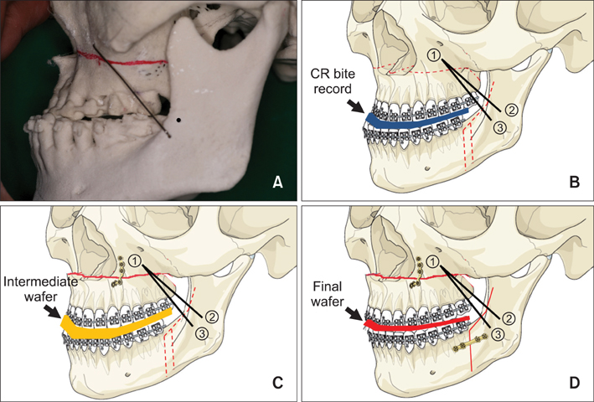
- Why do we do wafer??? 1- It helps the surgeon to position the jaw exactly. 2- We leave it for a period after the surgery as it helps in stability (the patient bites on it to adapt to the new position).
- If we want to do one jaw surgery we do a single wafer.
- If we want to do double jaw surgery we do two wafer splints, one of them is intermediate to help the surgeon to position the jaw the second one is the final one according to the final position of the two jaws.
- Sometimes it has holes for wires to be attached to the braces.
* Role of orthodontist:
1- Pre-surgical (before the surgery). 2- Post-surgical (after the surgery). 3- Retention (After taking the braces off).
1- Pre-surgical:
- Examination, diagnosis, and treatment planning.
- Four Pre-surgical aims: a- Relief crowding. b- Align and level the arches. c- Decompensation. d- Arch coordination.
a- Relief crowding:
- Extraction: The extraction pattern is different than extraction for camouflage (we will talk about it in decompensation).
b- Align and level:
- Fixed appliances (stainless steel not ceramic because ceramic is brittle). - We want to correct the teeth in the vertical plane and incisors level.
c- Decompensation:
**Compensation:
- A natural thing that is not done by us.
-They are adaptive changes (soft tissues have a big role) to decrease the severity of skeletal problems by dental movements.
- Class II: proclination of lower incisors/ retroclination of upper incisors.
- Class III: proclination of upper incisors/ retroclination of lower incisors.
**Camouflage: Is something that we do. - Class II patients we extract upper 4s and lower 5s, skeletal problems stay but we correct the occlusion and incisor relationship.
- Class III we extract the lower 4s to retrocline the lower incisors and get compensation.
** Decompensation:
- We remove any compensation ( A-P, vertical, transverse).
- Skeletally class II (division I and II), due to compensation the upper incisors are retroclined so we procline them, the lower incisors are proclined so we retrocline them.
- Skeletally class III due to compensation the upper incisors are proclined so we retrocline them, the lower incisors are retroclined so we procline them.
- If there is no enough space we go for extraction. As we said the extraction pattern is different, for example class III we don't extract the lower 4s, we extract the upper 4s because we want to do decompensation and retrocline the upper incisors so by extracting the upper 4s we provide space for retroclining the upper incisors. If there should be extraction in the lower arch we extract the lower 5s.
- So we tell the patient before he gets surprised that his shape will be worse because we will remove the compensation.
* Why do we remove the compensation???
- We want to move the jaws to a position near the normal one, if there is any compensation it will prevent jaw movement.
- We move the teeth until they reach the position in the normal angles (109 degrees upper incisors with maxillary plane, 93 degrees lower incisors with mandibular plane) like if there is no compensation.
- Example: class III patients the upper incisors are proclined, reversed overjet (overjet -1 mm), if we move the jaw in the surgery we move it 2-3mm only to get a normal overjet. If we remove the compensation there will be enough movement to move the jaws to their normal position. Compensation interferes with the positioning of the jaws to the normal position.
d- Arch coordination:
- Arch shape and width are planned so that it doesn't interfere with the surgery.
- As you remember in functional appliances if there is a skeletal class II patient when we posture the mandible forward the wider part of the mandible will occlude with the narrow part of the maxilla and this results in crossbite, so we put expansion screws in the functional appliance like twin block.
- It is the same in the surgery, class II problems when we move the lower jaw forward this will result in a crossbite so we might choose to expand the upper arch pre-surgical, in some severe cases when we can't so much orthodontic ally we plan with the surgeon to expand the upper arch surgically.
- The message here is that we have to pay attention to arch width and relationship in transverse dimension before the surgery, either the orthodontist corrects it or the surgeon.
* Note: upper arch is U-shaped, lower arch is V-shaped, we have to have a proper transverse relationship, we might choose to expand or contract or any other thing before or during the surgery.
- So we sit with the surgeon at the first visit and plan what we should do orthodontically and surgically, we get approval and do orthodontic treatment, before the surgery we take fill records for the patient to discuss what we have achieved and what we are going to do, we take model surgery and check everything and if the patient is fit for surgery then we do the surgery.
2- Post-surgical:
- Usually the patient comes back after a month from the surgery.
- Usually we use elastics to finalize the treatment (finishing step).
- This step should not take more than six months.
- We don't remove the braces during the surgery because they help in wafer fixation (They have a role before, during and after the surgery).
3- Retention:
- The retention requirements are the same as in conventional orthodontic treatment, the patient still needs a retainer!

* Surgical procedures:
- What are the procedures that are taking place in the theater? We will talk about them briefly (we will study them in details in the surgical course).
* Single jaw surgery:
- Maxillary procedures :
1- Le fort 1 "most common in the maxilla". 2- Le fort 2. 3- Le fort 3. 4- Segmental procedures.
- Mandibular procedures : 1- Sagital split osteotomy. 2- Genioplasty. * 1+2 the most common in the mandible. 3- Sub-sigmoid. 4- Body osteotomy. 5- Sub-apical osteotomy.
* Bi-maxillary procedure: we m7ean procedure involving both jaws.
* Maxillary procedures:
1- Le fort 1:
- It is concerned about the maxilla either moving it:
a- Anteriorly. b- superiorly (maxillary impaction in cases of open bite). c- Inferiorly (in this case we need to put a bone graft for stability). d- Posteriorly (It is difficult because we have to push the maxilla toward the pterygoid plate so we don't use it that much, and it results in premature aging for the patients).
***there were short videos playing in the background while the doctor was speaking.
- Le fort 1 is used for midface flatness patients (it is a higher level) who have retrusion in the paranasal and zygomatic areas.
2- Le fort 3:
- It is mainly for patients with syndromes (much higher level bbecase we advance the full face).
- Like: crouzon syndrome.
3- Segmental surgery:
- We extract premolars for example if there is no space and then we can play with the maxillary protrusion and retract the full anterior segment.
- The problem is thet we have to be careful because there are roots in the way and they should be away from the surgery.
- We can do segmental expansion.
* Mandibular procedures:
1- Sagital split osteotomy:
- We can move the mandible in any direction (Advancement, set it back, move it right or left for asymmetry).
- The main problem in the mandibular procedures is the potential injury to the inferior alveolar nerve which causes paresthesia to the patient and numbness in the chin area.
** All the procedures mentioned above are taking place intra-orally.
2- Genioplasty:
- Very simple procedure.
- In genioplasty procedures: we can move the chin in any direction (up, down, right, left, posterior, anterior).
- This procedure has a huge impact!
- It is for appearance (esthetic).
3- Sub -sigmoid procedure:
- Vertical sub-sigmoid is used in class III patients.
4- Body osteotomy:
- If we want a large movement in class III patients we use it instead of vertical sub-sigmoid.
- Asymmetry cases (not sure).
5- Sub-apical osteotomy:
- It’s problem is that it is near the roots, we move the sub-apical area. - In patients with very strong chin we try to move the chin with the body of the mandible below the roots level backwards.
*** Fixation after the surgery:
- In the past they used to place stainless steel wires “inter-maxillary fixation” for 6 weeks (the mouth should be closed during this period), the patient used to be on soft diet, uses straw to drink.
- In 90s the rigid fixation started “titanium plates with screws”.
- Advantages: 1- it is more comfortable to the patient and he doesn’t heve to close his mouth for 6 weeks and eat soft diet and use straws for drinking. 2- Earlier function for the patient.
- Sometimes we may use the wires again in cases when something called “splat” happens (something wrong or a complication goes in the surgery or the split is not done in a proper way), but in general it is much less used.
*** Relapse:
- It is the same as the one happens in conventional orthodontic treatment.
- In some cases it may be serious that the patient goes back to her/his situation before the surgery.
- There are many factors to justify the relapse:
1- Surgeon's factors:
a- Poor planning: as in the case of increasing the ptergo-maxillary area “posterior facial height”, the muscles will turn it back to normal (increasing the length in the surgery most probably will relapse so we should take this into consideration).
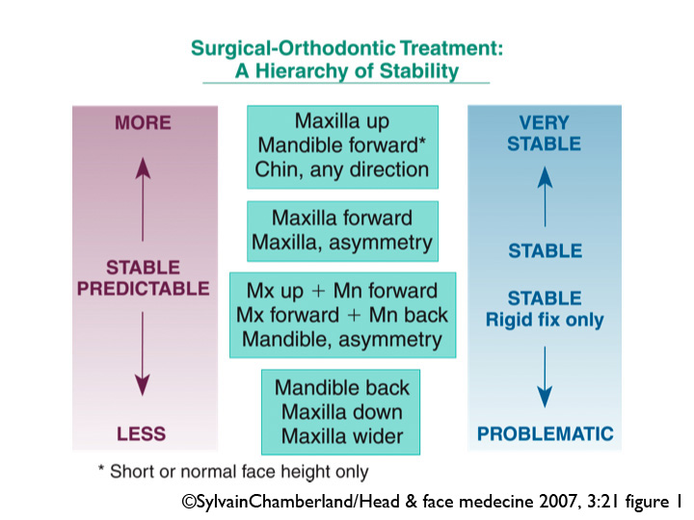
b- Also the size of the movement: there is a specific range for movement of each, if we move the jaw beyond it relapse will happen.
c- The direction and path of movement: - Certain types of movements are more stable than others. - Maxillary impaction “up” is the most stable one. - The maxillary expansion is the least stable, because of cheek collapse. - So if the movement that is going to be done is questionable, we have to take this into consideration by informed consent and retention. - Distraction of condyles from their fossae tends to relapse.
d- Inadequate fixation.
2- Orthodontist's factors:
a - Also poor planning.
b- Size of the movement: moving teeth beyond their biological limit tends to relapse
c- Direction and path of the movement: - Extrusion is usually not stable. - Also certain habits may affect the stability.
3- Patient's factors:
a- Patient cooperation is very important.
b- Certain anomalies that the patient can’t control: like clefts, strength of the muscles (weak muscles that can’t hold the jaw in it’s position).
*** Distraction osteogenesis:
- It is mainly used in young patients with skeletal problems. - It has shown success in pierre robin syndrome patients by mandibular distraction (class II). - We can do maxillary distraction too, rapid maxillary expansion (RME) is a type of distractive appliances.
4- Combination of them.

