*Orthodontics *space analysis *Lec. #19
- objectives:
space analysis; helps us in decision making regarding extraction
anchorage; do we need to use headgear or not…
- Special investigations in orthodontics:
1. Cephalometry
2. Space analysis of study models; aims to decide if we need to extract or not
- Crowding:
it’s a negative difference between the space available in the dental arch and
space required for teeth alignment.
divided according to many classification:
1. Degree of crowding: - mild <4 mm
- moderate 4-8 mm
- severe >8 mm
2. Etiology of crowding:
- primary:
* inherited “genetically determined”
* either the jaw is small or the teeth are large “tooth size-jaw size discrepancy
* features through which we can predict if it’s genetically related:
splaying out of upper incisors
lingually locked upper lateral
No spacing in primary dentition
early loss of “a” and “c”
undermining resorption of “E” by “6”
- secondary:
* acquired throughout local factors
* represented by: early loss of primary teeth
* example:
early loss of “e” mesial tipping of “6” no enough space for “5”
- tertiary:
* also known as: late incisor crowding
* multifactorial (late? growth of the mandible, Soft tissues “lips”,…)
* starts after an age of 12-13 year
* nearly “7” factors ,,, dr. didn’t mention
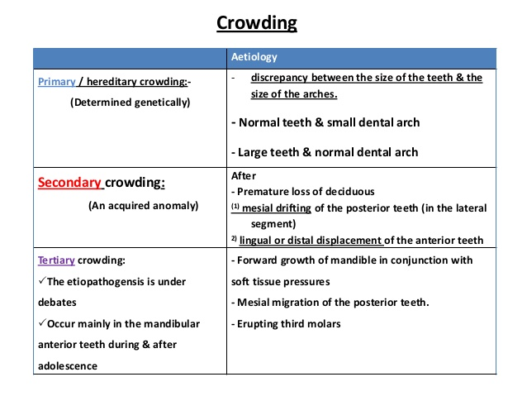
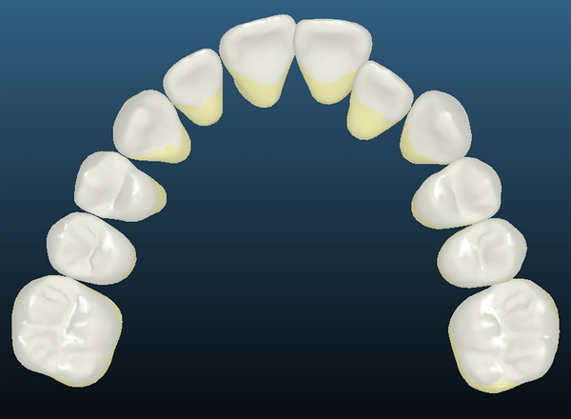
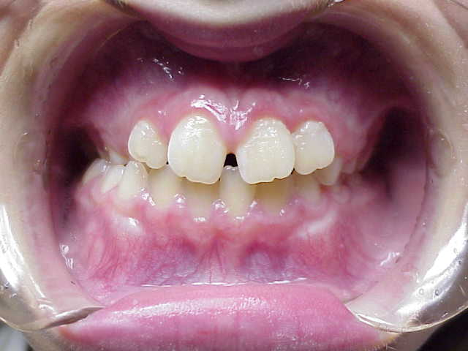
Space analysis:
- Principle: bacically, we want to compare the space available for alignment, and the
space required to align each individual tooth
- it can be done: 1. directly on the cast using “Divider”
2. On “3D” models using CAD/CAM technique
scanning of cast or impression = digital cast
space analysis is done on that digital cast by it self
it is becoming more and more accurate, but that doesn’t
mean that it’s more accurate than the direct way.
How to calculate the space “available” in the arch:
* Space from mesial side of “6” on one side to the mesial side of “6” on the other:
1. Wire is passed from the contact point “6” on one side along with those
“contacts” of posteriors and incisal edges of anteriors terminating in “6”
on the other side, then we measure the wire
2. Four segments way; we bring the divider and measure from:
mesial of “6” to the mid of canine (segment “1”)
mid of canine to the midline (segment “2”)
midline to the mid of canine on the other side (segment “3”)
mid of canine to the mesial side of the other “6” (segment “4”)
** the second way is more accurate.
How to calculate the space “required”:
- we need to measure the MD width of each “erupted” tooth from contact tocaontact
point using the divider or more accurately using the digital caliber “0.1 mm”,, then
we sum the values together resulting the value of required space.
The problem with space analysis:
1- it doesn’t give us any idea regarding the “protrusion”:
meaning that it’s not necessary to see the crowding grossly in the arch, there
could be an indication of that crowding through adaptation of teeth to that
condition
example: the presence of crowding isn’t indicated only through overlapping of the
contact points, we could see an arch with nicely aligned anteriors, but at
the same time they are “proclined” as an adaptation to the crowding
condition increase overjet.
so it must be taken into consideration
2- it doesn’t give as any idea about the growth:
this method gives us the space required for this moment only, it can’t predict the
space later on
example: till the age of “12 years”, the arch continues to grow and expand, as a
result of this we will have spaces that couldn’t be predicted previous to
that age.
3- Difficulty in calculating the required space in Mixed dentition:
due to multiple un-erupted teeth in that stage, there is some kind of difficulty in
calculating the MD width of those un-erupted teeth
solution: “step by step”
- there is no problem in measuring the space in mixed dentition from “6” to “6”, so
we can find out the space “available”
- the space “required” is measured indirectly through sth. Known as “mixed
dentition analysis”
mixed dentition analysis: method through which assessment/analysis the space
for the permanent teeth when the patient is in the
mixed dentition, involving estimation the size of
erupted permanent teeth (ex: “3”,,”4”,,”5”,.)
*Methods of mixed dentition analysis:
1. Radiograph:
- in a radiograph, “5” is un-erupted and overlied by “E”, and we want to estimate
the width of “5” from this radiograph: “steps”
construct a study model: we will get “E”, then we can measure
the width of “E”.
Take a periapical radiograph “parallel technique more accurate”: from
this radiograph, we can measure the width of both “E” and “5” under it
use this formula: “compensation method in order to know the magnification”
width of “E” on radiograph width of “5” on radiograph
width of “E” on the cast width of “5” on cast (x)
for every individual tooth, we take a periapical radiograph
the problem with this method:
1. Usually, we have distortion in the radiograph specially in the canine area
2. Too much exposure to radiation “each individual tooth must be radiographed”
2. Proportionality tables without using radiographs:
- Tanaka & Johnston measure the total width of lower incisors from the cast, and
from this value, they could predict the width of “3”,”4”,and “5” in one
quadrant.
- original equation “don’t emorize”:
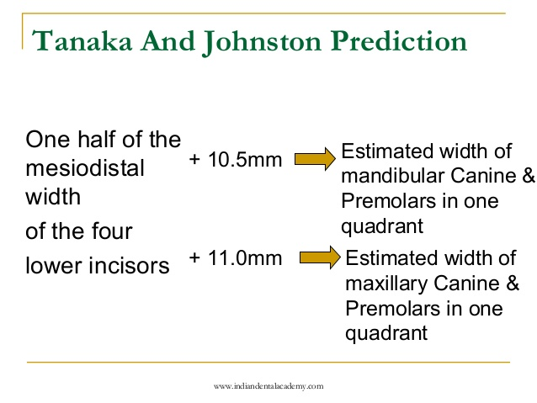
** Dr. will give us a reference including Jordanian equation!
- why we don’t use the width of upper:
cuz there are a lot of variations specially in upper laterals “peg-shaped,
missing,..”
advantages: no radiographs
disadvantages: small tendancy for over-estimation of the width compared to it’s
actual value, but it’s practical and used (Y)
3. Combination of both “most accurate method”:
- no need to take it in details
- combination between both methods, but it’s only related to lower arch
- population specific
** as I understood from the record, that all these methods are population specific
except method #1
-----------------------------------------------------------------------
* Space planning:
- After we determine the amount of space that is required, we want to calculate the
amount of space that we’ll create during treatment.
- you have to put in your mind that there are many orthodontic procedures that need
space, not only the crowding:
1. Crowding :
mild: <4 mm
moderate: 4-8 mm
severe: >8 mm
2. Decrease overjet
related to antero-posterior position of the tooth in the arch
every reduction in 1mm needs 2mm space in the arch:
- if the overjet = 3, and want it to be “2”, then we need 2 mm space
- if the overjet = 4, and want it to be “2”, then we need 4 mm space
- formula: (current overjet – required overjet ) X 2 "الأولوية للأقواس"
3. Arch contraction
4. Tooth angulation “mesio-distal tipping”:
- if the tooth is angulated, then it occupies more space than when it’s upright
- also if the tooth is severely upright, then we need to angulate it in order to get
a space
5. Tooth inclination “bucco-lingual tipping”
6. Leveling of curve of spee:
- the normal curving of this curve is almost straight, so when we face a case
more curving of curve of spee, this means that the patient has deep over bite
- if we want to level this curve, the incisors will procline, then we need a space
- if we don’t want to procline the incisors, but at the same time we want
to level this curve, we have to create a space:
If the deepest part of curve of spee ≤ 3mm then we need 1 mm space for
all arch
If the deepest part of curve of spee = 4 mm, then we need 1.5 mm space
for all arch
if the deepest part of curve of spee ≥ 5mm, thwen we need 2 mm space
for all arch
- according to that, the maximum space required for leveling the curve of
spee is : “2mm” for all arch
7. Torque: position of the crown in relation to the root:
- correct the inclination of retroclined upper incisors so as to provide a space
- How to correct retroclination:
bringing the root palatally, and this involves movement of contact points
distally
the idea: bringing the roots palatally “retroclination” does need space
------------------------------------------------------------
** What about expansion:
- by arch expansion, we provide a space
- by arch contraction, we need a space
- according to many experiments, every “1 mm” expansion of the whole arch, a space
of “0.5 mm” is provided in the whole arch, and vice versa “regarding contraction”
-------------------------------------------------------------
because of that before any orthodontic procedure, we must do what’s called
(comprehensive space analysis), in order to collect all our information and confirm
the treatment plan
Thank you
Done by : Dana Ayman

