Ortho lecture No. 7
26/10/2016
Dr. Ahmad Hamdan
Written by Leen Musharbash

Unerupted Maxillary Canines

**Definition:
The canine that is prevented from eruption into its normal functional position by bone, a tooth or fibrous tissue. Impaction could be bony or dental.
** Normal eruption time of the canines:
- Maxillary canines → 11-12 yrs
- Mandibular canines → 9-10 yrs
Note: the clinician should know when the canines should erupt. Otherwise a wrong diagnosis of impaction could be given, and an unnecessary radiograph would be taken.

Note: Maxillary canines should be palpable in the buccal sulcus at around the age of 10.
Note: In case of the presence of “C’s”, whether or not the four permanent Canines are palpable should be recorded in the “canine relationship blank” in the case summary form.

**Prevalence:
1-2% In Europe (Study made in 2001)
5% in Jordan
0.08% are developmentally absent
→ which means if the canine is not there it’s probably impacted.
Notes:
- palatal location is twice as common in girls than in boys.
-If you suspect there is an impacted tooth, take a CBCT.

**Aetiology: (form the most important to the least)
- Long path of eruption
→the Canine starts up beneath the orbit and travels all the way down to the mouth.
- Displacement of the crypt itself
- Maxillary lateral Incisor Abnormality
→ If there is an abnormality in the lateral incisor, for example; it’s congenitally missing or if it’s microdont. The patient is 2.4 times more likely to have an impacted canine.
- Crowding
→ the last tooth to erupt in the upper arch is the canine, so there might not be enough space for the canine.
- Retention of primary Canines.
→ the primary Canine might be ankylosed and hence; preventing the eruption of the Canine.
- Unknown.
- Mesial dilaceration of the upper 4
- Trauma to the anterior region of the maxilla (however usually affecting the centrals and less commonly the canines)
- Pathology
- Systemic causes – general causes of delayed eruption

There are two main theories of impaction:
- Guidance Theory:
The distal root of the lateral incisor guides the canine into its position.
A study conducted at JUST concluded that 12.6% of patients with missing lateral incisors had lingually displaced canines (6 times more than the normal population)

- The genetic theory :
Genetically determined. The canine will be impacted regardless.

**Concerns (in case of an impacted canine):
Our main concern is root resorption of the lateral incisor; you might lose another tooth.
→ Ericson and Kurol conducted studies on the incidence of root resorption shown on a radiograph.
- in 1987 they found that 12% of impacted canines had resorbed roots on the lateral incisors. (2D radiograph)
- They repeated the same study using CT scan in 2000; 48% had resorbed roots on the lateral incisors. (3D Radiograph)
** Risk Factors for root resorption (due to an impacted canine):
- Females
- Less than 14 years of age
- Horizontal Palatal Canine
- the more developed the root of the canine is, the higher the chance of resorption
- if the canine moves half the midline of the lateral incisor

**case: patient comes with an impacted canine.
Investigations:
- A buldge in the labial sulcus is palpable upon examination.(you need to palpate higher in younger patients). Always examine the inclination and color(necrotic) of the adjacent tooth. If the canine is labial to the lateral incisor, the root is going to go back and the crown is going to move forward. So, if the crown of the lateral incisor is proclined (coming forward), that is an indication that the canine is palatally impacted. The opposite is true.
- Presence of mobility of C and the lateral. Compare with the contralateral.
- Radiographs →Use the Parallax technique –horizontal and vertical techniques
- The panorama is taken at zero degrees beam.
- Occlusal Radioraphs are taken at 60 degrees.
- In an occlusal radiograph the cone is moving Apically.
- To know whether the canine is impacted labially or palatally, we need to check if the tooth moved in the same direction as the cone beam did. To do that we need a horizontal reference line.
- The horizontal reference line; the CEJ of the central for example is taken from the OPG.
- Compare the position of the tooth with the horizontal reference line. In this case the tooth moved upwards, in the same direction as the cone beam so the canine is palataly impacted.
- Note: If I took an OPG and two periapical radiographs then I’ll need a vertical reference line.
** Prediction of impacted canines:
Ericson and Kurol did a study where they followed children from the age of 8 to 12.
At the age of 8 :
73% were not palpable
At age 10:
29% were not palpable
At age 11:
only 11% were not palpable
After the age of 11, only 3% were not palpable
So as the patient becomes older, there is more chance to palpate the canine. And if you palpate them they’re most likely to erupt.
note: Age 11 is the best time to palpate

**When do we take a radiograph?
- If it is not palpable
-asymmetry on palpation
-Age (not always a good indicator) (use the contralateral as your guide)
-lateral incisors displaced buccaly or inclined in the mixed dentition (not the ugly duckling stage)
**The Lindauver et al study (1992)
Aim: identifying the prognosis of the canine.
The patients were compared retrospectively. Two groups;
- 28 patients with unilateral/bilateral impacted canines
- 28 patients with normally erupted canines.
- All had panoramic radiographs between the ages of 11-12 years
- The key to this method is the lateral incisor on an OPG.
- Look at the tip of the canine, and relate it to the root of the lateral incisor.
- If the tip is distal to the distal surface of the root of the lateral incisor, it is sector 1
- If the canine tip is between the distal surface and the long axis of the lateral then its sector 2
- If the canine tip is between the long axis and the mesial surface of the lateral then its sector 3 (does not cross the mesial surface of the lateral)
- If it goes through the mesial surface of the lateral then it is sector 4
- By this method we could tell the likelihood of canine to impact.

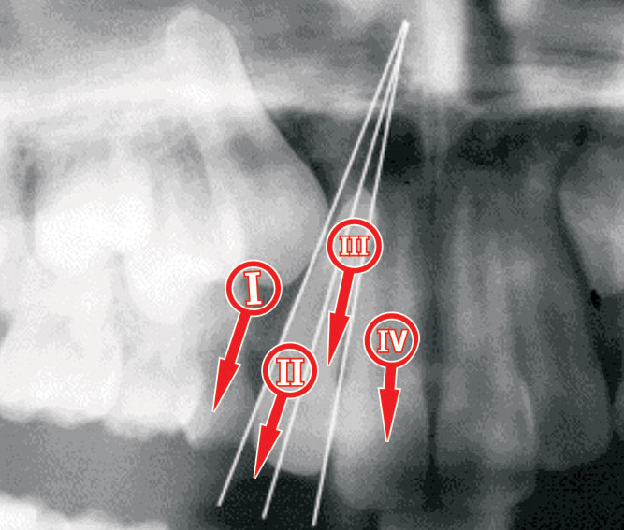

Results:
Sector | Impacted (%) | Not impacted /erupted on their own (%)
1 | 9 | 68
2 | 15 | 3
3 | 10 | 0
4 | 7 | 0

-All the canines in sectors 3 and 4 became impacted.
-91% of canines in sectors 2, 3, and 4 became impacted.
-Keep in mind that even canines in sector could be impacted.
- the Accuracy of canine impaction was 78%
- Accuracy of canine eruption 91%

**Prognosis: (how successful is the prediction of the success of the treatment) (prognosis of treatment of an impacted canine)
To determine the prognosis there are certain factors (related to the cone beam) that need to taken into consideration.
Vertical:
Mc Sherry (1998) came up with the rule of thirds.
If the tip of the canine is in the apical third (or above) of the lateral incisor, then the prognosis is poor.
If its in the middle third it is fair, and if it is in the cervical third its good.

So the position of the tip of the canine determines the treatment time. If it is less than 14 mm to the occlusal plane, it would take 24 months.
If it is above 14 mm, it would take about 31 months. (stewart et al 2001)

- Horizontal:
Line from the long axis of the canine and the mesial surface of the 4 and if it is between those two lines, the prognosis is good.

Angulation to midline:
As the angle increases (as it goes out and away from those lines) the canine becomes more horizontal, and the prognosis becomes worse.

Stage of root development:
The more developed the root, the worse the prognosis

Treatment of difficulty index: based on all these factors, the horizontal position of the canine is the most important. It played the biggest role in the prognosis and treatment planning.

Note: the canine usually should be at 45 degrees, more is unacceptable.

**Treatment options :
- Leave and observe
-when do we leave it? No pathology, no functional or aesthetic problem, good occlusal contacts
- Interceptive treatment; take out the C’s
-ericson and kurol, if you take out the C at the age of 10 or 11 and the canine is sector 2, 3, or 4 78% it will normalize within a year if there is no crowding
So, Take the C’s out at the age of 10/11 if the canine is in sectors 2, 3, or 4 even if there is no crowding because it will normalize itself.
- If there is crowding, 68% will normalize
- The more the overlap (greater sector) the less the likelihood of normalization.
- Expose the tooth surgically and pull it down orthodontically(using a chain)
-distalize the buccal segment, extract the 4, pull down the canine.
-make sure the canine is not ankylosed in the bone before extracting the 4. Start by exposure of 3 and pulling it down, when you’re sure it is moving, you extract the 4.
-If the canine is impacted palatally we usually expose them surgically (open surgical flap)and wait for them to erupt. A lot of them do.
-if the canine is impacted buccaly we do a closed surgical flap to preserve the attached gingival OR if it is not too high up we could use an apical positioned flap which also preserves the attached gingiva.
** Surgical extraction of the canine: ??
- Poor prognosis for alignment
- Good room for contact
- Poor patient cooperation
- Pathology

4) Take the canine out and reimplant it (auto transplantation)
- you need an open apex with 50-75% of the root formed
-used usually when the lateral is missing and the canine is impacted, so you want to save the tooth (since the prognosis is poor)
- Parking (a technique used when there is no place for the canine to erupt because the laterals are in the way (even if there is space, the laterals could be in the way), so you extract the impacted canine surgically, park it in the labial sulcus above the periosteum. Move the lateral out of the way of the canine, and then reimplant the canine.

**Orthodontic force application:
- Upper removable appliance
- Lower removable appliance
- Fixed appliance
- Elastics
- Ligature wire
Notes:
-the type of anchorage that I require to apply traction and pull the canine down is vertical to resist the vertical pull. The removable appliance gives the best vertical anchorage since it covers a great area (the palate, the teeth).
-gold standard for the pulling force is the gold chain
** Treatment time(horizontally impacted canines):
Sectors 1 and 2 almost 17 months
Sector 3 ; 20 months
Sector 4; 27 months
- The more horizontal the tooth is the longer the treatment time.

** note: if you are pulling on a canine for 6 months and it’s still not where it should be then stop.

