Management of hospitalized patient
Why does a dentist need to administer a patient in the hospital?
1. when you need to do a surgery under anesthesia specially in case of children or anxious pt. or even afraid pt. who need multiple implants or extraction of the 3rd molars and many other major surgery cases
2. Give consultations : in many cases like in the ER, we can assess the patient who has abscess, who is subjected to trauma (maxillary or mandible ), fracture; whether the patient is a kid or an adult.
3. Emergency room consultation: as we said in the ER
4. In patient consultation : like patients who require chemotherapy need to have their teeth assessed before starting chemotherapy which may affect their immunity, also any dental treatment should be done before the chemotherapy , or when applying a tube and there are some mobile teeth the dentist should check if there is a chance that those teeth might fall or not
5. Do procedures that are best done in the hospital: like dental procedures for kids or pt that need hospital admission which is not usually allowed in the dental practice office.
So why do we hospitalize the pt for dental care?
Hospitalizing the pt for dental care:
* Behavior management: sometimes it is difficult to deal with kids and mentally retarded pt like Down syndrome.
* Patients with medical problems. Like uncontrolled epilepsy, bleeding tendency, prosthetic heart valve pt. who need to be given an IV antibiotic cover
* If patient needs sedation (IV sedation) or GA. in some countries it’s okay to administer sedation in the dental chair but here in Jordan you should consult a hospital
* Day surgery: day care unit is a special unit that the pt comes to in the morning and leaves in the afternoon ( day case surgery ) , and you can do certain mild to moderate procedures so the pt comes and leaves in the same day to save time .
Preoperative pt evaluation:
* Preoperative medical examination, medical history and medications.
* Contact operating room staff: first you need to book the dental chair and equipments, usually in the hospital there are specific nurses responsible for organizing equipments for GA .
* Prepare the instruments: especially in dentistry the hospitals don’t know much about dental instruments so you should prepare them.
* Operating time and list: you should write down the name of your pt, the operation time and name of the operation and this should be handed before to the hospital . also you should give the pt. an aggression note listing the history , medical examination , xrays and operation plan etc. so everything is available when needed .
Preparing the patient:
This is in case of an inpatient meaning he is going to stay in the hospital for a time not like the day case patient
* Prepare the pt at least 24 hours before the operation.
* Assess general health and fitness like checking for infections or any problems in the days before which may postpone the tx to another day .
* Investigations: depends on age and the medical fitness of the pt. like If the pt is young we probably need nothing or just do a CBC ( complete blood cell ) count which gives us the bleeding tendency, platelet number ( 150-400 is the normal ) , hemoglobin (if less than 10 than you cant give the pt. GA nor go through any elective surgeries but considering emergency you have to proceed (12-16 females /14-18 male is normal) , wbc that give you an idea if there is an infection or not which increase in these cases, we can do a deferential blood test too . if the pt is an elderly we do cbc, chest x-rays ( to examine the heart size ) , glucose test to see if he is diabetic or not. Radiological, microbiological, biochemical investigations; each one is done for the specific need of each pt.
* Informed consent: is a document where you save all information about the procedure and the possible complications relatively. So you need to make sure that the pt knows about it an example is the chance of paresthesia as a complication.
(Neurosensory is the most important complication which means saying things to the pt. before the surgery that might frighten the pt making him worried).
* Anxiety : we can give the pt oral sedative pills that can relieve anxiety before the operation
* Foods and drinks : are not allowed 6-8 h before the operation to avoid aspiration .
* Premedication: are the medications that we give it to the patient before surgery.
There are 2 types of medications:
Medications that the patient already take them before; like hypertensive ptns. And diabetic ptns. , so if they need to take it before the surgery, they can take it.
Medications that we prescribe to the patient to take it before surgery and we tell the anesthetist about it like ; antibiotics (as a prophylaxis), steroids (to minimize the edema or the swelling after the operations, like Dexamethasone "4-8mg, one dose before and two to three doses postoperatively to minimize possibility of swelling", Analgesics (preoperative analgesics can minimize the need for postoperative analgesics like; NSAIDS, Prophin, voltaren) .

The Profs. Show a picture for a patient needs an operation for the lower jaw;
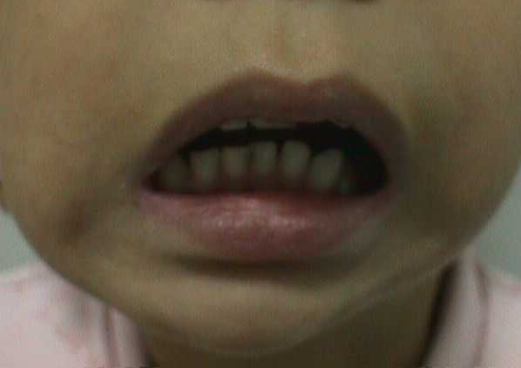

she has facial Asymmetry, retrognathia and limitation of mouth opening "the pic. Shows the maximum mouth opening".
The History of this case is: trauma when she was a Kid>> Bilateral fracture of the TMJs, one of them ends with ankylosis (ankylosis: ossification of blood clot that might happen around the joints)….. this happens from 13-14 years old,,, now she is 18 years old!, and now she is admitted to JUH to treat the ankylosed TMJ ; SO NOW we have to
Take a good medical history.
Do investigations "X-ray; shows the right ankylosed joint, CBC".
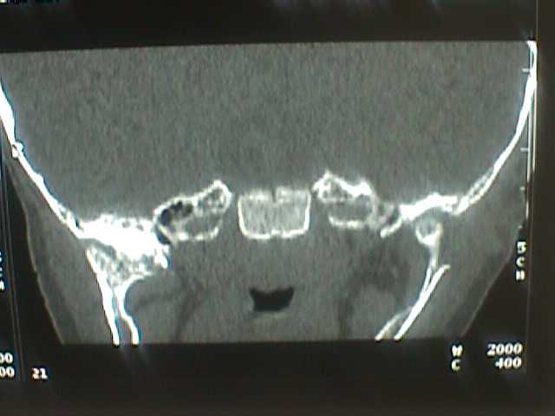
WE have to tell the anesthetist that she has a limited mouth opening; to determine the appropriate entry and position of the tube.
They cover the ptn except the area of incision, eyes are protected, clean the area with iodine, close the external auditory meatus to protect the ear.
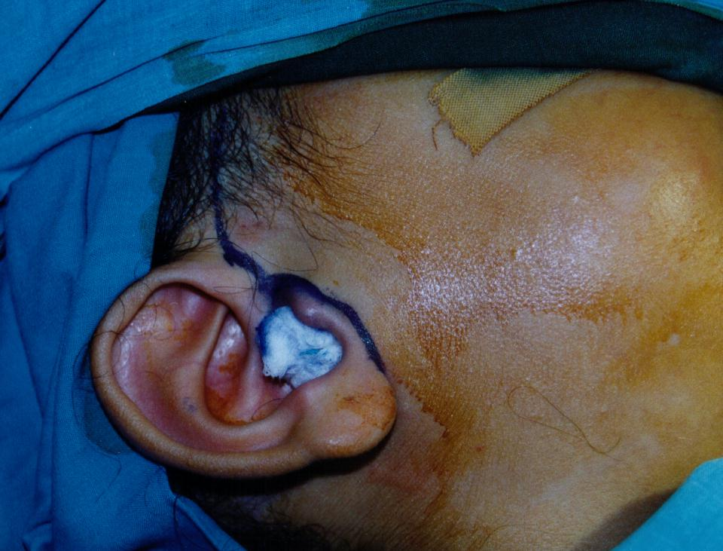
Intraoperatively, they marking the incision, then they made excision for the ankylosis, then they use part of the temporalis muscle as an interpositioning muscle to replace the disk, then closure.
Postoperative X-ray; a joint space is created on the right joint.
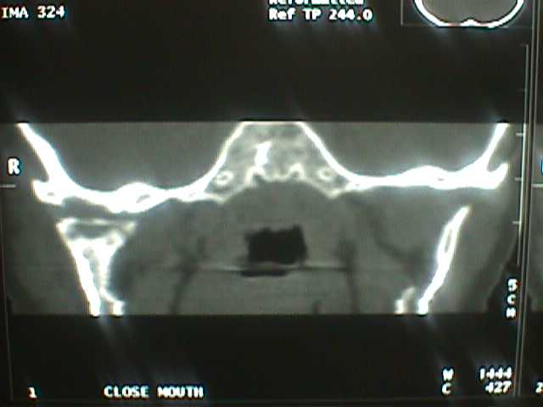
Operating rooms protocol
Get an assistant
Anesthesiologist
Scrub nurse- gowned & gloved ; this nurse did not touch any thing except the patient and the instruments.
Circulating nurse; bring the instruments BUT did not touch the patient.
Local / sedation; we have to determine what we need before the surgery.
Day-case surgery; we have to determine what is the case.
G.A / admission; we have to determine what we need before the surgery.
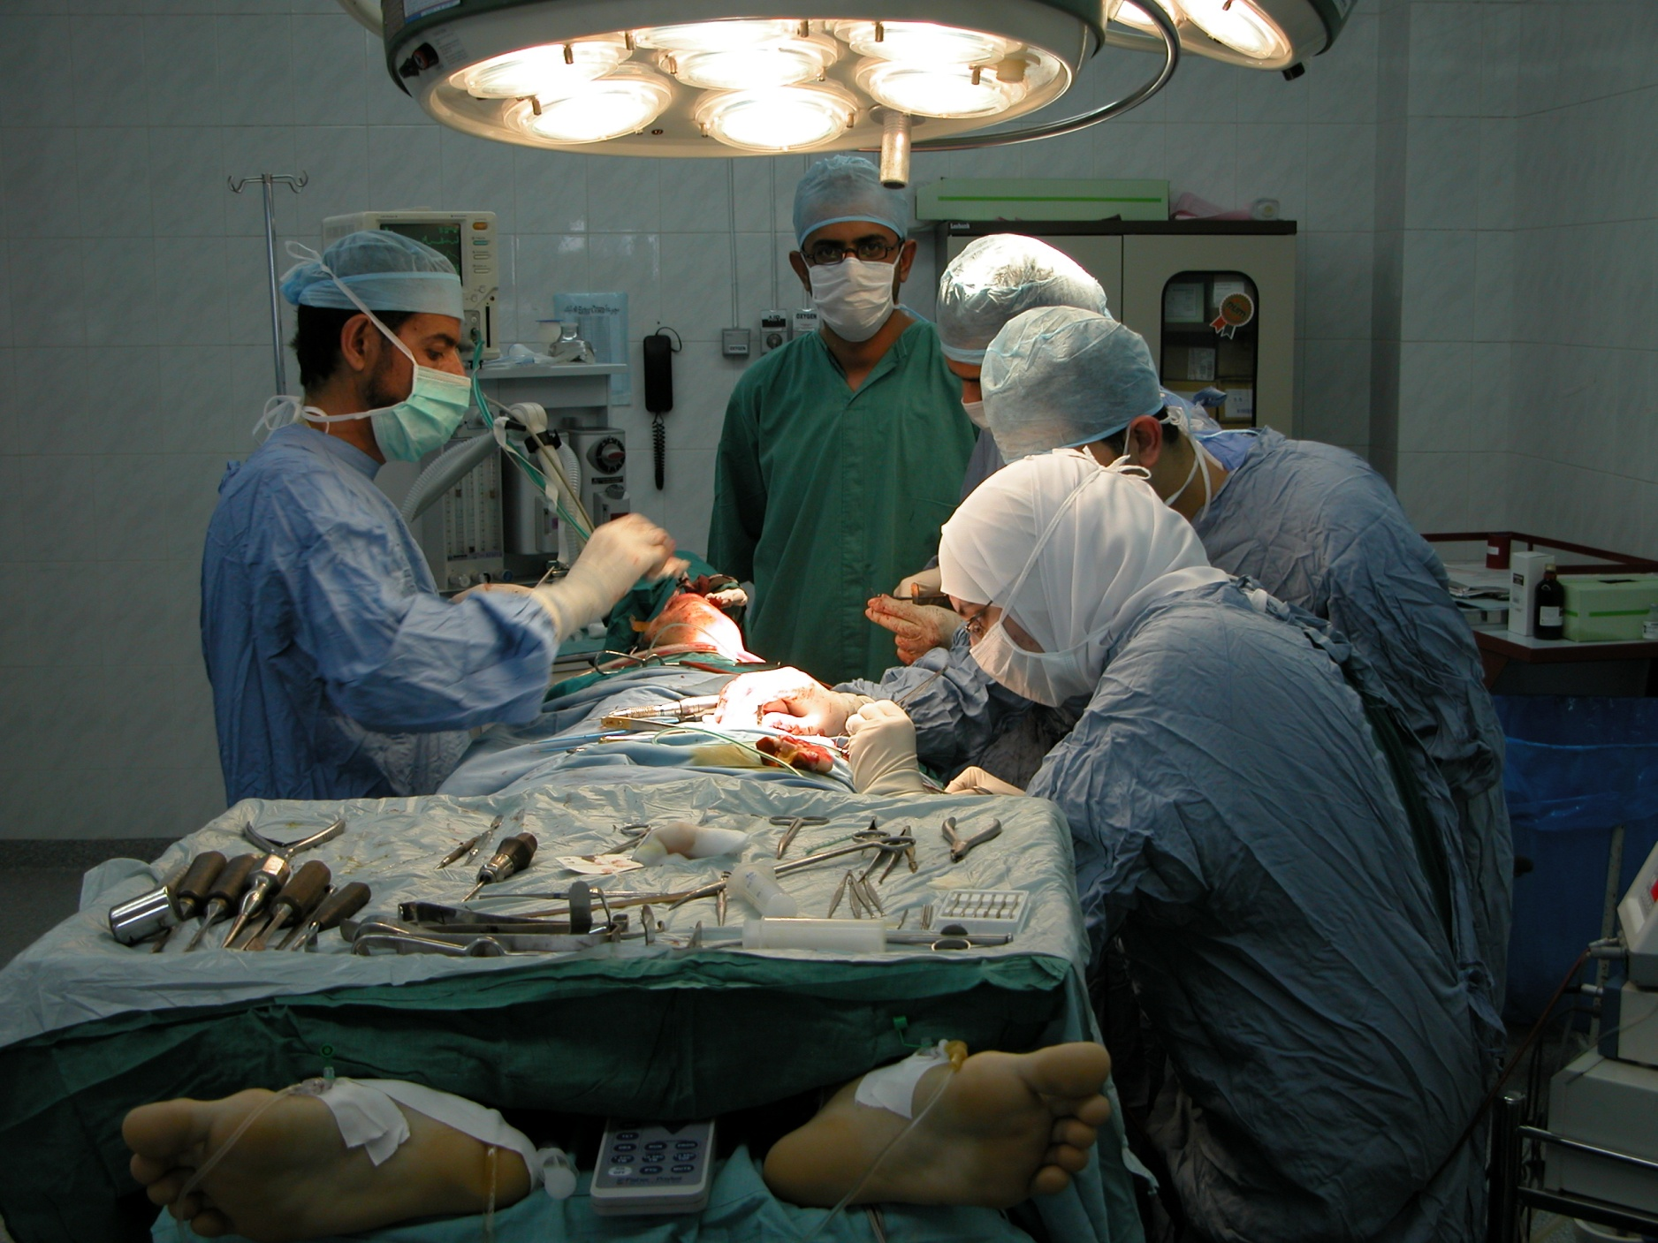
In the operating room (as shown in the pic.) we have:
Instrument's table.
Scrubed staff; washes their hands by special solutions to the elbows for 5 mins. , wear the masks, gloves and gowns.(( the persons who wear the blue gowns; they do not touch anything except the ptn and instruments)), the person who wear the green cloths must not touch any instrument and the ptn; cause he is not scrubbed.

Route of intubation; nasal (which is more difficult to the anesthetist and we need it in cases of orthognathic surgery or fracture for the mandible in which we have to maintain a good occlusion "we need to close the mouth during surgery" or oral or sometimes tracheostomy .
Length of procedures; if the procesure is longer than 4 hours, a problem with fluid balance happens; cause the ptn takes IV fluid during the surgery and there is NO OUTPUT cause the ptn is sleep>>> so we need to use Foley’s catheter which is a catheter enter the urethra reaching the bladder to release the urin so a good fluid balance during surgery happens now.((we have to take the patient's consent to put this catheter)).
Eyes protected
Scrubbing, painting, drapping ; we clean the area by iodine, and we cover all things except the operating area.
Moist throat pack "putted by the anesthetist but we have to know about it"; which is a very long moist gause enter the throat to seal it to prevent the aspiration, and we have to be sure that the anesthetist remove it after surgery NOT TO KILL THE PATEINT!.
Surgeons:
Surgical scrub uniform
Shoe cover

- Cap
Surgical hand and arm scrub
Pressure gauze with tail

Postoperative Care:
Make sure that you write down everything you do.
Postoperative instructions; time of using gauze, mouth washing allowed or not, drinking and eating, mobility of the ptn, The medications needed.
You have to decide if the ptn needs to go out to the recovery (every ptn putted in it after surgery immediately for immediate care by nurses; they have to check that the gauze is in its place, oxygenation of the blood, blood pressure…. If the case was simple, the ptn then go from recovery to the ward الطابق: الغرف العادية ) OR the intensive care unit if his case needs more intensive care; in which one to one; ptn to nurse care….. we need it in ptn needs care for their occlusion, blood loss, fluid balance. In the past they was do IMF; intermaxillary fixation بربطوا الفكين مع بعض, so a suffocation may happen cause the ptn cannot open his mouth, so dentists was alert the nurses to cut the wires if the ptn had been suffocated.
postoperative pain control and sedation, is very important; so you write down the appropriate analgesic.
Local (the wound itself) and general (systemic conditions)care of site of operation.
Discharge
Oral hygiene
Wound care
Diet instructions
Activity levels
Follow up visits
prescription

Postoperative complications:
Throat discomfort; like sore throat, this from intubation from the anesthetist not the surgoun.
Airway obstruction or laryngeal oedema; which is life threatening.
Nausea and vomtting – antiemetic drugs- IMF; intermaxillary fixation, and wire cutters
Fever oral > 37.2, rectal >38 , if it happen for only one day after surgery, it will be normal and known as physiological fever, and the ptn takes paracetamol to relief it.But if the fever continue, you should look to the infection that is cause it.

Fluids and electrolytes
We have to maintain good fluid level; either orally or IV … Daily intake 2.5-3 L

Like:
Dextrose 5%
Normal saline
Lactate ringer’s solution

Blood transfusion
We ask for it when we expect bleeding, 2 units before the operation.
We can use Autogenous blood transfusion; in which the ptn donate his blood before 6 months from the operation, to keep it and use it during operation.
During the operation we go to hypotensive anesthesia to minimize bleeding during surgery.

