Oral Surgery lec#20
Dr.Zaid .
Done by:Gayda Alfaraheed & Tamara Baker

Facial spaces infection 2

Facial spaces based on mode of involvement are:
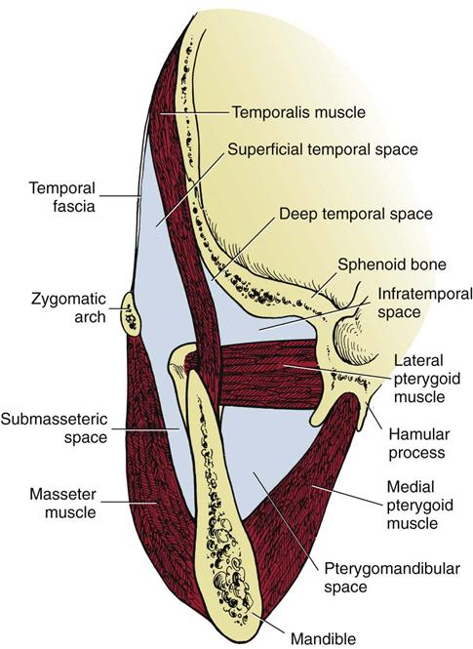
1.primary spaces: spaces that are first involved in odontogenic infection ; submandibular , submental, sublingual ,canine ,buccal , infratemporal, and tempromaxillary.
2.secondary spaces:
a.masticator spaces : group of spaces surrounded by the masticator muscles, these spaces are connected to each other so infection can spread from one space to other, they are divided into:
1.submasseteric space abscess: between the masseter and ramus of mandible (submasseter on the way) the infection usually spread to it from the buccal space or infection of lower 3rd molar which can improve as submandibular space or directly go to submasseteric space.
The pt comes with tender swelling on the angle over the ramus of mandible and trismus.
2.pterygomandibular space: the same space we give ID in(between medial ptereygoid and ramus).
One of the reasons when the needle we use in ID not clean or not sterile .
-it is considered as 2ndry space because the infection spread to it from submandibular and sublingual space.
-the pt come without extraoral swelling (this is a tricky thing) but in pain ,with severe trismus and difficulty in swallowing.
3.+4.superficial and deep temporal space infection : the swelling usually high in place superior to the zygomatic arch and they are rarely involved in odontogenic infections.
-the pt come with swelling limited by outline of temporalis fascia,trismus,severe pain(superficial temporal)
Less swelling,trismus,difficult to diagnose (deep temporal).
b.cervical spaces: its uncommon yet its more dangerous and life threatening infection, they are divided into:
1.lateral pharyngeal.
2.retropharyngeal.
3.prevertbral space.
When we look to the pt throat we can see posterior wall of pharynx,retropharyngeal,prevetebral space and at the sides lateral pharyngeal SO any swelling in these spaces cause obstruction of the airways and that’s why they are dangerous facial swellings.

1.lateral pharyngeal space:
inverted cone or pyramid in shape ,the base at sphenoid bone and the apex on hyoid bone, has two compartment: anterior muscular and posterior vascular comartments.
Anterior compartment: fat,muscle,lymph nodes and connective tissue.
Posterior compartment: carotid sheath (carotid artery,internal jugular vein,vagus nerve),cranial nerves IX-XII.
-the pt come with trismus,induration, swelling at the angle of jaw, fever, pharyngeal bulging (not symmetrical when we look by arthroscope),thrombosis of internal jugular vein due to swelling and pressure on it which irritate it and may cause perforation and go to retropharyngeal space.
-infection of lateral pharyngeal space can come from pterygomandibular space (2ndry space).
2.retropharyngeal space :
posteromedial to lateral pharyngeal space and anterior to the prevertebral space . between serratus sup. Post. muscle and alar fascia .
-Further information from the net-------
Borders of the retroph.space:
Ant.:post.pharyngeal wall.
Post.: prevetebral fascia.
Sup.:skull base.
Inf.:mediastinum.
Lat.:lat.pharynopharyngeal space .
-pharyngeal space is a potential space the infection in it spread to post.sup. compartment of the mediastinum (heart) and eventually can cause acute mediastinitis after spread to the danger space.
-the pt come with neck stiffness,dyspnea,dysphagia,bulging of post. Pharyngeal wall.
3.prevetebral space: is even more dangerous potential space between two layers of prevetebral fascia(alar and prevetebral layers) located in the bottom of chest cavity .
So it can also cause mediastinitis as retropharyngeal space.
#1,2,3 infection spread to these spaces from 2ndry spaces (ptyregomandibular space specifically).
#the significance of facial spaces infection is that they may end up with cervical spaces infection.

Clinical and surgical management

When a pt come with primary or 2ndry space infection we need to keep an eye on the retroprogression to specify the severity of the condition.
Q.what are things I worry about and need to be handled as an emergency situations or need a hospital admission?
A.1.when a pt come with trismus : limitation of mouth opening.
2.dyspnea:difficulty in breathing,breathlessness.
3.presence of draining sinus,fistula.
There are many other clinical features like rubor (redness),tumor, calor(heat),pain, lymphadenopathy , fever …etc.
Q.what investigations needed for pt with facial swelling?
A.1-hitory taking and clinical examination like asking the pt when it started.
2-routine and special lab investigation .
3-radiological examination :OPG,ant.post.and lateral view of neck,ultrasound,CT scan…etc.
#airway obstruction caused by swelling can be partial or complete…complete obstruction is difficult to be handled and named emergent airway management.
The most important thing in management of odontogenic infection is to secure (protect) airway by (oral intubation or nasal intubation) and whatever complicate the procedure ; bleeding ,swelling ..etc the airway is secured and because of its importance the first thing that need to be checked by an anesthesiologist ,in cases the pt come to emergency with cervical swelling is if he can insert a tube to help in breathing or not.
In some cases when there is a threat of rubturing a swelling or if it was tender we have to think in surgical approach like: tracheostomy (mostly) or cricothyroidectomy. Tracheostomy is an incision done in certain anatomical land marks between cricoid and thyroid and then obliteration of trachea and a tube is placed in the hole.
-in cases of partial airway obstruction the pt come to clinic breathing but with sounds or when he sit he trys to sit in high position or holding the neck straight while setting (changing position to be comfortable), this pt need to be referred for further investigation .
The respiratory rate is fast and the pt is gasping for air.However, sometimes the respiratory rate can be less than normal and the patient is barely breathing.
We can use the pulse oximeter which is a device that measures the oxygen saturation in the blood by putting it in the patient’s finger, values below 60mm Hg indicates that the hemoglobin is not saturated and the pt has hypoxia.
There is certain cases that we do stats test which are:
1.pnemonia
2.cardiac disease (heart failure )

*Management of patients with facial spaces infection:
- The medical support is very important, and the host defense is important as well. For example if the pt is a poorly controlled diabetic and his blood sugar is 350 there’s no way to relief the symptoms no matter what you do,firstly, we need to control his blood sugar.
The medical support includes three major things:
- To rehydrate>> by giving the pt I.V fluids because these pt’s usually dehydrated.
- To look after their nutrition >> because infection is a highly catabolic phase and this will cause depletion of the body sources.
- To resuscitate the pt by antipyretic to give the body a chance to recover.

- Antibiotics
- Surgery, it’s extremely important to remove the cause .. in the pre-antibiotic era they used to remove the cause surgically i.e incision and drainage without antibiotic cover-some people die from this procedure-.

*its very important to know when to refer … any case you don’t feel comfortable with like for example a pt difficulty in breath , difficulty in swallowing , trismus , any swelling that extends beyond alveolar process , pt who
is severely malaise and toxic or with high temperature (more than 38 c) , compromised pts , if you tried to treat
but the treatment fail , in these cases u have to refer them either to maxillofacial specialist or to the ER.

*we decide to admet the pt to hospital when he is: pyrexy , dehydrated, air way risk, need general anesthetic, systematically compromised.

-elderly pt sometimes they are not on the same physiologic state as young people , so the come with mild fever (38.3 or 38.4) DON’T underestimate this mild increment in the temperature.
The body increases it’s temperature to facilitate the phagocytosis .However, this has drawbacks as we said the catabolism will deplete the sources , and it cause dehydration.

-so we give hydration, nutritional support, and sometimes if the pt is diabetic then there will be electrolyte imbalance so the first thing we do is to stabilize his condition , and we put him in a high protein diet.
But if he is airy compromised then the most important thing to do is to secure the airways.
Its very important to know if the pt is on steroids ,or if he is diabetic , he had a renal transplantation , has a malignancy , or if he is immunocompromised .. etc.
Now after that we start thinking about antibiotics, if we want to give the pt antibiotic and we don’t have a culture test, then what we do is that we give him a broad spectrum antibiotic coverage in order to target aerobes and anaerobes as well so we start by giving him penicillin (amoxicillin is the best) and metronidazole, amoclan if we want to cover beta lactamase producing bacteria, then we give flagyl.

If the pt is allergic to penicillin then give clindamycin , if the case is really complicated and there is cervical space involvement then you have to start a more sophisticated treatment by giving the pt vancomycin and flagyl depending on the hospital protocols for treating severe infections.
Usually we give I.V antibiotics for a rapid action.

When you are NOT supposed to give antibiotics ?
If the pt is in severe pain without infection, dry socket, in periapical abbesses because anti biotics are not effective you need to remove the cause first inorder to induce healing by either RCT or extract the offending tooth.

When the pt is supposed to inter the operating room??
If more than one facial spaces are involved, if the air ways are compromised , if we want to remove an impacted third molar without GA.

Now inside the OR the surgical treatment is about two things that are need to be done , the first thing is removing the cause .. if a tooth caused a facial space infection then get rid of it don’t think about RCT , we do a RCT for abbesses and periapical lesions but not when it involve the facial space.
The second is drainage , and you have to be very generous with your incisions .
You need to evacuate and make big incisions then use your fingers to induce bleeding.

The aim of the incisional drainage is to allow the oxygen to inter the site of infection, and increase the blood supply to that area and that’s mean the antibiotics now can reach to that area , it decreases the load of bacteria by getting rid of the puss or any exudate , reducing the hydrostatic pressure that compressing the tissues aganest the air ways (if it was close to it).
Its not necessary to see puss coming out , but that doesn’t mean if we don’t have puss we don’t do incision.

Facial spaces are surrounded by fascia and it lack blood supply, so its very difficult for the body to get rid of the infection by its own, its very difficult for the antibiotics to reach the area and start its action, the bacteria inside the exudate will proliferate and increase its number and that will cause a new source of infection and from there we can see the importance of the incision and drainage.

If the infection involves temporal spaces then do an incision in the temporalis muscle and use your fingers
To allow the puss to come out and put the mosquito in the space then you need a drainage to prevent the incision from healing for the next 24 hour, and that’s by cutting a finger from the surgical gloves and put it inside then you stitch it.

For the submasseteric space involvement the incision is done in the angle of the mandible I go through skin, platysma , cervical fascia , and I go in, from there I can reach the sublingual space and we go to the medial aspect of the border
-Be cautious of the facial artery – then we insert a drain we might use more than one drain.

For submasseteric and lateropharyngeal spaces incision see the figures below: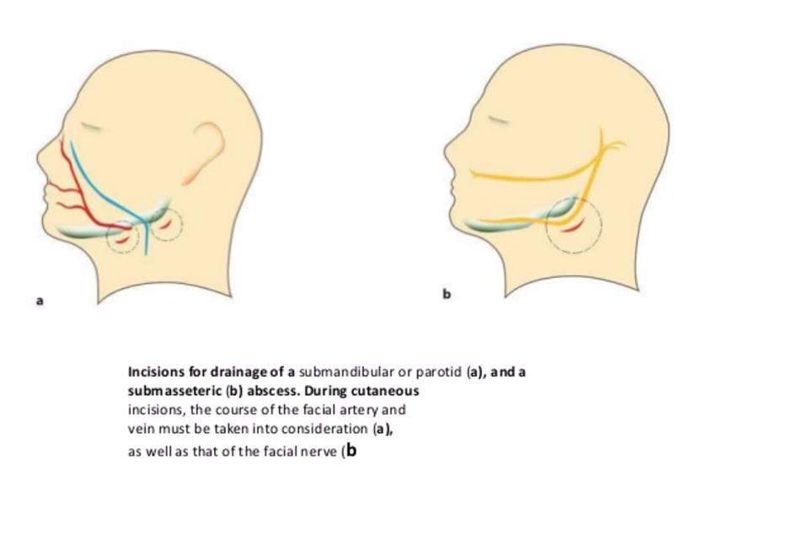
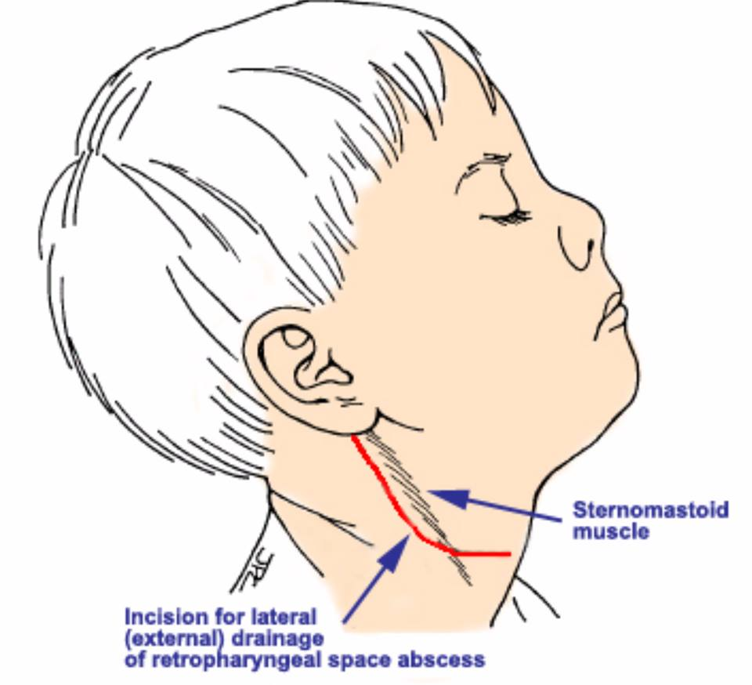

Now whenever fluids come out take a swap for the culture test just in case if it was a weird bug becaouse the pt is immunocompromised or something , not for sensitivity test to select antibiotic treatment.
And then we evaluate the pt, we follow up and make sure that his temperature gets back to normal, if the pt didn’t get better in the next 48 hours then you know that you missed an infected space , and it happens.

One of the famous scenarios that we are going to be asked about in exams is ludwing’s angina it used to be a very
Fatal , as you know the temporomandibular spaces are connected to each other , sublingual and sub mandibular
spaces as well, in ludwings angina the two sub lingual and two submandibular spaces will be affected, so the floor of the mouth will be raised and the tongue become raised against the palate , and this will suffocate the pt and cause trismus to him, the treatment is by incision and drainage but here we will need multiple incisions (btshatteb lmareed)
and in the most cases there will be no puss coming out because it’s celluitec but we have to make incisions to remove the cause .

best wishes...

