Sheet no. : 3
Written by: Ayyan Abu Hawash
Corrected by: Eathar Usama
Surgical Instruments
To start performing surgical procedures you should have a good knowledge of all surgical instruments.
The first instrument that surgeons usually use is the BLADE.
We also have blade handle or scalpel handle.
-Scalpel is the blade itself so don’t confuse it with the handle.
You should handle your blade carefully by which you incise the tissues.
The blade handle has many designs:
1) ruler like handle 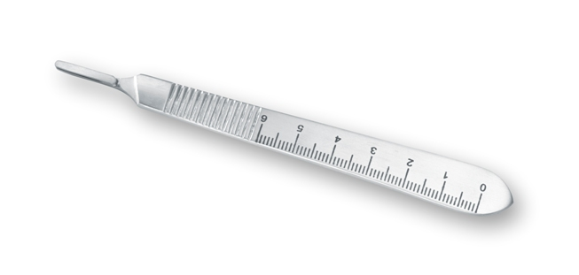
2) pin grip (cylindrical)
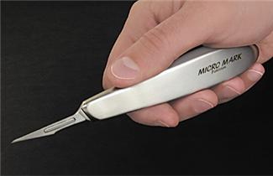
It is also of many types material wise, delicate, soft etc. which make a difference for a skillful surgeon.
-what do we benefit from the ruler like handle?
It helps us in some measurements while performing surgeries, for example osteoctomy (a major operation where we cut the maxilla & elevate it by few millimeters to get rid of gummy smile) here we need to know how many millimeters, we usually have those measurements pre-calculated but we can benefit from this ruler during surgery.
BLADES :
- SIZE 15 BLADE
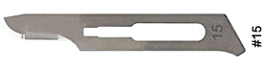
It is the most common blade used in the oral cavity.

- Size 10 blade
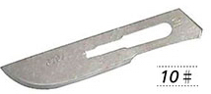
looks like size 15 but slightly larger which is used extra orally (on the skin)

- SIZE 11 BLADE
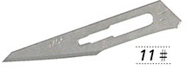
used for stabbing when we have collections or abscess, we need to open it this way.
- SIZE 12 BLADE
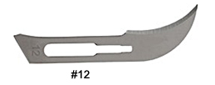
It has a curve for inaccessible areas ,for ex. Palate.

Instruments :
1) MUCOPERIOSTEAL ALEVATOR (FRYER)
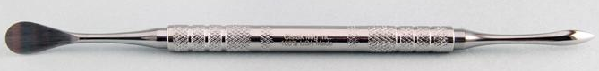
It has two ends ,one round end that has convex & concave surfaces. The other end is more or less triangular.
It raises the mucoperiostium up , when I make an incision I need to raise flap up.
Convex part(which is delicate) is usually toward the periostum to protect it as you know periostum is the source of blood supply.
The flap should be intact so it won’t get necrotic.
The other end which is more or less triangular is used to raise up the interdental papli gently specially in the anterior area where aesthetics is of a major concern.
it also has many designs.
2) RETRACTOR
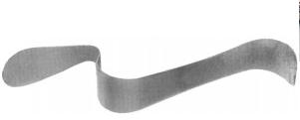
Retractor has many designs: cheek retractor if we have a bulky cheek, flap retractor & tongue retractor that is malleable.
In the principles of surgery, we have to respect all the surrounding tissues that’s why we may need retractors.
Tongue retractor looks heavy because the tongue itself is a heavy muscular structure.
Instruments do make a difference in surgery, for a successful operation we need:
1) Skillful surgeon
2) Good planning
3) Good prepared instruments
-we can use the mucoperiosteal elevator as a retractor, especially if we have a small flap for gentle retraction.
3) FORCEPS
You should distinguish toothed from non-toothed forceps.
We use tooth forceps for suturing so we can hold the needle.
4) TWEEZERS
The final step in tooth delivery after luxation is done by tweezers or a mosquito.
We use it to hold the tooth firmly so the patient doesn’t swallow it; if the patient did the following might happen:
- It may go in most cases to the stomach & get excreted by the normal digestive pathway.
- It may go to the airway & suffocate the patient, ultimately causes death or it may go to the lung & causes foreign body reaction ultimately lung abscess.
-if a patient does swallow his tooth, we take two perpendicular radiographs to make proper tooth locating.
If it’s proven that it’s in the lung, we refer the patient to do endoscopy.

5) CLIPS
Used in major surgeries when we towel the patient for getting a sterilized field, we clip the towels with it.
The correct handling clip is when you have 3 points control.
In major surgeries we use sterilized towels to cover the patient up.

6) BONE CUTTER (ROUNGEUR)
The middle part of it makes a special sound.
It’s used to cut the excess bone,when you perform multiple extractions sometimes the interseptal part is still there ,you need to cut it.
We have two sides cutter roungeur & one side cutter roungeur.
-For bone removal ,we can use hummer & chisel or a roungeur.
You should be extremely careful when cutting with the hummer not to cause bone fracture.
-Maxillofacial surgeons use the roungeur to do what’s so-called planned fracture/surgery for the mandible where we advance or set back the mandible.
-it’s preferred to use hummer &chisel under general anesthesia.
-we have different sizes of the chisels.
7) BONE FILE
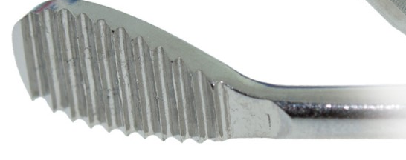
Bone file trims the bone or smoothens it.
-the most common method of bone removal is the HANDPIECE That has a specific torque & force to drill bone & have a calculated speed measured by rounds per minute (round & straight burs) that have many different sizes.
So we remove bone with rotary instruments with continuous irrigation whether internally or by the help of an assistant.
-you should not overheat the bone to above 47˚C, or you’ll end up with bone necrosis.
8) CURETTE
In many cases, tooth has a periapical granoluma or lesion so we need to do curettage.
You have to know how to perform it so you don’t cut through the sinus if in maxilla or through ID canal if in mandible.
-cysts have different management.

9) NEEDLE HOLDER
-you have to differentiate between it, mosquito & artery forceps because they have the same outer shape.
-needle holder working end is short
-artery forceps working end is long
-If we look at the differences cross-sectionally, we’ll find:
-needle holder has a criss-cross pattern so it holds firmly on to the needle.
-artery forceps has one type of striation so it clips the artery when we need to control bleeding.
-we have different types of sutures(resorbable & non-resorbable) & needles (cutting & non-cutting) that have different ways of handling.
- facial wounds suturing is kind of an art.
10)MOUTH GAG
in cases of limited mouth opening or if I need an access to the mouth cavity in surgeries to open the mouth from one side & it has a stopper at the other side.
11)CRYER’S ELEVATOR
Most common elevator is the straight elevator then we have cryer’s elevator that has a triangular working end.
-it has different designs with hand-grip or without.
-cryer indications:
1)when I have remaining roots of lower 6 teeth
2)having a lower wisdom tooth with an apparent bifurcation that I can see (the only case where I can rest on the external oblique ridge)
-we usually cant rest on bone but here the external oblique ridge is a heavy bone so I can rest the convex part on it where by the triangular end will engage the bifurcation to extract the tooth.
12) STRAGHIT ELEVATOR
It’s an extremely useful instrument.
1) Detachment of the gum around the tooth.
2) Luxation
3) Extraction of remaining roots
it is useful but also dangerous if no good support used that it may slip and cause penetrating wounds.
-bleeding in the oral cavity is profuse so be careful & use a good support when using elevators.
-concavity in any elevator is usually toward the teeth, it should engage the tooth.

13) FORCEPS
we have two types of forcepses for the maxilla & mandible.
-mandible forceps have an angle at its hinge.
-maxillary forceps have no angle.
-peaks should rest on the CEJ, you hold it very well then start the movements buccally palataly & more labially because palatal bone is thicker so we usually move more towards the less resistant area.
-notch of the forceps should engage the bifurcation area.
-in upper teeth, notch located buccally. So we determine right or left according to that.
-we have a forceps for every tooth but surgery is feasible so in general use the proper instrument for its proper use.
-if we’re extracting a lower anterior teeth ,body 7 working end is straight while premolars have curve so forceps are expected to have a bend.
-if peaks are closed then it a remaining root forceps, if bent then it’s for lower 4.

*Bayonet forceps is especially for upper wisdoms
*Warwick James’ is a specially designed elevator for upper wisdoms

-Slides have the instruments that you should have a good knowledge about.

