Oral surgery
Lecture #4 ,refer to slide number 4
Written by : JUMANA DALBAH
Principles of exodontia
Developing communication skills with your patient is something very important in dental practice .. patients mainly come to your clinic terrified and afraid even if they are doing simple endodontic or other dental treatment so what about doing teeth extraction ? so here comes your role in the management and control of the patient’s anxiety and pain through the development of good and extra communication skills with ur patient to make him feel comfortable and less afraid . so we as a dentist should all improve our skills !
Note : Due to the plenty of materials that we’re dealing with as a dentists it’s recommended to know what is the material we are using and what’s the purpose of using it as well as checking it’s expiry date specially when using local anesthetic products !
Extra note : to anaesthetize the teeth in the maxilla we mainly give infiltration ,and nerve block is been given most of the cases to anesthetize structures within the mandible and infiltration to anesthetize the teeth in the anterior region !
After dealing with the patients anxiety it’s time to achieve the proper use of local anesthetic for your patient .. notice that local anesthetic giving for endodontic and other dental treatments such as cavity preparation and fillings is not the same as when applying anesthesia for oral surgical operations such as tooth extraction; in endodontic treatment buccal infiltration might be sufficient to anaesthetize the patient’s tooth ,whereas when we want to extract any tooth the whole surrounding tissue and structures must be well anesthetized ( from the buccal and the lingual / palatal side ).ex: the lingual and long buccal nerves and the whole surrounding structures should be numbed when extracting a tooth in the lower quadrant for example .
# There are many indications and contraindications regarding tooth removal ,contraindication could be due to systemic factors or local factors .
Systemic factors :
Remember to take a good thorough medical history of the patient ,know the major contraindications that limit your surgical procedures and not to miss anything because this may not only threat the life of the patient put also yours and put you in a big trouble as well !
One of the systemic contraindications that limit the local anesthetic procedure as well as the exodontias is to have a severe uncontrolled metabolic disease such as :
- uncontrolled diabetes : these patients will have limited and inappropriate healing as well as the higher tendency to establish infections …
Many diabetic patients came to our clinic weren’t treated well by their GPs and Dentists ended up in the emergency room gasping their last breath and eventually they died due to severe infections and uncontrolled diabetic levels (dentist or GPs fault in dealing with such patients), so be careful when dealing with a diabetic patient specially when giving anesthesia or do extraction or other surgical operation .
So what should be done when facing a patient with diabetes is to make sure that his/her diabetes is CONTROLLED by measuring the fasting blood sugar and controlled blood sugar ‘?’
- patients with end stage renal disease : usually those patients undergo dialysis so we as a general beginner practitioners should not be working on such patients ;they need special care and way of management and should be treated in special clinics !
- uncontrolled leukemias and lymphomas .
- uncontrolled cardiac and other ischemic heart diseases , so patients with such diseases must be treated in specialty clinics .
- bleeding problems : patients with bleeding problems and taking medications such as WARFARIN to control their bleeding problems should not be treated by us as a GPs in the surgery clinics instead they should be referred to special clinics where there is experienced drs ,check their INR , have proper consultation and do something that is called bridging which will be discussed later in more details ..
- Extra note : warfarin is an anticoagulant (blood thinner). It reduces the formation of blood clots ,it is used to the prevent heart attacks, strokes, and blood clots in veins and arteries.
Note : patients with prosthetic heart valve should be managed in a certain manner :
-if he/she want to do surgical procedure (for example extraction of his tooth ):the patient should enter the hospital before the surgical procedure in about one week .
-the situation will be different if the same patient want to undergo an endodontic treatment for example ..here he/she should be given prophylactic antibiotic to protect him/her before the procedure starts .
- Note : there is a difference in between a patient with a prosthetic valve and stent(شبكات قلب (;prosthetic valve is big story where as there is no problem of proceeding an endo treatment for a patient with a stent as the universal guide lines have implied but at least this patient should be given prophylactic antibiotic .
- Note :if the patient is under warfarin medications bleeding is what we are afraid of mainly so if the endodontic treatment is confined to the apex of the root as it should be then worries shouldn’t be taken into consideration (even if the endo treatment was a little bit beyond the apex it is not a big deal) but try always to ask your supervisor what is the best to do …where as this drug limits our SURGICAL PROCEDURE and special care as we said above must be given to the patient !
- Note : we should avoid working on a pregnant lady .. but if the circumstances have forced us to apply a treatment on her it’s important to get an approval from her doctor and to work during the second trimester (4th,5th,6th ) months .
- steroids : we can apply surgical procedure on a patient with steroidal consumption but he/she should be given prophylactic dose ; he should be given double or triple the dose before the extraction procedure.
- even if the patient consume a minimum dose of steroids and has a very simple mobile tooth for extraction this procedure mustn’t proceed unless if he was given a prophylactic dose(of steroids) !
- patients who has been on steroidal drugs due to insufficiency of their steroidal levels will raise this level by external supplements ,until reaching a point where inhibition of the endogenous pathway will occur ..
So why should they be given a steroidal supplement before a surgical procedure ?
>>the surgical procedure put the patient under stressful condition ..so the adrenal gland of the patient will try to secrete and excrete endogenous steroids but this endogenous pathway has been inhibited in patients who has been taken exogenous supplements of steroids .. so if there wasn’t a prophylactic dose of steroids given to the patient he will drop and end up into something called adrenal(or steroid) crisis ..
Conclusion : giving him this dose is important before any surgical or stressful condition to compensate the endogenous inability of the excretion of steroids that has been developed since they have been on these drugs !
The amount of this steroidal supplement when giving a patient the prophylactic dose depends on the type of the procedure to be taken (one tooth isn’t as stressful as in the case of working on four teeth nor as applying surgery ,,thus more steroidal supplement must be given in the more stressful conditions ) and also depending on the amount of steroids he/she has been taken so far .
- Pay attention to the difference in between the prophylactic antibiotic and the prophylactic steroids :
>>prophylactic antibiotics are given in certain guidelines such as patients with prosthetic heart valve ,where as the prophylactic steroids as we said above is giving for patient who has been on steroids for certain time and has developed endogenous pathway inhibition so you have to supplement them with it!
- DON’T CONTINUE OR START YOUR SURGICAL PROCEDURE IF THE PATIENT IS ON WARFARIN OR ON IMMUNOSUPRESSIVE DRUGS !
Now what are the LOCAL FACTORS that considered as contraindication for tooth extraction ?
- histrory of radiation :such as a patient who is suffering from cancer and takes radiation this should not be undergo tooth extraction otherwise he will be subjected to necrosis !
- teeth in the area of the tumor :even if the patient has a mobile tooth in the area of the tumor extraction procedure must be stopped to avoid dissemination of the cells while doing the tooth removal.
- pericoronitis around an impacted mandibular molar : pericoronitis is an indication of an active infection around the tooth that is going on so avoid doing extraction; instead the patient should be given therapeutic antibiotics (not prophylactic ) and irrigations to eliminate the infection .
- So if a patient came to your clinic with acute stage of infection and has the welling to extract his tooth .. you should wait and avoid extraction .. give him antibiotics and drugs to eliminate the infection ..then apply your extraction procedure later on !
BEFORE you do extraction you should evaluate the tooth that you are going to work on and if this case of exodontias suit you as a beginner or not to know whether to start or to refer it to a more experienced practitioners ;
1-so for example we should have a good access to the tooth we want to extract and the patient’s mouth opening shouldn’t be limited …those patients with a very minimal mouth opening (less than 1 cm for example ) have a special way of management and there surgical procedure is done under sedation ..so avoid bringing such cases ..and also avoid bringing cheeky patients because you will face difficulty in the retraction of their cheeks and tissues as well as getting a good access to the tooth .. so in general bring people who has a proper and wide opening for the ease of work !
2- mobility of tooth: try to bring a patient with a mobile teeth to have an easier extraction.. so if you bring a patient with a periodontal disease this will be something for your own good .
3-the condition of the crown : if the crown of the tooth you want to extract has large caries and amalgam restorations on it avoid its extraction because it might break with you and harden the extraction procedure so save this cases for the 5th year and try to start with a more easier extractions.
4-scaling is better to be done before extraction so that the load of bacteria and the microbes on the teeth will be reduced and prevent the patient from acquiring a post operative infections such as the dry socket .. so what is right is to do scaling before extraction to protect the patient, but unfortunately this is something we don’t do strictly in our faculty .
5-try to avoid extraction of wisdom teeth at this stage , save these extractions for the 5th year !
6-retained deciduous teeth are not easy cases for extraction .
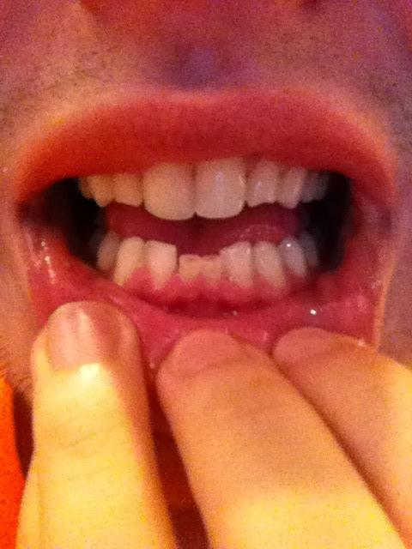retained deciduous central lower incisors in an adult ..and these cases are hard to apply exodontias to !
RADIOGRAPHIC evaluation of teeth :
It’s something mandatory to have radiographs for the teeth of your interest , and by these radiographs certain things should be evaluated in order to give you a hint whether to start with the extraction of the tooth or not ..
- So it’s a must to have radiographs before you apply the work !!
You should evaluate certain things in the radiograph you have already taken such as :
- The configuration of the roots : the root might have dilacerations or curvatures that you have noticed due to the radiographs ..in this way you will prepare yourself to apply a certain extraction technique that suits these conditions .. these findings you will not be aware of in the case of not taking radiographs.
- Condition of the surrounding bone :whether there is resorption or not, presence of ankylosis ,and pathological features such as the presence of granulomas ,cysts,infections ..etc .
- So you should evaluate your radiographical findings and correlate them with the ease of the surgical procedure ; for example if the tooth you want to extract showing a denser than normal bone around the root this is an indication that it’s removal wont be as easy as a tooth with a surrounding radiolucent areas and a widening in the PDL space …and then according to these radiographs you should be smart enough to decide whether or not to proceed and what’s the specific technique to be used with the procedure !
- The condition of the crown : in the case of big restorations or large carious lesions ,as well as root caries there is a high susceptibility of causing fracture of the tooth while doing the extraction .. so such cases needs surgical extraction not a simple exodontias and it’s better to avoid them and save them to the next year !
- So avoid extraction teeth with big fillings or restorations and root caries that might extend the CEJ because the tooth might fracture .
- Notice the bifurcation of the multi rooted tooth ..assist whether it’s an easy case to work on or not ,and the technique and the special way of management in the removal of the roots according to the radiographs .
-in the case of a tooth with dilacerations, radiographs give you an idea of what to do .. you should open a flap and remove the tooth surgically ..but if you didn’t take a radiograph you will apply the extraction procedure as if the tooth is normal thus leading to fracture of the tooth and extract the crown and part of the root where the other part is still impacted .. so you will need a further surgical extraction of this remaining fractured root ..wasting the time of both the patient and you .. so radiographs give you an idea of what to do !
-in case of ankylosis we should open a surgical flap and in order to gain an access to the root then you decide :
#either we remove the excess bone around the tooth and we extract it .
#or in the case we don’t want to remove bone we do create something that is called trough ( (نفق,or we create a hole or a window around the root and then extract it !
-isolated teeth specially in the maxilla are not easy to extract ( not as we expect )
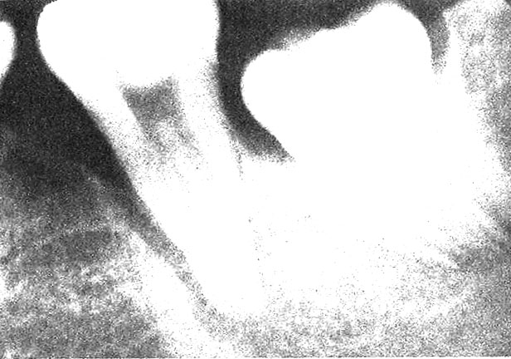this picture shows increase density of bone around the tooth thus it’s difficult to extract, where as the 2nd tooth there is a widening in the PDL space thus easier to extract .
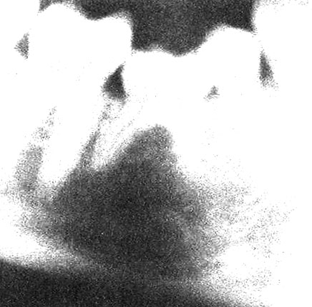this pic shows retained deciduous teeth ,which is hard to extract ,remember to notice any radiolucency or any pathological feature around the root .
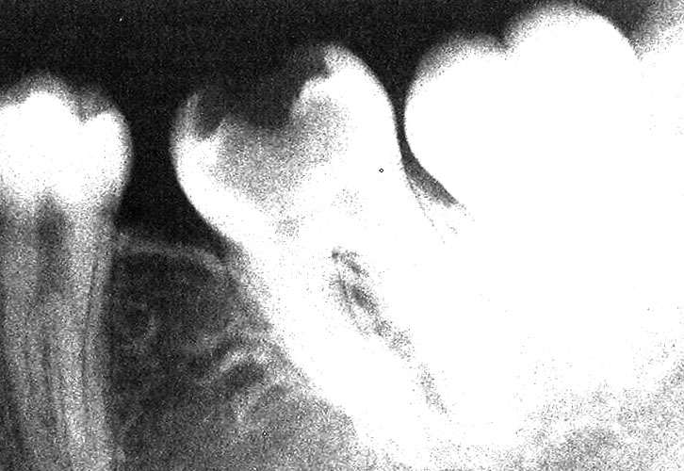this pic shows large carious cavity ,so as soon as I place the forceps on the tooth this will lead to its fracture ,so you better not to work on it at this year save it to the 5th year requirements.
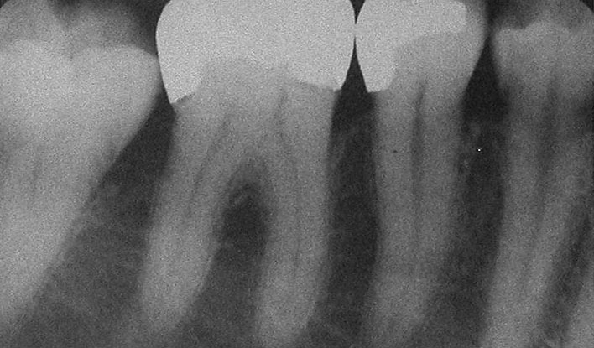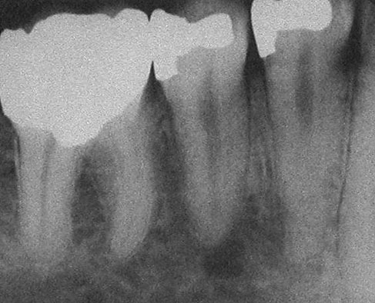 large restorations on the teeth thus you better not to extract such teeth ..and do surgical extraction later next year !
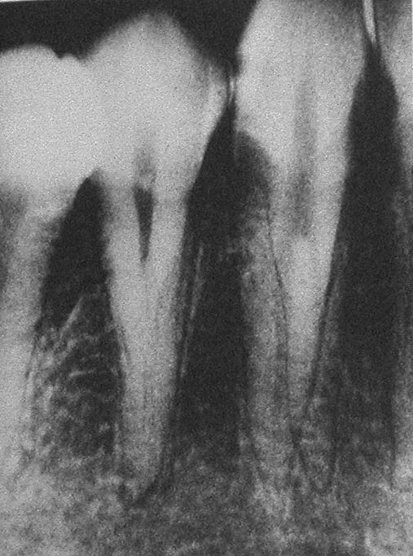root caries below the CEJ .(tooth might fracture ;so avoid doing such case this year )
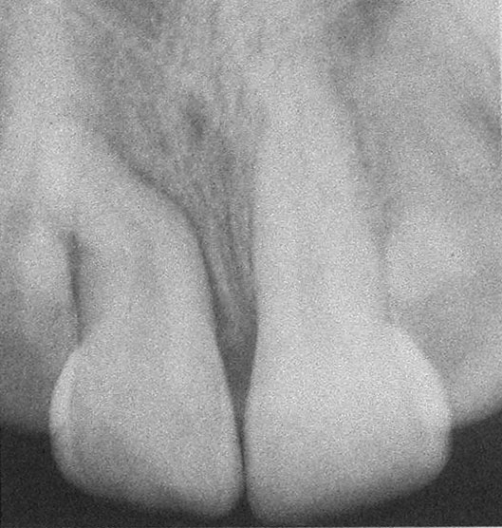dilaceration on the tooth.
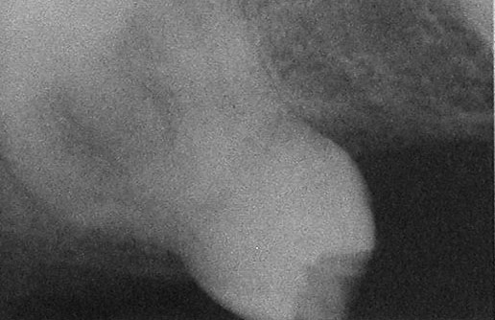this pic show an isolated maxillary 3rd molar ,represents a difficult case to apply extraction on ..and it’s difficulty is due to two points :
1st :due to the bone surrounding the tooth (bone support ).
2nd :due to the presence of sinus which get larger when teeth are lost for a long time ,
- So this a case to be avoided to work on because the teeth and the alveolus might fracture when applying the extraction force using a forceps,and the maxillary sinus might be included and and perforated while applying the forces causing oroantral communication .
(in general any isolated tooth is difficult to extract specially if it was in the maxilla )
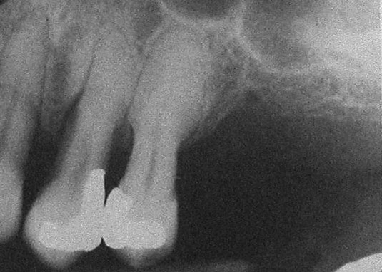 this pic shows hyper cementosis ,thus the tooth will get fractured from the half when you try to extract it , always pay attention to patients with behcet disease ,when the bone density increases and thus affecting the way of extraction .

- When applying extraction respecting the whole surrounding structures and tissues is something essential and mandatory ,examples on such an important vital structures that you should pay attention not to cause any damage to are :
- Maxillay sinus : don’t you ever push a root toward a sinus ,if this happened you and the patient will end up in a big problem that most probably will need operational (surgical ) intervention .. so the patient will come with a simple extraction case and end up with a surgical operation !
- Inferior alveolar canal :don’t you ever use an elevator and force it deep to the socket ,other wise you’ll cause injury to the canal ..the patient will experience numbness that was absent just before before the extraction, and you might cause any of the different types of nerve injury that will be discussed later (paresthesia, dysesthesia ,anesthesia ) .
- Closed versus surgical extraction : closed extraction >>using a forceps without any surgical intervention (the extraction we do now in the surgical clinics ),,,where as surgical extraction >>here you need to open a flap and apply surgical extraction of the tooth under a supervisor , and later on when you open your own clinic and faced such cases you are not a professional at you can refer the case to maxillofacial or oral surgeon !
- so as a conclusion :you should always be on the safe side ,so don’t you ever do anything you don’t know how to apply it or not sure that you are good at !
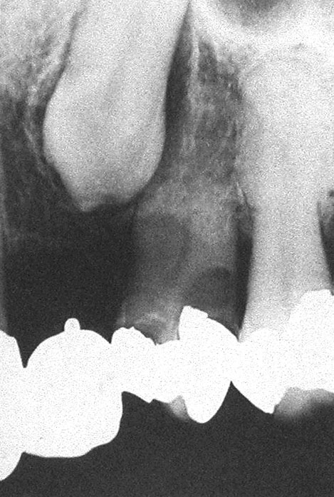here the pic shows an impacted tooth which can be removed surgically .
Notice the tooth the big restoration and internal resorption in the root here the tooth will get fractured if we apply simple extraction using a forceps !
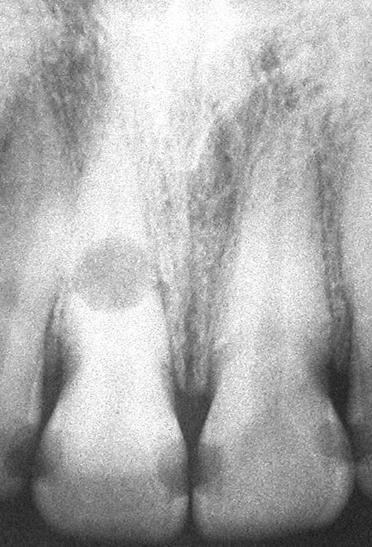 Internal resorption .

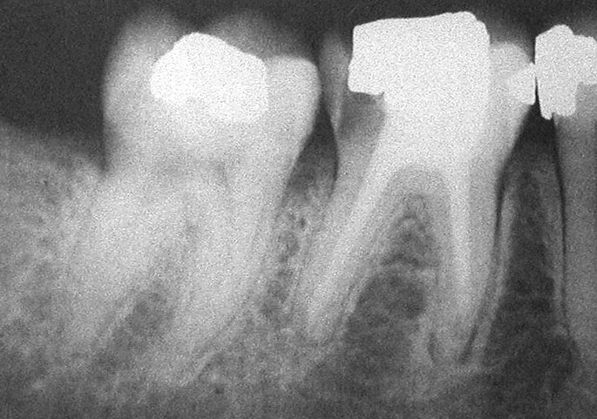 endo treated tooth it’s better if we do surgical extraction to remove it because the root will be brittle and upon extraction the root will be extracted chip by chip and still not fully extracted and this will lead to surgical approach either you do root separation or you open a whole flap and remove it .

- during the tooth extraction both the patient’s and your position must be appropriate and right .. so when the desired tooth to be extracted is in the maxilla the chair(maxilla) reclination should be 60 degrees to the floor ,where as in the mandible more up right position is recommended and the occlusal plane should be parallel to the floor .
- you can lower the level of the chair when extraction a tooth within the mandible !
- ladies should tighten their hair while applying the extraction ,goggles and masks are mandatory ,firm support is essential !
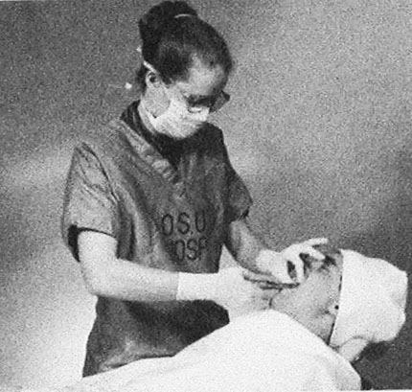what’s wrong about this pic is the position ;the patient’s shoulder must be at the level of your elbow, here in the picture the level of the patient is lower than necessary making the practitioner at higher risk of curving and tilting him/her self’s back during the procedure ..thus these multiple accumulated tilts and curves and wrong positions will lead to a higher risk of developing disc disease !!
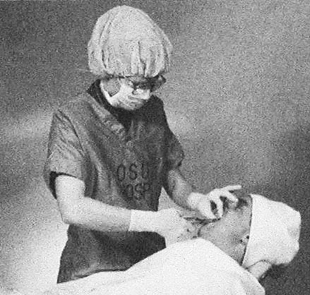here the patient’s position is better ,she also wears a cap!

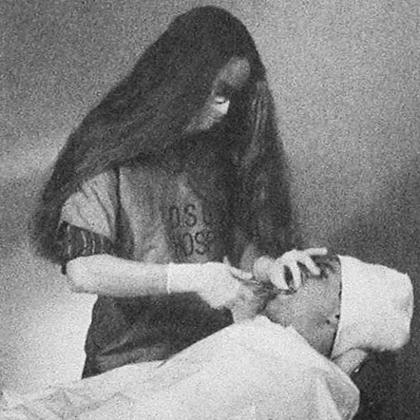notice the hair !
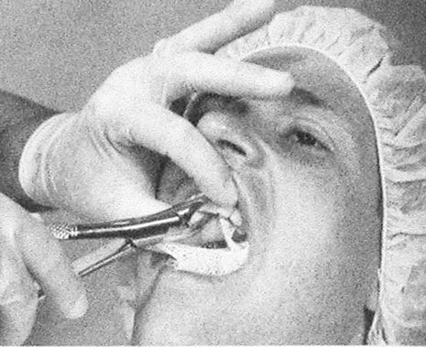here this picture is showing you the right way to apply support while extraction ,many of us find it hard to support during the extraction but it’s something important and with time we’ll get used to it ..
You should know which tooth to be extracted to be able to know what to support whether on the left or right side and according to that you know how to place your fingers (the index and thumb )to deliver the support needed !
- DON’T support the CHEEKS ..many of us retract and support the cheek while applying the extraction and there is no point of doing that , your grasp and support must be directed to the alveolus to maintain and achieve the appropriate support ,then direct your forceps correctly and apply the recommended tooth extraction !
- mechanical principles of extraction :how to use the cryer and the elevator ?elevators and cryers are very useful when you use them in the proper and the appropriate way .
-the elevator is best described using the lever system ,so if you acknowledge the basic and physical principles of the lever system you’ll be able to know when and where to apply the elevator .
-so according to the lever system you are considered the force , and the tooth to be extracted is the resistance , so the arm of force and the arm of resistance should be manipulated in a way to make sure that the force you apply will be controlled and lower (you don’t want to apply and exert too much effort and force ,that’s why this way is considered a smart way of force application )
-so being a muscular is not an indication of a good extraction with less effort and force ;on the other hand other practitioner might be thin but she/he was able to deliver the extracted tooth in a very smart way due to the understanding of the lever system principles ,and the choice of an appropriate fulcrum point that aids and help in a better elevation and delivery of the tooth .

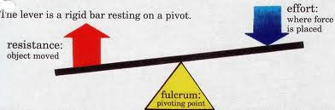extra picture for further understanding !

-wedge action : beaks of the forceps must be directed and placed at the level of CEJ ,or below or above depending on the tooth your working on whether it’s upper or lower tooth ,and what you care about is to achieve bone expansion !
-we care about the bone elasticity because our aim is bone expantion first then the tooth extraction and delievery .
-elasticity and expansion of bone changes upon aging ,thus the younger the patient the easier the extraction .
-so while using the elevator and forceps try to expand the bone in a way your force be gradual and controlled .
-wheel and axle :this type of lever system is seen while applying the cryer in an appropriate way -cryer is triangular in shape .

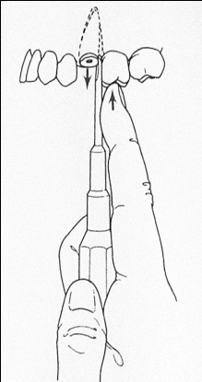this is an appropriate way of handling and positioning the elevator ,so you should support your elevator the same way the pic illustrates ,and you should be careful not to place your elevator toward an adjacent tooth in order not to end up extracting the sound adjacent tooth instead of removing a RR for example .

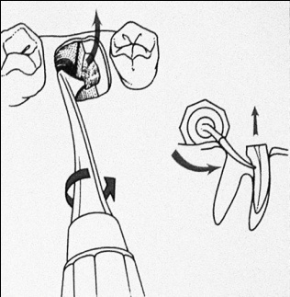this pic shows the way to use and handle the cryer specially on the lower 6 ,here the distal root of the lower 6 has already been removed and the mesial root still needs removal ..so the cryer is placed inside the socket and engages the root in a way similar to that in the picture ..then the remaining mesial root will be removed .
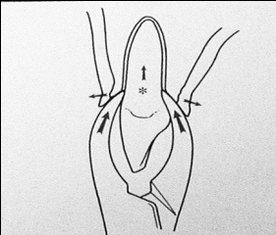this pic illustrates the appropriate way to handle and place the forceps ;don’t engage the forceps to the crown and apply the extraction force cause this might and most probably leads to fracture of the tooth .
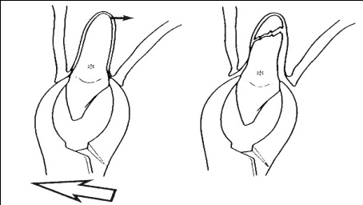
-So if your handling the forceps in the right way and the right position and the tooth fractured this won’t be a problem to your supervisor otherwise tooth fracture will be an indication of inappropriate handling and placing of the forceps .
-when extraction and while handling the forceps make sure you go buccally and lingually several times then do rotational movement(you must feel it ) ..do it several times until the desired tooth is extracted .. always remember to go more and to move the forceps further toward the labial side because the bone is thinner and it’s density is lesser on labial /buccal side .
- so we go labially more than lingually except for the lower wisdom tooth or 7 here we go more toward the lingual side using the forceps because here in this case the labial side is denser due to the presence of the buccal shelf on the buccal side .
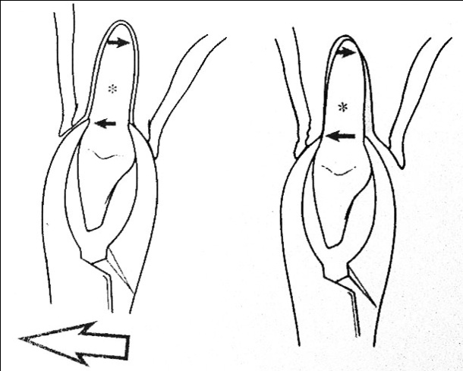
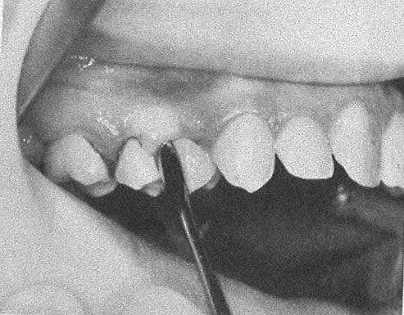the pic shows how to detach the gum or soft tissue around the tooth .
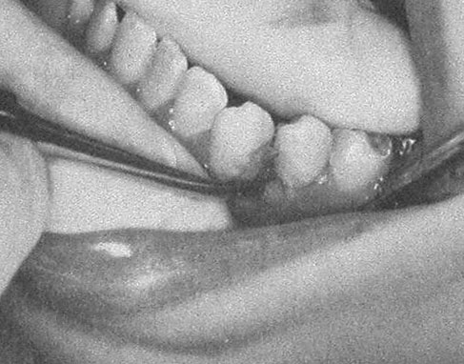 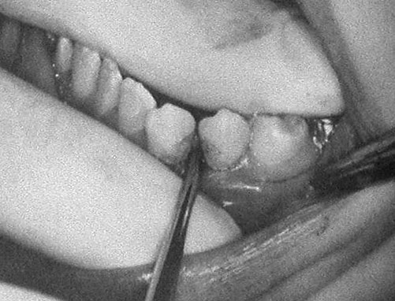These showing how to applicate the elevator wedging action , the mesiobuccal application of the elevator ,then how to remove the tooth .
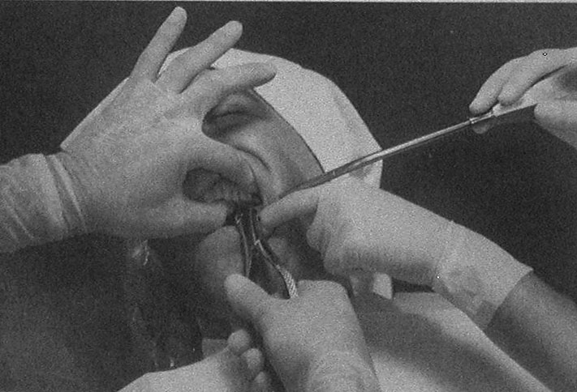 notice the support .. here the pic showing sort of forehanded dentistry which is something is very preferable and helpful and in this way everyone helped will get some knowledge ,and many will help in the retraction ,access and support needed for the procedure which will result in a better easier work.
- ALVEOALR BONE ANATOMY
- - Buccal versus lingual movements
- Give the bone time to expand
- Avoid jerky movements
- SO YOU SHOULD ALWAYS AVOID THE JERKY MOVEMENTS ..SLOW DOWN ..GO BUCCALLY AND LINGUALLY SEVERAL TIMES WHILE GIVING THE BONE ENOUGH TIME TO EXPAND ,REPEAT THE SAME STEPS UNTIL THE TOOTH IS EXTRACTED ..
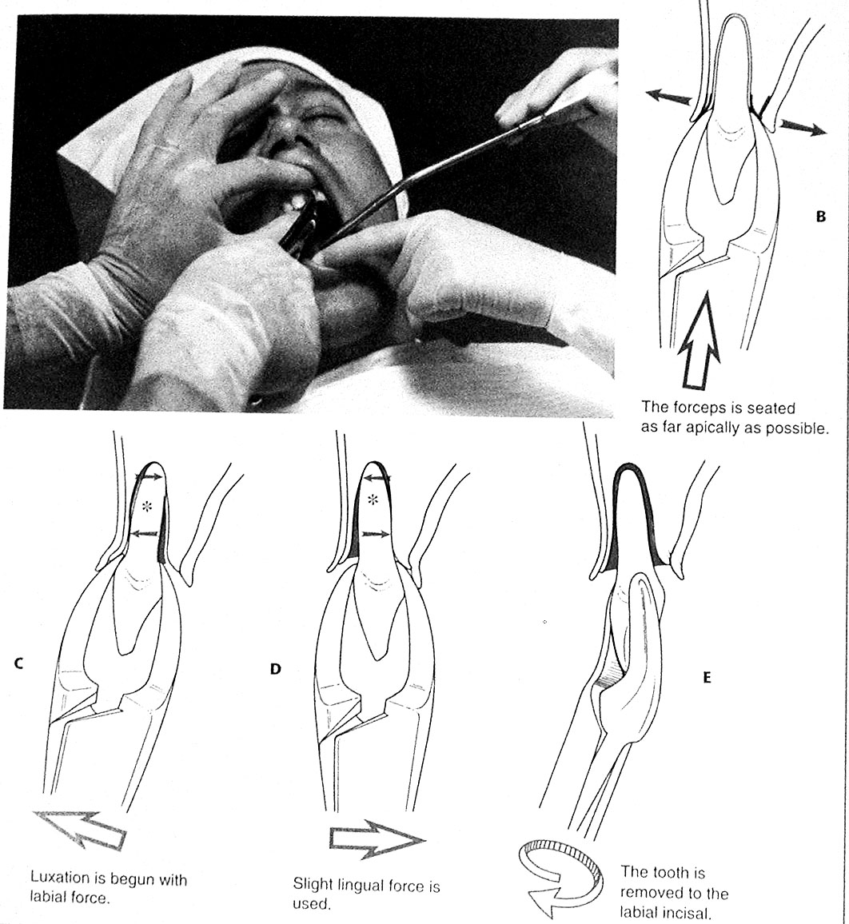Notice the suction ,the support ,the bone movements and finally the last step when the tooth is delivered.

Sorry for being late
GOOD LUCK every one you CAN DO IT !!

