**Surveying**

The paragraphs that are in italic and the images are from our book ; a clinical guide to removable partial denture design .

In the previous lecture we talked about the steps of surveying , starting from holding the cast to detect any undercuts ,if there’re interferences or not ,we check the appearance as well and then we do our first surveying at the zero tilt because it is the closest position to the path of displacement.

- we do different tilts depending on several factors , recall ; posterior tilt 🡪 heels down . Anterior tilt 🡪 heels up . lateral tilt 🡪 to right or left .

-reasons why we tend to choose different paths of insertion :

1- appearance

2-retention

3-interference

4-Parallelism of guiding planes

* **APPEARANCE**

In the underlying case we have undercuts proximally so we tend to open them up by doing a **posterior tilt** and if we don’t we end up with having black triangles and the denture wont be able to engage the undercuts .



* **INTERFERENCE**

In this case a **posterior tilt** would eliminate the interference and improve the esthetics



* Pay attention to the upcoming case :

(I couldn’t find it’s picture but it was a lateral , a 1st premolar and the canine was missing . there were papillae on the two sides around the missing canine and two undercuts on both sides ;one is deep and the other was shallow )

🡪 we have an interference buccally infront of the teeth so we have two problems the interference and esthetics .Doing a posterior tilt here won’t solve the problem since esthestics will be compromised , the black triangle won’t be equal we have a big papilla on one side and an absent papilla on the other side so we tend to do a **lateral tilt** .* a lateral tilt in order to distribute the undercuts evenly on both sides .

*there’s no way to memorize the tilts , you have to think of them concerning each case .

* In some cases we tend to get rid of interferences surgically by opening a flap if tilting the cast fails in doing it .
* **RETENTION** 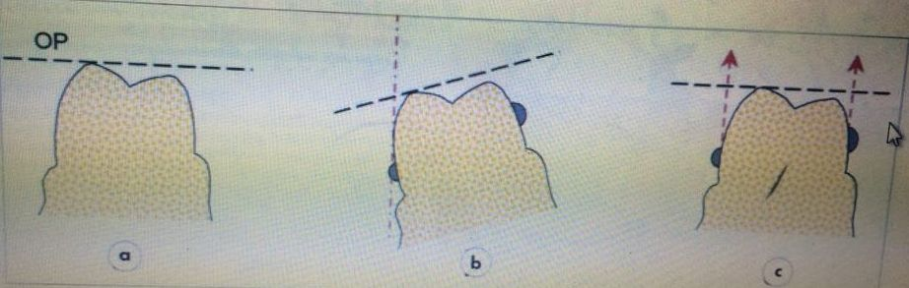

a)cast is surveyed at the zero tilt ( no height of contour appears so no undercuts present ) then we tilted the cast and this created a **false undercut** buccally on the molar however in the patient’s mouth it’s similar to **a NOT b** .

c) there is no undercut .

* What we do is that we Don’t create undercuts we distribute them ; in case of having a deep undercut on one side we distribute it to the other side .

***Figure 3. 25a-c - Retention***

***To obtain retention, undercuts must be present on teeth relative to the horizontal survey. It is a misconception to believe that changing the tilt of the cast will produce retentive undercuts if none exist when the cast is horizontal.***

***a) No undercuts on the tooth when the occlusal plane (OP) is horizontal.***

***b) An apparent undercut created by tilting the cast laterally.***

***c) Clasp arms placed in this false undercut do not provide any resistance to movement along the path of displacement.***

**\*Retention is increased by altering the path of insertion from the common path of displacement .**

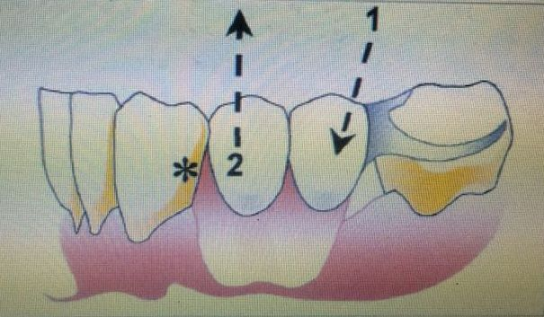

Regarding #2 ; if we survey the cast at the zero tilt which represents the path of displacement for the patient and constructing the cast at this zero tilt it will lead to the fact that the path of insertion and withdrawal will be equal to the common path of displacement . hence we won’t be able to engage the undercut presented by the ‘*’ .

* Tilting the cast **posteriorly**  will lead us to another path of insertion ,presented in 1, allowing us to engage the undercut which is not an undercut anymore to the new path of insertion .
* Engaging the undercut provides further retention for the denture during function . ** we can’t engage both undercuts ;only one is engaged “distal to the canine” and the other one is blocked out by wax “distal to the 5” .

***Figure 3.26 - Retention***

***The principle of tilting the cast to enhance retention is that by so***

***altering the path of insertion (1) a rigid part of the denture can enter an area of the tooth surface or an area of the ridge which is undercut relative to the path of displacement (2).***

***In this example, providing retention by engaging the distal undercut***

***(*) of the canine may well look more pleasing than a clasp arm on the same tooth.***

***Thus a posterior (heels down) tilt would be selected for the final***

***survey which favours appearance at the expense of clasp retention.***

***It is of course possible to create more favourable undercuts***

***on the molars by tooth preparation***

* **PARALLELISM OF GUIDING PLANES**

-guiding planes should be parallel to each other .

*why it concerns us having parallel planes meanwhile tilting the cast did not change the relationship between the two surfaces ?

🡪 answering this depends on the explanation of the lower case ; during preparation it is required to remove lets say 10% of the premolar and 0% of the molar and this is traumatic for the premolar . Tilting the cast will lead to 6% removal of the premolar and 4% of the molar and by this we distributed it on both teeth .

This guarantees minimal preparation of the teeth ,being conservative and getting parallel guiding planes .

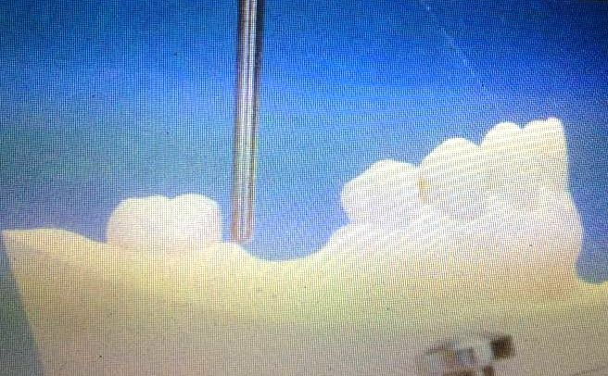

*parallelism of guiding planes is also concerned about distributing the undercuts as in case of having a deep undercut on one side and a shallow undercut on the other side . The goal of distributing the undercuts is that if we have a deep undercut and a shallow one we will get good retention on one side and poor retention on the other side , thus tilting the cast would distribute the undercuts resulting in even retention on both sides .

* How can we bring the previous 4 factors together ?
* The doctor says that **appearance/esthetics is the most important factor** for him because the patient won’t wear a denture that doesn’t look nice no matter how good the materials used to construct it . once patients are satisfied with esthetics everything else will be easier .
* **If the anterior teeth are missing , most probably a posterior tilt is needed since it’s a matter of esthetics .**
* The second factor which is retention ; as soon as you change the tilt retention is improved . **Changing the tilt gives you extra retention .**
* The third factor is interference , should be avoided either by tooth preparation or surgically . if present then this means the denture won’t go in .
* The last factor is parallelism of guiding planes and its not possible to construct a denture without this factor since we want to get one path of insertion . it’s assumed that parallelism is always there but it’s the least important compared with the others .
* If no anteriors are missing you skip the first factor which is appearance and move to the rest factors .
* The next step is final surveying in which we have two survey lines and now we’re ready to prepare the guiding planes according to the path of insertion / the second tilt .
* Depending on the next case where should the clasps be placed ?

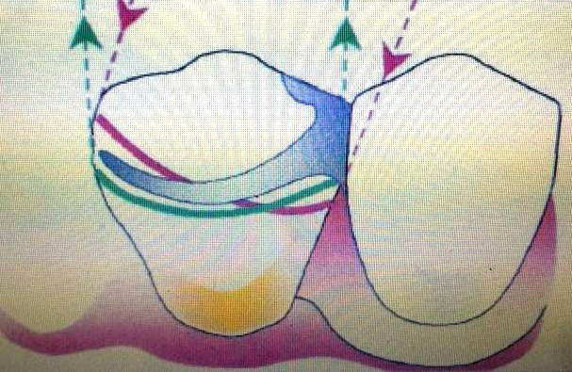

-we have two survey lines ; the green one at the zero tilt and the red one at the 2nd tilt . retention here is gained from the clasp arm and from the guiding planes , the clasp arm is preventing the movement of the denture against **the path of the insertion** .

The clasp arm is below the 2nd survey line “the red line” hence it is engaging a false undercut to the path of displacement but it is a true undercut to the path of insertion.

** in this case we have guiding planes on the tooth that will provide resistance against the path of displacement so we need resistance against the path of insertion that will be provided by the clasp arm (positioned below the 2nd survey line) .

-another solution for the same case which is as follow :

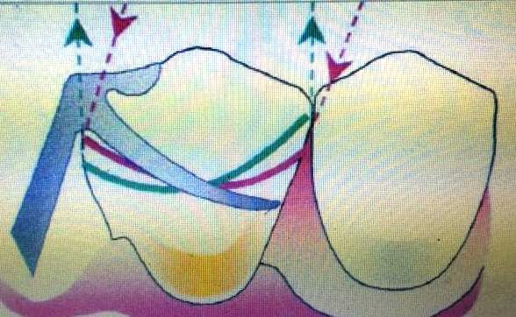

* The clasp arm here engages both undercuts ;the true and the false ones . we need resistance against both the path of insertion and the path of displacement thus engaging both lines won’t result in deforming the clasp arm since the tooth has guiding planes to resist the path of displacement .

***Figure 3.29 - Final survey***

***It does not matter if, as in this example, the clasp engages too deep an undercut relative to the path of displacement. Movement of the denture in an occlusal direction is prevented by contact with the guide surface,therefore permanent deformation of the clasp will not occur.***

* if the tooth has no guiding planes to resist the path of displacement and if the clasp arm has to resist both paths;path of displacement and path of insertion it is going to deform .

*If the clasp arm engages a deep undercut , the clasp arm flexes over a large area so the arm tends to deform .

* If we don’t have retentive elements other than the clasp arm ( as in guiding planes ) the arm will deform .
* The position of the clasp arm depends on what you want the arm to do for you; resisting movement against path of insertion or against the path of withdrawal or both .

*the clasp arm here engages the point of overlap in order to protect the clasp arm and to prevent it from being deformed ; the demand on the clasp arm is high . 🡪

***Figure 3.31 - Final survey***

***If the survey lines converge mesially or distally, the tip of an occlusally***

***approaching clasp can engage the common area of undercut to***

***provide resistance to movement along both paths.***

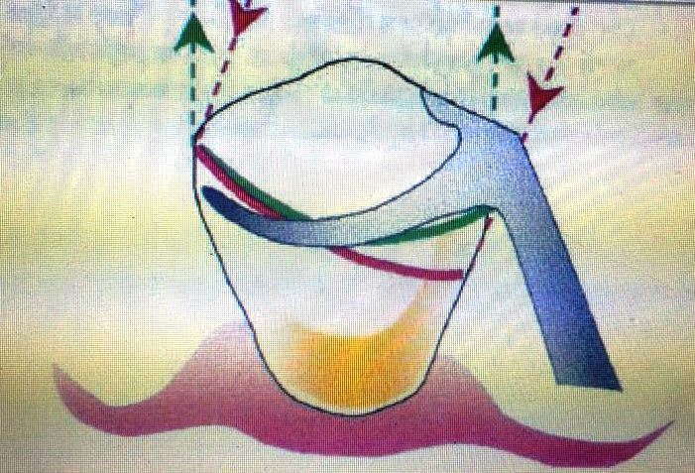

***\*when the denture does not contact guide surfaces on the clasped***

***tooth the clasp will have to resist movement of the denture along***

***both the path of withdrawal and the path of displacement. The***

***clasp will thus need to be positioned in the correct depth of***

***undercut relative to both survey lines. The clasp will then pro-***

***vide the necessary retention without being permanently deformed either by insertion and removal of the denture along the planned path, or by inadvertent displacement of the denture during function.*** 🡪

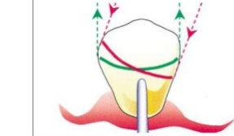

We’re done with the surveying and now we’re moving to another topic .

* **COMPLEX RPD’s DESIGNS**
* We used to say that we only have one path of insertion .however we can have more than one path of insertion in a type of dentures known as **sectional removable denture** which consists of two parts; a metal one and a flange with the teeth . its about engaging all the undercuts around the teeth .
* Since it engages all the undercuts we don’t have black triangles .
* Usually it is used anteriorly, however can be used posteriorly .

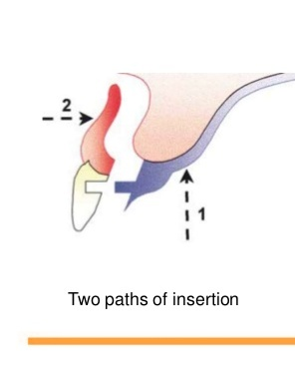

-another denture that can be seen is a one with a rotational path of insertion instead of having a straight one . it hits the tooth then it rotates to get into it’s place .

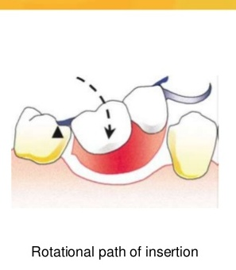🡪 used when we don’t want to block out the 2nd undercut to gain more retention , so we keep it and then insert the denture in a rotational manner .

-its more conservative but difficult to be done .

* In some cases when we perform a crown for the patient , we don’t prepare the tooth we prepare the crown itself instead . 🡪 we do guiding planes and when we want to make the crown it’s going to be milled.

-used when we need two crowns on both sides of the denture .

* The dr. talked about attachments ( will be discussed next year ) . we have extraoral and intraoral attachments .
* The dr. gave us an introduction about treatment planning for the clinics in 5th year : chief complaints ,full medical&dental history ,social history , clinical examination ,mounted casts ,radiographs and photographs to come up with the diagnosis then stabilization phase until we reach the treatment plan .
* Treatment planning is important in: confirm which means confirming the occlusion or reorganize which means treating the patient as a complete denture patient

**SHORTCUTS LEAD TO DELAYS IN PROSTHODONTICS**