Sheet no.: 2
Refer to slide num: slide 1
Written and corrected by : Tala Qutachi and Dima Kilani
History taking and clinical examination of the oral cavity .
In dentistry patient’s psychological make-up is classified by: Type of patient , attitude of patient , characteristic , prognosis of treatment .
patient’s psychological make-up or personality:
First type of patient’’ Philosophical’’ : trust you, accept what you do and the prognosis is good .
Type two patients’’ Exacting or critical’’ : are always doubting , critical ,giving advice to dentist , prognosis is fair/poor.
Type three patients “Hysterical / Skeptical “: are always demanding , have bad experience from dentists , have fear , lack of trust , prognosis is poor .
Type four “ Indifferent” : Unconcerned , Sent by relatives or friends , prognosis is fair
Type of patient | Attitude | Characteristic | Prognosis
Philosophical | Trusting | Accept | Good
Exacting or critical | Doubting | Give advice to dentist | Fair/ Poor
Hysterical / Skeptical | Demanding | Unpleasant past experience | Poor
Indifferent | Unconcerned | Sent by relatives or friends | Fair

Oral Examination

The examination is subdivided into intra and extra oral
- Extra oral examination of patients
A)The way you receive your patients , appearance and patient’s personality ,the way the patient talks i.e. if the patient well groomed (smartly dressed) you shall expect that the patient cares about oral hygiene
B) Clinching or grinding habits .
- Facial color and any obvious swelling or asymmetry( seen from first look ) i.e :pigmentation / bony growth either acquired , congenital or accidental.
D )Palpation of submandibular, submental and cervical lymph nodes.
- TMJ examination by standing behind the patient , then we palpate the condyle( roughly its away from the tragus of the ear by 10 – 30 mm .) ask patient to open his/her mouth widely and slowly . if there was a problem in the TMJ you will hear a click , then at the same time from behind the patient examine the joint disk .
Clicking is the first sign of TMD syndrome .
if there is clicking and pain this is an advanced chronic case of TMD , you feel after the click there is crepitus ( you can feel the bones breaking)

- Limitation in mouth opening or deviation
Deviation: by standing from behind the patient , bisect the patient from the forehead between eyebrows , tip of the nose , chin to the body. When you ask the patient to CLOSE his mouth , you notice the chin tilted either on the left or right that’s called deviation.
Limitation in mouth opening : by standing infront of the patient , ask patient to open his mouth , if it was about 2 to 3 fingers then that’s fine .

Intra-oral examination :
- lip size : normal(medium) , large or small.
( it benefits in bite registration once we choose the size of teeth and amount of tooth showing )
- Sulcus depth : the height alveolar ridge from the crest of the ridge to the junction with the buccal cheeks . examination : palpation by index finger or by asking the patient to smile or visually , check the height of labial and buccal sulcus if its within the normal range then write on the sheet the sulcus is” fair enough “
if there is advanced or moderately resorped ridge the depth of sulcus is inversely proportional with the resorption .

usually resorption happens in lower mandible buccal side near buccal shelf because we loose molar teeth before anteriors why molars before anteriors? because of caries and the surface area in molars , also the first tooth to erupt is the 6th so its more predisposed to caries and extraction , also that its multirooted so its occupies more space so resorption happens there more .
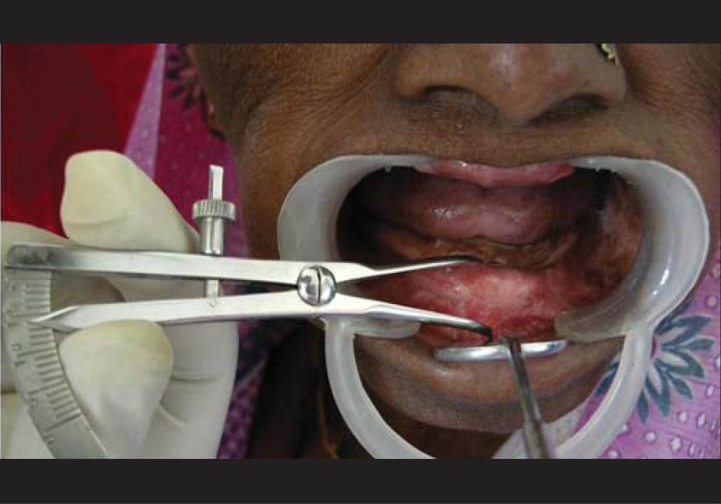
- Skeletal relationship :at this stage we cant tell skeletal relationship only if an expert checked it , its can be determined only in “bite registration stage”.
Can we determine precisely the class of the patient during examination? No we can't. But some things might help us like old pictures of the patient, also family histories (for example if his uncles had big mandibles then he might have big one as well). You also show him the different classes and you ask him which one resembled his past occlusion. The patient must give us the feedback and you have to confirm it through the bite registration once you take eccentric relation or retrusive contact put it on articulator , mount them , remove the bite block , you will have two casts upper and lower and the relation( molar/ incisal relation) on the articulator :
if its overlapped by 1/3 of insical edge its class 1
if the upper is more forward than lower(increased overjet ) that’s class 2 division 1 (incompetent lip , opened mouth , mouth breather )
if the lower is more forward than upper that’s class 3

- The freni : most of the time 99.9% upper labial frenum is present only if frenctomy was done (very rare)
Its either broad or near the crest of ridge depending on the amount of resorption
Buccal upper frenum most of the time its present , ask the patient to relax and reflect the lip you will see it .if it’s a thin line you write in the sheet faint freni .
We have to relieve the denture from that area by creating an opening to help in retention also applied to lower labial frenum which is usually present , stripping usually happens to lower labial frenum by trauma .
Lower Buccal frenum might or might not be present .
Lingual frenum is always present because its associated with the tongue . the patient might have ” tongue tie “ the frenum is near the crest and patient cant lift his/her tongue .
- Tongue size :can be examined by using a gauze and pulling it to check ,but the ideal way to examine the size is by putting the chair in an upright position and ask the patient to breath through his/her nose , then ask him/her to open slowly if the tongue is within the inner border of alveolar ridge then the patient has normal tongue size , but if it was above the alveolar ridge then its large , if there was a space between inner side and ? border it’s a small tongue .
- .shape of the alveolar ridge ; width and height
Ridge shape is either: u shape, v shape , oval or square shape
We classify them to record precisely the quantity and quality of bone
So we have 1. well developed ridge that means the height and width are excellent and smooth all around without any irregularities or undercuts – this is the ideal ridge
2. moderate If the resorption was more drastic higher but still within the normal
3. highly resorbed ridge ; no height no width no sulcus atrophic ridge
4. irregular ridge: specially on the anterior part of the lower and upper jaw, there is either multiple extractions with immediate prosthesis or partial denture followed by resorption which cause scalloped appearance or "down elevation in the socket? "
5. knife edge ridge: high resorption of the alveolar ridge but the height is not affected in a bucco or labiolingual manner resulting in a knife edge crest. The patient would suffer from it because of ulcers formation, not enough retention the denture wouldn't be stable harming the patient

- the presence of Tori; by definition it means any bony exostosis exist in:
- the maxilla at the middle of the palate called Torus palatines either single or multiple
- or in the mandible between 4 and 5 called torus mandibularis
- Undercuts: The contour of a cross section of a residual ridge or dental arch that would prevent the insertion of a denture.
-Canine eminence of the upper jaw; the canine has a prominence on the jaw since it has the longest root even when we extract it we still have an elevation on the bone, with resorption the sulcus lower its level and the eminence is still prominent on the buccal side of the alveolar ridge. This most probably always considered an undercut
- and after traumatic extraction, the cortical plate is broken, after healing it causes irregularities on the ridge surface resulting an undercut. If it interferes with the fabrication of a denture or an impression you need to take it out via surgical procedure
- check for an impacted tooth by taking a panorama
- Saliva flow : you put the mirror on the floor of the mouth if it was watery the mirror won't attach to the wall, or can be sticky which is better for the retention. Heavy smokers, hypertensive would have a very low saliva flow, in such cases you should inform your patient from the start that the retention is compromised and he might have difficulties with his denture
- special tests in case of any suspicious lesion we refer them to oral pathology and they perform a biopsy

if the patient was a denture wearer : Extra Oral Examination of existing Dentures: we need to examine it to detect the faults and to avoid making same mistakes
1. Degree of acrylic teeth wears.
2. Oral hygiene → degree of cleaning of the denture.
3. Type of denture → design and materials used in construction (flangeless denture, clear acrylic, nylon, etc).
--flangeless when the patient has deep undercuts and refused to do a surgery or has class two division one we can't put flanges because flanges fall in the sulcus injuring it, we call it "gum fit denture" –from canine to canine there is no flange or semi flange.
-The denture might be horseshoe because the patient had a gag reflex, so if we decide to cover it this time the patient will not accept.
-Pay attention that we have different types of acrylic so we have to ask the patient if he likes the current one before we decide to change anything regarding the material.

- To select the custom trays, size and color of acrylic teeth….etc.

Intra oral examination :
- Visual Examination (Naked eye); using a mirror examine: tongue, cheeks, pigmentation,
- Digital examination: you have to use ur index finger; by it you can feel the depth of the sulcus, undercuts, sharp projections,
- Radiographs: it ranges from periapicals to OPGs to cephalometric in case of TMDs and this is in very rare situations
- Special test in case of any suspicious lesion

Slide 35
- In relation to the reddish or whitish patches this is related to the denture wearer
- Over extension, patient has a high pain threshold, if he continues to wear the denture this would result in ulcer formation
- Ill-fitting dentures: continuous irritation, debris and bacterial growth result in denture hyperplasia as seen in denture stomatitis
- Continuous wearing of an upper denture: Day and night wearing may cause acute denture induced stomatits then if it passes to the chronic stage it forms granular or papillary hyperplasia; elevation of papilla in the hard palate
Denture stomatitis occurs on the upper jaw due to the obstruction of minor salivary glands orifices of the palate that leads to irritation then stomatitis

Slide 36
- Rubber suction disc;
sometimes you find a circle on the median raphae of the hard palate of acryl produces relief to increase retention or the median raphae itself is prominent so we try to do a relief
before that we used to use rubber disc consist of a rubber and a metal base work on suction and this resulted in perforation in the nasal cavity in multiple cases and in other cases it predisposed cancer that's why nowadays its forbidden to be used. Still you can find them in some developing countries

slide 37

- Shape of the hard palate: if we had resorption we call it flat, if it was bulbous we call it steep which effect retention
- Buried roots: discovered by x-ray with no communication with the oral cavity we just leave it, even if it was an impacted wisdom tooth but we notify the patient to take an OPG every 6month-1yr
If it had any lesion we have to take it out
- Sinus tract: usually an infected area in bone either from a buried root or sequestra (X-ray).
- Unilateral swelling: Abnormal swelling is more likely to be pathological. Bilateral bony existosis
Slide 39

- Relief the denture at that area if not contraindicated to surgery. Like cardiac problem; artificial valve you relieve that area instead of pushing the patient to high risk surgery
Slide 40
Mylohyoid ridge we examine distally to the seven by index finger you go up and down the ridge, its either prominent with undercut or smooth
If your index catch the undercut you relief at that point if it'ssevere we refer it to the surgery
**structures that can't be resorbed in the oral cavity throughout life:
- Mylohyoid ridge
- Buccal shelf
- Lower border of the mandible
- Root of the zygoma
- External oblique ridge
Slide 41
• Tone of facial muscles “Age”. Muscles stretch more in older patients
Please refer to the slides

