Prostho sheet no.24
Done By :ANFAL ATASH

Today we are going to talk about RPD repair
We spent a lot of time in treatment planning and designing so we will not get any interference in the patient’s mouth.
You should educate your patient how to put and remove his appliance in the right way.
Fracture of the RPD could be from wrong diagnosis, inadequate preparation, or not enough education to the patient.

Clasp arm fracture most commonly is caused by wrong path of removal by the patient especially if it engages a heavy undercut. So this will exceed the clasp arm proportional limit and lead to fracture.
Other causes include using a material that don’t flex properly (rigid, no tapering) so that the clasp tip will exceed the proportional limit and break.
The management here is by making a pick up impression. I put the denture inside the patient mouth and take an impression for the jaw with the denture. After that I will send the denture to the lab
In the lab, they cast the impression and we have two options here. Either to use a wrought wire in the place of the broken clasp, or to cast a new clasp and solder it later on with the RPD. This is a costly way so most of the time; we go for wrought wire replacement.
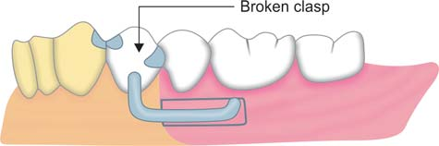

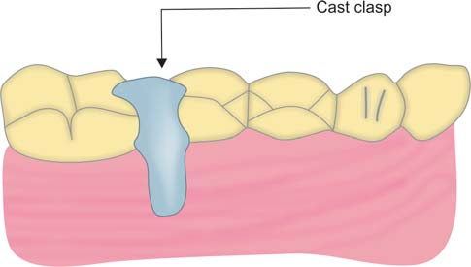
Occlusal rest fracture
It is rare to see a broken rest
The common place to have a fracture is when the rest cross the marginal ridge.
When we do preparation for the rest seat, we should lower down the marginal ridge so we will get enough bulk for the rest.
So insufficient preparation or high occlusal load are the most probable causes for occlusal rest fracture.
The management is to reduce any interference on the rest first, then take pick up impression.
In the lab they use a platinum foil and they adapt it in the place of the rest seat then they seat the denture on the cast and use melted metal and solder it with the RPD
So here melted metal will replace the RPD rest

Fracture of major or minor connector
In major connector, mostly the cause is from manufacturing (not bulky and not rigid enough) or from faulty design of the major connector (like using a U shaped major connector in upper jaw when it is not indicated). In this case, we remake a new RPD. There is no repair for the major connector.
In minor connector, the management depends on the case.
Always management depends on a case. Like if we have a broken rest and we have a good support and the major connector is covering the palate, here we could not do any repair to the rest.

If we have an obvious fracture in a minor connector, we make a pick impression, send it to the lab. On the cast, use platinum foil under the 2 piece and solder them together. If it fractures again later on, you have to remake a new one.
Sometimes it is difficult to allocate the fracture site so here also remake a new RPD.

If you take a good impression that was poured directly, you should have a perfect major connector that is well seated without impingement on the tissues.
When you have Impingement on the tissues, you have to relief it and this will compromise the thickness of the major connector.

Loss of tooth or teeth not involved in support or retention
Loss of a tooth (extraction) in the arch that is not a primary abutment.
Management is by making a pick up impression and a bite and sent it to the lab to add a new acrylic tooth.
It is not easy for a single tooth to be placed in the RPD. Putting acrylic around it is not enough for its retention. So the lab can use readymade hooks to get more retention. Also the lab could cast a part of the RPD and add new acrylic and teeth on it and then solder it to the other part.
Multiple teeth addition is easier because here the retention is better.

Some of the complications that we might face after acrylic addition is that it could interfere with the fitting surface and cause rocking to the denture. To get a homogenous acrylic base we go for relining.

Loss of tooth or teeth involved in support or retention
We take a pick up impression. Then, we do surveying for the new primary abutment teeth mesial and/or distal to the extracted tooth.
In surveying we decide what we are going to make inside the patients mouth like preparing a guiding plane for the new primary abutment that goes with our path of insertion and removal, preparing rest seats if we need them and to adjust the contour (survey line) to get a good engagement of the clasp tip.
Then we prepare the new primary abutments inside the patient’s mouth in a way that obey our RPD and take another pick up impression.
On the new cast, we make waxing up for the clasp, rest, and guiding plate and cast it separately. After that we solder it with the RPD.
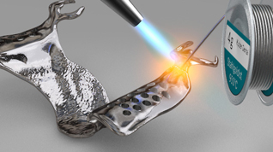

Management depends on the case as we have said. In some cases, we can only use a wrought wire for the new primary abutment if we have a good support and retention from other teeth. Also if we have a lingual plate and good support, we could also go for wrought wire for the new primary abutment and prevent going into a complex wax up, casting and soldering.

Other types of repair
Every case needs a special treatment plan and management.
In this case there was detachment of part of the acrylic and teeth. Here, we take a pick up impression. On the cast, we put the broken piece in its place. After that, we did an index using silicon to record the fractured acrylic flange and teeth.
After that we use cold cure acrylic (brush technique) which comes as powder and liquid and start to add acryl with the help of the index.
We can’t cement the fractured piece back into its place because it will be embedded properly and it will detach later on.

Relining
Here we use the closed mouth technique. Closed mouth technique is done when we want the same occlusion to be recorded. Here we use a low viscosity impression material (like zinc oxide eugenol impression material) in the fitting surface of the RPD and we tell the patient to bite so we get the same occlusion as it was.
Any impression here should be taken on healthy tissues.
In inflamed tissues, we use soft tissue conditioner and give oral hygiene instructions to our patient, and then we go for reline later on.
Thank you

