Sheet cons #5
Part 2

If there's no remaining tooth structure to hold the core , or the core part is within the gingival margin the tooth will be indicated for extraction

The use of prefabricated cast and core :

-For endodontically treated anterior teeth with moderate to severe destruction the cast post and core is the treatment of choice rather than prefabricated .

-for molar teeth :perform with direct cores retained by engaging the pulpal chamber and portions of root canal , the retention of the core can be increased by placement of one or more prefabricated posts.

The dr showed a tooth which has part of the buccal and palatal walls missing + missing mesial and distal walls , here the retention can be increased by removing part of the gutta percha in the pulp chamber and condense the amalgam properly.

Premolars : can be restored by cast posts and core or prefabricated posts. ( it depends on the case )
Cast ( post and core ) preparation :
1- Removal of carious tooth structure
2- Reduction of remaining tooth structure and preparing a finish line for the future crown
3- Maintain at least 2 mm tooth structure coronally for ferrule effect after preparing the finish line all around the tooth .
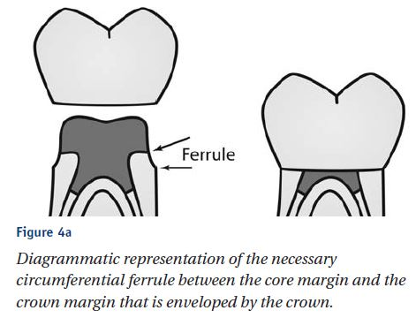
Ferrule : refers to a ring sold tooth structure after the tooth prep. Which 's recommended to be 2 mm minimally ( it dosent include the build up )

( before making the RCT you have to decide if the tooth is restorable or not , by removing the carious tissue and the weak tooth structure , then if there's remaining 2 mm sound strong tooth structure coronally , its indicated for RCT , and then we prepare it for the cast , if not its not restorable and we refer it for extraction )

4- Prepare post space (canal preparation )

The Dr showed a photo for a cast post and core after cementation , the core was subgingivally ( no ferrule effect ) even with gingival cutting all around , no ferrule effect will be gained , the correct treatment was to extract the tooth not restoring it .
( here any force on the prepared crown will fracture the root )

The dr showed another photo for a cast post and core which has the ferrule effect , the final crown will be seated on this remaining tooth structure , the presence of this ferrule effect coronally will prevent the root fracture due to occlusal forces

5- Retain as much coronal tooth structure as possible in order to increase the effective post length and to enable the subsequent crown to produce a ferrule effect.
6- Ensure the remaining dentine is strong and doesn’t have any sharp angles and is contoured and aligned correctly.
7- Remove Gutta percha from the root canal using progressively large diameter of peeso burs or gates glidden burs to remove the Gutta percha to predetermine initial depth established by measurements of the radiographs.
progressively large diameter of burs : size 2 then 3 then 4 as we need to remove the gutta percha without weakening the tooth structure of the canal ,as we already have made correct preparation of the canals in the RCT, we only need to remove the Gutta percha not the sound tooth structure .

The post space should provide resistance to rotation of the post and core. If the configuration of the prepared canal is circular in cross section it will not provide a resistance for rotation so a keyway is placed within the canal .

Keyway : small cutting in the wall that has a good thickness of dentin which work as antirotational areas

The keyway:
- provides a positive seat for the core at the opening of the post space
- it prevents the over seating of the post which may wedge the root and cause vertical fracture.
- The keyway should be cut to a width of about 0.6 and a depth of 2 mm

After proper cementation of the post the keyway ( an undercut ) will prevent the cement from going more inside as it works as an antirotational area

- The post length in cast posts should be equal to or more than the length of the clinical crown to provide 4-5 mm of gutta percha as apical seal.
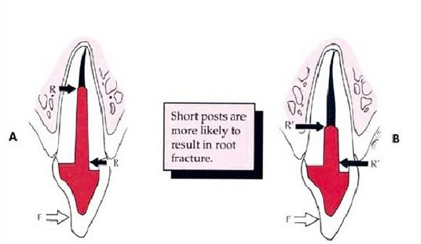
-A post length is stated as 7-8 mm as a typical guideline

-For prefabricated post the length of the post I should be about 7 mm in molar teeth )

- in the cast post : its important to determine the estimated length of the post even by looking at the adjacent tooth and estimating the crown length .
remember that the post length preferably should be equal or more that the crown length .

(when fabricating a post for a molar , its dangerous to remove from the gutta percha and keep 5 mm as apical seal ( high risk of perforation and overcutting ) , so its enough to remove just 7mm for the post )

-Many studies have suggested that the clinical success of the posts is directly proportional to their length.
And it’s rational to prepare a post that is as long as it’s consistent with anatomical limitations while maintaining 4-5 mm of gutta percha as apical seal.

- The width of the post is also an important consideration because randomly widening of the diameter of the post will reduce the thickness and strength of radicular dentine,
The thickness of the remaining tooth structure is critical ( at least 1 mm thin ) .

-The post diameter should be no more than 1/3 the diameter of the root diameter and the walls should be at least 1 mm in thickness.
- we have to keep as much tooth structure as we can ( don’t do overcutting or weaken the tooth structure )

- the dr showed a photo : after completion of the cornal preparation , removal of the carious tooth structure , preparing the finish line , maintain 2 mm of sound tooth structure as ferrule we remove from the Gutta percha to get the proper post length ( its important to provide 4-5 mm of gutta percha as apical seal )

role of ferrule effect:
- a post and core in abutment tooth can transfer occlusal forces intraradiculary , which result in tendncy of vertical fracture of the tooth .
- the role of the final crown restoration is the protection of post core restored tooth
the dr showed a diagram for an anterior teeth which has ben treated endodontically , post and core cast then was placed , the final crown was seated on the ferrule to get the ferrule effect , which will protect the root .
if the remaining tooth structure has no ferrule , the root will be fractured

ferrule : a vertical band of tooth structure at the gingival aspect of the crown preparation , it adds some retention and provide resistance form to enhance longevity of the final restoration
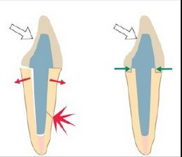
the dr showed 2 diagrams : the margin of the first crown is seated on the core part not on sound tooth structure , on the second picture the tooth is seated on a FERRULE ( sound tooth structure ) ,so any force come to the first crown will cause fracture to the root or the core , while in the other there's a protection against fracture .
متل العكاز الخشب اللي فيه مطاط باخره ميشان يحميه من الكسر :p

The ferrule effect was used To describe the 36 degree ring of cast metal crown and recommended extension of the crown restoration at as least 2 mm apical to the junction of the core and remaining tooth structure

Its very important in Increasing fracture resistance , Improving the integrity of cement seal of the cast crown and improving the resistance of fatigue failure of the cement sealed crown

The final crown has to be always placed over sound tooth structure ( we can't build the tooth up and place it over composite )

GOOD LUCK
HADEEL ALJARHI

