Title of Lecture: Cell Injury

Date of Lecture: 28/9/2014

Sheet no: 4

Refer to slide no. : 51-83/ 119-149

Written by: Dalin Jihad

Intracellular accumulations are just an example, part of the abnormalities that happen in cells.
Part of abnormalities and even disease processes are related to accumulation of different substances within cells. Accumulation of normally present substances that should be present. However, an increase in the substance load within the cell leads to defection of function and that’s why it manifests to abnormalities.
Some are mild and treatable and some are associated with disease process.
Examples of accumulation:
Fatty Acid, Carbohydrates can be deposited, some foreign material that can enter the body in different ways. And all of these are related to abnormalities.
First example is related to fat accumulation within cells, a very important example which can vary from something very simple to something not associated with disease process is xanthomas (accumulation of cholesterol and simple fat in macrophages and can appear due to manifestation of certain diseases, also it could occur without any disease process..
So, very simple xanthomas can be seen since the accumulation is mainly under the skin. Xanthomas are small projections and lesions. However, sometimes this deposition can be related to very serious diseases like atherosclerosis which results in the deposition of simple fatty acids within the endothelium of the blood vessels and within the media, smooth muscles, of the walls of blood vessels. This deposition is associated with the increase in size of the cells leading to increase thickness of the wall causing narrowing in the lumina and that’s why atherosclerosis is a major problem in blood vessels which can lead to something serious in tissues like the heart. Coronary arteries, once they close, the patient will have increased chance of getting myocardial infarction and it is the most common cause of M.I. So it is something serious.
Example 2: protein accumulation
Simple accumulation of proteins is like that in plasma cells. You know that once plasma cells are activated they start to synthesis immunoglobulins. Upon continuous stimulation, the immunoglubins, proteins, can accumulate in the plasma cells. This accumulation is called Russell Bodies and sometimes seen when the tissue is inflamed, plasma cells enlarge with abundance of protienation of immunoglobulin.
Another example that results from injury to the cell, and that why, in the liver, we see cells with accumulation of certain proteinating materials and are easily seen under microscope as pinkish material. It is *(I can’t hear the word) injury, because hepatocytes can be injured through exposure to toxicity, to infection, to drugs and that’s why the cytoskeleton which is a form of protein can collapse. Therefore, clumping occurs and protein accumulation happens. This is called Mallory Bodies. It is not specific but it can indicate previous exposure to drugs, chemicals, or infections. Even though all evidence of inflammation will disappear, the Mallory bodies will remain.
A certain disease, a very important one, is Alzheimer’s. It is a form of degeneration of neurons and deposited causing Neurofibrillary tangles. It’s correlated to Alzheimer’s disease.
Alpha-1-antitrypsine is an enzyme which can be synthesized in abnormal structure. Patient had inherited alpha-1-antitrypsine deficiency and because of the abnormal structure the alpha-1-antitrypsine cannot be excreted and it accumulates. Hepatocytes are the sire of synthesis.

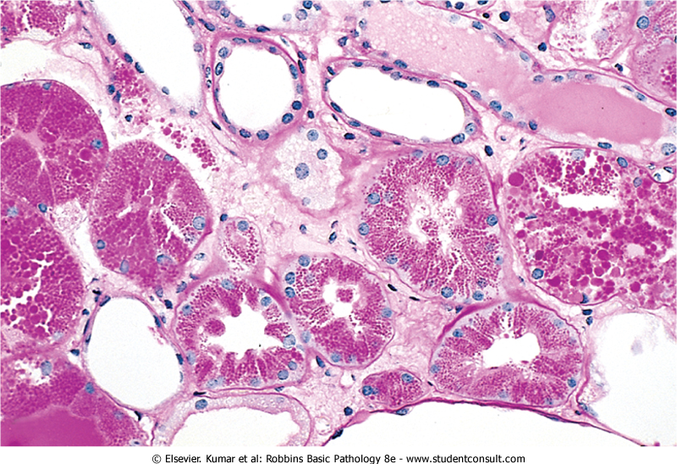
Figure 1: Primary, this accumulation is a disease primarily that manifests in the lung. However, chronic accumulation can lead to liver dysfunction. As you can see in the picture below, Kidney function is affected by excreting large amount of proteins normally, very small amount of protein can escape into urine. But those with kidney failure or Glomerulonephritis excrete large amounts of protein. Because of the large protein concentration in the tubule, we find proteins inside the epithelium. Eventually, this will lead to atrophy in the epithelium because it cannot take this huge amount of deposition even though it is merely albumin, which is a normal protein present in the blood.
Figure 1Protein reabsorption droplets in the renal tubular epithelium
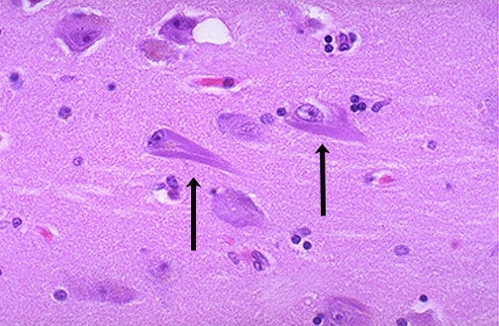
Figure 2: You can see the neurons have this structure called neurofibrillary tangles. And because of serial deposition, patient will start to have dementia and lose brain function because of this.
Figure 2Here are neurofibrillary tangles in neurons of a patient with Alzheimer's disease. The cytoskeletal filaments are grouped together in the elongated pink tangles.
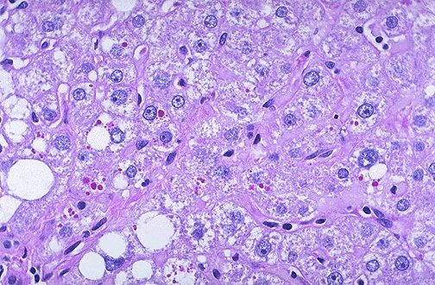
Figure 3: We can detect that this is protein not carbohydrates because it does not react to the stain and it differs in color. And to be surer, we apply an enzyme which is diesterase which digests carbohydrate. These protein globules will be resistant to the enzyme and won’t be digested. Also, carbohydrates are present in large amount in the liver. In a normal liver, these pink globules won’t appear, all hepatocytes will be purplish in color since glycogen is present in the liver.
Figure 3the red globules seen in this PAS stained section of liver are accumulations of α-1-antitrypsin in a patient with a congenital defect involving this substance.

There are many carbohydrate deposition diseases. Like in diabetes, accumulation of carbohydrates because metabolism is ineffective leading to deposition as glycogen in different cells like the heart, kidney, liver and B-cells of pancreas.
We have a large group of glycogen storage disease. Metabolism of carbohydrates involves many enzymes and usually, is specific to one or two tissues. A deficiency in any of these enzymes can lead to accumulation of glycogen in many organs since it isn’t metabolized. This group mainly affects muscles and liver. Because of enzyme deficiency, metabolism of glycogen or carbohydrates cannot proceed to the simple form to be utilized and so it is accumulated. This deposition may lead to loss of function and liver atrophy. Even though they have a large supply of carbohydrate and glycogen, they cannot use it. First sign of disease is hypoglycemia. Manifestation happens by growth retardation because it mainly happens in children.

Deposition by foreign substance, exogenous or endogenous. Every person has a degree of carbon deposition depending in the lungs on the pollution of where they live. As you breathe in, air particle will go inside the alveoli and into the macrophage. Now the carbon had deposited. This is called anthracosis, which is harmless. However, if the deposition was excessive, as in miners, this might be associated with disease process, maybe associated with fibrosis. If fibrosis happens in the lungs, the function of the lung will be lost since all the alveolar tissue is replaced by fibrous tissue. These people will suffer occupational lung disease, the coal miner disease.
Tattoos, pigments injected under skin and collected by macrophages.
Slides 126-129
Macrophages are easy to identify, they’re big and always have something in their cytoplasm. The black part is the pigment, it is injected then collected by the macrophage and it stays in its place.
Endogenous
Lipofuscin: a complex of lipids and proteins that is deposited in cells, maybe mild and not associated with disease process. But sometime it could give the cell atrophy, brown atrophy since the tissue is brown. Could occur in liver and heart. Can be seen in liver due to aging, or previous injury. During injury to liver, the degradation of cell component may deposit as this form, common in elderly.

Other pigments that get accumulated like, the melanin which present in the melanocytes in the skin. Sometime this melanin could get accumulated in the epidermis or dermis and that’s why we have moles. As melanin increases, the person’s color darkens. Sometime if someone upon injury, melanin can escape the melanocytes and deposits in the dermis.
Hemosidrin accumulation from iron, hemorrhage could be at any site and after a while the RBCs will rupture and the hemoglobin is degraded and the iron get taken by the macrophages and this give pigmentation. If you get hit, the first color that’ll appear is red then it will fade till only the hemosidrin is left, this is due to the hemorrhage.
Special stains are used to differentiate hemosidrin from other pigments since they have the same colour.
Anemia result from excessive of rupture RBCs, which won’t live more than 2 weeks, hemoglobin deposited with be dealt by the liver and so they have overload on the liver, iron deposition. We stain to identify that iron is present not something else, to help us know the disease.
Calcification
Deposition of calcium, it is normally stored in the bone and doesn’t exist in the soft tissues unless calcium ions in cells. But it could occur as calcification. Dystrophic calcification, the calcium deposition happens in dead or dying cells. The calcium level in the blood is normal, it occurs because cells are degenerating.
Metastatic calcification can occur anywhere in the body without degenerating, normal tissue and it is associated in excess Calcium in the blood like hyperparathyroidism. After deposition, the cells degenerate, and that’s why keeping the calcium level very low is very important.
Atheroma
Fat deposition will affect the endothelial and smooth muscle in the vessel wall. And this is a step ahead the fat deposition. Fatty infiltration can be reabsorbed, but if calcified it will be hard tissue and can block the vessel.
Diseased and inflamed valves can be calcified which leads to closure of the valve, and patients may have stenosis and many other serious heart diseases. Calcification ends in tissue damage and collagen reaction and the progress depends on many factors, Calcium level, other ion also depends on collage, since deposition of calcium is easier.
Hyperparathyroidism affects 3 sites,
Bone store site, resorption by action of osteoclast, it attacks bone and releases Calcium
Increases absorption of calcium from the gut and increases the reabsorption of calcium in the kidney.
Increased Parathyroid hormone diseases have hypocalcaemia
Back to necrosis
It is death of cells
It is different from apoptosis is that there’s inflammation, and always pathological. Necrosis is important since it give us clue about the disease.
Necrosis of tissues can occur due to 2 things regardless of underlying cause.
1. Affection of proteins, proteins are very important they make the structure, the enzymes and membrane of organelles. And once affected, this can lead to cell death.
2. Action of enzymes on different components. Normally the cell contains many types of enzymes. Normally enzymes are in inactive form and preserved in organelles to prevent their action on self cell. But if any condition associated with activating the enzymes or releasing them from the organelles, it will act on cell.
Depending on the prominent action it is divided into types. Ischemia is the most common necrosis, and is characterized by preservation of the outside of the cells. Just like boiling the egg, the inside is dead issue but from outside it is preserved. Loss of oxygen, proteins within cell coagulate including the enzymes becoming non functional and cannot affect the cell. Preservation of the shape is due to denaturation of proteins and coagulation.
Depending on site of infection, we’ll group into white and red.
Ischemia is loss of oxygen by losing the blood supply; necrotic cells are pale cells and so called white necrosis, kidney, adrenal or spleen. Those are organs with only one artery.
But, dual artery organs, with an obstructed artery will lead to hemorrhage from the non obstructed artery leading to red area. Happen in the Intestine, liver.
When the intestine is fully red and necrotic, the only way to treat is to dissect the whole area. Why not leave? Since perforations will happen and all the content of the intestine will fall in the peritoneal layer, and there infection may happen creating bacterial peritonealis.
Liquifative necrosis, activation or release of enzyme in cell which are capable of acting on the cell causing lysis. This will create a thick liquid composed of degenerated cells and maybe some bacteria and other things. Bacteria are the most common example. Pus formation is liquifactive necrosis. Infected wound is liquifactive.
Necrosis happens in individual cells, not by groups.
Remember, in the brain it is always liquifactive even with no bacteria presence. This is related to the brain tissue itself since it gets lysis very easily.
Caseous necrosis, a combination of both types of necrosis, lquifactive and he coagulative which seen in only tuberculosis, caused by infection by micro bacterial tuberculosis. In general inflammation is due to microbacteria and infection is granuloma specific.
Caseous necrosis tissue changed into pale, soft friable material looking like cheese. After necrosis, cavities will occur, so in patients with long TB infection, they’ll have lots of cavities.
Granuloma in histocytes, and if we stain the bacteria we’ll find them in the granuloma.
Fat necrosis is due to release of fat due to lipase and the common example is the pancreatitis. It affects the tissue and the surrounding fat tissue.
Fat necrosis can be due to trauma, to an area rich in fat. Also in the breast tissue, it can happen and can create mass like the malignant tumor mass; it could be due to trauma.
Once there’s fat necrosis, it’s an invitation for calcification. Acute pancreatitis, it will calcify.
Chronic pancreatitis will show on x-ray, easily identified.
Gangrene: a coagulative necrosis due to major injuries to extremities.
Dry gangrene is usually due to artery obstruction, but venous obstruction which can back pressure on the artery leading to ischemia then coagulative necrosis. Dangerous is tissue death, cannot be compensated. Gangrenous tissue is blackish in color, must be dissected or it will spread and will have even more infection.
Fibrinoid necrosis is specific to blood vessels. When an injury happens to the wall of blood vessel, protein fibrin will leak. When endothelial lining degenerates, the proteins will infiltrate the surrounding wall creating fibrinoid necrosis. Fibrin gets deposited damaging the wall. Seen in different diseases, all affecting blood vessels causing inflammation, a lot of blood vessel disease are characterized by fibrinoid necrosis, vasculitis. Surrounding tissue will also undergo necrosis.

