Chronic periodontitis

- The second most common disease in periodontology .
Every periodontitis is preceded by gingivitis but not every gingivitis is followed by periodontitis .
-both are chronic diseases with the same etiology but they differ in the transitional period ;periodontitis has the same inflammatory process starting with the deposition of plaque and after 2 weeks followed by established stage of gingivitis that will eventually transform into chronic periodontitis .
-gingivitis is a disease affecting supragingival structures “ gingival margin and the attached gingiva ‘’ . once it becomes periodontitis there’ll be activation of osteoclasts indicating the beginning of bone resorption .
-before the stage of bone resorption , the junctional epithelium will be infiltrated with fluids and inflammatory cells and proliferation of Rete pigs ‘’ the base of junctional epithelium ‘’, ending up with epithelial Apical migration .
- the distance between the base of junctional epithelium and the crest of the bone = 2 mm
- depth of the sulcus ( histologically is zero but clinically it never reaches zero ) = 1-3 mm
- An increase in the sulcus depth is the first sign of chronic periodontitis this is the first difference between gingivitis and periodontitis .

-the increase in the sulcus depth is called probing depth , and measuring the sulcus is called sulcus depth.
- Probe depth of 5 mm chronic periodontitis without bone resorption .
- Probe depth of more than 6 mm chronic periodontitis with bone resorption .
**the distance between the base of junctional epithelium and the crest of the bone is called the Buffer zone because it can be manipulated by scaling,polishing , raising up the standards o patient’s oral hygiene , accessing the area by an instrument called ‘’ curette ‘’ ,debride the root and removing the infected cementum , by this we have a clean environment subgingivally and re-attachment /epithelization takes place .
**in case of a pocket of 6 mm there’ll be a breach . And the resultant bone loss should NEVER be treated by scaling and polishing only , there should be Bone Grafting supplemental to it to compensate the bone loss .
- Chronic periodontitis was known as adult periodontitis or chronic adult periodontitis . it’s scientifically proven that it affects variable ages so the new term is chronic periodontitis .
- Slowly progressing disease .
-chronic diseases progress slowly on the other hand aggressive types of diseases progress rapidly in a short period of time.
- Progresses rapidly in cases of : diabetes ,smoking ,stress and thyroid dysfunction .’’ these are cofactors / contributing risk factors BUT plaque is an etiological factor “.
- Most prevalent in adults ;however it might affect geriatrics and pediatrics .
- The amount of destruction is consistent with the presence of plaque, calculus, and other local factors.
- The more the plaque in a quantitative manner in addition to the time factor , the more the effects of the disease .
- Ex: a 30 years old hypertensive patient vs. a 60 years old hypertensive patient . the 30 years old one is prone to more effects as compared to the 60 years old patient .
- CONCLUSION :the exposure of time is extremely important .

- the disease is an infection caused by Bacteria , signs and symptoms are the result of inflammation .
- cardinal signs and symptoms of any inflammation : redness , swelling ,bleeding (these three can be detected clinically ),pain (is told by the patient ) and heat (specific instruments measure the thermal changes in the surrounding tissues ) .

Manifestations of chronic periodontitis :
1-inflammatory appearance of the disease
2-progressive attachment loss
- attachment loss can be one of two things : 1. An increase in the sulcus depth “pocketing “
2. recession / coronal migration due to bone loss
- sometimes the disease passes through a quiescence stage and bursts all of a sudden .
3-the presence of pockets of variable depths
4-has supra and subgingival plaque (similar to gingivitis )
5-supra and subgingival calculus; labially or palatally “ calculus is a secondary factor and it doesn’t initiate the disease “
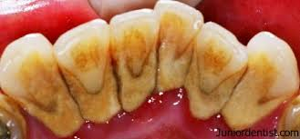
6- redness and swelling extending to the mucogingival line ;not restricted to the interdental area .
Without the probe we can NEVER prove that we have chronic periodontitis . Evidence of diagnosis, it’s indication of the treatment and upon the treatment ‘scaling ,polishing ,..’ we will have Re-attachment of junctional epithelium and reduction of the pocket .
-a 7 mm pocket requires scalingpolishing OH instructions surgical intervention .
NOTE : recession will be discussed further more next semester .

- recession is of two types : 1- due to chronic periodontitis ;redness and swelling of gingival margin since it is inflamed .
2- traumatic injury due to excessive brushing ; gingival margin is thin ’’knife-shaped’’ since it’s not inflamed .

- recession is a term called for gingival apical migration in the anterior teeth :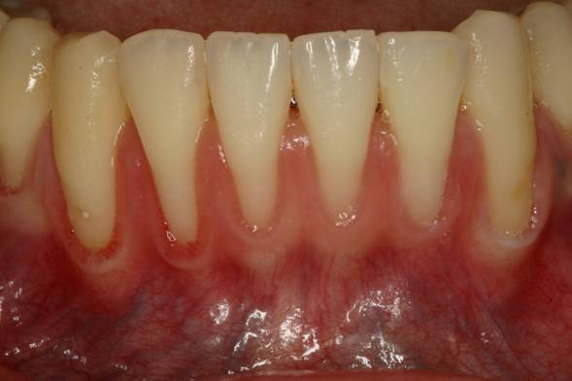

- whereas for the posterior teeth it’s called furcation involvement due to the exposure of the furca (multi-rooted teeth can never be termed as recession );
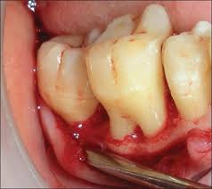

- active pocket ( suppurative pocket );as we said previously the disease goes through periods of quiescence and bursts . in the burst stage the disease becomes acute associated with fluids and immune cells that infiltrate the junctional epithelium resulting in an oozing pus whenever we compress on the tooth by the thumb or the index .
it started from the chronic disease with pocketing that lasted for a long period of time and through the burst stage it was transformed into the Acute stage .
- in the acute stage we have Ag-Ab reaction ,dead cells and macrophages that result in the pus .

- Periodontal Abscess ;resulting from the pockets
- Shallow pocket is up to 5 mm
- Deep pocket is 6,7,8,9 mm

- The periapical abscess is located apical to the root and lunar in shape whereas the periodontal abscess is ALWAYS LATERAL to the root .

RECALL : whenever we say periodontal think of the periodontium (ligaments and tissues )and gingival think of supragingival structures .
- In the periodontal abscess ,its opened to release the fluids by inserting the probe into the anesthetized sulcus and removing it by a gauze . if there’s no tip for the abscess to be drained we go to the most fluctuant part of the abscess to release the fluid and the patient is then given antibiotics to prevent the recurrence of the abscess.

- MOBILITY assessed by bringing two instruments opposing to each other moving it in an anterior-posterior manner (mobility will be discussed next term ) .

-suprabony sulcus pocket superior to the crest of the bone (starting from 5 mm ,will be discussed in the next lecture ).
**remember that the round tip of the probe is 0.5 mm and from the tip to the first band is 3 mm .

- Pseudopocket : a false pocket due to the coronal migration /enlargement of the gingiva .

Radiographic findings
- Gingivitis is not associated with any form of bone resorption however it’s presence is an evidence of periodontitis .
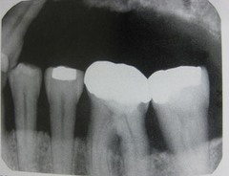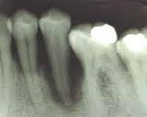

Our guideline in determining the bone loss is the cemento-enamel junction ; we place a line passing by the CEJ of the teeth on the xray and a line on the uppermost bone appearing and we measure the distance between them .
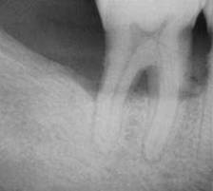 this is how the furcation involvement appears ; a radiolucent triangular-shaped area due to bone resorption .

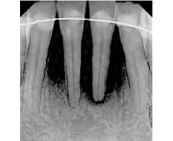 these teeth have poor prognosis and they are ready for extraction .

- Bone grafting depends on the amount of bone surrounding the defective area .
- Vertical bone loss is represented as a V-shaped area ;surrounded by two sound walls .
- In periodontology ,whenever a radiograph is examined ,bone level is the thing that matters .its either divided into upper and lower arch or you mention that there’s horizontal or vertical bone loss directly .
- The lost teeth or the extracted ones due to bone loss should be also pointed out upon radiographic examination .
- Multiple periapical xrays were discussed in the manner explained previously .
- Periapical radiograph usually gives us a closer look and should be supplemented by the periodontist .

