priodontology

sheet :12

dr. murad

done by : Razan Al-laham

***what is the definition of aggressive periodontitis ???
its an inflammatory disease of the periodontium causing rapid bone loss (which is one of the primary features) and periodontal destruction around one or more permanent teeth in an otherwise healthy adolescent
we mean by healthy adolescent is that they don't have any significant systemic diseases which have a direct effect on the periodontium ( like ehlor-danlos syndrome , cyclic neutropenia ....).
diabetes has an impact on health , but if the patient controlled it he can live a healthy life, so diabetes isn't considered as a significant systemic disease , the patient is considered as a "healthy adolescent" ; so he can suffer from aggressive periodontitis.
*** it causes rapid bone loss , clinical attachment loss , deep pockets and it may or may not cause mobility ; that is because periodontitis is a site specific disease .
sites specefic disease : means that we can detect severe bone loss on the mesial side of the tooth for example but not on any other surface of the tooth , thats why sometimes it doesnt cause mobility.
in the past the classification of periodontal diseases was dependent on age ( if the patient's age was less than 35 they called it juvenile periodontits and they classified it into ; localized juvenile peridontitis , generalized juvenile periodontitis and rapidly progressive peridontitis , and if the patient's age was more than 35 they called adult periodontitis) , but recently they reclassified periodontal diseases into chronic periodontitis , localized aggressive priodontitis and generalized aggressive periodontitis .
*** primary features of aggressive periodontitis which apply to both localized and generalized (this is the main way to differentiate between aggressive and chronic periodontitis ):
1. otherwise clinically healthy individual , and this is to differentiate it from periodontitis as a manifestation of systemic diseases ( smokers and diabetic patients are considered healthy)
2. rapid rate of bone loss ,this can be determined by comparing probing depths or radiographs overtime , however , if periodontal charting and radiographs are available for only one date , and the patient meets the other criteria described here , then the diagnosis of aggressive periodontitis may be assumed with a fair degree of certainty.
***although we don't consider age as a primary feature but it can help us to determine the rate of bone loss ; if a 30 years old patient came to your clinic with a probing depth of 10 then he has aggressive periodontitis (rapid bone loss) , but if he was 50 years old or older then most probably he has chronic periodontitis
3. familial aggregation ; if the patient was young and his parents suffered from early teeth loss or one of his siblings suffers from a periodontal disease (it doesnt have to be the same severity or extent )
*some of the references include "young age" as one of the primary features
***secondary features :
1. amount of microbial deposits is inconsistent with the amount of destruction ; the patient has small amount of plaque and severe bone loss , unlike chronic periodontitis where the patient has abundant plaque
2. elevated proportions of Aa (Aggregatibacter actinomycetemcomitans) in both localized and generalized , and Pg (porphyromonas gingivalis); their presence , in part , forms the rationale for use of adjunctive antimicrobials as part of the therapy.
3. reduced phagocytic function specially in localized aggressive periodontitis
4. hyper-responsive macrophage phenotype including elevated levels of PGE-2 and IL-1b , we mentioned in previous lectures that periodontitis is prevalent in patients with exaggerated immune response
5. progression of attachment loss and bone loss may be self-limiting , in some cases , localized aggressive periodontis is self-limiting (if we check the x-rays we will find that the disease is stable without treatment ) >>> this is an exception but mainly its not self limiting and it needs treatment .
*** not all features have to be present to establish a diagnosis
*** combination of clinical , radiographic and historical findings (sometimes laboratory findings) will aid in establishing a diagnosis

. localized aggressive periodontitis 1
clinical features :
***in most of the cases it is discovered by coincidence
1.onset around puberty (circumpubertal)
2.robust (strong , powerful) antibody response to infecting agents specially to Aa
3.localized first molar/incisor(lateral or central) presentation with interproximal attachment loss on at least two permanent teeth , one of which is a first molar , and involving no more than two teeth other than first molars and incisors
examples for further explanation :***
1. if a patient came to you with attachment loss on the first molar and any of the incisors >>> localized
2. patient with attachment loss on the first molar , incisor , second molar and canine >>> localized
3. patient with attachment loss on all the first molars and all the incisors >>> localized (usually the clinical presentation is two first molars and one of the incisors or vice versa)
4. patient with attachment loss on the first molar , incisor , second molar , canine and premolar >>> generalized ; more than two teeth other than the incisors and the first molars are involved
P.S >>> the patient who suffers from localized aggressive periodontitis doesnt have a different pathobiology from the one who has generalized aggressive periodontitis , the disease is kind of arbitrary (based on random choice, rather than any reason or system)

why first molars and incisors ?***
nobody knows but there are several theories that tried to answer this question ;
a. the development of adequate immune defenses to bacteria such as Aa after the initial colonization of the teeth to erupt first (1st molars and incisors) which prevents colonization of other sites ; the initial colonization of these teeth that erupt first before adequeta maturity of the immune system
b. bacteria antagonistic to Aa may colonize the periodontal tissues and inhibit Aa from further colonization of periodontal sites in the mouth ; teeth other than the first molars and incisors develop antagonistic biofilm that doesn't favor maturation and proliferation of periodontal pathogen
c. Aa may lose its leukotoxin-producing ability for unknown reasons which could impair or arrest the progression of the disease and avert the colonization of new periodontal sites
d. a defect in the cementum formation may be responsible for the localization of the lesions
5.in most of the ceses there is lack or minimal clinical inflammation (gingivitis) , in the following picture , the gingiva looks normal , but when we took x-rays we discovered severe bone loss ; that's why in most of the cases , localized aggressive periodontitis is discovered by chance
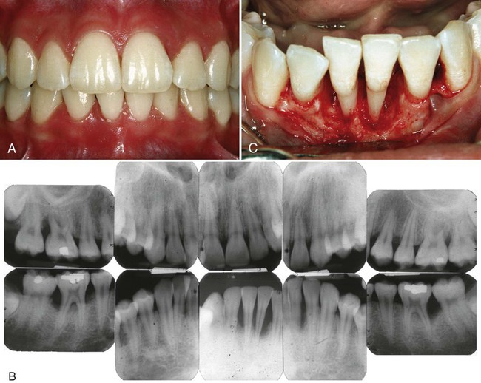
6. minimal plaque , rarely mineralized to calculus
7. elevated levels of Aa
8. rapid progression of bone loss (3-4 times the rate of progression in chronic periodontitis)
9. distolabial migration of the maxillary incisors (centrals or laterals) with concomitant diastema formation >>> this feature isn't specific for aggressive periodontitis , we can see it also in chronic periodontitis
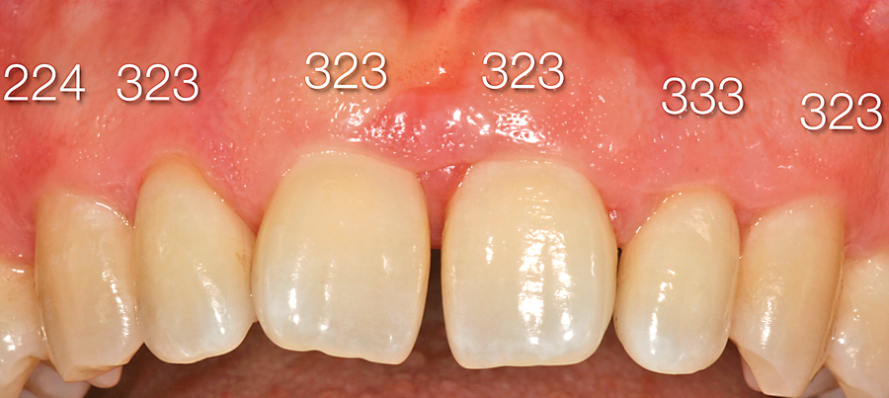

10. increased mobility of the maxillary and mandibular incisors and first molars
11. sensitivity of denuded root surfaces to thermal and tactile stimuli
12. deep , dull , radiating pain during mastication , probably caused by irritation of the supporting structures by mobile teeth and impacted food
13. periodontal abscesses may form at this stage , and regional lymph node enlargement may occur
***radiographic findings
1.vertical loss of alveolar bone around the first molars and incisors
what is the difference between vertical and horizontal bone loss ?
Vertical bone loss describes a specific area/root/tooth and is more pronounced, horizontal bone loss is a generalized loss of bone. In this picture the parallel lines are (mild) horizontal bone loss and the diagonal line marks vertical bone loss (restricted to that one root)
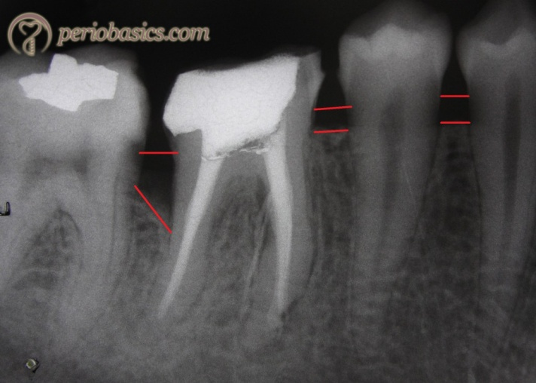
The way to tell the difference between the two is to draw two lines and compare them. Draw a line that goes from CEJ to CEJ between teeth. Draw a line over the crest of bone. If there is bone loss, but the lines are parallel, then it's horizontal bones loss. If the lines are not parallel, it's considered vertical bone loss
P.S >>> normally , the distance from the CEJ to the crest of the bone = 1-2 mm , if it was more then there is bone loss
2. "arc-shaped" defects , looks like a bow
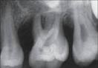

*** prevalence distribution by age and gender
<1% in a diverse population
<.2% in whites
2% in blacks
* historically was thought to be more prevalent in females(because females have more interest to visit the doctor and do examinations and thereby discover the disease more than males ) but studies correcting for ascertainment bias show no sex predilection
***management :
1. non surgical ; scaling and root planning , oral hygiene instruction , systemic antibiotics
2. surgical ; bone grafting , GTR , less likely osseous surgery (The surgical procedure is used to smooth and reshape the affected bone and create a shallow pocket that makes it more difficult for the more aggressive bacteria to survive , pocket elimination) .
*** drugs used for treating aggressive periodontitis : in the past , they used to treat aggressive peroidontitis with 100 mg doxycyclin 1×2 for 14 days , nowadays the drugs of choice are amoxycillin 500mg 1×3 for 10 days and metronidazole 250 mg 1×3 for 10 days , if the patient is allergic to amoxicillin we prescribe erythromycin 500mg or azithromycin 500mg for 3 days

generalized aggressive periodontitis 2.
affects individuals under the age of 30
poor antibody response to the infecting agents
minimal plaque , elevated Pg , Tf and Aa
generalized interproximal attachment loss affecting at least three permanent teeth other than first molars and incisors
***clinical presentation
two types of gingival response :
1. severe , acutely inflamed tissue , often proliferating , ulcerated , and fiery red and bleeding may occur spontaneously or with slight stimulation , suppuration may be an important feature
2. tissues may appear pink, free of inflammation , and occasionally with some degree of stippling , although stippling maybe absent
**GAP may be arrested spontaneously or after therapy while other cases continue to progress and eventual tooth loss despite intervention ; most of the cases respond to treatment , other cases don't respond and continue to progress and most probably these cases are not well diagnosed and there is an underlying syndrome
** new cases should receive medical checkup to rule out systemic diseases
** average rate of annual bone loss in a patient with chronic periodontitis is 0.1-0.5 mm , but in aggressive periodontitis the average rate is higher and it equals to 1-2 mm
***radiographic presentation :
bone loss of varying severity , mainly there is vertical bone loss but we can also see horizontal bone loss
longitudinal comparison of x-rays in some cases shows extreme rate of bone loss
*** prevalence and distribution by age and gender :
1. 8% of sri-lankan tea laborers had progression of attachment loss of about annual 0.1-1.0 mm
sri-lankan tea laborers study : (the doctor mentioned it in the lecture but not in details , so i goggled about it , read it , and the underlined paragraphes are the things that the doctor mentioned)
Over a period of 15 years, le and others examined a group of male tea workers in Sri Lanka. These men did not use any oral hygiene methods and had no access to dental care, allowing the study of the natural progression of untreated periodontal disease. The results showed that all individuals were not equally affected. The vast majority (81%) of the men showed moderate progression in attachment loss, 11% did not progress beyond gingivitis and the remaining group (8%) exhibited rapid loss of attachment, losing between 10 and 32 teeth over 15 years.
These findings bring up a number of interesting points, which have shifted the focus of periodontal research over the last few decades. First, although gingivitis may represent an early stage in the natural history of periodontitis, it may also be a separate disease entity, which in some patients will not progress. Second, it appears that the prevalence of periodontal disease severe enough to cause tooth loss is lower than originally believed. Finally, the findings suggest that periodontitis is not a single disease entity, but rather a family of closely related diseases that vary in etiology, natural history and response to therapy. All of these theories have been substantiated by other researchers, indicating that although bacteria are essential for periodontal disease to occur, other factors may play a significant role.

***What was the conclusion from the Sri Lankan tea laborer study of periodontal disease?
Severity must be related to factors other than the amount of plaque and calculus; Somehow the host must be also involved.

2. 0.13% of adolescents 14-17 years of age had GAP
3. higher risk in blacks than whites and in males than females
PS>>> primary etiology of aggressive periodontitis is plaque
***microbiologic factors :
Aa has been implicated as the primary pathogen associated with LAP :
1.Aa is found in high frequency (approximately 90%) in lesions characteristics of LAP
2.sites with evidence of disease progression often show elevated levels of Aa
3.many patients with the clinical manifestations of LAP have significantly elevated serum antibody titers to Aa
4.clinical studies show a correlation between reduction in Aa during treatment and a successful clinical response .
5.Aa produces a number of virulence factors that may contribute to the disease process
**in some reports , Aa was not detected and in other reports , Aa was detected in healthy sites
**serotype b has been shown to be the virulent type of Aa in US studies and elsewhere
**Aa has been shown to have the ability to invade periodontal tissues
***immunologic factors :
aggressive periodontitis patients display functional defects of polymorphonuclear leukocytes (PMNs) , monocytes , or both .
these defects could :
impair the chemotactic attraction of PMNs to the site of infection
impair the ability to phagocytose and kill microorganisms
hyper-responsiveness of monocytes , HLA markers , autoimmunity
***genetic factors :
autosomal dominant inheritance in LAP (studies done in african-americans )
immunologic PMN defects cluster in LAP families which indicated they might be related to gene clusters and inherited
different patterns of inheritance might exist in other populations
***environmental factors :
smoking in GAP patients is associated with more CAL and more teeth being affected
smoking has less impact on attachment levels in young patients with LAP
summary :
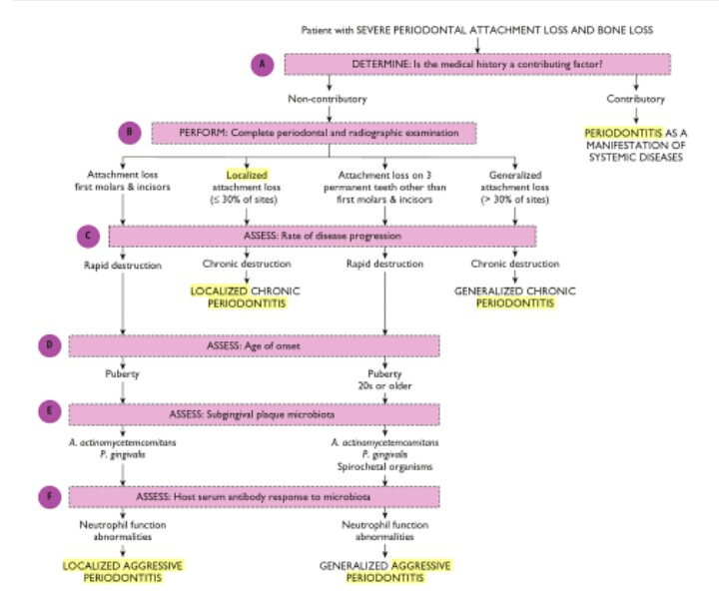

the end

