Sheet number 17
Doctor Omar Karadshe
Done by Rima mackan and hashem abu safi

Local factors

Overhanging restoration might be mechanically invading the space, and aids in plaque accumulation.
How can we remove them?
Ideally you should remove the whole restoration, but it's not that feasible cause sometimes you might end up removing more than you should or need
So what should you do concerning overhangs is to get the Eva system , now the Eva system is made of a reciprocating handpiece that turns back and forth , it has a specific bur that removes the over hangs smoothly so it doesn’t cause any defect

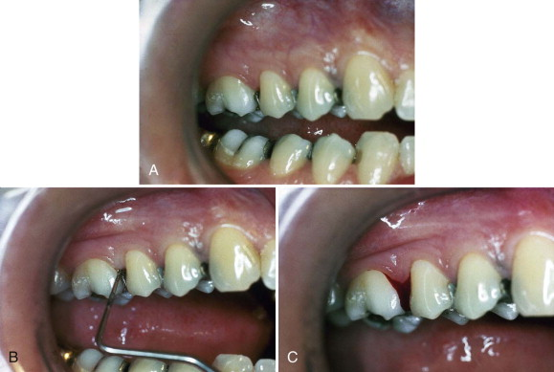
As you can see in this slide using the probe to remove the overhang will most probably cause bleeding and a defect in the restoration

As you can see it has special burs and the handpiece can go back and forth so you can remove it smoothly with the contour of the tooth

Why do we care about caries?
1) Cause caries is a disease and we should control it
2) Carious lesions aid in plaque retention
3) Caries is a source of bacteria
4) If caries went sub gingival they’ll invade the cementum and cause loss of attachment

So what do we do about caries?
Clean it as much as you can or temporize the situation until you can put your final restoration

What are the conditions you give antibiotics for?
If there was a spread for any disease gives antibiotics
Indications:
1) Aggressive periodontitis
2) Severe generalized chronic gingivitis
3) Necrotizing gingivitis if there were systemic signs such as fever and malaise
However if we had a fistula we don’t give antibiotics cause fistula means that there is already drainage
4) Uncontrolled diabetes or immune compromised

Features of the Ideal antibiotic:
- Selective to the targeted microbe.
- Doesn’t have side effects.
- Safe.
- Doesn’t induce resistance.
- Able to stay in the body for a good amount of time to eliminate the condition.
- Cheap.

The thing is the oral cavity is polymicrobial so you can't give an antibiotic for it unless it’s a broad spectrum drug, and that will induce resistance
We are not going to talk a lot about this however they have recently discovered that a combination therapy is better regarding periodontal issues
The best combination is :
Metronidazole + amoxicillin covers a good spectrum and less resistance and gives better attachment gain.

Again why do we give antibiotics?
- Because some areas are inaccessible
- Fear of bacteria invading tissue
- Deep pockets
Why not just antibiotic?
Because the effect will be temporary, because the cause of the disease would still be there, so the effect would be short term, so you should always do your procedures along with antibiotics once needed

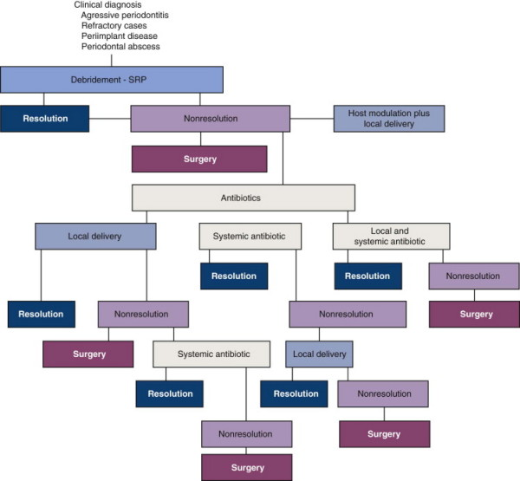
This chart is about how you should address the problem in a systemic manner, read it and try to understand the concept behind it cause the doctor will probably ask about this in the exam, the question will be almost based on which of the following will need surgery?

in severe cases you can give 400 mg of metronidozole , if the patient is allergic then give ciprofloxacin instead of amoxicillin

There is something called local antibiotics , these are antibiotics that are concentrated locally to have better effect on the bacteria and less systemic effect
In general they discovered that it doesn’t really reduce that much almost a .5 mm difference, the American academy of periodontics did a guide line for it that says: if for instance you did a scaling and root planning for a tooth and the pocket depth was 5 mm or more , and it's still bleeding this might be an indication for a local antibiotic especially if it was in a localized area , like 2 pockets so why to give systemic .
We only give systemic if it were generalized or for instance we had one quadrant full of pockets.
One of the used localized antibiotics is tetracyclic fibers , these fibers contain tetracycline you put them in the pocket. The problem is these fibers are non resorbable their existence causes local factors such as inhibition of attachment so they are no longer available
So they came up with doxycycline gel concentraton of 10% (atridox ) so they discovered that when putting a gel into the pocket , it gave the same results but resistance occurred unlike tetracyclic fibers that had no resistance.
Metronidazole a viscous material that hardens once it sets in the tissue , it reacts with the tissue , concentration is 25% applied once weekly for 6 weeks
The problem with all those local antibiotics is the multiple follow ups with the patient , the resistance , and most importantly is it really coast effective ?

Minocycline microspheres

Studies prove that this works the most, it resorbs by itself, and it has sustained release for 7-10 days then it resolves

Chlorhexidine chip

Also called perio chips, it has a promising future

So to sum up local antibiotics vs. systemic antibiotics, which is better?
Systemic side effects are worse
However generalized are cheaper and less follow ups and better in generalized conditions
Localized however has higher concentration in the targeted tissue (better), so it’s a matter of balance

Now let's talk about Host Modulation Therapy (HMT)

Diseases are driven by both the bacteria and the body, so why don’t we manipulate the body?
The concept behind this is to try to control the defence mechanism of the body.
For instance we know that prostaglandins, interleukins...etc control inflammation and the drugs that inhibit it such as ibuprophen cause peptic ulcer so you can’t use the drug all the time to control the inflammation cascade.
Bisphosphonate for instance stays in the bone for a long time and reduce osteoclast (this drug is given for osteoporosis)
They discovered that tetracycline inhibits osteoclast but the problem is you can't give an antibiotic for a life time, so they made a drug called sub antimicrobial doxycycline, it doesn’t have any antimicrobial effect it just down regulates MMPs
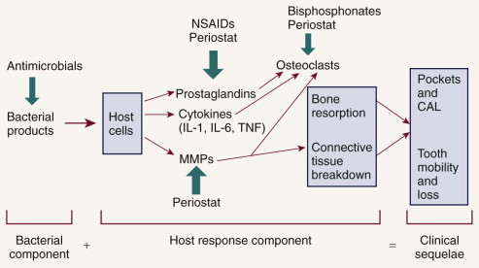

Orthodontics can aid in perio, for instance in crowding teeth or tilted molar, if you upright it, it will solve the problem, diastema also once closed will decrease the inflammation in the gingiva.

Finally, reevaluation

This step is still part of the non surgical treatment
We need to do this to see the effectiveness of our treatment, reevaluation is done after 3 months cause this is the time needed for bone, soft tissue, and socket complete healing
You evaluate through measuring the pocket depth, recession, inflammation, furcation and bleeding on probing so you can't measure a non fully healed pocket, cause that will traumatize the tissue, that’s why you should wait for 3 months
Now if the results weren’t satisfactory you should consider retreatment, surgery and even extraction
How does the tissue heal?
The epithelium regenerates after you clean the pocket, and healing occurs mainly through the long junctional epithelium
Ideally since we lost the pdl , cementum , bone and the epithelium we should restore all we lost ,so we put a barrier membrane (surgically ) that’s made of resorbable collagen on top of the root and we separate it from the epithelium above , now this barrier will give time for the other slow growing tissues to regenerate , this is called guided tissue regeneration we will take it in details in fifth year , but mainly we should know that in non surgical treatment healing is mainly through the long junctional epithelium
So in re evaluation we see :
Less plaque
Less pocket depth
Bleeding is less
When to refer your case ?
More than 5 mm pocket ( cause when a pocket is that deep it means the crest of bone is about 7 mm apical to the cementoenamel junction, therefore only about half the bony support for the tooth remains.

