periodontics
sheet #5
Dr. Murad
done by :Razan Al-Lahham
at first we have to understand the definition of periodontal diseases ; in general they are a big group of conditions and what we are going to talk about is plaque induced periodontal diseases ; mainly gingivitis and periodontitis
***we have primary etiological factors and we have secondary etiological factors , both have strong impact on periodontal diseases but we have to differentiate between them ; plaque(bacteria) is the primary etiological factor , and smoking , medications ... are secondary etiological factors (we will talk about them later)
***gingivitis : inflammation in the gingival part and is the mildest form of periodontal disease. It causes the gums to become red and swollen and to bleed easily. There is usually little or no discomfort . Gingivitis can be reversed with treatment , the most important thing that differs it from periodontitis is that there is no bone loss and no attachment loss (you don't differentiate between periodontitis and gingivitis by pocketing ; pocketing is one of the important signs of periodontitis but we don't depend on it in differentiation )

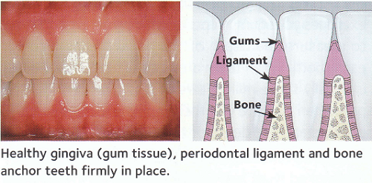
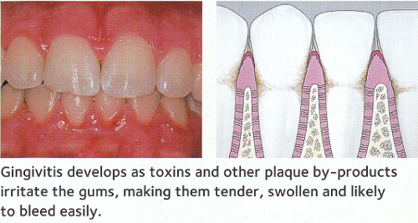

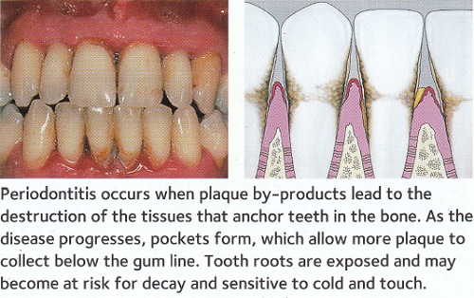

*** smoking , stress , uncontrolled diabetes accumulation of plaque inflammation ( either gingivitis or periodontitis) bone resorption (in case of periodontitis)
>>>what is the difference between teeth surfaces and other tissues ?
one of the protective mechanisms of soft tissues in mouth is the continuous shedding ; that's why we don't have true build up of plaque on soft tissues , on the other hand teeth are considered to be non shedding surfaces which means that there is no turn over ; so that's why plaque can grow and mature and become a pathogenic biofilm.
*** teeth are unique , they are the only hard tissue penetrating the intact lining of the body , what about nails ??? ( they are not hard tissues , they are protein ; keratin)
***Circumferential Defects: A vertical defect that includes more than one surface of a tooth, e.g., a vertical defect that includes the mesial and lingual surfaces of a tooth.
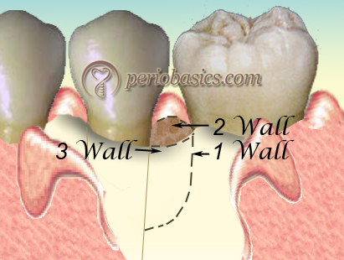
P.S : apical migration of junctional epithelium is called pocket*
***plaque : is a host associated biofilm , consists of complex ecosystem of bacteria , forms clear or yellow deposits on teeth and other hard surfaces , and its the primary etiological factor of periodontal diseases
>>> years ago there were lots of theories that tried to explain periodontitis and gingivitis :
1. they thought that one of the causes of peiodontisis is malocclusion or occlusal interferences , they thought that this was the reason behind bone loss
2. they thought that gingiva is like fingers "an end organ" ; where the circulation is kind of compromised
3. lack of gingival message , there isn't enough stimulation
4. defect in the cementum; the periodontal fibers break down
50 years ago the detection and identification methods of bacteria have developed , so that's how they realized that the primary etiology is bacteria
>>>how did they know that bacteria is the reason behind caries ???
1. they did some studies called experimental gingivitis studies , and what they did basically is that they asked a group of dental students not to brush their teeth for almost 20 days and every day they took samples of plaque and analyzed them , after that they told them to brush their teeth for almost a week and also they took samples , they noticed that the type of bacteria changes as the tissue condition changes toward the inflammation state
2. germ free animals : they are also called gnotobiotic animals
you may ask yourself how can we isolate an animal without having any sort of bacteria in its mouth ??
these animals are born in aseptic conditions, which may include removal from the mother by Caesarean section (not normal birth , because when the animal passes through the canal it will pick up bacteria) and immediate transfer of the newborn to an isolator where all incoming air, food and water is sterilized . Such animals are normally reared in a sterile or microbially-controlled laboratory environment, and they are only exposed to those microorganisms that the researchers wish to have present in the animal. These gnotobiotes are used to study the symbiotic relationships between an animal and one or more of the microorganisms that may inhabit its body. This technique is important for microbiologists because it allows them to study only a select few symbiotic interactions at a time, whereas animals that develop under normal conditions may quickly acquire a microbiota that includes hundreds or thousands of unique organisms.

3. other studies show , when you control plaque you will not have an inflammation (gingivitis)
years ago when they discovered that plaque is the reason behind gingivitis they thought that any type of plaque can cause gingivitis . as our knowledge in microbiology improved , it turned out that there are certain types of bacteria in plaque that cause the disease
***over time they noticed that there are types of bacteria that are normally found in the oral cavity without causing any inflammation (disease)
so to explain this they came up with a hypothesis called etiologic plaque hypothesis >>> we have to have certain types of bacteria that causes the disease but also they have to be in a certain type of biofilm (ecologic certain type of environment to cause the disease ) , its a specific disease but that doesn't mean when you have a specific type of bacteria you will have the disease directly we also need another condition for the bacteria to cause the disease which is the availability of certain environment (unlike anthrax , which a specific disease with a specific bacteria ; when you get this bacteria you will have the disease).
>>>plaque cant be removed with water only (rinsing) and even if you use water jet (water jet : strong spray , it only removes inflammatory mediators , it doesn't remove plaque)
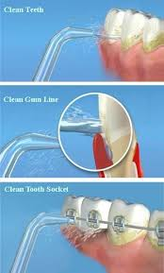
(water jet)
>>>materia alba is easily removed with water (rinsing)
P.S >>> materia alba : its A white matter , which is an accumulation or aggregation of microorganisms , desquamated epithelial cells , blood cells , and food debris loosely adherent to surface of plaques ,teeth , gingiva or dental appliances .
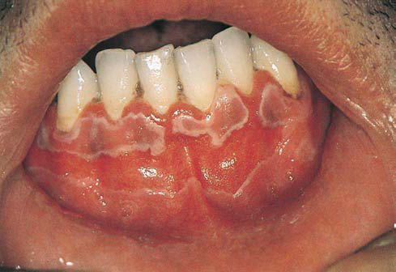
(materia alba)
>>>calculus is a hard deposits
i googled about the definition of calculus : (you have to know it)
calculus or tartar is a form of hardened dental plaque. It is caused by precipitation of minerals from saliva and gingival crevicular fluid (GCF) in plaque on the teeth. This process of precipitation kills the bacterial cells within dental plaque, but the rough and hardened surface that is formed provides an ideal surface for further plaque formation. This leads to calculus buildup, which compromises the health of the gingiva (gums). Calculus can form both along the gumline, where it is referred to as supragingival ("above the gum"), and within the narrow sulcus that exists between the teeth and the gingiva, where it is referred to as subgingival ("below the gum").
Calculus formation is associated with a number of clinical manifestations, including bad breath, receding gums and chronically inflamed gingiva. Brushing and flossing can remove plaque from which calculus forms; however, once formed, it is too hard and firmly attached to be removed with a toothbrush. Calculus buildup can be removed with ultrasonic tools or dental hand instruments (such as a periodontal scaler).

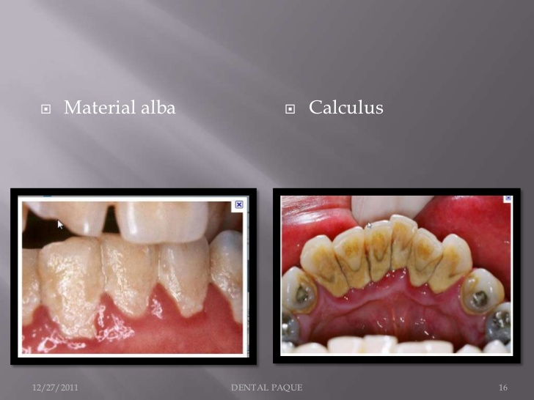

>>>plaque disclosing factor : we ask the patient to rinse his mouth with it , and then the areas where plaque is accumulated appears pink or purple ; by that we are able to locate plaque
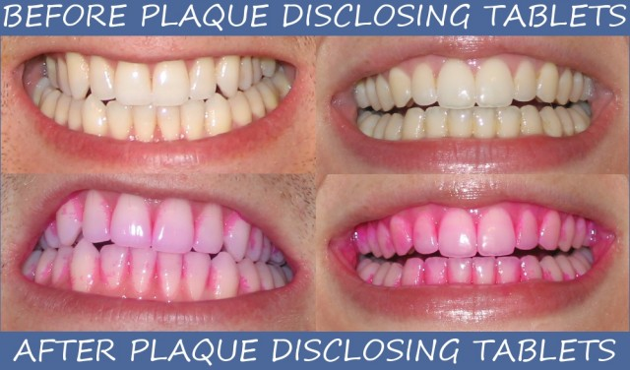
how can i examine dental plaque ? >>>>
1. visually , by using plaque disclosing agent
2. instruments , probe or explorer .... etc

**** we have different types of plaque :
1. supragingival : above or at the gingival margin , when its in direct contact with the gingival margin its called (marginal plaque)
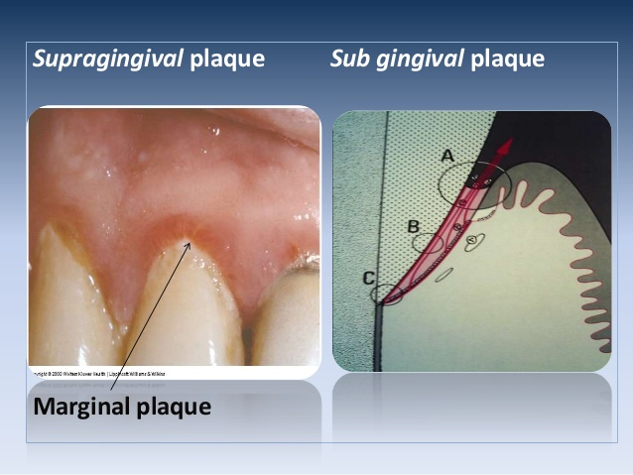

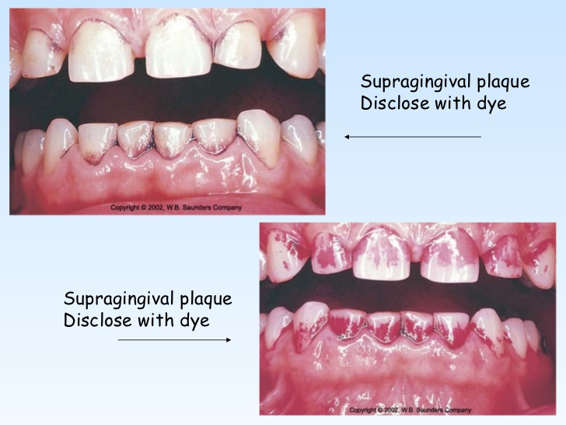
2. subgingival : found below the gingival margin , between the tooth and gingival sulcular tissue

>>>> subgingival plaque is divided into two regions :
A. tooth associated regions : they are adhered to the root cementum
B. tissue associated regions : they are loosely detached from the tooth (its like they swim in the sulcus)
*the difference between these two regions is in the composition of bacteria
*** the difference between supra gingival and sub gingival plaque is in the attachment and in their composition.
extra information :***
the site specificity of plaque is significantly associated with diseases of the periodontium , marginal plaque , for example , is of prime importance in the initiation and development of gingivitis , supra gingival plaque and tooth-associated subgingival plaque are critical in calculus formation and root caries , where as tissue-associated subgingival plaque is important in the tissue destruction that characterizes different forms of periodontitis .

>>>> composition of plaque :
1. microorganisms , most importantly bacteria , there are also other types of microorganisms ; protozoa , yeast , viruses and mycoplasma
-more than 1100 species have been identified in the oral cavity
2. inter-cellular matrix consists of organic and inorganic constituents
- 20-30% of plaque volume
- these constituents (organic and inorganic) are derived from saliva (like glycoproteins , enzymes ...) , GCF and bacteria
*** Gingival crevicular fluid(GCF) : is a fluid occurring in minute amounts in the gingival crevice (in the sulcus between the sulcular epithelium and the junctional epithelium) , believed by some authorities to be an inflammatory exudates and by others to cleanse material from the crevice, containing sticky plasma proteins (albumin is found in small amounts , but in case of inflammation its concentration increases) which improve adhesions of the epithelial attachment, have antimicrobial properties, and exert antibody activity .

*** Organic:

1. Glycoproteins: saliva
2. Mucopolysaccharides: bacteria (dextran)
- dextran : the main bacteria that produce it is streptococcus mutans , dental plaque is rich in dextrans
3. Proteins: GCF (albumin)
4. Lipids: disrupted bacterial and host cells

source : saliva , GCF , bacteria

*** Inorganic:

1. Calcium and Phosphorus
2. Sodium, magnesium, potassium, fluoride,...

Source: saliva or GCF

3. host cells

***plaque is mainly composed of bacteria , that's why they use both terms interchangeably , as if they were the same , although they are not ; bacteria is part of the plaque

>>>> bacteria exist in a very organized community not haphazardly , its a very complex ecosystem , made in such a way that allows the biofilm to stay alive ; if bacteria started to accumulate layer above layer above layer , the deepest part of bacteria will not get the nutrients that it needs so it will die , that's why it is made in such a complex structure .
** after you brush your teeth , bacteria will starts to accumulate after 3 minutes mostly on the gingival third and then it extends
***can we stop plaque from extending on the tooth surface??
yes ,if there is balance between the cleansing effect of chewing and plaque buildup , you will get to a point that plaque doesnt extend on the tooth surface

***Formation of plaque

Stages:

1. Acquired pellicle :we dont know exactly how it happens , there are several theories that tried to explain it ,one of these theories explains it as if it is a primer , activated on the tooth surface , made from saliva (glycoproteins)
2. G +ve facultative aerobes(fix it in the slides ): the first layer of bacteria that attaches to the pellicle
3. G -ve Anaerobes : as plaque matures new bacteria will attach to it which is G-ve an aerobes .

- G+ve aerobies decrease the oxygen tension on the tooth surface , which allow the anaerobes to grow

Growth:
1. aggregation(new bacteria is attached to the biofilm) 2.proliferation(same bacteria is increasing in number)
30 matrix(increase in the amount)

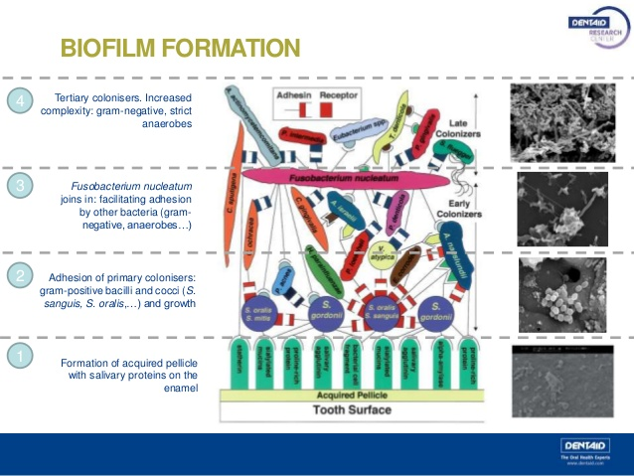

Dental pellicle is a protein film that forms on the surface enamel by selective binding of glycoproteins from saliva that prevents continuous deposition of salivary calcium phosphate. It forms in seconds after a tooth is cleaned or after chewing. It protects the tooth from the acids produced by oral microorganisms after consuming carbohydrates.

***Plaque formation (abstract)
Plaque is a biofilm composed of several different kinds of bacteria and their products that develop over the enamel on a layer known as pellicle. The process of plaque formation takes several days to weeks and will cause the surrounding environment to become acidic if not removed. The surface of enamel attracts salivary glycoproteins and bacterial products creating the pellicle layer. This thin layer forms on the surface of the enamel within minutes of its exposure. These glycoproteins include proline rich proteins that allow bacterial adhesion.

****there is a type of communication between bacteria called quorum sensing , bacteria use it to coordinate certain behaviors such as biofilm formation (biofilms don't exist only in human bodies , they exist in any wet environment like rocks on rivers , it could be made from bacteria ,yeast or fungi) .
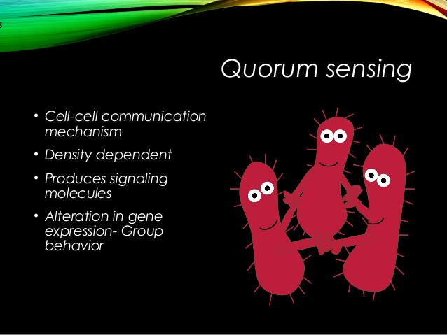

*** Structure of plaque >>>

Supra-gingival plaque:

- Stratified organization
- it starts with G+ve cocci and short rods and then G-ve rods, filaments and spriochetes

Sub-gingival plaque:

-tooth-associated region
G+ve rods and cocci

-tissue-associated regions
G-ve rods & cocci, spirochetes

-there is an extension of gram +ve bacteria subgingivally , followed by an extension of gram -ve bacteria , so once gram +ve bacteria is populated in the sulcus they reduce the oxygen tension creating an environment that favors gram -ve anaerobes .

*** lots of doctors prescribe antibiotics for almost every patient with periodontal infection ( the most prescribed antibiotic is rodogyl which a combination between spiramycin and metronidazole )

- there are indications for systemic antibiotics but they are not considered the first line . (we will understand that later on)

biofilms have lower Susceptibility to antibiotics , they resist antibiotics , why ??? why are bacteria in biofilms more resistant to antibiotics in comparison with when they are suspended in a solution (called planktonic bacteria)(not in a biofilm)(معلقة) ???

- biofilm functions as a barrier , so that limits the availability of the antibiotic around bacteria ; which means bacteria in biofilms has a different LD50 from when its in a planktonic state .

- the proliferation of bacteria within a biofilm is lower compared to the proliferation rate in planktonic state ; antibiotics are effective when cells are rapidly proliferating , so when the proliferation rate in the biofilm is lower that means the antibiotic effectiveness is less .

- some bacteria have developed resistance to certain antibiotics (including the penicillin family) and last year we talked about the ability of some bacteria to transfer certain genes (these genes are responsible of making the bacteria resistant to antibiotics ) to other types of bacteria , and thats another reason .

>>> the proliferation rate in biofilms is lower , why ???
there is a competition between bacteria on recourses , nutrients and oxygen ; that's why proliferation slows down .

**** antibiotics are not effective on their own in treating periodontal diseases

*** if a patient has an artificial heart valve we give him prophylactic antibiotic

*** if a patient got infective endocarditic from a dental procedure ... how do we treat him ???
we don't give him antibiotics , we remove the heart valve and replace it , the biofilm that has established on the heart valve doesnt respond to antibiotics , because bacteria in the biofilm is resistant to antibiotics .

**** conclusion : the discovery that communication between cells in biofilm communities occurs has been key in understanding how dental plaque acts as a single unit. Communication can occur in a variety of ways, including gene expression, cell-cell signaling (ex. quorum sensing), and antibiotic resistance, among others

very important : exam question

******scientists took samples from 30.000 different sites intra orally , they tried to study the composition of bacteria in these sites , they found that there is cluster formation associated with a clinical presentation

>>> for further explanation :

Sigmund Socransky and Anne Haffajee have been able to explain much of the unique colonization patterns and positive cooperation observed in plaque biofilm. The method that has helped explain this is one involving “clustered” groups of bacteria, where each cluster is created based on similarities and differences in nutritional and atmospheric environments). Each of the clusters is said to influence the other clusters, in addition to being related to a specific periodontal state, thus showing that these microbes are very closely associated with one another . Socransky and Haffajee found that within different periodontal states, either all or none of the species belonging to a particular cluster were found. Very few individual species or pairs of species were found, which further helped show that biofilms were a community of microbes. Certain clusters were also found to interact particularly well with other clusters. For example, microbial species found in the red cluster were rarely observed without the presence of the orange cluster species Because of these associations found by Socransky and Haffajee and their cluster analysis, it provided further knowledge to the idea that the microbial communities in plaque biofilms were involved in a great deal of inter-species communication.

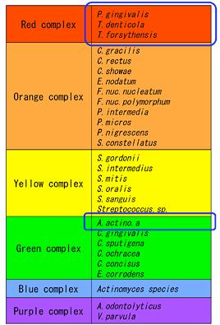

only memorize the framed ones *
* correction : the second one in the red complex is named Tannerella forsythia
* The red complex showed the strongest relationship with the clinical parameters considered most meaningful in periodontal diagnosis.
*treponema denticola is a spirochete
*these complexes are usually associated with health

****usually when there is bacterial infection , you have to apply Koch’s postulate to identify a specific bacteria as the cause of oral infection , but you have to meet certain criteria :
1. the bacteria is the reason behind the disease "if there is bacteria there is disease "
2. when you eradicate the bacteria , resolution happens

- we cant apply Koch’s postulate in perio because as we said earlier sometimes you have the bacteria but you dont have the disease ; thats why these criteria were modified

***Perio pathogen must: ( the modified criteria)

1.increased numbers in diseased sites , not just the presence of bacteria "they have to increase in number"
2.decreased numbers in clinical resolution , "you dont get red of bacteria"
3.induce an immune response
4.causes disease in exp. animal models
5.demonstrate virulence factors

*** there is a table(6-2) in the slides which is very very very important
,you have to memorize it , if the dr. asks you is p.gingivalis a periodontal pathogen? you have to say yes because it meets these certain criteria

(from this point the dr. started reading the slides and added few notes because there was no time)

***Periodontal health: (in case of periodontitis)

1. Primarily G+ve Facultative species
2. Streptococcus and Actinomyces genera
3. Small proportions G-ve species

***Gingivitis:
1. Initially -->G+ve cocci and rods & G-ve cocci
2. Later --> G-ve rods
-Equal proportions of G+ve and -ve

*** Chronic periodontitis:

1. Anaerobic (90%), G-ve bacteria (75%)
2. Spirochetes
3. Pg( p.gingivalis) , Tf, Td, Cr, Pi, Ec, Aa, Fn, Pm

*** Localized aggressive periodontitis:

1. Capnophilic( favors co2 ) ,
2. Anaerobic like A actinomycetemcomitans
3. Pg, Cr, Ec, ..

****if there is anything that wanst clear enough , im always here :)
*** check the slides

good luck

