Preventive resin restoration​

- Used when decay is confined to a part of the fissure system​
​
- includes the removal of carious tissue, insertion of a resin filling and sealant application​
- Used when decay is confined to a part of the fissure system

WE HAVE 3 TYPES OF PRR DEPENDING ON HOW EXTENSIVE THE CARIES IS :
- typeA
- typeB
- typeC

TYPE A:using high speed bur and explore area that is most carious in the fissure system "the most area that we suspect about it and has brownish color. Then by using the bur for widening this area and look if there is no caries stop and put fissure sealant only, don’t remove a lot of tooth structure. Because we want to be conservative
So in type A we use fissure sealants ,not restoration .
Type B: open the fissure and if you find caries soyou have to prepare this area "just carious area not all the fissure " .now, after cleaning caries you have small cavity that will be filled with composite and then fissure sealants for remnant fissure .
Type c : start to prepare and if you find extensive caries so you will end by having conventional class I cavity which will be resorted d by amalgam or composite.

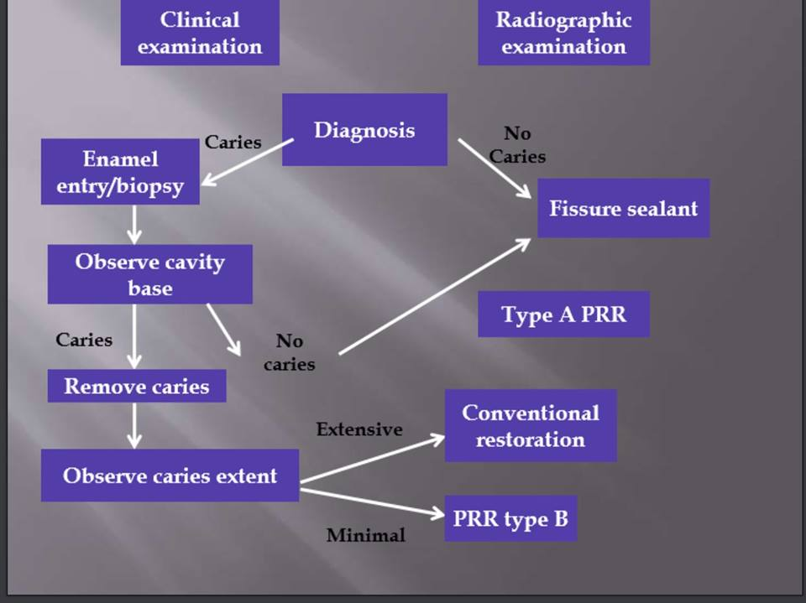

GI FISSURE SEALENT :
The idea of use GI as FS was coming from ART "alternative restorative technique"
ART appeared in developing countries where there are no facilities ,water ,electricity…
ART may be used to restore and prevent dental caries in young patients, uncooperative patients, patients with special health care needs, and situations where traditional cavity preparation and placement of traditional dental restorations is not feasible.
so the GI is easy to apply and attach to the tooth surface without need for light cure.

GI is not use in all cases so what are the indication of use it ?
- erupting "partially erupted molar where we can't achieve good isolation
- uncooperative patients "behavior problem
Note:
Glass ionomers need some sort of isolation not ideal but if we have wet condition it won't bond to the tooth structure .

ALL the clinical studies that compared the conventional resin sealant with GI showed that :
1-resin is much higher retentive than GI ,so GI not adhere properly to the tooth structure and it will wear with time
Note: all studies encourage using of high viscosity GI sealant because its more retentive than low or medium viscosity .
2- both of them have the similar effect on prevention of caries

When we are talking about sealant .we have 2 ways of prevention caries :
1-physical :binding to the tooth structure as conventional resin sealant
2- biological : as GI 'FLUORIDE REALES "
How both resin based sealant and glass ionomers sealant have similar effect on caries prevention ?
They did microscopic studies and found there are remnants of GI at the base of fissure and these remnants prevent formation of caries by release fluoride

Why do concern to use GI sealant more than conventional rein sealant ?
Because of investminal "BPA" material that is released from most of resin material
This material has possible carcinogenic and estrogenic effect.
So we go through using GI instead of resin to reduce of carcinogenic effect

AAPD​ said the the resin based sealant achieved better retention but GI could be used as transient sealant especially when moisture control is not possible as in pt with high risk caries

Example : pt with carious Es and D's and partially erupted 6's ,so this pt is indicated for using GI until the 6s is fully erupted then we can do pope isolation and go for conventional reisn sealant

What do we need to place fissure sealant ?
1-proper isolation
2- cleaning the tooth structure
3-acid etching
4-sometimes bonding agent
5- instruments (probe ,fissure sealant material,microbrush,articulating paper,to check the occlusion at the end )
- Prepare patient (Tell, Show, Do)
Firstly ,EXPLAIN what is about to happen, in language appropriate to your particular patient’s level of understanding
​ EXPLAIN what is about to happen, in language appropriate to your particular patient’s level of understanding
DO
- ​ Isolation
- IS AMUST ​
- Done by using rubber dam"needs anesthesia", or cotton roll
- Or by dry dam that put buccally or lingually to absorb the saliva
Isolation is critical because enamel porosity will be compromised with any liquid
​
- ​ Surface cleaning​
By brush or cup not use a pumice because it will stick to the tooth structure
- Etching
- 35%phosphoric acid​ for 15 sec
- acid selectively removing crystalline phases of enamel
- Vastly increases surface area for adhesion​
​

​

* acid itching in fissure sealants and the produced patterns:
This mainly seen in permanent teeth not primary because of less enamel prism and more organic control :

1-Honey comb etch pattern​:
The crystal with no core because its destructed and periphery intact .this is the best pattern of etching

2- Reverse honey comb etch pattern
The core is intact and the peripheral is destructed

3- Haphazard etch pattern​
Destruction all over mno pattern at all .

What is the significant of the pattern ?
That means that the histology of enamel differ from tooth to tooth and surface and even in the same surface we can see differences

Note : you can refer to slides because I can't here the last 2 minutes

