Pedo sheet No.#9
Refer to slides #9
Written and corrected by: Aseel Al Ananzeh

Last time we talked about chronology and eruption of primary teeth, properties of the primary dentition, shape of the mucosa and teeth, the relationships between the teeth, and so on.
Today we’re going to talk about the period of the mixed dentition; early and late.
At the end of the primary teeth stage, they’ll start to shed and will be replaced by permanent teeth, shedding of teeth results from the progressive resorption of the roots of teeth and the supporting tissues, and is accomplished by the multinuclear odontoclasts, part of the resorption happens to the bone and the other part to the roots of the primary teeth.
This process of resorption will undergo periods of rest and repair, but at the end the resorption will predominate and the permanent successor will erupt.
Causes of shedding: mainly pressure from the underlying erupting successor tooth and this is not the only reason that results in exfoliation of primary teeth, because some primary teeth exfoliate even when the successor is missing, example is the lower 5 even if it’s not there the E will eventually exfoliate, sometimes the pressure from the mastication will stimulate the resorption of the roots of the primary teeth ( mastication acts as a trauma to the primary tooth and the PDL can’t withstand this pressure so resorption is stimulated) the primary tooth will eventually exfoliate. This is seen in patients with missing permanent laterals but the B will exfoliate and will not stay forever.
Pressure from the underlying successor. 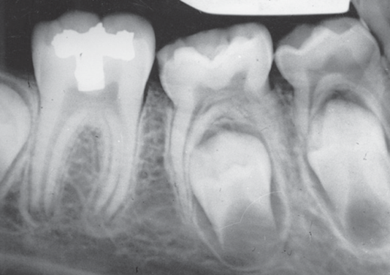
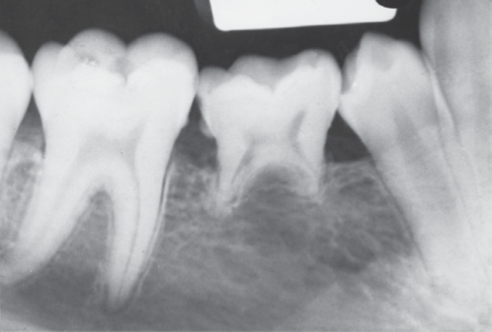5 is missing but roots of E still undergoing resorption.

Resorption pattern of anterior teeth:
Permanent teeth undergo complex movement before they reach their position from which they will erupt “pre-eruptive movement”, the tooth germ will be in a certain place but before the eruption it will move until it reaches the proper position.
Permanent incisors and canines first develop lingual to the deciduous tooth germs, but as the child grows they will move to a more forward position until they become apical to the primary tooth, so they move to a more apical position until they occupy their own bony crypts.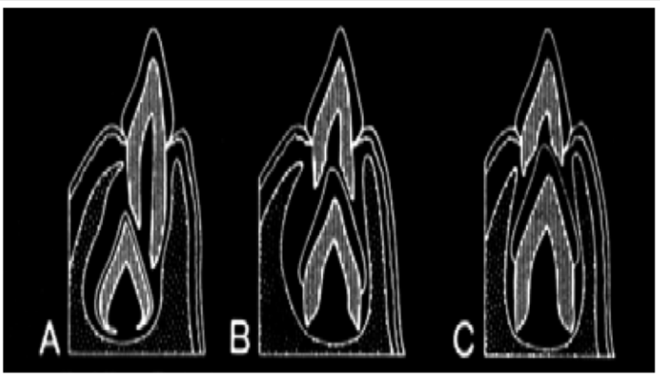
The tooth is lingual at the beginning then it moves apical until it reaches its position as in the picture above.
Regarding the premolars they also will erupt lingual to their predecessors and then they will shift so they are situated in their own crypts beneath the divergent roots of the primary molars. This change in position provides the growing premolars with adequate space for their continued development until their roots is completed. So premolars erupt in the position of the deciduous molars.
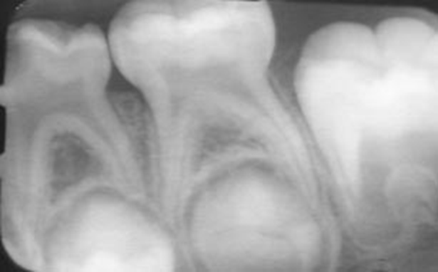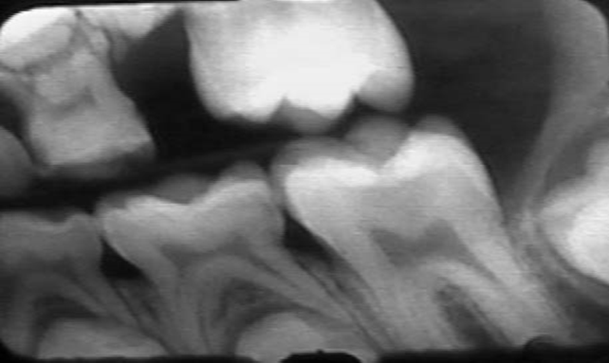

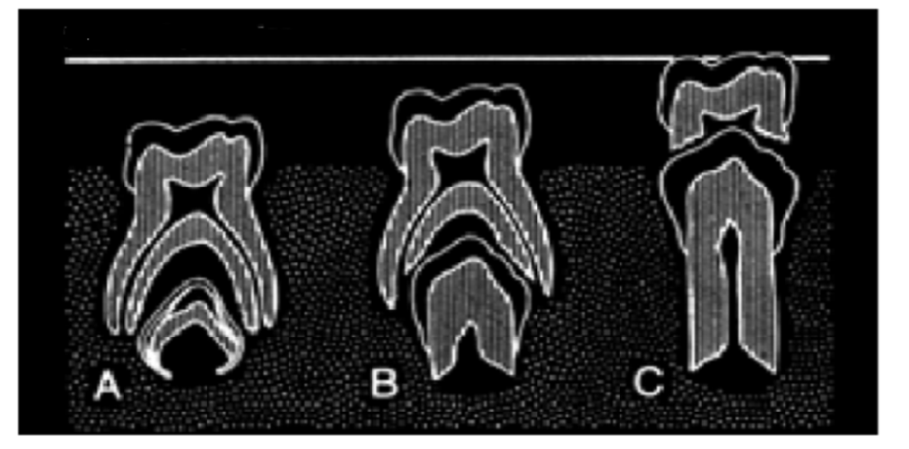
So as you see in the pic above, the premolar is lingual to the primary molar at the beginning, then it’ll move until it reaches the interradicular area of the primary molar then it’ll erupt after the exfoliation of the molar.

Eruption of permanent teeth:
- Chronology of eruption.
- Sequence of eruption, variations.
- Rhythm of eruption.
chronology:
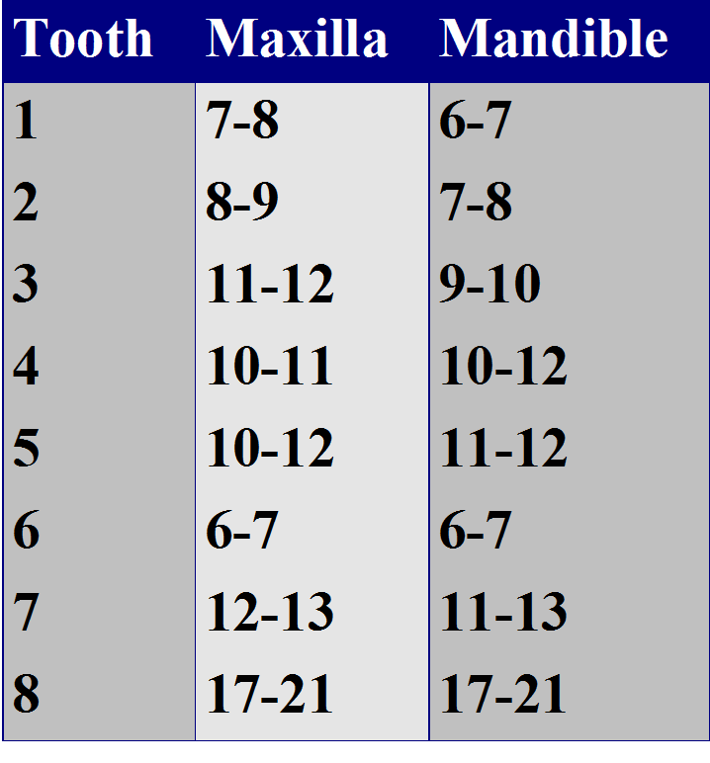
the first permanent tooth to erupt is the 6 ( first permanent molar) it tends to erupt in the same time in the maxilla and in the mandible at 6-7 years old, an important point is that this tooth erupts distal to the primary teeth ( not due to exfoliation of a primary tooth) you have to explain this for parents because they come wondering that their children have caries on a permanent molar but saying that the primary didn’t exfoliate so explain to them that the 1st molar erupts distal to the primary teeth and tell them about the importance of the oral hygiene because this is a permanent tooth.
After that also at 6-7 years the lower incisors erupt followed by upper incisors then lower laterals then upper laterals, then for the other teeth there is variations in the sequence between the upper and lower arches.
In the lower arch: ( 6,1),2,3,4,5 then 7 and 8 will erupt.
Upper arch: 6,1,2,4,5,3, then 7 and 8 will erupt.

The most likely tooth to become impacted in the upper arch is the canine and the second premolar in the lower arch; based on the eruption sequence.
What happens if the primary molars are lost prematurely?
3 aspects:
- If they are lost very early around 4-5 this will result in a considerable delay of eruption of the premolar teeth, example is child with abscess and we extract the D or the E.
- If extraction occurs after the age of 5 years there is a decrease in the delay of premolar eruption; there is a delay but not as much as when we extract at 4-5 years.
- Extraction at 8, 9, and 10 years of age (before the physiologic exfoliation) will provide space for the permanent tooth and accelerate the eruption.
Variations in eruption sequence:
**Eruption timing in girls generally precedes that in boys by an average of 5 months, but this is not a rule.
**Alteration of sequence of eruption alerts the practitioner to potential problems, always count the teeth.
**No clinical significance to the eruption of incisors before first molars, if the incisors erupt before the molars that’s normal and acceptable.
** It is desirable that the mandibular canine erupts before the first and second mandibular premolars, this aids in maintaining adequate arch length and in preventing lingual tipping of the incisors.
** If the mandibular second permanent molar erupts before the second premolar, a deficiency in arch length can occur; if the 7 erupts before the 5 pushing of the 6 mesially will occur and the 5 becomes out of the line of the arch.
** Untimely loss of primary molars in the maxillary arch may allow the first permanent molars to drift and tip mesially, resulting in the permanent canine being blocked out of the arch.

Rhythm of eruption:
*Two stages:
Eruption of Incisors and first permanent molars: Early mixed dentition.
Premolars, canines and second molars: Late mixed dentition.
Third stage: third molars (full permanent dentition)

** The rule of four for permanent tooth development; for every 4 years something happens:
- At birth, four first molars have initiated calcification.
- At 4 years of age, all crowns have initiated calcification.
- At 8 years of age, all crowns are complete.
- At 12 years of age, all crowns have emerged.
- At 16 years of age, all roots are complete, except for the third molars.
This helps you to memorize but it’s not a golden rule.

**Crown formation completed at least 3 years before eruption; what actually happens is that in the tooth germ enamel and dentine are laid down and then they start to calcify. Crown is divided into 3 parts incisal/occlusal, middle, and cervical thirds, each third needs one year to complete the calcification; so 3 years in total and then another 3 years to erupt, 6 years in total.
Example: 6 starts it’s calcification at birth, at 3 years old the crown is completed and at 6 years old the tooth will erupt. Crown formation completed at least 3 years before eruption.
Roots completed around 3 years after eruption and the teeth erupt when 2/3 to ¾ root development is completed.

Hard tissue formation (initiation of calcification) is important and is a considerable factor in hypoplasia, at birth 6s will start to calcify, 1 and 3 in the upper arch, 1,2,3 in the lower arch start calcification at 3-6 months of age, upper 2s at 10-12 months of age, lower and upper premolars and second molars at 1.5-2 years of age, upper and lower third molars at 7-10 years of age.
For crown completion add 3 years to the age at which initiation of calcification occurs for each tooth, 6s crown will be completed at 2.5-3 years of age, 1s,2s,4s, at 4-6 years of age, 3s,5s,7s, at 6-8 years of age, and third molars at 12-16 years of age.

Now we’re going to talk about some variations and disturbances related to eruption of teeth:
- Lingual eruption of mandibular permanent incisors.
- Ankylosed primary molars.
- Eruption sequestrum.
- Ectopic eruption of 6s.
- Incisor liability.
- Leeway space.
- Late mesial shift.

** Lingual eruption of mandibular permanent incisors:
A cause of concern for parents, “my child has two rows of teeth “the area is accessible and they can see it, seen both in patients with an obvious arch length inadequacy and in those with a desirable amount of spacing in the primary dentition, it’s not related to crowding, it’s just related to the position of the tooth germ sometimes the germ failed to move apically and the incisors erupt lingually. All you have to do is reassure the parents because this is normal and can be managed; if the patient is 7-8 and the primary incisors are not mobile or more than a half of the permanent incisors has been erupted then extract the primary incisors. But in majority of cases the primary incisors are mobile especially if the patient is around 6-7 years of age or if less than a half of the permanent has been erupted so we only reassure and observe because the primary incisors will eventually exfoliate spontaneously and the movement of the tongue will push the permanent incisors into the line of the arch, there is no need to interfere or extract.

**Ankylosed primary molars:
Ankylosis is the cause (pathogenesis), infraocclusion( submerged teeth) is the clinical observation. PDL will no longer be there and the root of tooth will be fused to the bone and the tooth will be locked in place. All the adjacent teeth will continue to grow so the tooth appears as if it sinks down. Mandibular primary molars are the most commonly affected and the cause exactly is still unknown could be familial, sometimes they think that absence of the successor cause ankylosis but you can’t actually say that because in some cases the primary tooth becomes ankylosed while the successor is there. What actually happens is that the resorption undergoes phases of activation and suppression, if the suppression predominates ankylosis occurs due to the fusion between the root and the bone (solid union).
Ankylosis mainly diagnosed when the tooth is out of occlusion and by percussion (the PDL acts as cushion around the tooth so when the tooth is ankylosed and there is no PDL a metallic sound will be heard upon percussion)
If the tooth is normal the PDL will absorb the force of percussion and tapping on the tooth and the sound is normal, if there is periapical pathology the percussion sound will be more dull.

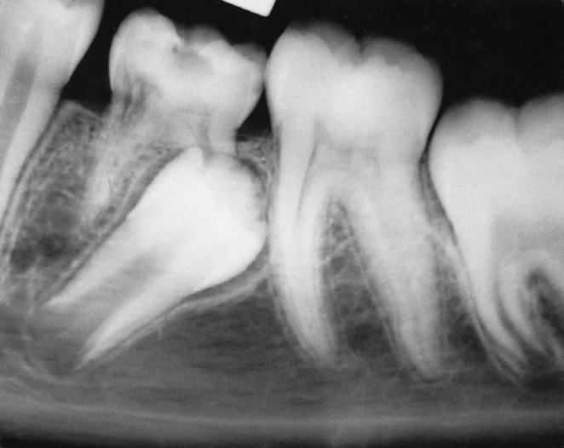
The ankylosed tooth is not mobile even if the roots are resorbed; you notice in the x-ray that there is a break in the continuity of PDL (no PDL at all).
In this case you have to interfere and extract because ankylosis resulted in change in the eruption path of the premolar, but generally you keep the ankylosed tooth under observation the tooth may undergo exfoliation, in majority of cases and as long as the successor is there you leave the ankylosed tooth in place and it’ll eventually exfoliate within 12-18 months so no need to interfere, we only interfere if the tooth becomes severely sub gingival (progression of infraocclusion is very evident) or if there is obvious malocclusion in the same arch or the opposing (tipping of the mesial and distal teeth or over eruption of the opposing teeth) or if the roots of the permanent tooth is almost complete (eruption potential is high).
When the permanent tooth is missing we consult an orthodontist and a prosthodontist because if the arch is crowded the orthodontist may need this space so we extract and put a space maintainer or we keep the tooth as a space maintainer. Sometimes the ankylosed tooth needs surgical extraction when it’s too deep sub gingivally.

**Eruption sequestrum:
Is seen occasionally in children at the time of the eruption of the first permanent molar, Dr Rawan has never seen one, it’s a tiny spicule of nonviable bone overlying the crown of an erupting permanent molar just before or immediately after the emergence of the tips of the cusps through the oral mucosa, it develops from either osteogenic or odontogenic tissue mucosa.

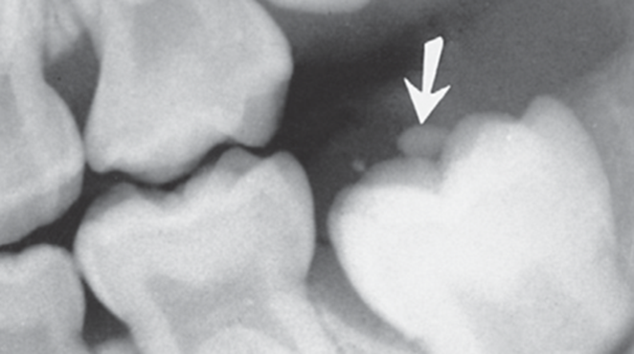
as you see the partially erupted molar with the arrow at the sequestrum overlying the central fossa, embedded, and contoured within the soft tissue.

Some of these sequestra spontaneously resolve without noticeable symptoms, because it’s only overlying the tooth.

It may easily be removed if it is causing local irritation.

The base of the sequestrum is often still well embedded in gingival tissue when it is discovered; we have to apply full topical anesthetic or few drops of local anesthetic to avoid discomfort during removal.

**Ectopic eruption of first permanent molars:
6s may be positioned too far mesially in their eruption path with resultant ectopic resorption of the distal root of the second primary molar; the permanent molar becomes locked behind the distal root or the distal bulge of the E.
There are two types of ectopic eruption—reversible and irreversible; in the reversible type, the molar jumps back into its normal position, it frees itself and erupts into normal alignment with the second primary molar remaining in position no need for any intervention.

Most permanent molars in children with reversible patterns free themselves by 7 years of age, if delayed we start to think that it may be irreversible and needs interference.

In the irreversible type, the maxillary first molar remains unerupted and in contact with the cervical root area of the second primary molar, and by the age of 7 and 8 years, any ectopic eruption of a permanent first molar should be considered irreversibly locked.

Prevalence is low, around 3%, and it’s seen more frequently in boys than in girls and it occurs in more than one quadrant. Most often observed in the maxilla. Exact etiology is unknown but they think that when there is no enough space in the arch the 6 will be ectopic and when the tooth germ or the path of eruption is mesial it’ll erupt ectopically.
Two thirds of cases erupted in their normal position without any corrective treatment.
Children with irreversible ectopic eruption have significantly large permanent first molars and more pronounced mesial angle path of eruption with a tendency towars a shorter maxilla in relation to the cranial base.
No significant differences in these variables were found between sides with reversible eruption and sides with normal eruption.

Ectopic molars also show a significant familial tendency with a prevalence of 19.8% in affected siblings versus the overall 2% to 3% general occurrence.

A frequent occurrence rate of ectopic first permanent molars at 25% in cleft lip and cleft palate children. Possibly caused by maxilla positioning and basal arch size.

Irreversible ectopic molars that remain locked, if untreated, can lead to premature loss of the E with a resultant decrease in quadrant arch length, and asymmetric shifting of the upper first molar toward class II positioning.
Irreversible ectopic molars that remain locked, if untreated, can lead to: Supraeruption of the opposing molar with distortion of the lower curve of Spee and potential occlusal interferences.

If detected at 5 to 6 years of age, an observation approach of “watchful waiting” with appropriate monitoring is indicated, usually before 7 it’s reversible and needs no correction.

With self-correction being unlikely approaching 7 years of age, continued “locking” of the first molar with advanced resorption of the primary second molar usually warrants intervention.

Another timing clue is that when the opposing molar reaches the level of the lower occlusal plane, intervention is indicated to establish proper vertical control and prevent supraeruption, if the lower molars are erupted and are at the level of the occlusal plane and the upper molars are still not erupted yet then we have to interfere to prevent over eruption of the lower, this can be corrected by separators or distalizing appliance.
Orthodontic elastic separators are the first choice if access is sufficient to allow insertion for engagement in the contact areas of entrapment, we try to slide the separator on the distal side of the E by a floss by this we are pushing the permanent molar into the arch, progressive use of larger separators facilitates this approach.

Separating springs can also be used provided sufficient eruption for insertion between the contact areas, metallic springs can be used if there is sufficient access. Elastic separators are easier to use.

Brass ligature wire threaded between the contact areas of the affected teeth may facilitate distal movement of the permanent molar. Periodic tightening of the looped wire every 3-5 days is indicated as a separating force.

Treatment with any of the separator techniques requires that only a minimal lock be evidenced and that minimal resorption of the primary second molar has occurred, separotrs can’t be used in advanced cases (class 3 and 4) these need a distalizing appliance; fixed or removable results in distal tipping of the tooth.

If the condition is symptomatic and the pulp is involved we may need to extract.

**Incisor liability:
Permanent incisors are larger than primary incisors, How does the body create enough room for the larger permanent incisors?
- Interdental spacing of primary incisors.
- Intercanine arch width growth.
- Labial positioning of the permanent incisors provides a larger arch.
- Favorable size ratio between the primary and permanent incisors, if primary are tiny and the permanent are large this causes a problem.

Good interdental spacing of the primary incisors allows for better positioning of the permanent incisors, parents find it it unaesthetic but you have to explain that this is a good thing.
*Arch length prediction from alignment of primary teeth:
Crowding of the primary: almost certain extraction to molars or premolars to allow the incisors to fit in the arch.
No spacing and the teeth are fit in the arch: extraction is possible.
Fair spacing: mild to moderate crowding.
Good spacing: no or mild crowding.
Excess spacing: no crowding/excess.
The more the spacing between the primary the better the alignment of the permanent.

Intercanine arch growth creates more room for the permanent incisors.
Mandibular intercanine growth occurs mostly during permanent incisor eruption.
Maxillary intercanine growth occurs during incisor eruption, and continues. This is unpredictable.
Labial positioning of the permanent incisors:
Permanent incisors erupt to a more labial position
Permanent incisors are angled more labially, primary are more upright this provides larger arch space and more arch length.
Favorable size ratio between the primary and permanent incisors; may be favorable or unfavorable.
Favorable: large primary, small permanent.
Unfavorable: small primary, large permanent, this dictates a problem and the child is probably needs extraction.

**Leeway space is the amount by which the combined size of the primary canine and molar teeth exceeds the combined mesiodistal widths of the permanent canine and premolar teeth, MD width of C,D,E is more than that of 3,4,5. Primary molars are larger than the premolars.
Leeway space of the upper arch differs than that of the lower, 1.5 mm in the upper arch and 2.5 mm in the lower arch. this is related to final molar relationship. Difference of the leeway space will determine if it’ mesial step, distal step, or flush terminal relationship.
Flush is preferred because it allows the 6s to drift mesially and result in class 1.
Distal step>> class 2
Mesial space>>could stay class 1 or could result in class 3.
Best occlusion in the primary teeth is flush terminal.

Sorry for being late, and sorry for any mistakes.
Good luck
Aseel Al Ananzeh.

