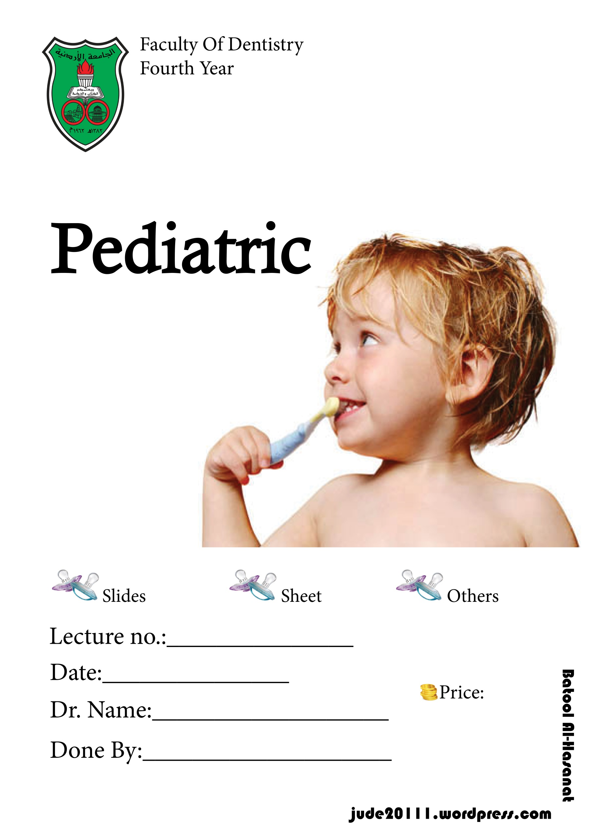
Batool M Hasanat

8/2/2015
Dr. Suha Abu-Ghazaleh
2

Lecture outline :
*Clinical examination
*behavioral management

Dr Continue the last part of the last lacture :
- History : it's help to establish a relationship to the child and his or her parents
- Clinical examination, start to take overall impression of the child’s health and development the moment he or she enters the clinic , and do a spot diagnosis if there is something major as soon as u see them enter the clinic .
It's useful to know the following from the first :
- General health
- Age ( overall physical and mental development that seen a propriate for the child morphological age, dose he act as 7th years old child for example or not )
- Weight ( under or over weight )
- Gait ( Normal , obvious motor impairment )
- Speech (Normal, slurred, stuttering, lisp)
- Hand ( nail biting , finger clubbing )
In this clinic we deal with children who are difficult to deal with them even to take a look on their teeth upon examination .
Pediatric patient categories :
- Happy and confidant ( (على طول بقعد على الكرسي وبفتح فمه ومتعاون لابعد الحدود
- Little action and shy ( allow the examination after some communication and reassurance , very frighten , avoid eye contact , not answer the direct question )
- Sever behavioral problem ( they may have learning disability , بضلوا يصرخوا ,this category is treating under GA (examination and treatment in the same time )

Vary young children that we can't communicate with them ( call them pre cooperative, 2-2.5 years old or less, vary difficult to let them set on chair and leave us to examine in easier way , so we need to do an examination in the control but restrained manner ) we use knee to knee examination
knee to knee examination
Explain the position for the child's parentوراسه مايل باتجاه الدكتور يحطوا الولد بحضنهم و وجهه الهم
The parent can help you by holding the child’s hands as you complete the examination
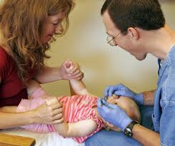
Reassure the parent that the child will not be hurt
Very quick look on teeth , fluoride application , GI on cavitation teeth

Examination : ( in systemic manner )
- Extraoral examination
- head :size and shape , abnormality , asymmetry
- hair : head lice ,
- eyes : wear a glasses , blurred vision
- ears : any abnormal morphology , neurology
- skin : document any scar , laceration , paler
- TMJ : any pain , deviation , restricted opening
- Lymph nodes : palpate mandibular lymph node , not always indicative oral problem ( very commen on children to have idiopathic frequency viral infection )
- Lips

- Intraoral examination
- Soft tissue ,check for any pathology , find sinus mean non restorable tooth
- Periodontal tissue.
- Oral hygiene- poor, fair, good.
- Plaque index : using plaque score ( disclosing tablet ) good acclimatization procedure.
- Occlusion ; over jet , over bite , molar relationship (if the 6s not erupted we look at the distal aspect of the Es, and if the 6s erupted we go to angle's classification) , cross bite, Incisors erupted(in the age we expect them to erupt) ,Canines palpable (by 9-10 years of age).
- Teeth ( count the teeth , not to miss any supernumerary teeth , set a routine for examination , if their any hyperplasia or discoloration )

For proper assessment ;
- each tooth should be Clean , dry
- Good source of light
- Carful use of a probe to remove any food
- Record every thing ; teeth present , unerupted or missing , caries ,restoration / fissure sealant , teeth to be extracted , anomalies

- Radiographic examination ( must be appropriate and justified )
To diagnose :
- Dental caries
- Abnormalities in development
- Bony or dental pathology

Bitewing radiograph :
- To detect the proximal caries specifically in primary molar due to the wide contact in primary dentition ,clinically ; primary teeth may appear good but on BW radiograph there will be interproximal caries
Kidd and Pitts (1990) The use of Bitewing radiographs is essential if much a proximal caries is not to be missed. (50% were missed !!)
This is especially true in small lesions

- For diagnosis of hidden dental caries under sound looking occlusal enamel.
Caries progress rapidly in primary teeth & may involve the pulp if left undiagnosed.

Panoramic radiograph :
- Unerupted teeth, ectopic teeth, congenitally missing teeth ( i.e. lower 5 ), supernumerary teeth.
- Parallax technique for exact location of impacted teeth. i.e. max. canines. ( SLOB )
- Abnormalities in dental development

Periapical radiographs :
- When increased detail of a particular tooth is required.
- Pulpal involvement suspected following trauma (PERMENANT U1 MAINLY )
- Assess root development/ resorption (* resorption root : Tx extraction , *interradicular radiolucency indicate that the pulp is irreversibly inflamed unlike the permanent teeth; we check the periapical area to diagnose the state of teeth .

Special investigations :
- Vitality testing: Ethyl chloride, hot Gutta Percha, electric pulp testing use them in permanent teeth following trauma , Not very reliable in children," false positive " but still use them to give a base line in our assessment
- CBC ( info from the pedo lab ) , related to infection , syndromes , …

Treatment Planning
- Management of pain (the most common ):
A priority ,Have the long term treatment plan in mind before embarking on a single item of treatment. in the case of traumatic injuries, it is necessary to carry out immediate treatment( close expose dentin ). A subsequent appointment is made to formulate a long-term treatment plan.

- Preventive care.
The most important aspect of treatment planning for the young patient.
Advice should be realistic and tailored to each individual case ( مراعاة وضع الام )
Dietary advice, fluoride supplementation & oral hygiene measures.
Preventive advice should be reinforced regularly ( في كل زياره ارجع أكد على الاهل )

- Restorative care
Start with the easiest restoration
Obtain the cooperation of the child.
Good clinical judgment: examine , x-ray ,,, Is the tooth restorable? Is it about to exfoliate?
Start with easy operative, if possible, usually maxillary arch (because the LA with the upper arch is easier).
Larger restorations later on.
*Temporizing : child with multiple caries ; excavate the wall as possible as we can ,then temporize with GI , then focus to restore each tooth a lone ( reduce symptoms , reduce level of bacteria )

- Surgical Treatment
Have a long term treatment plan before embarking on an extraction.
Consider the need for space maintenance

- Orthodontic treatment
Refer at the correct time.
Space maintenance when indicated

- Review and recall
Review is an attendance at a further appointment within a course of treatment ( what we will do on each visit ).
Recall is defined as the planned, unprecipitated return of a patient, who when last seen was in good oral health. For check up , Recall at least once a year. Most of the time, 6 months is a convenient interval which provides for continuity of care , sometime the period be less depending on caries risk of patient and specific case ( wait eruption of central , sequence of eruption , periodontal health , so recall every 4 months ) .

Variations in recall frequency
- Milestones in dental development.
- Eruptive sequence of teeth.
- Signs of active oral disease.
- Specific oral conditions i.e. periodontal disease.
- Medically Compromised children.

Aims of Pediatric Dentistry
- The child reaches adulthood in a state of good dental health.
- The child develops positive attitudes to dental care.

Behavior management in children
( behavior guidance )
Behavior management:
- The means by which the dental health team effectively and efficiently performs treatment for a child
- The aim is to instill a positive dental attitude
- The child is weak physically فا بسهوله ممكن نمسكهم من ايديهم ونثبتها بس هيك بنعقدهم من دكتور الاسنان
- Behavior management methods are about communication and education.
- The relationship between the child, the child’s family and the dental team is a dynamic process
- it starts before the patient arrives in the surgery and involves dialogue, voice tone, facial expressions, body language and touch.
- The appropriate management technique should be chosen based on the individual child’s requirements.
- Every practitioner integrates his or her personality with basic psychological principles in managing children in the dental environment.
- What works for one practitioner may not necessarily work for another.

Dental anxiety :
Dental anxiety : (related to dental treatment ) A vague, unpleasant feeling, accompanied by a premonition that something undesirable is about to happen . anxiety is a more general, non-specific feeling of apprehension
Fear is a dread of something specific in the external environment ( LA , hand piece sound )
In a study by Agras et al, visiting the dentist ranked 4th behind snakes, heights and storms
as an anxiety producing situation
The most anxiety provoking procedure at the dentist has been reported
to be the local anesthetic. (Humphris et al, 1995)

Manifestation of anxiety :
- Physiological and somatic sensations.
Perspiration, palpitation, breathlessness.
- Cognitive features.
Interference of concentration, imagining the worst that can happen.
- Behavior.
Avoidance; postponing a dental appointment.

How do you measure anxiety?
- Physiological measures: polygraphic recording of heart rate, hand and face temperature , measure physical reaction . ( مش كثير بتفيد لاحتماليه انه الاجهزة الي بنستخدمها في القياس تسبب هي نفسها anxiety )
- Self-report measures: interviews and questionnaires.
Venham picture test : for small children.
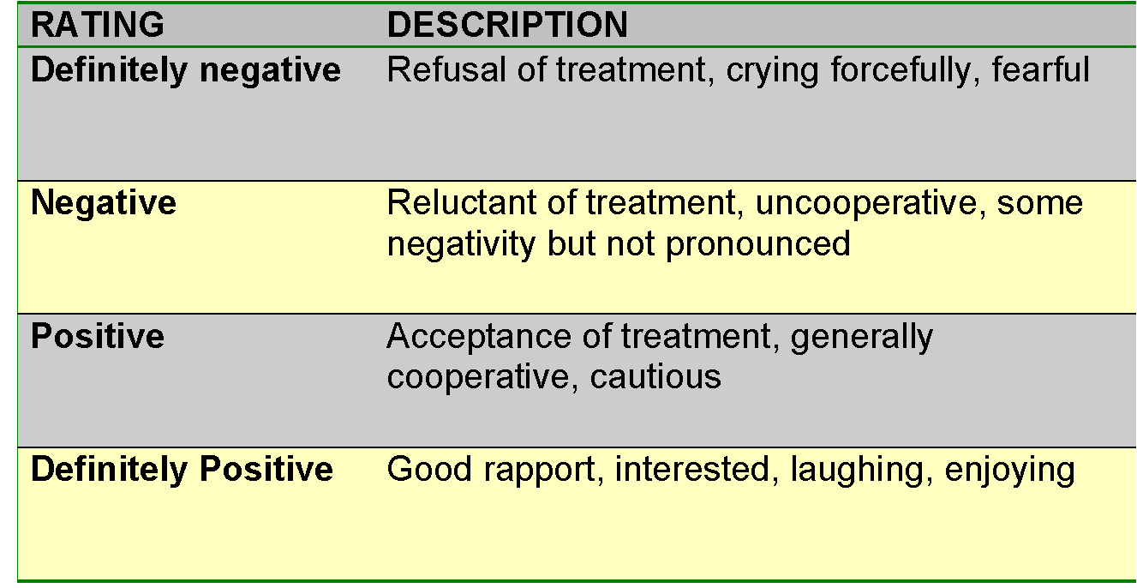
Corah’s dental anxiety scale: for older children
- Behavioral observational scales:
Frankl behavioral scale. (old and quick way)

Frankl behavioral scale.

Wright’s clinical classification:
- Cooperative: get along fine in the dental environment without significant disruption.
- Lacking cooperative ability: Because of their young age ‘less than 2 years of age’ or low mental level , these children are unable to cooperate and unable to communicate at the proper level . Don't try with them .
- Potentially cooperative: have cooperative abilities but for some reason, elect not to cooperate.
Your most challenging patients , divided it into Uncontrolled , Defiant ,Timid ,Tense-cooperative ,Whining.

*Uncontrolled :
- 3-6 years of age.
- Tantrumبلشوا يصرخوافجأه ويحركوا ايديهم ورجليهم
- Can result in a dangerous situation.
- If the child became uncontrolled; deferral of treatment is to be employed (temporization and dismiss the patient )

* Defiant:
- All ages.
- ‘I don’t want to’ in young children.
- Passive resistance in older children. ( بدفشوا بايديهم )

* Timid.
- Shielding behavior or hesitating.
- Hide face with hands or hide behind their mothers.
- May deteriorate into uncontrolled.

* Tense-cooperative
- Older children, more than 7 years of age.
- Trying to be helpful, but are very anxious at the same time. ‘White knucklers.’ شادين على ايدين الكرسي

*Whining.
- Usually continuous.
- Absence of tears.

Creativity is contagious. Pass it on.
Albert Einstein

