University of Jordan
Faculty of Dentistry
Fourth year –2nd semester 2014-2015

Periodontics

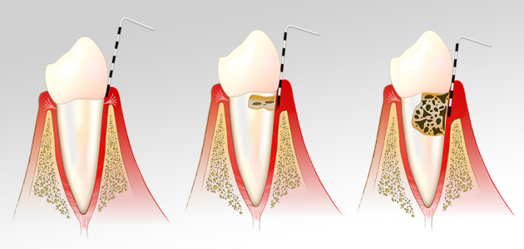

Hand Out
Sheet

Slides

Dr.omar
24
Nour al. sobani
Doctor:
Date:
Lecture No.
Done by:

27/4/2015

Periodontal maintenance therapy

Phases of periodontic therapy:
- Initial phase (non-surgical phase) or phase I.
- Surgical phase or phase II.
- Maintenance phase or phase III.
The word maintenance means to protect thing.
- In cons when we restore a tooth do we need to do maintenance for the patient?

** Probably no, but we should keep an eye on it to prevent recurrent caries for example.
** Most of the time if we eliminate the bacterial source and provide good seal by the restoration everything will be good.

- In perio everything is different, you can't eradicate bacteria completely from the pocket, because the oral cavity is full of germ and it is the filthiest place in the body.
- So once you have a deep pocket and you treat it and there is partial healing, the part which remain unhealed it might get reinforced.
- So in perio the patient must always keep on maintenance because of the tendency to relapse after treatment.

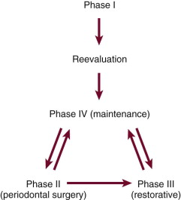

- In this diagram we always put phase IV before phase II and III, because you need to make sure that there is no progressing or active disease.

- What we do in the reevaluation phase?
** We reevaluate the response of the tissue to our treatment, so we aim to remove the cause of the disease then we need to see if the tissue responds well or not, and decide if you need further treatment or not.

- How to know if the patient responds well or not?

** In case of gingivitis, the redness goes off, the size of the gingival will reduced and the bleeding will reduced also. So we will end having a healthy gingiva.
** It takes from 1 to 2 week to back to normal.

** In case of preiodontitis, the pocket will reduce, also the bleeding will reduce.
** It takes from 1 to 2 month to back to normal.

** The reevaluation is still part from the non-surgical therapy by the way**

- The maintenance is what you decide in the reevaluation, do you need further steps or just keep the patient on a follow up visit and after that if he needs surgery, antibiotic or other type of treatment.

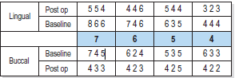

- This chart showing just a segment of teeth before and after treatment.
- You can see that the buccal and lingual baseline pocket is from 6 to 8, in the post operative it is reduced slightly, some teeth reduced to become 3mm and some just to 4 and 5.
- So we asked ourselves is there any improvement? Yes ….. Is the treatment is complete? Probably not.

- Notice that 4 to 5mm pocket can sometimes acceptable, for example, if the pocket was 9mm and reduced to 4 or 5mm and there is no bleeding and no inflammation you can just keep the patient on maintenance, but if it still inflamed you will think of retreatment or doing a surgery.

- The outcome of perio treatment can be one of three :

- Treated site (the pocket reduced to less than 5mm and there is no bleeding on probing).
- Responding or partially treated site (there is pocket reduction from 8 to 6 for example or still there is bleeding on probing, there is improvement but after 1 to 2 month it will become re infected again).
- A non-responding site (the pocket remain as it is or even getting worse).

- In the reevaluation stage we depend on the outcome to determine the next step of treatment.

- Why some areas don't respond to treatment?
- Incorrect initial diagnosis (maybe the pulp is the problem not the periodontium).
- Inadequate plaque control(patient doesn't follow the oral hygiene instruction correctly)
- Inadequate subgingival debridement
- Smoking
- Anatomic factor (mesial concavity on upper 4, enamel pearls and furcation for example).
- Other factors (systemic (diabetes), genetic, microbiology).

- What we do for the non responding site?
- Re-scale or redo root debridement, if there is deposits remaining specially in the anterior area where we don't prefer to do a flap(to prevent recession and formation of black triangle) or the systemic condition of the patient doesn't permit doing surgery.
- Surgery , if you think you need better access, if there is an inaccessible very deep pocket , especially in the posterior site, deep site and if there is an infrabony pocket.
- Giving antibiotic.

- What is the most important out come in dentistry, what is your goal in treatment?
** prevent tooth loss.

- So we look for how long the tooth will last? , how can I keep this tooth? , we can know how from the prognosis of tooth which we take it before.
- Depending on the prognosis, we do a risk assessment,, should I keep this tooth? If yes,, what is the risk factor (local or systemic) which will affect the survival,, and after I collect all the needed information I decided when to see the patient once every month, once every 3 month or once every 6 month depending on the risk assessment we do.

- Phase IV or the maintenance phase is the last phase of treatment,, and you need to write it with the treatment plan.

- Periodontal maintenance therapy (before they call it supportive periodontal therapy (SPT)) aims to prevent the progression of the disease, identifying the site that continue break down and providing additional treatment when indicated.

- So the aims of periodontal maintenance therapy are :

- Prevent tooth loss.
- Minimize recurrence of disease
- Check if the patient has any other oral condition and treat them,, oral cancer ..etc

- Why we do maintenance?

** when we treat a pocket and the patient adhere to the oral hygiene, the pathogenic bacteria return to the site after around 8 weeks ( it goes back as you never did any treatment before).so this is one of the problem why you need to see the patient every 2 to3 months.

** when you treat a pocket the reduction of the pocket depth will happen, but if the patient doesn’t follow good oral hygiene and maintenance the level of the pocket will goes back to the baseline.

- Why the disease is reversible?, why we can't eradicate bacteria?(the scientific rationale for maintenance)

- when we treat a pocket the healing occurs throw the long junctional epithelium, which will grew down word and full the space of the pocket and adhere to the tooth, Very rare to get new connective tissue, bone and periodontal ligament.

** the epithelium need 1 to 2 weeks to heal ,connective tissue needs 4 to 8 weeks to mature, bone need longer time , so if we have a periodontal pocket and we keep every tissue to grew as normal the first and the fastest one to heal is the long junctional epithelium.

- The long junctional epithelium is weak compared with bone and periodontal ligament, so it is more susceptible to re infection; this is other reason why we need to see the patient very frequently.

- Oral hygiene motivation, Patients tend to reduce their oral hygiene efforts between appointments and
Knowing that their hygiene will be evaluated motivates them to perform better oral hygiene in anticipation of the appointment.

- So in conclusion the rationale for periodontal maintenance :

- Poor motivation and plaque control.
- Incomplete subgingival plaque removal.
- Healing by weak long Junctional Epithelium.

- Clinical significance of periodontal maintenance :

** do we have clinical data that support what said above, if I don't have maintenance for this patient do they go down the hell, do they loss their teeth faster or not.

** there is a study follow two group of patient for 22 years, one group they keep them on maintenance and the other one without maintenance. They have the same diagnosis and they provided by the same treatment.. After 22 years they discover that the patient that didn't get any maintenance loss their teeth more than the patient whom get maintenance.

Note: the studies are not included with us and the doctor won't ask about them.

- Take a look on the data on slide 22,23,24,25
** slide 22 … the left high columns represent the plaque for the two groups , in the baseline everything was high, after treatment the plaque in the two group reduced, after that the maintenance group which kept under regular follow up stay the same as after treatment, in the other group the plaque level increase .

** the same thing applied for the propping depth, bleeding on probing and attachment level.

Authors / year | Mean annual rate of tooth loss | Treatment/SPT provided?
Loe et al. 1986 | 0.1 - 0.3 | Untreated
Becker et al. 1979 | 0.61  0.11  <0.1 | Untreated  Treated  Treated/SPT
Hirschfeld & Wasserman 1978 | 0.03 | Treated/SPT
Wilson et al. 1987, | 0.06 | Treated/SPT

- In the first study the patient loss 1 to 3 teeth every 10 years, if you treat them they loss 3 years every 100 years.. And the maintenance comes in the middle.

- Conclusion :
- ** Longitudinal studies showed that the outcome of successful periodontal treatment can be maintained for years, which subsequently reduces the incidence of tooth loss.

- How we do maintenance?
- When does it start?
- Who performs it?
- What does it involve?
- How frequently?

- Maintenance visit involve :

- Update the medical history and social history.
- Examine the patient (clinical examination and perio examination and perio charting).
- Take radiographs if necessary.
- Assess the oral hygiene.
- Provide treatment.. Re treat the non responding site, apply fluoride, doing surgery, restoration.. etc
- Make discussion with the patient and educate the patient.
- Arrange for other maintenance visit according to the outcome.

- This maintenance phase should last for one hour , including :
- Part I: Examination (should last for 14 min).
- Part II: Treatment.
- Part III: Discussion, reporting, schedule.

The end of part 1 … Good luck

