Lec title : Suturing and suture materials .
Lec date : 4-9-2016
Dr : Ahmad abdalsalam hamdan
Sheet writer : Aseel Majali .

- Proper closure and stabilization of wound margins in their positions are critical events that affect the success rate of any surgical operation .
- the wound margins have to be passive and stable to ensure as well as we can a primary healing .
- The main factors that affect the outcome of any surgical procedures inside the oral cavity are :
1- incision placement
2- flap management
3- flap adaptation and stabilization at the end of the procedure : this shouldn’t be based on suturing ! , sutures are aiding factors that help the tissues close , they are just fix the tissues in place maintaining the flap closed .
*** The surgeon must not rely on sutures to pull the flap beyond its passive positioning, as tension is created on the flap .
Suturing challenges in the periodontal ligament inside the oral cavity :
1- varieties of anatomical structures : presence of the tongue and the limitation of the mouth opening which will affect the access of the procedure .
2- The aqueous environment and the continuous contamination ( biofilm formation within minutes ) .
3- mechanical influences of the action of mastication and other functions ( affect the sutures during the healing phase ) .
4- environmental and behavioral aspects such as smoking .
************************************************************************
Goals of Suturing :
1- Approximation of the adjacent cut surfaces and complete closure without blood oozing and bleeding .
2- compression of blood vessels to stop bleeding in case of the connective tissue graft in the palate or free gingival graft , the surgeon make a periosteal suturing to compress the blood vessels .
Note : Suturing must be tense enough obviate any dead space and Loose enough to obviate ischemia & necrosis .
3- Maintain hemostasis .
4- Allow primary-intention healing .
5- Provide support for tissue margins until healing
* healing time is not a catalogue , it could be ( 5-7 days ) , (7-10 days ) or ( 10-14 days ) and this depends on many factors : the surgery type , location , suturing material used , suture type and method and the innate potential of the patient .
6- Reduce postoperative pain
* the cause of the p.o pain is inflammation ( to be specific more , it’s the edema )
-how ?? because of the diffusion gradient from the high concentration to the low concentration , influx of PMNs will occur and this will trigger nerve endings causing pain .
* suturing will keep the tissue closed as possible , the edema will be minimized and the space for the clot will be minimized as well .
7- Prevent bone exposure.
8- Permit proper flap position.
***************************************************************************
sutures materials :
* there are differences in the inherent characteristics of the suture materials themselves ( plaque accumulation , tensile strength ) . also there are differences in the uses of such suturing materials .
Qualities of Ideal Suturing Materials :
1-Pliability, for ease of handling.
2-Knot security : depends on the tensile strength of the suture material it self .
3- Sterilizability
4- Appropriate elasticity : allow the movement of the muscles and pulling of the tissues .
5-Non-reactivity : obviate any inflammatory reaction that might lead to allergy .
6- Adequate tensile strength for wound healing
7- Chemical biodegradability (opposed to foreign body breakdown) : biodegradable through the normal mechanical biodegradation in the oral cavity .

Types :
- absorbable vs. non absorbable .
- natural vs. Synthetic .
- monofilament vs. Polyfilament .
*what is the main difference between them : the Polyfilament accumulate more plaque and bacteria but it is stronger . to obviate this problem, braiding of the Polyfilament sutures was introduced to close the micro spaces between the filaments and reduce plaque accumulation .
the choice of the material based on :
1- Surgical procedure
2-Biocompatibility
3- Clinical experience & preference
4- Quality & thickness of tissue :
* thick tissue needs a material with higher tensile strength ( suture with more diameter ) 3.0 or 4.0
* thin gingiva : 5.0 , 6.0 or 7.0 less possible trauma to keep the vascularization of the area.
5- Rate of absorption vs. time for tissue healing .
***************************************************************************
Knots and Knots Tying :
* Suture security is the ability of the knot and material to maintain tissue approximation during the healing process.
* Since the knot strength is always less than the tensile strength of the material, when force is applied, the site of disruption is always the knot. weakest point of the whole loop of the suture that might be broken is the knot .
Knot security depends on :
1-Nature of the material
2- Suture diameter
3- Type of knot
Note : , although the natural silk is inferior to other materials in it’s strength and has high degree of tissue reaction but it is the most common suture material because it’s user friendly and the cheapest .
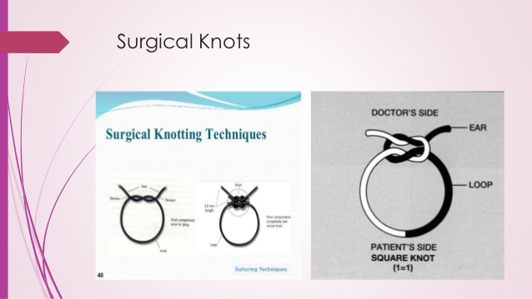
* Knot anatomy :
3 components :
1-Loop: created by the knot
2- Knot: composed of a number of tight throws ( surgical knot )
3-Ears: the cut ends of the suture : should be 2-3 mm not less or more than this .
*************************************************************************
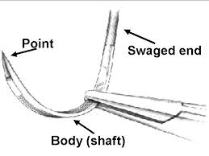Suturing :
*all the knots must be tight, firm, & tied so slippage will not occur
* To avoid wicking of bacteria due to moisturing ability of the material , knots should not be placed in incision lines.
*Knots should be small & the ends cut short (2-3 mm)
* Avoid excessive tension to finer-gauge materials because breakage may occur .
*Avoid using a jerking motion, which may break the suture
* Avoid crushing or crimping of suture material by not using needle holders on them except on the free end for tying if we use the needle holder along the suture material line , the strength will be less .
* Do not tie sutures too tightly because tissue necrosis may occur (Avoid tissue blanching)
* Maintain adequate traction on one end while tying to avoid loosening the first loop.
*Area should be swabbed with H2O2 to remove any encrusted necrotic tissue or blood.
*Sharp suture scissors should be used to cut the loops of sutures avoid using blades because it will cause a mechanical trauma that leads to increase the tension on the threads causing infection .
***************************************************************************
Neddles :
3 parts :
1- Eye
2- body
3- point
* Needle should be grasped ¼ to ½ the distance from the swaged area to the point , don’t affect the curvature of the needle .
- it’s length depends on the area that we work at , for example : interdental papilla on the posterior teeth needs long needle .
Needle holders :
* choose a needle holder that has Approximate size for a given needle
* The smaller the needle, the smaller the needle holder required
* The tips of the jaws of the needle holder should meet before the remaining portions
* Needle should be placed securely in the tips of the jaws without rocking, twisting or turning
*Avoid over closure of the needle holder to avoid damaging the needle
* Needle holder should be directed by the thumb.
<< when place the needle in the tissues the force applied in the direction following the curvature of the needle
* Suturing from movable to non-movable tissue.
* Avoid excessive tissue bites with small needles ( reduce the tissue trauma ) .
* Sharp needles should be used with minimal force
* Do not hold the swaged area nor the point area.
* Needle should penetrate tissue at right angles (never force needle) : why ?
1-to take the full thickness of the tissues and ensure maximum adaptation
2- minimal surface area
* Avoid retrieving the needle from the tissue from the tip in order not become a blunt and the success rate decreased .
8. Adequate bite is required (2-3 mm below the tissue margin ) to avoid tissue tearing .
***************************************************************************
Suturing techniques :
1- interrupted (each knot alone ) vs. continuous ( multiple knots that end by final single knot )
2- periosteal vs. non periosteal .
*the choice of the technique ,depends on :
1-Individual operator’s preference
2- Educational background
3- Skill level
4- Surgical requirements
* surgical sutures should fix flap edges in position until the wound has treated and has enough strength to withstand mechanical trauma . in order to achieve this , many points must be selected to maintain the stability of the sutures over time .
- in the oral cavity there are 4 anchorage points that have different firmness and the following order is from the more secure to the least :
1- Teeth and immobile implants .
2- mastictatory mucosa ( less anchorage than teeth because it lacks elastic fibers ) .
3- Periosteum : periosteal suturing used in apically positioned flaps .
4- connective tissues of the vestibule ( oral mucosa ) the least secure one , avoid it as much you can .
- the availability and selection of appropriate anchorage point is a key issue in the decision of flap design and must be determine before the incision ! .
*Periosteal suturing permits precise flap placement & stabilization
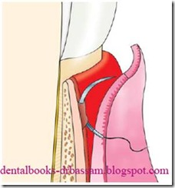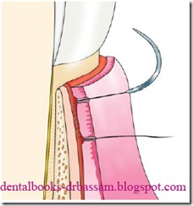 Penetration – Rotation – Glide – Rotation – Exit

Interrupted sutures :
Uses:
Vertical incisions
Tuberosity & retromolar area
s Bone regeneration procedures +/- GTR ( guided tissue regeneration ) . which is technique sensitive .
Widman flaps, OFD, repositioned flaps, APF
Edentulous areas
Partial- or split-thickness flaps Implant surgery .
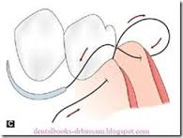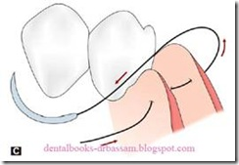Types
1 – Circumferential , direct , or loop (the easiest )
2- Figure eight ( used in crown lengthening ) .
3- Vertical or horizontal mattress Intrapapillary placement
Figure eight interrupted suture :
out- in –out–in
Direct interrupted suture :
out- in –in –out

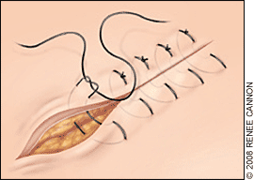Mattress sutures :
provide Greater flap security & control
passively placed with more tension at the edges
more precise flap placement
Good papillary stabilization & placement
1- the vertical mattress : used in bone regeneration.
Vertical mattress interrupted suture :
(out- in –in-out ) , at the buccal flap .
( out-in-in-out ) , at the lingual flap.

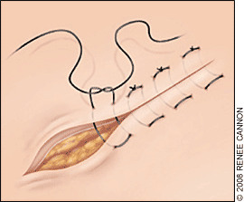2- the horizontal mattress : used in the edentulous area .

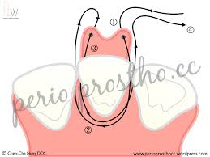* Sling suture :
used when flaps raised on only one side of a tooth, involving only 1-2 adjacent papillae.
- coronaly transflap or lateral positioned flap .
- plz refere to the slides and read the advantages and disadvantages .
Sling suture : from the flap around the tooth to the lingual flap without lingual penetration
- fixed against the tooth .

