Periodontal Restorative Consideration 1
It’s important lecture because most of us will be restorative dentist, so its relate to us in every day practice ,we must understand how our work affect periodontium & how to minimise any damage for them.
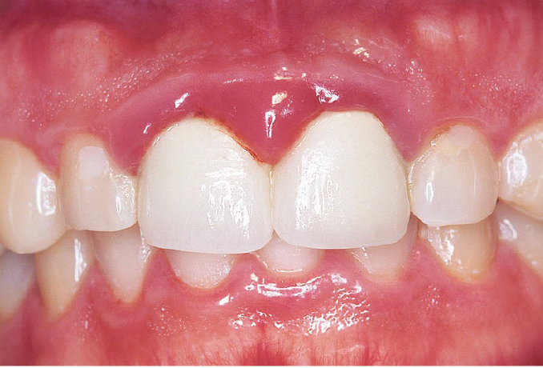
*About this image:-
-it's a photograph showing upper & lower teeth in occlusion, gingival enlargement, redness & shiny surface .
-the 2 CI are crowns, the other natural teeth don’t have the same condition of gingiva so we suspect that we have overhange affect the gingiva here "localized damage".
In this lecture we will talk about how to avoid like this situation, & how periodontium will benefit from our work.

***How u will descripe this dental appearance from cosmotic aspect?
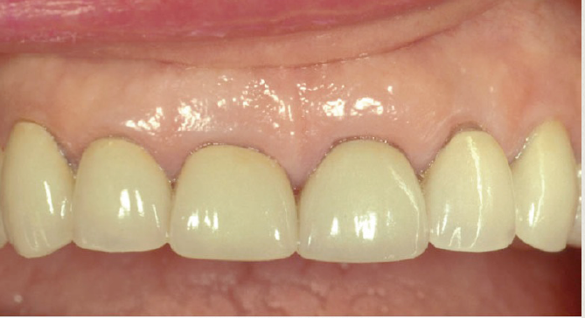
1-there's gingival asymmetry.
2-the crowns appear short & sequare in shape >>so we have to do lengthening to the teeth for pleasant appearance.

Preparation of periodontuim
*what does periodontal ttt mean & composed from? Why we start with perio ttt?
-Periodontal health is a pre-requisite for successful comprehensive dentistry
1. Control periodontal infection (surgical & non surgical , scaling only part of ttt not the whole of it).
2. Address residual eﬀects of periodontal disease, like in bone resorption we control the infection and still we have pocket, mobility & swelling so we can consider some restorative procedure like crown lengthening , so sometimes we control the infection but we have to deal with the results of that infection.
3. Techniques and procedures in anticipation of esthetic and implant dentistry in order to optimize our treatment as much as we can

*we should start with perio ttt to establish a good isolation for any restorative procedure bcuz sometimes calculus will mask underlying cavities .
* u have to know why to start with perio bcuz when u graduate & someone came to u want to do a crown for example with inflamed gingiva & ur dr tell u why who cares , u have to give rational reasons for him .

*Here no one will disagree with u if u want to do perio ttt , notice the changes in the gingiva before & after the ttt.
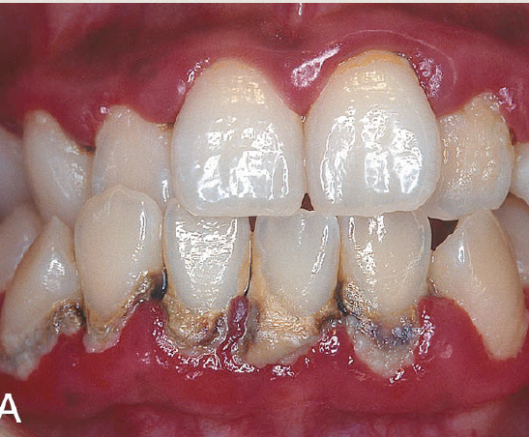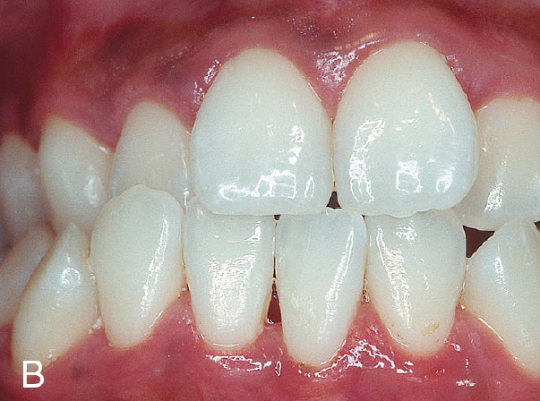
BEFORE AFTER

Rationale for therapy
1. Establish stable gingival margins
In case you are doing preparation and you have inflammation ,some time when you do cord packing the biofilm will disturb that cause cretin degree of healing and shrinkage in next visit, so u surprise the finish line become supragingival & when you seat the crown it will be short, sometimes its ok with posterior teeth but will not be acceptable whatever with anterior teeth .

2. Healthy gingival tissues allow more predictable restorative procedures
-Have inflammation mean you have bleeding so will affect :
Composite restoration ,matrix band placement ,cord packing , making impression
Wedge placement maybe reduce bleeding .

3. Certain periodontal procedures provide adequate tooth length for retention and access for restorative procedures
-like crown lenghthing, if u have subgingival calculus u cant restore it probably.

4. Periodontal therapy could result in repositioning of teeth. "the dr don’t explain it but I copy this from last year sheet for better understanding"

One of signs of periodontal disease is pathological tooth migration – distobuccal migration for teeth mainly incisors- after periodontal therapy we have spontaneous repositioning .

2 theories explain :
1- When we lost the support from bone , the tongue will push the teeth .
2-presence of inflammation cause shifting of teeth
It’s not well understood and we don’t know why the spontaneous repositioning not occur in all cases

5.Traumatic forces placed on teeth with ongoing periodontitis may increase tooth mobility, discomfort and possibly the rate of attachment loss. high occlusal forces will exaggerate the bone loss .
6. Orthodontic treatment in the presence of periodontal infections may result in negative detrimental outcomes

7. Successful esthetic and implant procedures may be diﬃcult or impossible without the specialized periodontal procedures developed for this purposes .

************************

Sequence of Therapy:
1-Control of active disease
2- Pre-prosthetic surgery
************************

1- Control of active disease involve:
1-emergency ttt ; abscess ,endo-perio lesion ,pain
2-extraction of hopless teeth ; advanced cases so you take decision before initial periodontal ttt.
3-OH measures
4-scaling & root planning as a non-surgical procedure .
5-reevaluation usually after 2 weeks.
6-periodontal surgery.
7-adjunctive orthodontic ttt (in case u have pathological teeth migration as a result of the ttt).

*NOTE: the dr did not mention the following but I found them in last year sheet so pass by them please
-Oral hygine instruction , antibiotic (local or systemic ), chemical plaque control using mouth wash ,host modulating factor
Mouth wash present in 2 forms : 0.12 in USA AND 0.2 IN Europe and Jordan there is no difference between them .both we use them for 30 sec ,twice daily for 2 weeks .
Doxycycline can use as antibiotic or host modulating factor
Doxycycline as antibiotic we give 100mg 1*2 for 14 days
Doxycycline for cretin period of time is drug of choice to treat periodontitis but nowadays if patient not allergic to penicillin we give : amoxicillin 500mg 1*3 for 10days and metranidazol 250mg 1*3 for 10days
If pt allergic we give Doxycycline or erthomycin (azethromycin ).
Note: if pt allergic to penicillin we don’t give him cephalosporin because usually the pt is allergic to cephalosporin too.
- Doxycycline as host modulating factor 20mg 1*2 for 3 months then break then 3 months
Its work on immune cell ,no antimicrobial effect its sub anti microbial effect .

2- Pre-prosthetic surgery involve:-
1-Management of mucogingival problems
2- Preservation of ridge morphology after extraction
3-Crown lengthening procedures
4-Alveolar ridge reconstruction especially in implant cases

**management of mucogingival problems :
the objectives :-
1-increase gingival dimention
2-achieve root coverage
3-manage root caries

Indication:-
1-creating a zone of attached keratinized tissue prior to restoration ttt.
2-augment tissue thickness prior or during orthodontic ttt.
3-esthetic need to cover exposed roots.
4-treat cervical carious & non-carious lesions.
5-pt comfort ; if the pt have recession so complain of root sensitivity.

*****************
CASE: refer to slides plz
-the only indication to do gingival graft in case of absence of attached gingival is only when we want to do restoration or preparation subgingivally cuz otherwise you will have inflammation.
-if the pt can maintain good plaque control & there's no need to do any type of restoration subgingivally so no need for attached gingival .
-in this case grafting was done
-the steps : recession > double pedicle > C.T graft > root coverage

CASE:-
Cavity extended to crown and root
we remove caries on crown and root then restore the crown cavity only and make new CEJ then we put connective tissue graft . we don’t restore the root cavity because the connective tissue graft suppose to adhere to root surface .
-we don’t restore the root bcuz: 1- finishing the restoration here is very difficult
2-they need frequent replacement
-one of success criteria for connective tissue graft is no pocket , if we have pocket the connective tissue graft not adhere .
-usually cavity on the root is shallow , if it deep then u cant do this graft

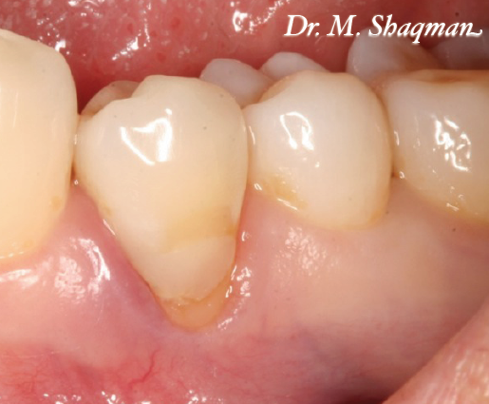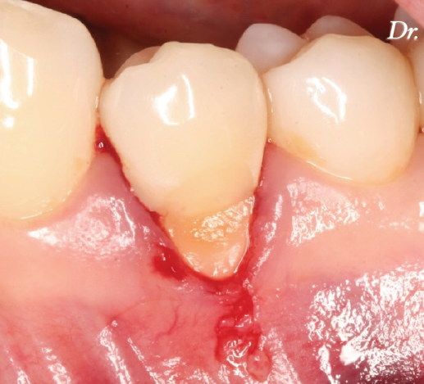

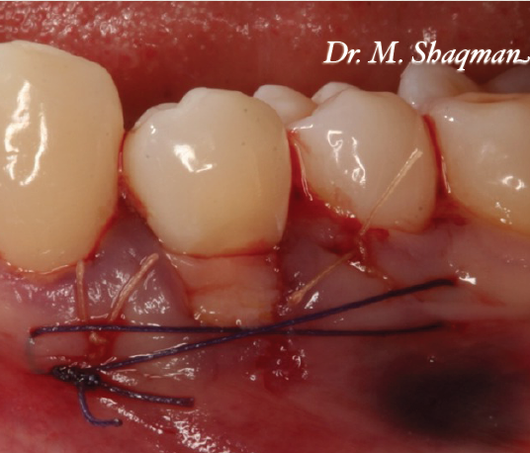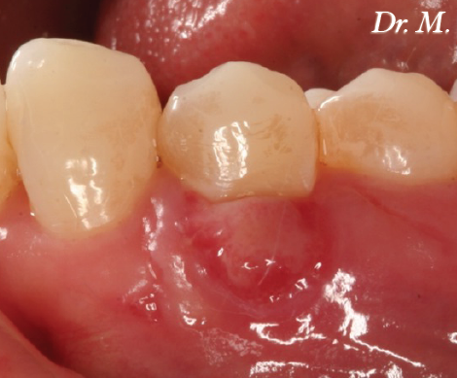

********************

***Preservation of ridge morphology after extraction :
-its one of the objectives of pre-prosthetic surgery.
-either for :
1-anticipation of future implant placement.
2-avoidance of aesthetic deformity.
3-improve aesthetic outcome of prosthesis .

CASE:
-bcuz the ridge resorbed so the pontic doesn’t look in a cosmetic way
-they put a collagen sponge just to hold the tissue then they put the temporary bridge right away ... the temporary pontic enters 2mm inside the socket & has ovate upper border (as if the tooth is emerging from the socket not only saddle on top of the tissue), so the tissue will take the shape of the ovate pontic.
-You should use special impression techniques to capture the soft tissue profile because the original techniques focus on capturing the finish lines (not the soft tissues).
-The final restoration doesn't look like a pontic, it looks like a tooth emerging from the socket. Note that the inter-dental papilla is still there because what determine the level of the papilla is the level of inter-dental crestal bone at the adjacent tooth.
-u cant do this if there's deficient ridge .

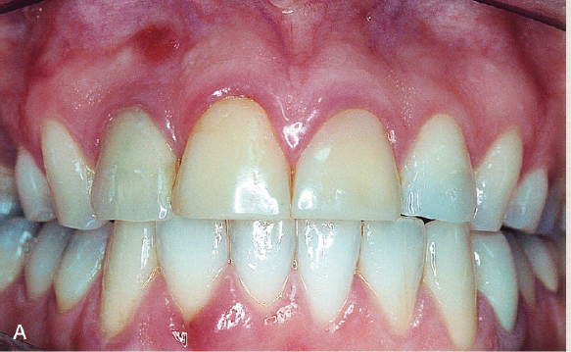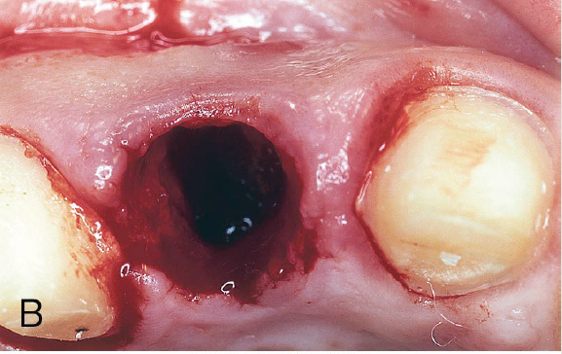

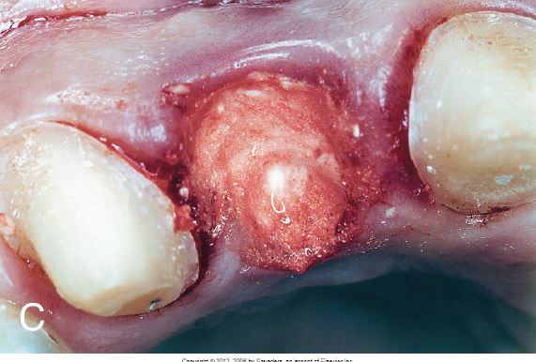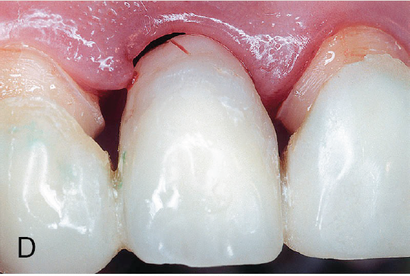

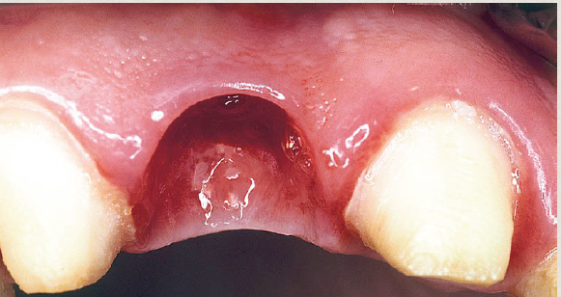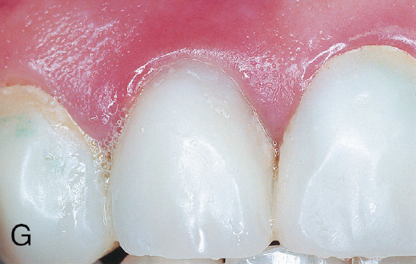

Case :
In this case, the patient wasn't happy with her proclined lower teeth (the 2 laterals). What options do we have here ??? Orthodontic treatment >>> the patient wasn't willing to do orthodontic treatment so we extracted the 2 laterals and prepared the canines and the centrals then we did ridge preservation (bone graft); to preserve the ridge shape and to avoid excess shrinkage then we seated the temporary bridge.

Note that we didn't extend the temporary pontic inside the socket because if we did so, we would keep the gingival margin as it was before.

- picture at the follow up stage, notice the staining on the temporary bridge due to chlorhexidine mouth wash.

- notice the ovate shape of the tissue at the pontic site after healing.

-Finally , we inserted the permanent bridge (this bridge is made of zirconia so the color matching isn't perfect).

-Notice the neck of the right lateral incisor, we made its color more pinkish to improve the appearance and match the gingival level at the other side (because even after grafting, still there is some deficiency in the gingival margin).
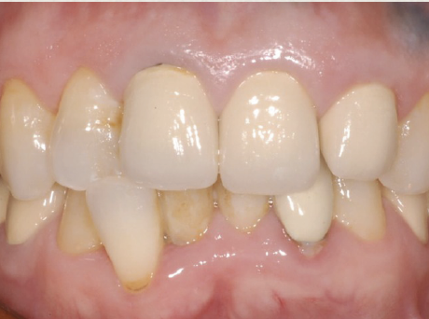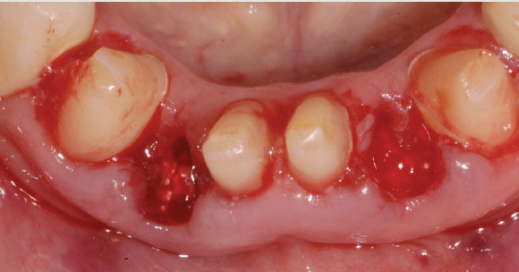

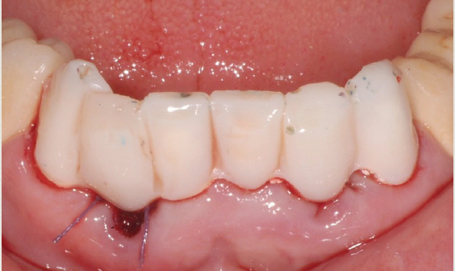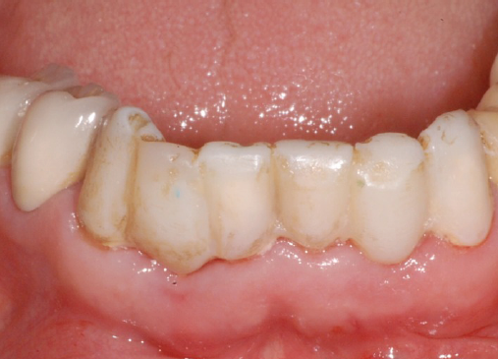

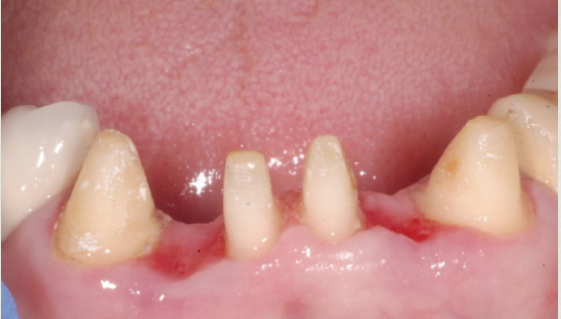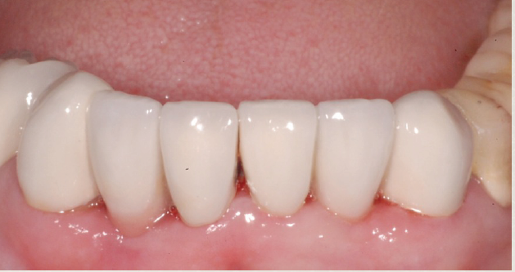

Clinical Crown Lengthening procedures
Indication :
1.To provide retention form to allow for proper tooth preparation, impression procedures, and placement of restorative margins.
2. To adjust gingival levels for esthetics.
3. To preserve the biologic width; prevent its violation.

**in case of deep subgingival caries, I want to go more subgingivally to put the finish line on sound tooth structure so here we violence the biological width

-The biologic width: deﬁned as the physiologic dimension of the junctional epithelium and connective tissue attachment
relatively constant at approximately 2 mm (±30%)-
-Bone “sounding” is used to determine the biologic width for a speciﬁc site.

**How to determine the biological width ?
Example :
- probing depth 1 mm
-force the probe to crestal bone 4mm (bone sounding)
Biological width 4-1=3mm
Note: before we do bone sounding we give LA .
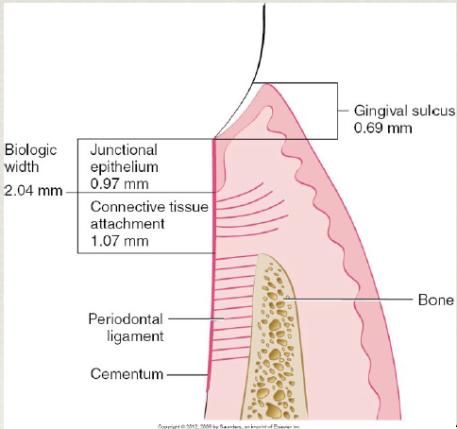

-in case of inflamed gingiva the probe will stop in the C.T attachement but after perio ttt & healing occur , it may also stop at the same place but with more resistant from the tissue .

Whats the mean that cause probing depth reduction?? ((VIVA QUESTION))
1-periodontal therapy involve the previous mechanism "resistant tissue ..etc "
2-recession
3-long junctional epithelium ?? " I cant hear it
4-regeneration of bone & reestablishement of attachement.

Biological width is junctional epithelium and connective tissue-
Biological width not involve sulcus –

What happen if we invade the biological width ?either one of two **
1- Chronic persistent inflammation ;most common to occur
Swelling ,redness and bleeding
2- attachment loss ; recession or pocket .

Contra-indications of Clinical Crown Lengthening procedures**
1. Surgery would create an un-esthetic outcome;more in aesthetic zone, if we do it on one tooth their will be asymmetry or black triangle if papilla undergo a recession.
2. Deep caries or fracture would require excessive bone removal on adjacent teeth; if there's a deep caries & u need to remove too much bone to restore it .
3. The tooth is a poor restorative risk; questionable endodontic therapy or very limited tooth structure
4. Signiﬁcant invasion of the furcation area is anticipated; if u gonna do ostetectomy meaning remove the bone at the furcation area end with exposeding it .

Keep in mind that since your restoration is within the sulcus you’re not invading the biologic width, whereas the problem starts when you approximates the most coronal cells of the junctional
epithelium. As we said before, when we put the probe the tip always penetrates in the junctional epithelium ”at least” .

For example, when you measure the probing depth equals 1mm ,actually, it’s less than that (let’s say it’s about 0.6),so when you go down for further 0.5 mm, you’re already invading the
biologic width. That’s why you have to be conscious and leave a safety margin. So when you have a probing depth of about 1mm,it’s very risky to have biologic depth invasion in a such cases .

However, The concept here is to stay around 0.5 mm subgingival and not more than that to minimize the risk of invasion the biologic width. But, as we said before, in some cases we have to go more than 0.5 mm sub-ginigivally,such as: when we have a deep sub-ginigval caries, fracture line ,a need for more tooth length for retention ,…etc

***Note : Almost always remember that when you measure the probing depth the tip of the probe doesn't stop at the most coronal cell of the junctional epithelium, so when we use the probing depth
keep in mind that it’s a clinical measurement that is done clinically and not histologically.So we have an over-estimation for sulcus depth. That’s why, it’s important to keep a safety zone which means when we say the probing depth is 1mm for example ,we go maximum .5 mm and not 1 mm (always keep a safety margin to avoid invading the biologic width).Anyways this scenario is only for clarifying what happens to understand the concept, but usually in clinic when we go sub-gingivally we go more than 0.5 mm.

-crown lengethining involve removal of a soft tissue but in most of the cases they involved bone removal. It's not only gingivectomy or gingivoplasty, its also osteoctomy .

*recall that osteoctomy remove part of the bone while osteoplasty remove the outside so reduce the thickness without touch the bone that attached the tooth .

**THE DR SHOWED A VEDIO EXPLAIN THE AESTHETIC CROWN LINGTHENING , here's some notes abt it :-

-we do wax up to make moc"not sure abt this" to guide us to the extent of the crown lengthening then we put beading marks then we do gingivectomy then bone sounding ( I need to make sure that we have 3 mm btw the FUTURE gingival margin & the crest of the bone)

**Recall: 3 mm= 2 mm biological width + 1 mm sulcus
**note : if we don’t have enough attached gingival we go for apically positioned flap not crown lengthening .

-here we don’t have 3 mm so we need flap & we do it buccally not palatally, we do full thickness flap bcuz we need access to the bone .

-then we do ostectomy > plasting > establish the length we need > put the moc up no ensure I have the clearance I need > suturing.

-so crown lengthening involve removal of soft & hard tissue.

*Funtional crown lengthening :
When we do occlusal reduction, we compromise the resistance & retention form of the tooth bcuz we shorten the clinical crown length so the PFM-CROWN will keep falling down .

**there's a pic were we do flap buccally & lingually & cut bone on both sides .

*why it's important to go more sub gingivally to do the finish line on sound tooth structure ? to establish ferrul effect.

-you have to engage sound tooth structure to achieve resistance form.

-ferrule effect usually 1.5 mm.

**when we need bone removal & when we don’t?
If we have 3 mm btw the future gingival margin & the crest of the bone so no need but if there's less than that so we need.

*you have to reposition all the dento-gingival complex to prevent the recurrence of the condition & that's the problem with the laser in the clinic if u don'r consider the biological width .

The checklist to prepare the tooth for crown lengthening :-
- Good quality diagnostic x-ray; don’t do it with panorama or angulated x-ray , the best is bitewing, I don’t want to see the apex , I want to see the margin of the bone .
- Caries should be excavated, to prevent envading the biological width bcuz if we estimate the extention of the caries & do crown lengthening according to that & when we finish & refer the pt to restorative dentist & surprise that the caries is more deeper so our ttt is failed & we need to RE-DO it .
- Is the tooth restorable, if we have a crown we need to remove it to determine the restorability of the underlying tooth structure.
- Determine endodontic prognosis.
- Establish tentative restorative margins/finish lines, yes the tooth is short but we use this finish line as a reference, remember that the length of ur preparation have to be 3-4 mm , & if it 3 mm u go for the retentive features like grooves.
- Establish adequate temporization, bcuz it's also acts as a reference like the moc-up as we said before .

**plz refer to the slides especially those at the ends , I cant copy them here :(

Good luck seniors

