Perio lec.14 Dr. Omar Karadsheh Done by: Sana Isleim, Samar Al-Jaiose

Introduction to peri-implant diseases
*** Implants in perio:
* To deal with implants you have to have a scientific/diagnostic sense as they aren't straight forward as natural teeth.
* Implants don't have a periodontal ligament so there is no proprioception; hence there is no feed back when encountering high occlusal points, so may be the implant breaks and the patient doesn't even know.
* In natural teeth when we have high occlusal points, there will be a trauma, pain, drifting that alarm the patient . Unlike implants in which the patient won't feel the forces especially the eccentric ones.
*Now let's talk about osteointegration:
- It's a clinical term with a histological definition, connection between the implant and the bone "implant inside the bone".
- This happens as a result of wound healing process, for example when you extract a tooth there will be a clot then granulation tissue, after that we will have some necrotic tissues, then the formation of other types of tissues, all the way to lamellar bone.
- The same happens in implants, it's a bone healing process-as implants are biocompatible-, and osteointegration takes place.
- Looking in a histological sections, there will be no cementum or periodontal ligament but we still find junctional epithelium and connective tissue.
- In implants we have a long junctional epithelium "longer than what we have in natural dentition". Also the fibers run parallel to the long axis of the implant "fibers don't insert inside the implants" which means that there is no attachment just a seal -not to get any deeper-, also the scar/healing tissue has much less vascularity "no blood sources( PDL, gingiva, bone)",and in scar tissue we have increased CT and decreased fibroblast, all those affect the response to any irritation "decreased resistance".
- We still have biological width in implants but it may reach up to 4 mm " 2mm Junctional epithelium, 1-2mm CT ".
- The doctor showed a picture where the fibers are radiating from the cementum to the gingiva in natural tooth , unlike in implants where the fibers run parallel.
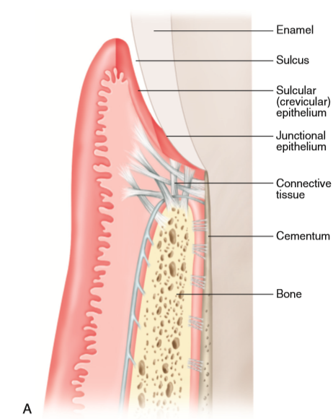
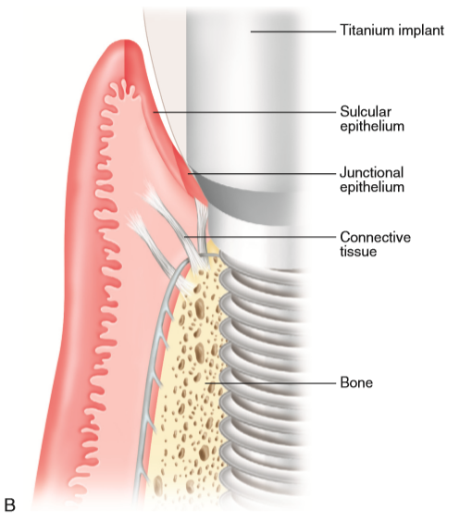

*probing depth:
- Will be more because there is no resistance, but in healthy situations it should be similar to a healthy tooth as the tissues are firm.
- If you get a probing depth of 4-5mm,don't mind, as in some cases it starts from 5 mm ,so you have to know your base line "from where you start your measurement"
*Question
Why implants are more prone to infection?
1- No PDL
2- Less vascularity "elimination of gingival vessels, periodontal vessels, bone ..... losing the vascular network"
3- Less cellularity
4- Less resistance to irritations
***Now what about implants complications?
-* We can have mechanical, biological complications, we may for example hit a nerve.
* So we have early complications and late complications .
1- Early complications:
- As in bone loss that happens within the first week or month as a result of overheating, infection, patient's own factors, procedural factors or site related .
2- Secondary failure "late complications ":
- When the patient comes after 2-3 years with bone loss "bone loss happens in a saucer pattern, crater",as a result-may be- of a mechanical over load which causes bone to resorb.Olso there is esthetic failure, although the implant may be perfectly osteointegrated but esthetically unacceptable "as in placing it too far labially".
* Talking about complications :
1- Peri - implant mucositis = gingivitis
2- Peri-implantitis = periodontitis
* Their etiological factor is bacteria (poor oral heigine, calculus) the same as in natural dentition.
* But here in implants we have some extra factors:
1- Cement : in case of too deeply placed prosthetics. In some cases you have to place it deep as in anterior teeth because placing short implant -4mm- with -9mm- prosthetic will show esthetic discrepancy so we place a deep one to to show a transition . So it's hard to remove/clean a cement in deep areas which cause inflammation and bone loss. Also the probing depth may be 4-5mm in this case-normally-,so again always know your Base line.
2- Rough surface "for better integration".
-In cases of thin biotope or recession , the rough surface of the implant may get exposed which harbor bacteria.
- How can we get a rough surface? Sand blasting, acid etching ..
3- screw-retained abutments :
Any junction between two metallic components will have micro-gaps, then it will become loose, then it will move over the tissues causing irritation.
*Signs of peri-implant mucositis "as in gingivitis" :
- redness, swelling, bleeding on probing. But those signs may be exaggerated "pus, more bleeding .. "
- You have to know that probing depth only, is not an essential criteria for confirming mucositis you have to see other signs to tell, but it is useful for detecting any abnormality. And the probing depth must be taken after one year of inserting the prosthetic, and bone remodeling happens down to the first thread.
* The doctor showed a photograph and radiograph of an implant with inflammation and no bone loss. Dx: peri-implant mucositis.
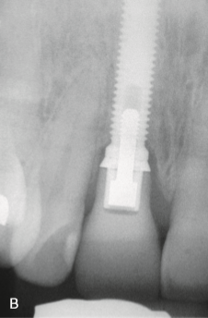
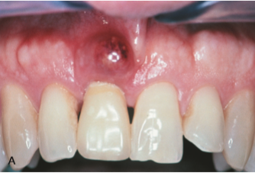

* In 80's and 90's they used to extract teeth and place implants instead without taking into consideration their bad effect. In this century they made studies on humans and animals :
- They took cross -sections and biopsy, they found that Peri-implantitis is similar to gingivitis in many features but in mucositis there is a big lesion with more inflammatory infiltrate "less resistant" ,but the same microbiology. And in both cases the process is reversible.
- In Peri-implantitis there is crestal bone loss with puss sometimes.
- Another thing is mobility, since there is no PDL, any mobility indicates a failure, since a significant amount of bone must be lost for an implant to be mobile . So mobility is not a sensitive criteria to detect an iflammation cause it indicates an already progressed inflammation and failed implant.
- Why bone loss is symmetrical around the implant?
There is a theory claiming that bacteria moves along the threads of an implants.
- Another thing you should know that marginal bleeding is the patient's problem while pockets bleeding is yours.
* Let's go back to the animals studies ..
- How could they simulate periodontitis in animals as it may take several months even years to develop?
By increasing the bacterial load and induce attachment loss. They use something like a cord that is saturated with plaque and push it deeper every while "apically", in this manner they cause trauma but that is the best they can do ... and the rationale is that when the plaque is left deeper, the disease progresses anyways.
Another important thing is that in natural teeth when periodontitis develops, there will be a capsule with the infiltrate trying to keep the inflammation away from the bone as possible -protection-. Whereas in peri-implantitis we won't have that kind of capsule .. so there will be more destruction to the bone "that is why the first thing you may see in peri-implantitis is bone loss".
*Things to remember:
- The epithelium is the first line of defense, so when we have attachment loss that means that the offending factor exceeds the host defence.
- Around the implant is ALL bone, no PDL... IF WE BREAK THE SEAL, WE LOSE THE PROTECTIVE FUNCTION OF THE EPITHELIUM AND CONNECTIVE TISSUE.
*Microbiology:
- In periodontitis we have gram +ve & -ve bacteria, the same thing was found in peri-implantitis in addition to staphylococcus aureus -50%-"staphylococcus aureus is normally found on skin, but they found it also on prosthetics ex: joints, streptococcus is found in the mouth ", they also found escherichia coli. and Candida.
- One of the doctors made a trial by putting three different implants with different roughness of their surfaces , in the bone and watch them for a while. He found that the one with more bone loss is the one with the roughest surface.
- The irony is that rough implant is from "branemark company " the founder of implants.
- So as a conclusion we tend to use moderately-rough implants, not too rough "although they osteointegrate better but are more prone to infections" and not too smooth.
-They compare implants to teeth, both have the same level of bone loss.
* So, the summary of perimplantitis:
1- It has clinical signs that include sapuration, swelling, bleeding, bone loss with or without pockets.
2- Microbiology is similar, aneoribic gram negative bacteria with staphylococcus aureus that is normally found on skin and Candida.
3- Progression of inflammation is faster, the inflammatory cells are usually bigger and there is no capsule that protects it.
- If the implant has done in a perfect way with a perfect oral hygiene it can last forever.
* Pravalence:
- mucositis: 50% which is high.
- peri- implantitis: 10%.
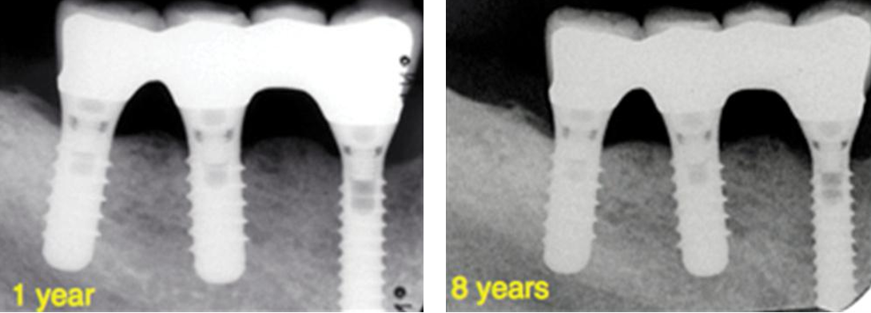
* Importance of follow ups:
- These implants at one year follow up show no bone loss.
- At 8 years follow up still there is no bone loss.
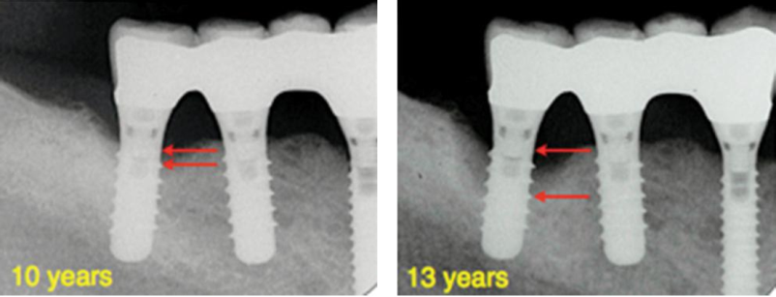
- At 10 year follow up you start to have some bone loss and after 13 years follow up there is a very significant bone loss.
- So it is important to follow up.

* How would you monitor?
- Usually full examination and radiographs should be taken at baseline (the date when you insert the prosthesis).
- Then you take a radiograph every year.
- Then you assess the risk every 2 years, then every 5 years, then every 10 years and so on.
- You have to do probing depth to see the level of inflammation.
* If a patient comes to you with an implant that has been done by someone else, how will you know where the bone level was at the baseline???
- We estimate, usually either to the first thread or at least 2mm is where you expect the implant to be.
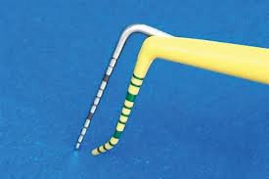
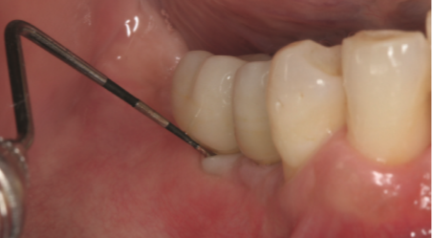
* This is how we measure the probing depth, the probe is flexible and brittle not to scratch the implant, the problem that faces us sometimes is when the crown is bulbous so the probing will be difficult and we can’t do the probing with the right angulation.
* Risk factors:
1- History of periodontitis.
2- Diabetis and smoking.
*** How do you treat???
1- Mucositis (the reversible and easy part):
A- Mechanical debridement: Implants are metal if you scratch them, they will become rough attract more plaque so we use: - Manual plastic/titanium scalers. - Ultrasonic scalers with carbon fiber tip/gold tip.
B- Antiseptics, mouthwashes, water jets.
C- Air abrasive polishing device:
- Soluble powder particles hit the surface of the implant and polish it, it is actually good for staining "interproximal staining" of teeth. It has ????? subgibgival.
- But the effect is good in mucositis not perimplantitis.
- It is considered mechanical.
D- Laser:
- There is no studies or proof that it treats mucositis.
-It is only marketing.
- It is good for mucositis but it is not better and not more effective than mechanical debridement and it is more expensive.
- No effect on perimplantitis.
2- Perimplantitis:
* You should start with something that stops the inflammation like antibiotics with non surgical Tx.
* But usually it doesn't respond to non surgical Tx.
* Studies have proven that it is not a predictable disease and there is always a high risk of recurrence and even with surgery success is 50% and half of the cases fail.
* The surgical therapy objectives:
1- To gain access.
2- To decontaminate the threads by:
saline, chlorhexidine, laser, thread removal with bur, studies showed that there is no difference between them.
* Surgical procedure:
1- Open a flap.
2- Bone resection (change the shape of the bone).
3- Debridement of the surface.
- the bone is a saucer shape 3 or 4 walk defect, there are walls all around, so we can put a bone graft and do regeneration.
- Note: In GTR membrane I'd more important then bone, bone is just a filler to hold the membrane.
*** An important thing:
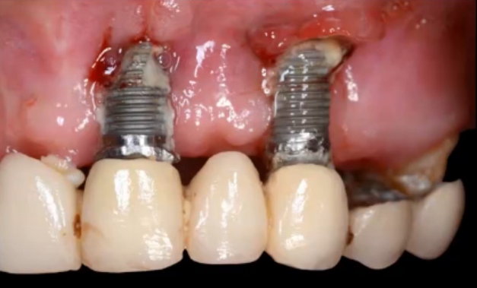
When we do implantoplasty and suturing, part of the implant will appear, this is fine for posterior teeth, but for anterior teeth this will compromise esthetics because surgery will cause recession. So usually if the damage in the anterior implants is severe we remove the implant.
*In this picture there is athin biotope, no enough buccal bone, you can't put a bone graft because it will fail. So you remove the implant and putt a bone graft, wait for healing and put a new implant.

* Maintaining implants:
- Similar as teeth: floss, brush, interproximal brush, and titanium brush.
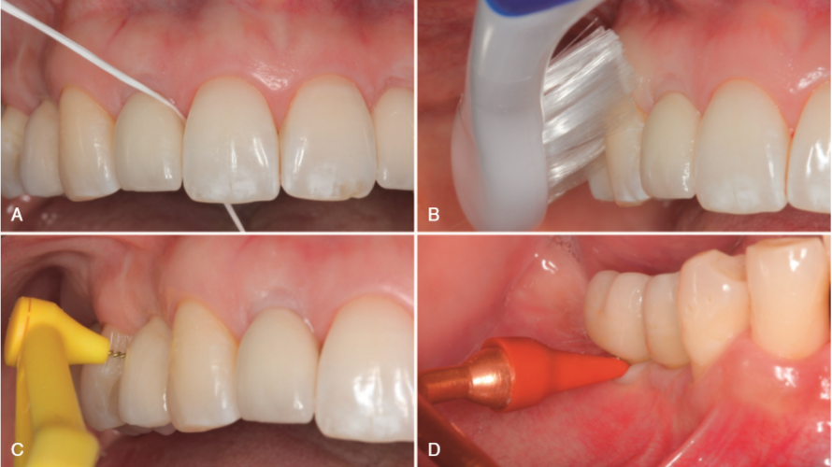

*** Perfectly designed prosthesis:
1- Cleanable.
2- Not bulbous.
3- You can probe around it.
4- You can clean around it.
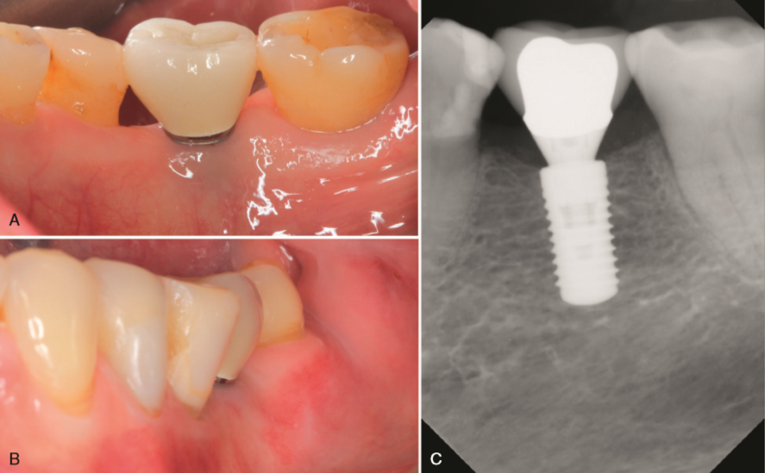
* You should tell the patient that he has to expect these empty triangles especially posteriorly.

