Lec#15 : last one
Done by : Zainab Mohammed

Basic principles and the philosophy of tissue engineering and how people start to think about it was discussed in the previous lecture
Periodontal tissue engineering:
In order to have engineering we must have these three factors TOGATHER :
Cells / scaffold / signaling molecules PLUS time and the appropriate environment
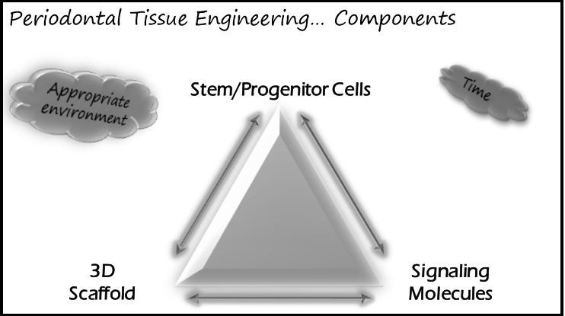
-factors that affect environment:
oxygen , acidity , presence of microorganisms , ….

Its called engineering because we are directing the whole process related to each different factor to gain the desired result

Signaling molecules
We have different types of signaling molecules, ex:
rhPDGF
BMPs
FGF-2
EMD
PRP
Can't be used alone , why ?
-Short biological half-life
-Receptor-binding problems
-Stability of carrier system >> carrier systems we have are unstable
-Cell adhesion >> the necessity of having a surface where cells adhere to , because these molecules in order to function it needs cells that already attached
Scaffold
Types : Autogenous graft /Allograft / Xenograft / Synthetic materials
function :
Provide physical support-
Barrier to restrict cell migration in a selective manner-
-Scaffold for cell migration & proliferation
-Serve as time-release mechanism for signaling molecules
*Even though we know the roles needed to have the perfect scaffold, but still we couldn’t create one that fulfill all of them
In order to have a scaffold that can act as time-release mechanism for signaling molecules it has to be fragile , so it will not provide physical support , and cannot enhance cell migration & proliferation

Why I could not only depend on the scaffold (bone grafts ) ?
-Most of them do Fibrous inclusion
Problems with resorption of these materials especially the bovine origin-
-Cell adhesion we need it to obtain regeneration
-Porosity : control is very critical :
Increasing porosity to enhance the blood supply , the material will loose its rigidity and it cannot withstand pressure ( less resistance )
Decreasing porosity to increase its resistance the vascularity will decrease and less O2 diffusion to the depth of the material
-Oxygen passage
-Vascularization
O2 passage and vascularization both related to porosity

Stem cells

More than one type , very complicated
There is embryonic stem cells and adult stem cells
Embryonic stem cells have lots of restrictions to use because it has been related to cloning

Embryonic stem cell could be totipotent or pluripotent

Classification:
-Totipotent: a cell that can give a complete organism + placenta and supporting tissue (similar to morula)

-Pluripotent: a cell that can give a complete organism without placenta or supporting tissues

-Multipotent: usually an adult stem cell , can give multiple tissue types according to the designed pathway

-Unipotent: give only one tissue type like precursors of keratinocytes that found in the basal cell layer of epithelium
its recently (2009-2010) known that most of the unipotent are inducible pluripotent

-Inducible pluripotent :
by activating certain genes ( 4 genes mainly )we can retune a fully differentiated cell to its origin ( undifferentiated stem cell )
so we know now that cells are plastic and it has the ability to accommodate and withstand different conditions

*they differs in the level of differentiation and the age of DNA ( DNA ages by shortening of telomeres , that’s why cancer risk increases with age because telomeres function is to protect genes and prevent any abnormal duplication of DNA )

Totipotent is very primitive
Pluripotent is more differentiated than totipotent and so on ..

Multipotent are easier to manipulate ex : from a bone marrow stem cell , it can give bone , adipocyte , myocardial cell , cartilage … depend on the genes that is activated

More plastic cells totipotent or pluripotent difficult to control and less stable and might induce carcinogenesis ( it has less number of genes and its only activity is proliferation)

Most cells that we work with is Mesenchymal stem cells :
Undifferentiated cells -
High proliferation rate over long time-
- Can differentiate into different cell types
- They have Asymmetrical mitosis
symmetrical mitosis : mother cell give 2 identical daughter cells identical to mother cells
Asymmetrical mitosis : mother cell will give 2 daughter cells one is more differentiated and one similar to it ( to protect its generation and maintain its continuity )
*That’s why some says that regenerative potential of the stem cells is not affected by age itself
What could effect is : metabolic diseases , environmental factors such as smoking , capacity of cells to respond changes with time
Number of stem cells decrease with age but it's not a determinable factor

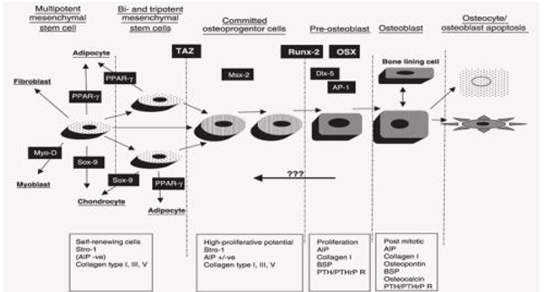

Runx-2 : the master gene of bone
Sox-9 : master gene of cartilage
PPAR-ɣ : master gene of adipose tissue
Myo-D : master gene of muscles
*So there are different control lines and steps

Types :
Bone Marrow Stem Cells (BMSC)-
Epithelial Stem Cells (ESC)-
Dental Pulp Stem Cells (DPSC)-
Stem Cells from Exfoliated Deciduous Teeth (SHED )-
Periodontal Ligament Stem Cells (PDLSC)-
Ordered according to their discovery dates*

Dental Pulp Stem Cells
We do know in very boring details how teeth are developed and how they are controlled and which genes that are implicated in this process from the first step where there is only 2 layers of cells ( epithelium + ectomsenchyme) to the last stage of development

Very simple example of regeneration:
**reparative dentine is formed in response due to pulp exposure or stimuli that is very close to the pulp , to protect cells and mainly the stem cells inside pulp and To protect its existence

Gronthos at 2000 : take tissues from the centre of the pulp and culture it then implanted it in mice subcutaneously for 3 weeks
Result was the formation odontome like tissue
So he conclude that there is a capacity of regeneration from an adult stem cells
Why odontome not something else because it’s a stem cell and it can differentiate to any cell type ?
Because it was taken from the centre of the pulp so we are sure that it's not an odontoplast ( located at peripheries )and it was taken with its environment including signaling factors
Ex: bone marrow stem cell when cultured subcutaneously it will produce bone , but when cultured in a muscle it will produce a muscle tissue ( depending on the environment )

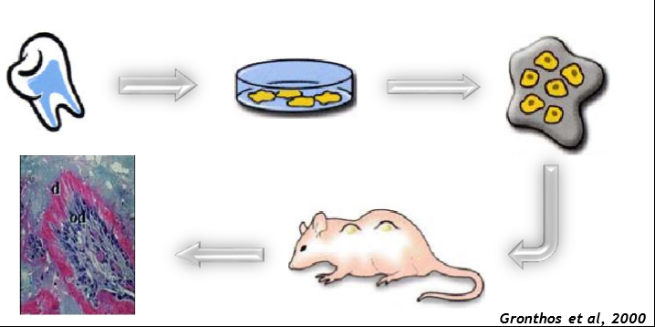

To make sure that these cells are from the pulp of the tooth not from the mice they look for certain factors that present in humans only :
ALP ( alkaline phsphatase ) , DSP ( dentine sialoprotien ) , OC ( osteoclasin ) and the three can induce mineralization

Dental Stem Cells
Dental pulp stem cells (DPSCs) ( Gronthos et al, 2000) -
-Stem cells from exfoliated deciduous teeth (SHED) (Miura et al, 2003)
exfoliated NOT extracted because with extraction there will be contamination and it affects the stem cells
Periodontal ligament stem cells (PDLSCs) ( Seo et al, 2004) -
-Stem cells from apical papilla (SCAP) ( Sonoyama et al, 2006 , 2008)
Specifically third molars
Dental follicle precursor cells (DFPCs) ( Morsczeck et al, 2005 ) -
Ex : from third molars or any other tooth in its early development

Chrastaristics of dental stem cells :
In comparing to BMSC ( classical examples , first discovered )
1-Higher proliferation rate than BMSC under same conditions
2-Expression of STRO-1, VCAM-1, α-sma more than BMSC so :
Heterogenous population : means different stages of differentiation -
-Present in Perivascular niche : around blood vessels
3-High plasticity
Can give : Osteoblasts, Chondroblasts, Adipocytes
And there is evidence that it can produce cornea and neural stem cells
So in same conditions it can produce more tissue types than BMSC

So what its tissue engineering ?
Taken a stem cell and culture it in certain conditions ( and here is the complexity ) , then implant it in vivo to produce the regenerative tissue >> ex vivo or in vitro
in vivo : directly without culturing , cells already present in tissue I do genetic manipulation to induce certain genes or inserting signaling factors to induce certain process directly
*When I work on a gene level the effect is way more than post-translation level (protein level) , when I insert a signaling factor ( a protein ) I will induce certain process that involve a gene , but when I am manipulating a gene directly the effect is way more and takes longer time
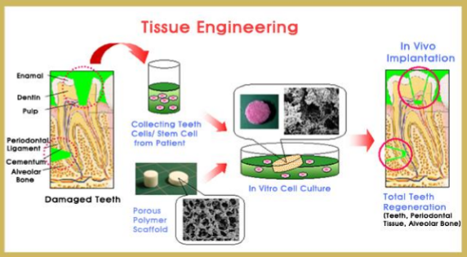

Akizukietal,2005 :
A study done on dog's teeth
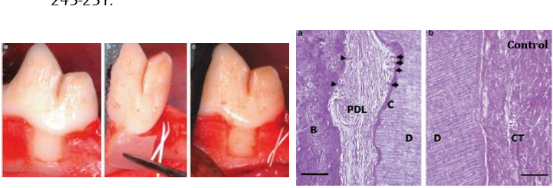
They did a periodontal defect with specific dimensions so it exceeds the regenerative potential of the tissue ( can't regenerate by itself ) , then they insert periodontal ligament stem cells in a shield (PDLSCs) , after certain period they took histological sections and found periodontal tissue regeneration full and functioning

Conclusion :
-The subject of tissue engineering it’s a domain that involves different sciences and needs real team work in order to obtain good results

-There is 2 types of tissue engineering :
Ex vivo Tissue engineering
In vivo Tissue Engineering

-Why we do tissue engineering ?
1-Dentine repair mainly
2-Tooth tissue engineering:
only one report in the literature by Sartaj et Sharpe, 2006 : thy mimic exactly the tooth development stages , so they culture two layers of cells in the diastema of the mouse's mouth and it produce fully functioning tooth with continuously producing enamel as the nature of mouse
( mice only have central incisors then a diastema then molars , and the enamel is continuously producing )
3-Tissue engineering:
Bone
Cartilage
Nerve
Muscles
Ex in 2004 :
a patient with hemi-mandibulectomy
they took a stem cell and culture it with a bone graft and did a 3D Ti mesh then implant it in the subpectoral area of the same patient for few months , result was full regeneration of resected mandible

Challenges :
Biological challenges :
1-Growth factors
2-Signaling pathways
3- Root development >> very difficult and still there is areas of uncertainty about cementum and PDL formation

Technical challenges :
1-Culture conditions
2-Xenogenic products >> usually they use (Fetal Bovine Serum) a material from the fetus of bovine because its rich in growth factors and nutrients help to culture cells
3-Timing
4- Ideal scaffold
5-Delivery system

Clinical challenges:
1- Immunogenic rejection
2- Oncogenic properties
3-Functional integration >> still there is no long term studies to know its functional integration

Good luck

