-
Lecture title: The periodontal flap .
Lecture number :3
Dr : Nicola

* Flap : separation of the gingival tissue from the underlining bone and connective tissue (surgical procedure ) .
* Periodontal flap : is a section of gingiva and / or mucosa surgically separated from the underlining tissue to provide visibility of and access to the bone and root surface .

* indication :
Access the area with a defect and visibility ( we should know the outcome of our surgical procedure ).
# dentist uses a sharp scalped and incise the gum , this incision now is not straight ,not vertical and not perpendicular >>> ( it is oblique ).
- sometimes raising up a flap , it require unilateral or bilateral releasing incision .
- we have raised the flap initially and then we bring mucoperiosteal elevator , a blunt instrument just to reflect the tissue far way from desired tissue .
- now the flap completely raised up and we have to decide where we return it back again either in orginal place or in another place ( coronally or apically or side to side elevation ) and so on …
- type of suture here is simple interrupted suture .

* objective of periodontal falp :-
1) improvement of prognosis of tooth and their replacement :
We can access the area and debrided it and remove the infected tissue , if there is bone resorption , we can fill it back again >> to improve prognosis . ( so rather than extraction ,we try to keep tooth).

2)improvement of esthetic :
e.g : recession on labial surface of anterior teeth .

# the surgical phase consist of various technique to improve that can be used for pocket therapy and related morphological problem mainly for gingival defect e.g: recession .

** object: what we want , our vision .
** goal: what we want to achieve after the surgical procedure .

## Goals :
1)to expose the root surface that are not accessible such as those associated with ( I cant hear) deep pocket and furcation.
2) surgical reduction or elimination of periodontal pocket
3) reduction of the pocket
4) induction of adaptation and new attachment and bone generation in periodontal pocket .

* in gingivitis : sulcus depth is normal .
* in periodontitis : junctional epithelium is lost .

_ if the pocket persist and proceeded to adherent cavity >> this mean there is a bone loss , So we should before close the flap to compensate this bone loss >> to induction and stimulation the cell of bone (regeneration ).
- another way to compensate the bone is GDR (guide tissue regeneration) , sometimes it self alone , another in combination ( put the bone then guide tissue regeneration and close the flap ).
- GTR ; we generate the tissue but we guide which type of tissue should repopulated.
- first cell will repopulate immediately after healing is epithelium cell , but epithelium tissue is not what we want to regenerate first , so we must use guide tissue regeneration to fasten repopulation of connective tissue 3la 7sab el epithelium .
- if we allow epithelium to grow >> sulcus of depth is epithelium >> so again periodontal pocket will happen ( long junctional epithium ). So GTR use to retard epithelium and enhance C.T of periodontal ligament.
-furcation come with bone loss , so recession will happen because tissue is not support the tooth .

#grade of recession :
1: we can treat .
2: is problematic .
3:We cant do any thing about it .
( we can repair mucogingival defect ).

# type of pocket reduction surgery :
- Receptive(I am not sure ) and gingivoectomy ( as last lecture )
- Apically displaced flap
- ( I cant hear ).

# first aim in pocket therapy : to reduce the depth of pocket .
in apically displaced flap >> we replaced the flap not to its original place ,but apically to its original place >> by this we achieve reduction in pocket depth .

*2 types of flap :
1- to reduce and eliminate pocket
2-to regenerate tissue

# free gingival graft :
i.e : we will take tissue from a donor sites and then we place it (cover) new root or multiple cervical areas.

- Ridge augmentation:
i.e if the pt extract some teeth and still long time then after healing the ridge will resorbed by the natural physiological process so we cant reconstruct a partial or complete denture >> so what we should do ??
1- open the flap and augments the lost tissue .
2- return the flap to its poison coronally not apically ( to close the bone ) so we will get a new ridge by which we can retain the partial or complete denture .
*other case :
Pt with ridge resorption but still acceptable to put the complete denture but sulcus is shallow ( not sufficient for a full retention ) >> so we can deepen the vestibule to increase the vertical dimension of the ridge and enhance the retention of complete denture .
*note:
U don’t touch the ridge at all but using a surgical knife to cut the vestibule so we achieve higher vertical dimension and higher retention .
* basic principle of the flap surgery :
Classification: *
A -according to the thickness of of the flap: ( depending on amount of tissue that decide to be removed ) : 2 types :

1-full thickness flap also called mucoperiosteal flap : remove all periostem with connective tissue to expose the bone .

2-partial thickness flap also called mucosal flap : don’t remove the mucoperiostem ,just remove the mucosa so there is a layer of connective tissue still cover the bone .

B -according to replacement of the flap : (depend on what we need to achieve for the pt )
e.g: remove or reduce the pocket or access the area and so on >> after we finish we have to replace the flap to its place we have 2 classification in this case :
1_ replace the flap in its original position (non-displaced flap)
2- displaced flap : if we decide to reduce the pocket , increase the attached gingiva ,we place the flap apically or the flap coronally reposion .
C -according to the management of interdental papilla :
Usually when we do flap starting with initial cut distally to attached interdental papilla as we said last lecture .
The same thing now we open the flap but still attached in the lingual and labial surface of the tissue depending on the space between teeth :
- If it is tight > split ( separate the labial papilla from lingual ) the interdental papilla .

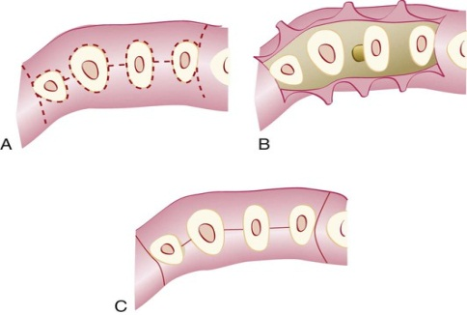

- if there is a space between all teeth ; i.e ( the interdental papilla is wide to split ) >> surgically remove interdental papilla to one side ether lingual or buccal ,after we finish then return the interdental papilla to its place .

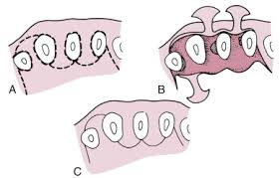

As a conclusion to this classification :*
-split the interdental papilla >>when the teeth are tight
-preserve interdental papilla >>when the teeth are spaced .

i.e : when operator done a surgery ,the interdental papilla still as one piece ( get it from one side to the side of the flap as a full papilla then after finish replace it and suturing ) .

above we discuss the classification of the flap ,*
let's talk about the types of the flap ;
a -according to thickness:
1-full thickness flap >>all soft tissue and periosteum are reflected to expose the bone .
-indicated when respective osseous surgery is done .

2- partial thickness flap >>reflected only the epithelium ,
-the bone remain l covered by connective tissue .

b-according to placement of the flap at the end of procedure :
1-non-displaced (access flap) , when the suture in its original position.
-use in root planning just to access the pocket .

* plate flap cant be displaced why ??
Because the palate is keratinized tissue (unattached gingiva ) so if operator doesn’t place it in its original position ,it will never heal again .

2-dis-placed flap include flap : that are placed apically ,coronally ,laterally to their original position .

c- according to the management of interdental papilla :

1-convential flap:
- splitting the papilla in two halves palatal and labial part.
-use it when the teeth are tight ( close to each other ) >>no way to preserve the papilla .
2- papilla preservative flap :
interdental papilla reflected as one piece lingual or labial .

- *design of the flap :
- - The operator should decide where he is going to place the flap before starting the surgery not haphazardly .
- Correct diagnose, what we want to do during the procedure , considering pocket depth ,amount of healthy tissue ,recession ,surgical judgment of treatment , what i want to achieve after procedure .

- We have 2 type of incision :*
- 1-horizontal incision : along the gingival margin ether mesial or distal direction :- 3 types :

- A-internal bevel incision (reverse bevel incision ) :

- - place the knife lateral to the gingival ,below the gingival margin by 0.5-1 mm ,don’t place the knife in the socket .
- -direction of the knife toward the teeth not toward the tissue ( ask ur supervisor to show it in the clinic )
- -used in most periodontal flap as an initial flap ( we start with it even if we need to do cervicular flap ) .

- B-cervicular incision also called sulcular incision :
- -is the second incision after internal bevel incision
- -place the knife at the bottom of the pocket and move from one side to anther and cutting the base of the sulcus .
- - directed to the bone margin

- C - interdental incision :-
- -- It is performed after the elevation of the flap to remove the interdental tissue that remained after making the first two incisions .
- - As we did in gingivectomy , insert the hairpin knife to release interdental papilla .
- -
- *as conclusion :
- We start with internal bevel incision (initial incision ) at 0.5-1mm then pressurize the knife until we reach to the crest of the bone in single cut single bush , then do cervicular incision to the bone then release and interdental incision .

- 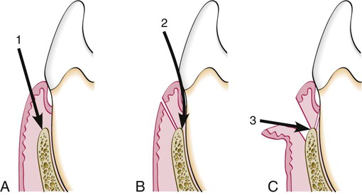
- A) internal bevel incision .
- B) cervicular incision .
- C) interdental incision .-

- 2 - vertical incision also called oblique releasing incision :
- -can be used on one or both ends of horizontal incision (unilateral or bilateral incision ) .

- *why oblique cut ?
- To preserve the interdental papilla , if it is perpendicular it will split the interdental papilla >>recession
- *we usually start the incision from distal to mesial to improve the visibility.
-

