Sheet no. : 5
Refer to: slides no.5 and Dr.Nicola’s handout
Written by: Eathar Usama

“Periodontal Flaps”
We have studied the classifications of flaps that were according to:
- the thickness of the flap (full thickness/ partial thickness)
- the placement of the flap after surgery (non-displaced/ displaced)
- the preservation of the interdental papillae (conventional/ papilla preservation)
What we achieve by doing any type of periodontal flaps is the following:
- Reduction or elimination of pockets
- Increasing accessibility to the subgingival areas to perform a meticulous root planning
- Expose the area to perform regenerative techniques

One of the steps of periodontal surgery after scaling, polishing and oral hygiene instructions, and anesthesia is “Incision”:
In conventional flaps or papillary preservation flaps, only one incision is done “crevicular incision” in which the knife is directed towards the crevice (the sulcus depth); because we have to preserve tissues as much as possible in order to regenerate the lost PDL. However, in all other types of flaps a second “horizontal incision” and a third “interdental incision” are done in addition to the first crevicular incision.

Now, we’ll go through the three types of flaps and how they’re done.
- Modified-Widman Flap
- One of the most commonly used flaps among periodontists and beginners because it doesn’t take time, so accurate and with predictable morphological outcomes.
- Why to use this type of flaps?
Only to gain access in order to do meticulous root planing and pocket lining removal with direct vision but it doesn’t remove the whole pocket wall, so it’s an access-flap which allows open root planning/ curettage, unlike the closed root planning that we used to perform in the clinics placing the curette subgingivally without direct vision.
- Healing:
When we return the flap back to its original place without pocket lining removal, this won’t eliminate the pocket or regenerate anything. However, when we remove part of the pocket lining that contains the infected part of the sulcus (granulation tissue) and provide direct vision meticulous root planing then return the flap back to its original place, re-epithelialization and mild recession would result leading to shrinkage/reduction of the pocket depth and subsequently healing of the pocket.

- Steps of any flap/ Modified-Widman flap specifically:
- Calculus removal by means of scaling, polishing and oral hygiene instructions on the first appointment
- Flap surgery two weeks later when tissue improvement takes place.
- Re-attachment not new attachment, because epithelial lining and PDL attachment were already present in the same tissues without regeneration, whereas new attachment means regenerating bone or PDL and redirecting the PDL on the expense of the epithelial tissues, because as previously known epithelialization is faster than the growth of PDL. In all cases involving regeneration of the PDL on cementum healing comes by “new attachment”.
- Primary-intention healing, minimal recession after flap closure.

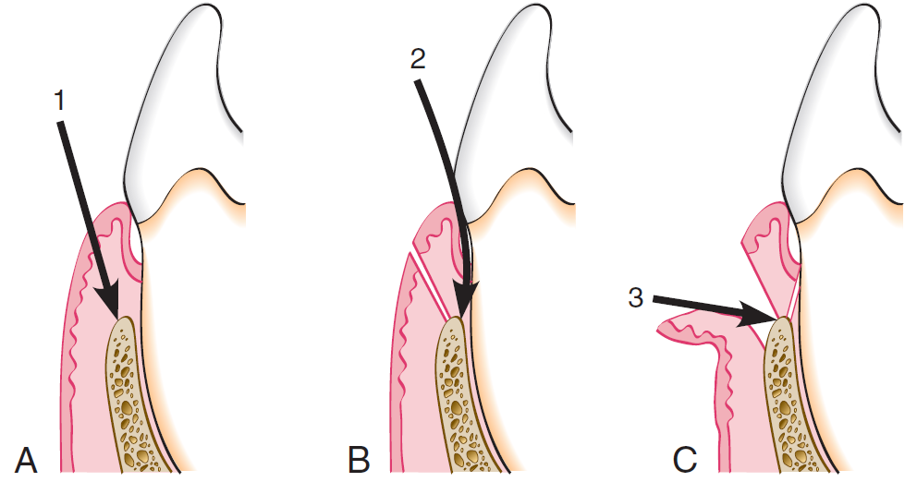
The figure shows the initial incision (inverse bevel) to the alveolar crest 1.5-2mm away from the gingival margin depending on the amount of attached gingiva, we insert the knife until it touches the crest of the bone, we remove the pocket lining/granulation tissue (not the whole pocket wall in this case). Then horizontal incision is performed, we do release to the crevice area and the interdental papillae remain attached lingually and labialy.

By periosteal elevator we only reflect the flap margins slightly. We use a scalpel blade to do the crevicular incision.

Then we perform the third incision “interdental incision”, the papillae are cut from the labial side or both the labial and the lingual sides bisecting them, which aids in pocket lining removal and meticulous scaling.
When done we do interrupted-sutures; to ensure the complete closure interproximally/ interdentally between the two interdental papillae (lingual and labial), we should stretch them not to allow bone exposure.
Here, we’re removing the pocket lining only from ABOVE the crest of the bone level, without the part below it to which the pocket is extended.
We should weigh the advantages and disadvantages of this type of flaps to decide whether to perform it or not.

- Displaced/Repositioned-Flap
- Placing the flap either more apically or coronally in relation to its original position, or sometimes laterally in mucogingival surgery to treat the mucogingival defect.
- Apically displaced (repositioned) flap: returning the flap more apically. Removing pockets and increasing the attached gingiva are achieved by this, because with the three incisions the entire pocket with its lining is removed, by that the pocket is reduced and apically shifted in position as well so we gain more attachment.
- Steps:
- Initial therapy: scaling, polishing, oral hygiene instructions and meticulous root planing.
- The initial incision horizontal, crevicular, interdental except for the regenerative technique its only crevicular.
Here we go up to 2mm or slightly more in distance (we go for the maximum); because in this case we’re displacing the flap and eliminating/reducing the pocket i.e we’re removing the pocket wall not the wall lining.
- Then we reflect the flap completely and do osteoplasty (bone reshaping) for the area; because pockets are deep enough (more than 5mm) and associated with bone resorption which is never found with a uniform manner on the tooth surface, so osteoplasty is done to enhance attachment and healing.
When returning the flap the mucogingival margin should be parallel to the bone architecture, if we fail achieving that this would lead to the absence of biological width, resulting in deep areas, close areas and areas of healing by epithelium (increase in sulcus depth).

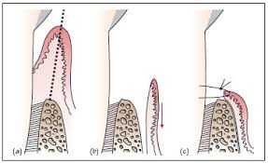
- Undisplaced Flap
- Means opening the flap and returning it to its histological position

- Look at the cut position to differentiate each type of flaps.
In “modified Widman flap” and “apically-repositioned flap” we only remove the lining where the scalpel is inserted till it touches the crest of the bone, whereas in “undisplaced-flap” it’s lateral to the crest of the bone.

- In undisplaced-flap we do surgical gingivectomy to remove the excess amount of tissue by making bleeding points on the outer surface of the gingiva using a puncher; these points represent the pocket depth.
Indication: when bone needs to be removed, in crown lengthening if we remove the tissues bone exposure would result, we can’t do crown lengthening leaving the bone, so we open a flap. After that we do osteoplasty to the area then we place it that’s why it’s called surgical gingivectomy, in which we have to remove part of the bone either by osteoplasty or osteoctomy and then replace the flap back.

In gingivectomy using electro-cautery which is not used in this kind of flaps we have to put a marker then we’ll have bleeding points to mark the depth of the pocket then we do incision by a scalpel blade 2-3mm away from the gingival margin then we touch the crest of the bone and do the incision.
Indication: used in cases of drug-induced gingivitis, in which the amount of tissue removed is supragingival to the marginal lining.

Flaps for Regenerative Surgery
- Conventional Flap
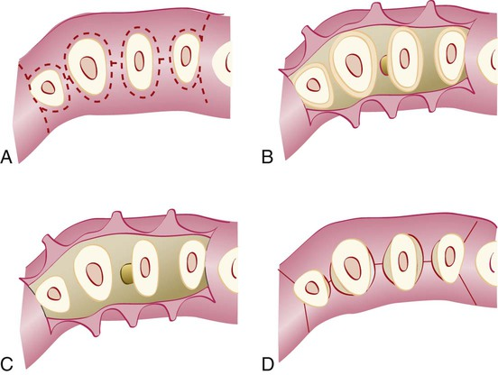
- The flap is made using only crevicular or pocket incisions, to retain the maximum amount of gingival tissue including the papilla, for graft or membrane coverage.
- Used when there’s no space interdentally

- Papilla-Preservation Flap
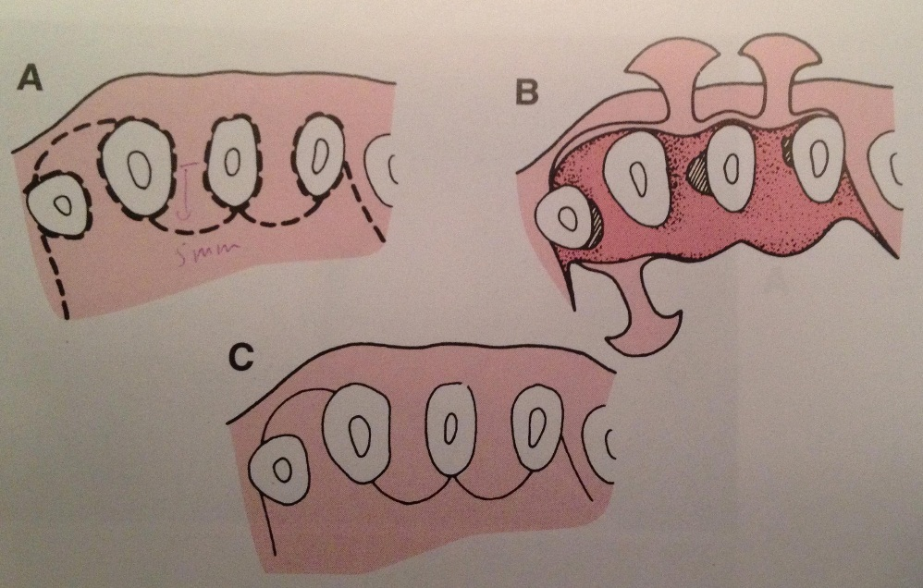
- Split the papilla from one side and shift it to the other side (lingual to labial)
- Used when there’s a space by which we can preserve the interdental papillae
However, both of the above flaps are used for regenerative techniques to preserve tissues as much as possible, then to induce regeneration.

Full-thickness flap, to expose the roots and the bones and to know defects in the bony architecture then we do bone grafting.
Therefore, with nowadays materials we have many options to regenerate tissues.

- Notes about the first exam:
One question for Dr.Ahmed about suturing
Dr.Omar material
As for Dr.Nicola’s material/handout:
You should memorize at least one or two surgical techniques and their steps in sequence:
- Scaling, polishing and oral hygiene instructions
- Anesthesia before flap opening
- Incision
- the three incisions in sequence if the flap was “modified-Widman flap”
- one incision if the flap was “regenerative technique flap”
Goals/ reasons why we do periodontal flaps
Classifications
Osseous resective surgery

