Perio sheet no. 7
Created by: Haneen Al-Khateeb - Ala’a Bashir

NOTE: The Dr. didn’t go through what is all written in the slides but he said that we should know them (from the slides), so, I added all the extra information from the slides & there is no need to get back to them

Today we will talk about the process that occurs on a cellular level that leads to bone resorption (in periodontitis).

Cells of the immune system:

Most of the destruction that happens in the periodontal disease is due to immune response (host response)
What is actually happens?
There is bacteria (biofilm) at the interphase between the tooth &the gingiva>>> lymphocytes & leukocytes function .
We will talk specifically about immune response & periodontium, what are the microbial relevance factors that are playing a role in the inflammatory process and the destruction of periodontium, inflammatory mediators & what is the process that leads to alveolar restoration
In pocket formation (attachment loss)…..there is extension for the biofilm & extra migration for the junctional epithelium
The aim of this lecture is to understand how the accumulation of plaque & bacteria end up with a bone loss ?!
U have to revise cells of immune system from the slides
Dendritic cells :
leukocytes with cytoplasmic projections; Are antigen presenting cells, these cells take the antigen and make processing then presenting it to (adaptive immune response) more specific type of cells like macrophages & neutrophils. They mainly express MHC II (Major Histocompatibility Complex 2) and other molecules that function in cell adhesion.

Macrophages, neutrophils, monocytes:
These cells are considered as one group together because they have the same line of cells that is involved in maturation.
They are 2/3 of leukocytes that are phagocytic & APCs
Even neutrophils (polymorphonuclear cells) & macrophages are APCs
PMN cells also have a role in phagocytosis
Monocytes & macrophages have many functions including that they are receptors for complement system, igG, MHC 2, blood & tissue chronicity.
PMN cells : phagocytosis, receptors for complement & igG

Mast cells:
Note: the Dr. didn’t mention it but it written in the slides
-immediate inflammation
-has receptors for complement & igG & igE
-Vasoactive substances: vasodilation & vascular permeability
-Histamine, heparin, ECF, NCF & others

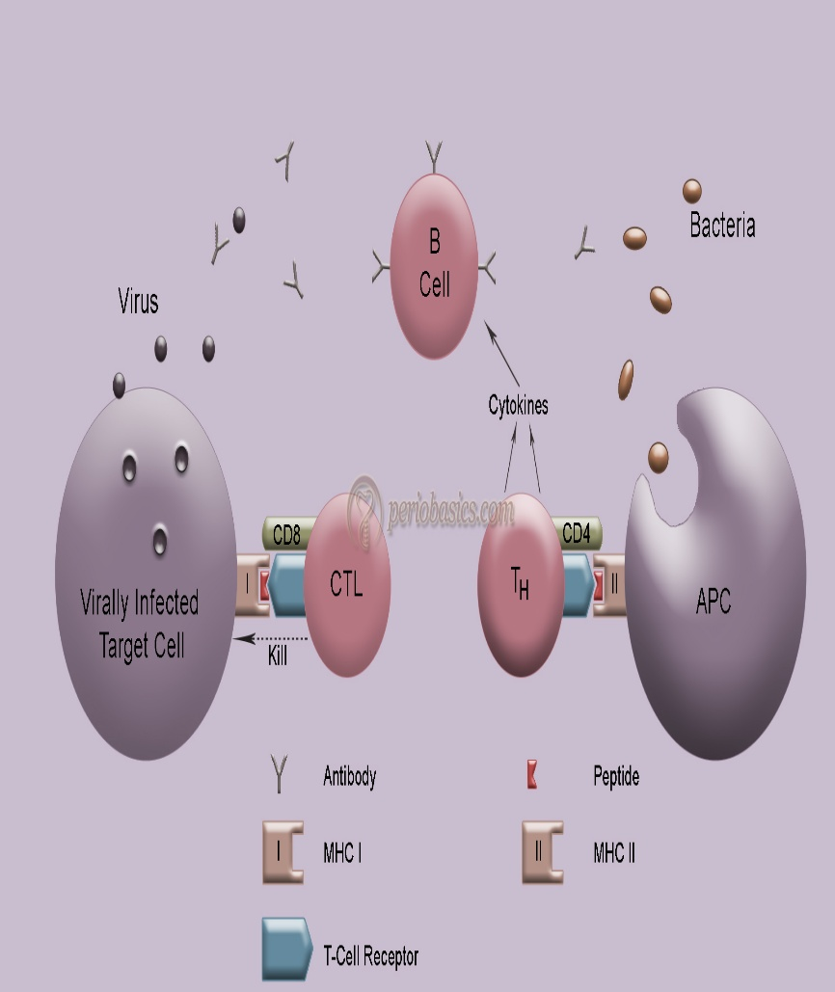
T cells:
They release cytokines ( are inflammatory cell mediated between different cells means that they work locally unlike hormones, so these are signals)
They have 2 types: CD4 (humoral response) & CD8 (cytotoxic)
They recognize antigen associated with MHC 1 or 2 on APCs . The difference between MHC 1 & 2 is :
When antigen is presented by MHC 2………there will be a Humoral response means response will be by T cells, plasma cells, antibodies
While when antigen is presented by MHC 1……there will be cellular immune response by killer cells

B cells:
They are APC
B cells transform into plasma cells & memory cells
Also they release antibodies & cytokines (to regulate processes)

Natural killer cells:
-They recognize antigens associated with MHC I (which gives a cellular immune response) and then they eat the cells.
-Autoregulation

Complement system:
Complement system is a set of 30 soluble or membrane associated glycoproteins, usually found in plasma.
It has 3 pathways of activation : classical –lectin - alternative pathway
The classical pathway: It is activated by ag-ab complex
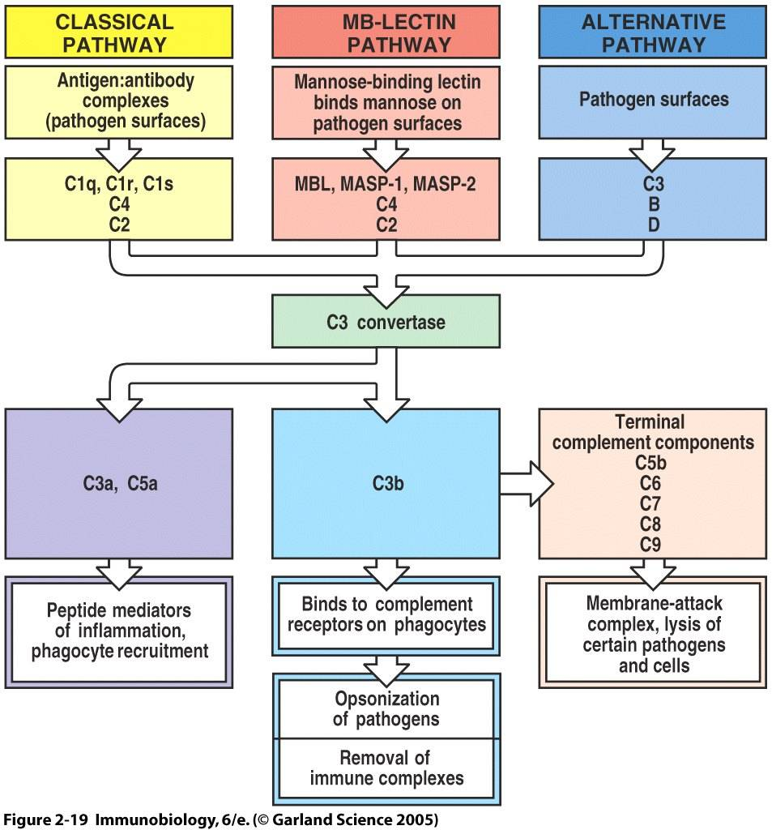
The alternative pathway: is activated by highly conserved molecular pattern such as LPS Endotoxin. The exposure of Endotoxin will activate the complement system.
Functions:
- They are Vasoactive. (makes vasodilation)
- Involved in Anaphylaxis.
- Involved in Chemotaxis.
- Involved in Opsonization (makes the molecule more easily to be recognized by phagocytic body)
Leukocytes

Functions:
1-Chemotaxis; movements of leukocytes along chemotactic gradient- assumes a polarized shape
2-Phagocytosis; a process of ingesting particles of a size visible to light microscopy. Killing mechanism: oxidative killing / non oxidative killing.
3-Antigen processing and presentation; MHC2 >> CD4+cells. /Co-stimulation. / toll like receptor.

T lymphocytes, B lymphocytes & antibodies:
-CD4 & CD8: are cell surface molecules; functional T cell subsets
-CD4 is the predominant phenotype in the stable periodontitis lesion

-B cell dominated destructive lesion
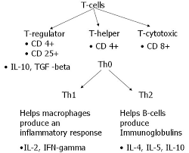
-B lymphocytes produce mostly igG, some igM & igA. It has low biological activity

Cd4, cd8 & T helper cells they differentiate into different types Th1 Th2 Th17,T regulatory. Th17 is the one that associated with periodontal disease. These cytokines induce the transformation of T helper cell into Th17 for ex.
When there is plaque accumulation, the first thing that happens is more than one thing. We know that bacteria has virulence factor & this factor has 2 types , one of them stimulates the immune response & lead to diseases & destruction & other product which is toxic to cells like for example ; hydrogen sulfide (which is one of the byproducts of the bacteria & its destructive to cells) , but most of the destruction is not due to toxins of these byproducts but its due to the intense stimulation of the immune response.
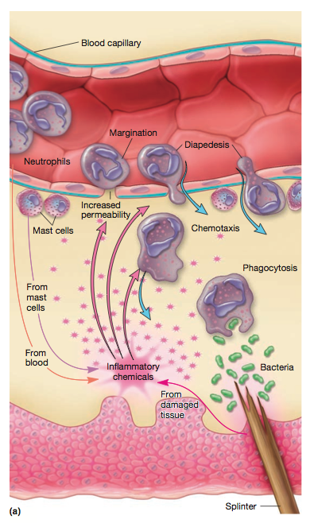
Here we have accumulation of the bacteria >>> and gradually the bacteria is transformed from [gram +] to [gram –] (that contain LPS Endotoxin) >>> & now we will have complements (complements are proteins exist in plasma , & the GCF *gingival crevicular fluid* is about nothing except plasma , so there is complements in the GCF ) >>> A contact between the LPS & complement will happen & this activates the complements (functions of complement as we said : chemotaxis – anaphylaxis – opsonization – Vasoactive) >>>bacteria now is opsonized by the complements & is ready now to be engulfed for phagocytosis >>> One of the results of phagocytosis -away from the destruction of bacteria -is antigen presenting & releasing cytokines (these cytokines are released by the complement system or through the phagocytosis process that is happening ). What actually cytokines do is the release of interleukins 1 &6 & tumor necrosis factor α. IL1 ,IL6 & TNFα are released to upregulate receptors located in the endothelium of the blood vessels inside the gingiva >>> this will attract neutrophils that’s circulating in the sulcus leading to margination on the blood vessel >>> diapedesis & migration of neutrophils crossing the blood vessels reaching the tissue matrix & this will concentrate the neutrophils , cuz in a healthy situation there is circulating neutrophils but to a minimal level but when there is stimulation to the immune response that’s what happens as a result of so many signals .>>> this affects blood vessels so we will see a vasodilation then chemotaxis (this means that bacteria will go toward the chemotactic stimulus). One of the chemotactic agent is the product of complement system ) .note: cytokines are not chemotactic agents but it activate the release of chemotactic , for example activation of a mast cells by complements lead to release of chemotactic agents.

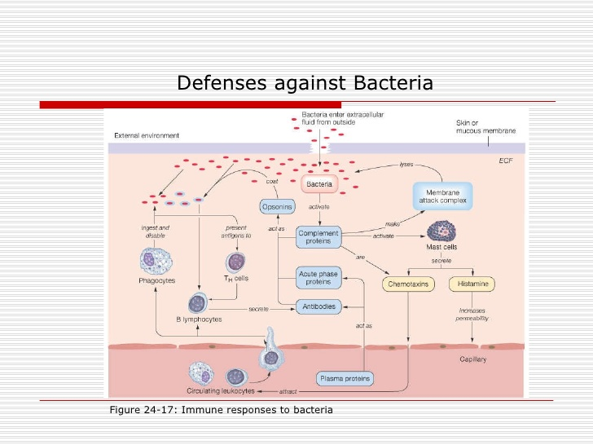

Microbial virulence factors that stimulate the immune response:
- LPS :
-Most of the gram negative have LPS. Its an Endotoxin
-Its highly conserved in bacterial species :
In the past the immune system was divided into specific and non-specific immune system & that was totally wrong (but now it is divided into innate and adaptive immune system), this is because that there is no interaction that is nonspecific , every interaction should be specific , on other words , how the immune cells could recognize the LPS if the interaction for the first time is not specific ! But here in the first time of attack , there will be innate immune response cuz the molecules of LPS are highly conserved, meaning that the LPS has a specific sequence of proteins that a body can recognize & this also means if in one day there is an LPS that the body can’t recognize , many people would become sick. In other simple words, highly conserved means it is preserved and does not change over generations, the innate immune system is specific enough to recognize these particles and because they don’t change these preserved molecular patterns are always associated with the membranes of one or more of the offending organism/s these organisms can be detected and identified by the immune system.
-It’s usually recognized by TLR 4 (toll like receptors): these receptors are the one that recognize highly conserved molecules, This is a specific interaction. TLR4 identifies for the first time the highly conserved molecules.
-P.gingivalis LPS is atypical in being recognized by TLR-2 & TLR-4
-Lipotechoic acid – ( G+ve bacteria )
2) Bacterial enzymes and noxious products that cause damage directly (where the host cells are damaged) or indirectly by (potentiating the immune response.)
These products include:
1) Ammonia (NH3)
2) Hydrogen sulphide (H2S)
3) Butyric and propionic acid
These products are toxic to cells, but most of the destruction is due to the indirect effect of virulence factors by stimulating the immune response.
Other virulent product:
- Proteases (some of bacterial product)
- Gingipains in P.gingivalis
These make degradation of proteins in matrix to provide nutrients for bacteria. Note: some bacteria species have the ability to invade the tissues
Note: the only bacteria that has the ability to invade the connective tissue is (Aa) (Aggregatibacter actinomycetemcomitans), especially in cases of aggressive periodontitis. So in these cases we give the patient antibiotic cuz there is invasion by the bacteria & do scaling and polishing.
Note: P. Gingivalis has been shown to invade only the epithelium not the connective tissue.
Remember: the invasion is not really the main mechanism of destruction, the way of tissue destruction is invasion in many body tissues –bacteria inside the tissues- , but the destruction in periodontal disease is not by invasion –not by toxic products of the bacteria- , its by the stimulation of the immune response.
Other risk factors:
1-Fimbriae :is one of the virulence factors that exists in p.gingivalis , it’s a fussy coating around the bacteria to protect it from opsonization & phagocytosis .
2-Also there is other bacterial product such as DNA & extracellular DNA also stimulating the immune response.

Host derived inflammatory mediators:
1- Cytokines
2- Prostaglandins found in cell membranes
3-Matrix metalloproteinases (similar to proteases)*MMP*

1-Cytokines: (like: IL-1β & TNFα)
Cytokines are Soluble proteins that function as messengers that transmit signals between cells, binding to receptors initiates an intra-cellular signalling cascade (as we said before, cytokines make upregulation on the endothelial cell walls for certain receptors) resulting in altering gene regulation & protein synthesis and ultimately affecting the cell phenotype and function.
They are:
- Produced by many cells.( like mast cells ,lymphocytes, macrophages, neutrophils & so many cells)
- They mainly act locally.
- They give +ve feedback; certain types of cytokines stimulate the release of other types of cytokines that inturn will also stimulate the release of other types of cytokines eventually the primary cytokines will be re-stimulated and so on. For example; IL1 induces the production of IL6 & IL 6 induce the production of IL1, its just like a circuit.
- Significant overlap and redundancy; sometimes cytokines do the same functions also means each individual cytokine has more than one function and its functions overlap with the functions of other cytokines.

-IL-1β :
Produced mainly by monocytes, macrophages & neutrophils , but not only by these cells
Elevated in sites infected with periodontal disease

-TNFα:
Is secreted by activated macrophages
Its function:
- Induces MMP secretion (this enzyme induces the degradation to the matrix of the connective tissue & the bone)
- development of osteoclasts
- apoptosis of fibroblasts (which leads to lesser deposition of a matrix), leukocyte recruitment
- stimulation of IL-1β & PGE2secretion. (PGE2 is very important in bone resorption.) . So its all overlapping

2-Prostaglandins:
* Lipid compounds derived from the degradation of Arachidonic acid found in the cell membranes of most cells.
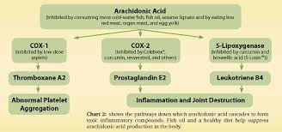
*Cox 2 enzyme are regulated by cytokines , so when there is upregulation for this enzyme by (IL-1β , TNFα & LPS )this means that we have more prostaglandins
*prostaglandins is an inflammatory agent so it functions to induce the immune response
* We have many types of prostaglandins, the most important of which is PGE2 because it activates MMPs and Osteoclasts.

3-MMP:
A family of zinc dependent proteolytic enzymes that degrade the extracellular matrix molecule such as: collagen, gelatin & elastic
Usually secreted by most of the cells like neutrophils, macrophages, T lymphocytes even osteoclasts
Its very important for the maintenance & turnover of the connective tissue, so its not static, its dynamic
Its upregulated by cytokines : IL-1β & TNFα
Contributes to the breakdown of the connective tissue & bone
There is a table in the slides but the dr. Asked to memorize the following only because they are the most important in periodontal tissue:
Group | Enzyme | Name | Produced by
Collagenases | MMP-8 | Collagenase2,  neutrophil collagenase | Neutrophils
Gelatinases | MMP-9 | Gelatinase B | Fibroblasts

Immune response in periodontal pathogenesis :
Innate immunity:
- Saliva: it contains proteins, histatin, peroxidases, mucin, lysozyme…
- Epithelial tissues: acts as a barrier, beta definsin
- GCF
- Pathogen recognition
- Neutrophil function
Exam question: All of the following about bacteria biofilm are true except: GCF helps in binding of the bacteria . This is wrong cuz GCF just makes motion

Adaptive immunity:
- T cells
- B cells
- Antibodies

Alveolar bone resorption:

What stimulates osteoclasts to act ?
All the mediators that get released during the interaction between the virulence factor & immune response & all the initiation & propagation of the immune response results in lots of cytokines & mediators ends up by stimulating the osteoclasts

Osteoclasts:
The origin of osteoclasts is the monocytes/OPC
Its responsible for bone resorption
Resorption stimulated by wide range of mediators (PGE2- IL1β- TNFα)

Now lets ask: when do u have resorption & when do I would not have resorption?! – why in cases of gingivitis there is no bone loss ?!
The answer is that there should be a threshold but actually we don’t know the answer for sure, cuz if this is right , the treatment will be more clear & follow a certain and specific protocol . The more accurate answer is related to :
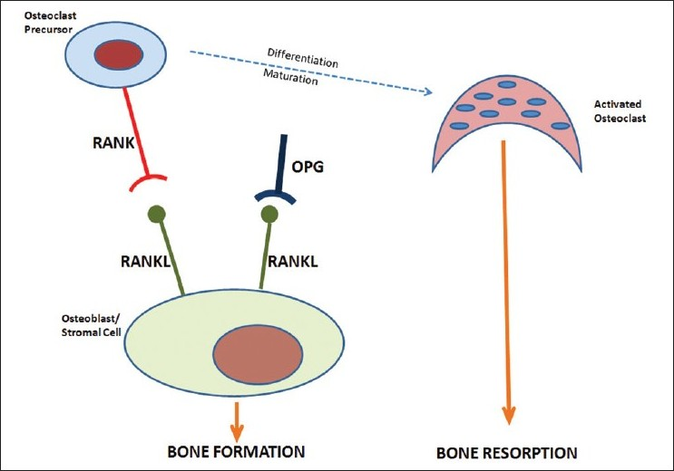
1-concentration of mediators, there should be a certain concentration to stimulate the osteoclast function.
2-distance from the bone
3-RANK/RANKL/OPG pathway: to have mature osteoclast from preosteoclast, we have 3 important molecules which are: RANK – RANK Ligand – OPG (osteoprotegerin) , (this pathway has been discovered while studying the multiple Myeloma which is a tumor that happens mostly in the skull ).
RANK (is a receptor associated nuclear factor kap) so it’s a receptor that’s located on the pre-osteoclast >>> once it stimulated by RANKL the pre-osteoclast will transform into osteoclast
Another scenario may happens if the RANKL binds OPG >>> then this stops the maturation of osteoclast
-Osteoblast makes production of RANKL.
- (PTH, vitamin D, Glucocorticoids *steroids*, inflammatory cytokines) makes potentiation for the production of RANKL >>> bone resorption
-One of the most difficult questions in periodontal disease, is when I do a periodontal therapy for a patient then he came the next visit for evaluation, & I noticed a 3 mm residual pockets, then how could I know that the site is stable ?!
We test the concentration of the cytokines in the GCF (TNFα, IL1β, MMP), but all of these cytokines still not reliable cuz u may check these but the result still normal & after 2 years for example there will be progression & farther deterioration!
The most important test is the ratio between OPG & RANKL
When the ratio of OPG is high>>> this means more of RANKL is blocked & so there is no osteoclastic activity and no bone restoration, its an anti-osteoclastic –protective-.
-Glucocorticoid blocks the OPG (OPG is produced by osteoblast)>>> this increase RANKL, this is part of regulatory mechanism . Even the regular bone turnover that is happening is related to this pathway: RANK – RANKL – OPG
-this produced by many cells including inflammatory cells, so RANKL is not only produced by osteoblast its also produced by neutrophils & lymphocytes
-vitamin D increases OPG & RANKL >> that’s because this pathway is related to regular & normal turnover

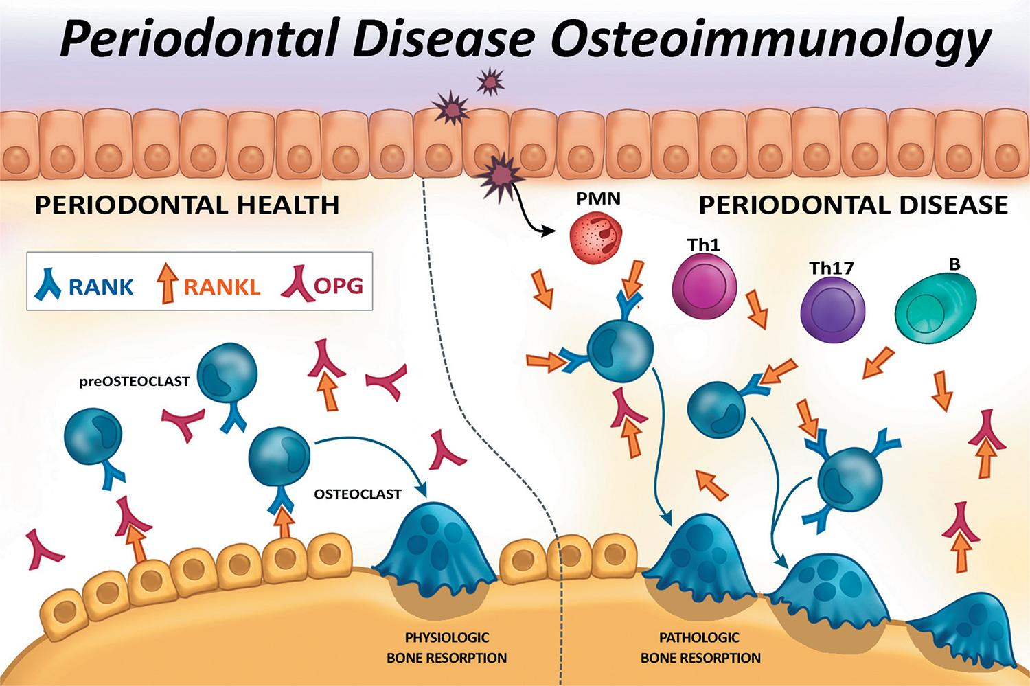
LPS( highly preserved molecular pattern) >>> activates Stromal cells, fibroblasts, osteoblasts >>> expression of RANKL >>> RANKL interacts with RANK on the pre-osteoclast >>>we will have osteoclast and bone resorption , or the OPG makes decoy & prevents RANKL from binding RANK

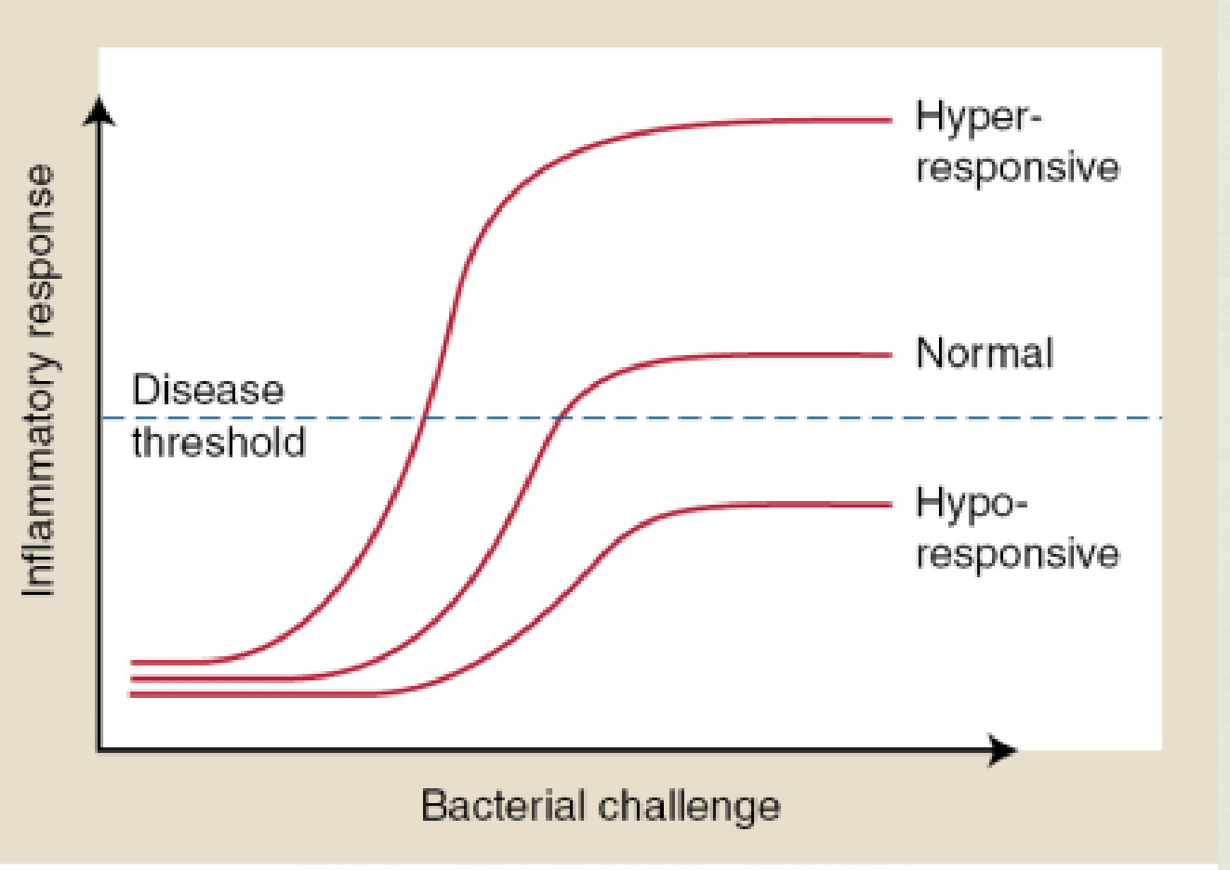
Concept of host susceptibility
Now a question is left: which is why some times we have breakdown & tissue destruction & sometimes we don’t?
-The sub gingival biofilm contains complex immune response mediated by large number of anti inflammatory cytokines
-this occur with a backdrop of other host and environmental factors (like smoking)
-It seems that when the inflammatory response is more intense >>> this will be more likely to cross a disease threshold
- when there is hyper responsive immune activation >> there will be bone loss
& the hypo responsive is gingivitis >> disease threshold is periodontitis.

Environmental & genetic risk factors:

We have microbial challenge LPS, antigens,PMN & other virulence factors >> activation of the immune response>>> production of antibodies and phagocytosis>> leading to more activation
Note: the immune response should be protecting the body , but when the immune response is so massive, this will lead to tissue destruction as on periodontitis. Let’s think a little bit, the immune response is just doing its job which is protection and nothing wrong although there is destruction happening, and what is actually happening is that the immune response is getting rid of the tooth by making bone loss until exfoliation take place. Periodontal disease heals when there is extraction and the infection is gone. This is confusing !

في أوج زحمة الفكر وانسداد الطريق إلى أملٍ على أوتار التّشبُّثِ يَسْتَكبِر، انظر لما وراء الأفق وانتظر فأزمة السير غالبا للدهر لا تنتصر
حنين الخطيب

