Sheet :8
Mucogingival surgery
- **Periodontal surgery its part from and more related to periodontitis type disease to ,(correction disease( treatment ) ,or correction residual disease effect.
- What is the goal of osseous surgery ?(what is primary object )
- Pocket reduction or elimination
- So our aim to reduction pocket by remove bony deficit (interproximal bone it is always present =present the pocket ,so we cut the crater (flattening it ) so no crater =redaction pocket .
What the primary goal for periodontal surgery?*
Access for instrumentation *
What the goal regenerative procedure? *
Pocket redaction but in other way (by try to grow bone close defect( falling it by bone ) to pocket redaction .
So (open flap surgery+ regenerative+ osseous surgery)=primary object is access for instrumentation .
*proper throw root instrumentation to make sure the root no have calculus.
No good access =failure procured (special in regenerative procedure .
Mucogingival surgery deal with other type periodontal or mucogingival condition or satiation.

We wil talk about :
- Terminology
- Indications
- Etiology of recession (recession is one of the mucogingival deformities)
- Techniques to address mucogingival deformities:
There is a wide range of mucogingival deformities and different techniques for addressing mucogingival deformities

- Mucogingival surgery: (classical restore)surgical procedures for the correction of relationships between gingiva and oral mucous membranes. (gingival: mean relating to the keratinized part(attatchment gingival +gingival margin ), and oral mucous membranes relating to the non-keratinized part and these two meet at the mucogingival junction)
- Mucogingival deformities could be:3 involving attached gingiva such as: recession,
- shallow vestibule
- large frenum.

More recently we are using the term periodontal plastic surgery and it’s a more encompassing term (wider) and is defined as: the surgical procedures performed to correct or eliminate anatomic, developmental, or traumatic deformities of the gingival or alveolar mucosa. It’s not only for the deformities between gingival and mucous membranes, it became a much wider term to include a wide range of procedures related to the correction of anatomic, developmental or traumatic deformities affecting gingival or alveolar mucosa such as::

- periodontal-prosthetic corrections: such as gingivectomies
- crown lengthening
- ridge augmentation: when there is a ridge deficiency vertically or horizontally we augment it (we enlarge it).
- esthetic surgical corrections
- coverage of the denuded (exposed) root surface: coverage of recession. This is the typical and the standard definition of mucogingival surgery.
- Reconstruction of papillae.
- Esthetic surgical correction around implants.
- Surgical exposure of interrupted teeth for orthodontics: even the exposure of an impacted canine is considered as a periodontal plastic surgery; depending on how u do it, it might have negative esthetic effect if the exposure was done improperly.

What is the indication of mucogingival surgery ?**
- Lack of attached gingival ; whether having actual gingival recession or just narrow zone of attached gingival .
- Shallow vestibule
- Removal of frenum
important

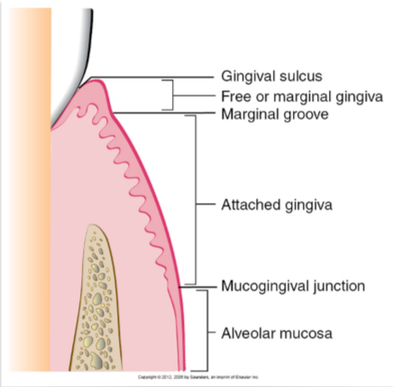
*free gingival margin (not attached)from gingival sulcus to marginal groove .
*attached gingival (from depth of marginal groove to mucogingival junction ).
*Attached for what ?to cementem and bone .
Are mucogingival coincident to Cristal of bone ?no is dependent ..
May the attached gingival found in different level .
How can be differentiation mucogingival junction ?
By 3 way :1 )visual demarcation line between mucosa and attached gingival .
2)mechanical by using cotton to push gingival and see where the fold is mucogingiva
3)using stain :stain the keratin area .

pic in slide :clinical photo ,showing the buccal surface of lower and upper anterior teeth ,most notable gingival recession tooth number (41 ) , attachment loss .
Keratinization and not attached ?that mean pocket.
with other pic : compare
Clinical photo for labial surface of anterior teeth ,see the recession ,no have defect in attachment ,so the different between to pic the management the 2 dealing only by recession .
**the first indication is lock of attachment gingival .
The amount of attached gingival is varies
Sometimes there is a very narrow zone of attached gingival and this is seen mostly in canines and premolars. The widest zone of keratinized attached gingival is usually in the upper lateral incisors.
In mandible the narrow found in labial in 3,4 go distal became wider .
In general the attached gingival in maxilla wider than mandible.

*is there a minimum amount of attached gingival that necessary for health ?
There are the not have attached will be came weak and occur recession .

Can maintain healthy gingival even in the absence of attached gingival
That means in long time when will not found attached gingival do the surgery graft .
No have attached =weak point=need graft .
In many study done found in pt maintain oral plaque no more at risk in pt have attached gingival.
Pt minim or no have attached gingival in one side do graft in other side not ,then follow up to 10years found =no different
we*know pt with poor plaque control may be slightly risk for recession .
- So why do we sometimes correct the lack of attached gingival ?:
- To facilitate good plaque control; the patient cannot perform good plaque control.
- To improve esthetics; because many times when there is mucosal margin without gingival margin the color of the mucosa will be more reddish and sometimes it’s not esthetic.
- To reduce inflammation around restored teeth. The only indication when there is no minimum of at least 2 mm of attached gingival that you would do a surgery to correct it when there is a restorative margin right there where there is a mucosal margin. (when there is no attached gingival and there is good plaque control you don’t have to graft it, but if there is no attached gingival and there is a crown or a restoration then you should graft). Because there are studies showing that when there is a crown there will be higher plaque accumulation and higher inflammatory status so you want to improve the quality of the tissues.
- To have a gingival margin that binds better around teeth and implants. Mucosa is movable it’s not tightly bound to the underlying bone or tooth, while gingival is not only bound to the bone but also to the tooth with dentogingival fibers (fibers that bind gingival to the tooth). So when there is mucosa around the tooth or implant there would be no good binding tissue around and that is another indication for correction of lack of attached gingival .

.
Pt have difficulty to brush this area is vary tender and uncomfortable one of indication to grafting.
*the first indication for grafting mucogingival surgery when =1)lack of attached .2)gingival recession
Gingival recession
Definition :location of the marginal periodontal tissues apical to CEJ.
(buccal recession or papillary recession between the teeth , but will talk more about buccal recession .
When occur the recession ? when the CEJ expose ,the gingival margin below the CEJ the root as to be exposed
**same time in young pt have crowding or teeth protruded buccaly ,see the gingival margin in incisor ,the one of teeth more buccaly expose apical part you think is recession =is wrong .the recession should be see the root
CEJ .
What the cause of gingival recession ?
3mains A\ Mechanical trauma :
1) Aggressive tooth brushing.
2) Iatrogenic: Aggressive finishing of class5 composite restoration by the dentist.
3) Factitious: which means self induced , for ex:. tongue &lip pearsing.
Regarding Occlusal interferences or malocclusion or bruxism you should know that it's per say does Not cause recession. Only actual physical trauma due to occlusion might cause recession for ex:. deep bite where the incisor edges are physically traumatizing the gingival.:
)
2) localized plaque induced lesions (mostly in buccal Localized plaque induced lesion in isolated tooth:
- Not mechanical trauma it's plaque induced.
-Remember that in case of aggressive tooth brushing it will affect multiple teeth.

Slide 21: this is a case of recession due to localize plaque induced lesion, the best think you can do in such a case is good plaque control, in which the inflammation will decrease but no such thing resolution of the recession.
\ generalized destructive periodontal disease:
- For ex:. in Periodontitis case.
-Here the recession affects also the proximal surfaces of the teeth (recession all around) because in periodontitis it starts proximally.
-Recession is attachment loss because the pt had attachment then it recceed, so he lost the attachment (so it's attachment loss).
-One of the causes of gingival recession is periodontitis, But it's not the only cause, so if you see a pt. with recession don't diagnose it directly as periodontitis.

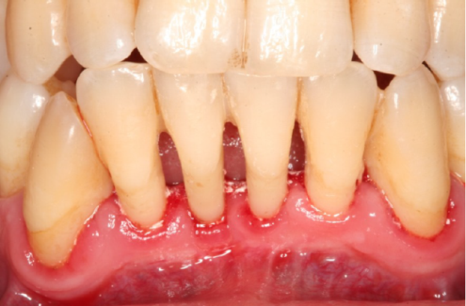
Slide: this is a case of periodontitis, note that the recession involves interproximal areas)
periodentistis
in this case the probing depth =3-2mm is normal ,by
recession .
**clinical photo showing the labial surface of lower
Anterior teeth >having plaque and calculus in proximal impresser (papillary recession) –the gingival :shiny , inflamed swelling , reddish .
Diagnosis : generalize destructive disease .
The teeth is stable in this case .

Note :***gingival recession =attached loss ,occur by the different source of trauma or diseases ,
3 thinks :bone loss usually proximal |+proximal attached loss
Plaque and calculus ,inflammation ,bleeding in probing ,(not ,not necessary present the pocket to diagnosis is periodentitis ).
**in preiodentisit pt the same diagnosis but is different management in pt have pocketing .
*should be know the pt is tenement before or not .
.-

**mechanical trauma :1-aggressive tooth brushing.2-latrogenic .3-factitions .

Predisposing factors :
1 )thin biotype what is mean :: it is a description of certain anatomical feature that is percent in the pt's gingival ,
More susceptible to recession.-

.

-High scalloped gingival margin.
-Long cylindrical teeth with triangular taper

- Very thin buccal bone in which if you rise a flap you will see fenestration, no bone and the soft tissue attached directly to the root
.
l
Thick biotype
More resistant to recession-
-Thick buccal bone.
This pt less likely to occuering recession becuos the bone is thiker

- A rectangle teeth.
-Average scalloped gingival margin
**same pt have average biotype .
2-)prominent root .
3-orthodontic therapy A Slide shows a tooth with prominent root for a pt with history of ortho tx, it's the only tooth that has recession because during ortho tx there was no good control on the amount of tongue forces and with time the root become prominent with recession.
.
4-high frenal attachment . So the only time I suspected that the gingival recession is due to the frenum is where the frenum is attached to gingival margin of the tooth.

Classification of gingival recession:
Very imp Because Miler Classification help us in prediction of the successful of the tx of gingival recession (prognosis )

Miller 1 class | Recession does not cross the mucogingival junction & no proximal bone loss (no attachment loss) ,best prognosis | 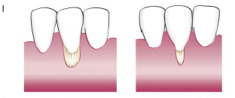
Miller class 2 | Recession goes pass the mucogingival junction & no proximal bone loss (no attachment loss),best prognosis | 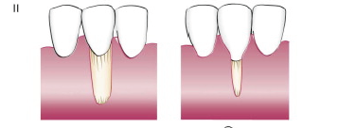
Miller class 3 | Proximal bone loss (attachment loss), But the level of proximal attachment loss is still coronal to the buccal recession. Less prognosis  Tooth are roteted also | 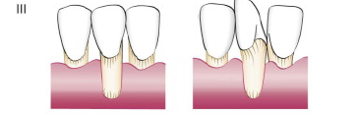
Miller class 4 | Proximal bone loss (attachment loss), But the level of proximal attachment loss is at or apical to the buccal recession. Poor prognosis | 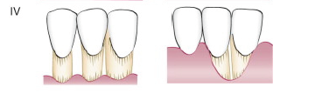

third Indication for mucogingival surgery:
Shallow vestibule :*impede proper plaque control.
*interfere with prosthesis .
Forth indication : aberrant frenum :
*Interfere with the gingival margin
*interfere with prosthesis .

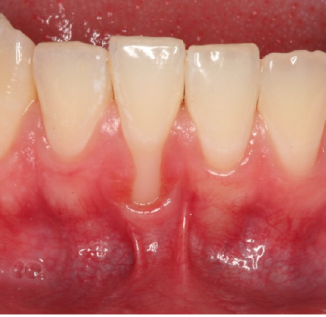
** a case where the frenum attachment is on the gingival margin and this could be predisposing factor for gingival recession & may prophylactically recommend to remove it.

Now Surgical technique: (For next time ):
1) Augmentation apical to the gingival margin:
To increase the width of keratinized gingival, the pt. has recession and he can't perform good oral hygiene or he has shallow vestibule or when I will do crown for him.
2) Augment coronal to the gingival margin:
To achieve root coverage.

