Sheet no. 13 - 11/1/2016
Doctor : Murad Shaqman
Written & corrected by : Ala’a Bashir & Haneen Alkhateeb ♥

This lecture is considered as an introduction to the perio clinics , we will talk about how to diagnose a patient in perio and some more extra informations
How to start diagnosis ?!
- Chief complain :
we start our diagnosis by asking the patient about the chief complain and history of it which could be bleeding , halitosis “ bad breath “ , swollen or red gingiva , mobility of teeth , gingival recession , black triangles , sensitivity etc …
some times periodontitis is associated with dull pain but its unlikely to see a patient with pain as chief complain ..
as we said we should ask the patient about the history of the chief complain ; onset , duration , relieving factors , aggravating factors …
- Let’s suppose that two patients came to us with the same chief complain , they both told us that they have bleeding gums but they differ in the history ;
The first case started 2 weeks ago , not associated with swelling and bleeding starts shortly after tooth brushing
The second case started 2 weeks ago , associated with generalized swelling and bleeding lasts for several hours
Ofcourse the second case is much more aggressive than the first one and we also might have systemic factor associated with it ..

- Medical history :
One of the important things we should also ask about when we are diagnosing a patient is the medical history , because we want to know 1) how safe it is to treat the patient , 2) we should know the effects of the disease on the oral cavity , 3) we want to know if an oral disease will affect the overall health of the patient .. Some studies said that oral disease could have effects on cardiovascular health ,diabetes control , pregnant ladies , or if the patient was edentulous we will suspect having nutritional problems ..
p.s : we should know how to deal with patients with high risks as prosthetic heart valves patients because it can cause endocarditis so we should give the patient prophylactics before we start our perio examination
- as we know already we should ask the patient what drugs he takes ..
Well the best way to collect all these information and to protect yourself medico-legally is to give the patient a questionnaire that he will fill and puts his signature on .
- Social history :
“ alcohol and tobacco “
We should also know if the patient is a smoker or not , if he was a smoker we should ask two important questions ; how long have you been a smoker ? and how many cigarettes you smoke per day ? .. we should also ask about Hookah “ Argeeleh “

- Family history :
We should ask about the family history to know if some one of the family had a problem as teeth loss due to perio issues.

- Dental history :
Asking about if the patient had perio treatment before is very important
- If we have a patient who had periodontitis before and got his treatment ; we diagnosed him and still there are signs and symptoms for periodontits , what does that suppose to mean ? there could be a cause that makes the disease starts all over again or it might be a difficult case that’s not responding to treatment .
- also asking about previous perio treatment shows us how much the patient took care of his oral hygiene since that time .

Orthodontic treatment :
Ortho treatment sometimes affects the morphology of the soft tissues .

- Extra and intra oral examination should also be done ;
In intra oral examination we look for caries , we check marginal ridges , open contacts , food impaction , pain upon percussion , fremitus ..
“ fremitus means movement of teeth during function which commonly seen in anterior teeth and could be seen in posterior teeth “
- The doctor said than when you find a mobile tooth , you should first take an x-ray , then you should check for fremitus by putting your finger on the tooth and ask the patient to bite then you do a lateral movement , if fremitus is existed you will feel the tooth moving .. this is very important because sometimes the reason behind the mobility is occlusal trauma not perio problem .
- Periodontal Examination :
We start our examination by visual inspection followed by periodontal probing “ we measure the probing depth and gingival recession “ , evaluate bifurcation areas , bleeding on probing , check mobility and finally we check plaque and calculus .

- Visual inspection :
The doctor showed a slide with red swollen gingiva , then he showed us the same patient after perio treatment , his gingiva turned back normal “ there is no swelling anymore “ but we can now see attachment loss , spaces appeared !! this is not due to the treatment , it was there already but the swollen gingiva was covering them ..
So , again as we said we start first with visual inspection ; we look for abnormal color ; red color , we look for swelling , recession , muco-gingival junction , plaque , calculus ..

Another slide with recession , bone loss , bleeding , calculus all of these are visual findings , we can see them by simple visual inspection

-Gingival recession :
We have to classify it , Miller’s classification is for gingival recession ; we have miller class 1 , 2 ,3 and class 4 “ we will take them later on “

- Periodontal probing:
The doctor wants us to differentiate between probing depth and pocketing depth
Probing depth : clinical measurements WHILE pocketing depth : histological measurements .
- when calculating probing depth the probe tip actually goes into the junctional epithelium but I could over estimate the probing depth for example when am having inflammation .
- when you are taking probing depth measurements “ the probe tip will never stop on the most coronal part of junctional epithelium , cause if that happened the probing measurements will be exactly the same as the pocketing depth because pocketing depth as we said is histological measurement from the gingival margin to the most coronal part of junctional epithelium .
- after perio treatment sometimes the probing depth will decrease because the inflammation will decrease “ when there is inflammation the probe tip will penetrate deeper “ , when the inflammation decreases the probe tip won’t be able to penetrate into the same depth that’s why it will decrease .
“ y3ni law kan 3nna inflammation w 3mlna probing mmkn msln ytl3 m3na el depth 2.5 w b3deen nsheel el inflammation had w nerj3 ne3ml probing mmkn nla2eeh sar 1.5 l2enno el inflammation be5alli el probe tip tfoot kteer la jowwa “

- there are some limitations of penetration of probe ; size of probe , the probe angulation , type of the probe cause we have different type of perio probes , over hang restorations & subgingival calculus .
Now we’ll start talking about some of these limitations in further details :
- Over hang restorations :
Over hang restorations make It difficult to probe and to evaluate the probing depth.
- Presence of subgingival calculus :
Having subgingival calculus will never give you accurate probing depth ; that’s why we first do scaling and polishing then we measure the depth.
- Angualtion of probe :
The probe should slide on the surface of the tooth , we shouldn’t place it with the long axis of the tooth .
*Always remember that you have to probe under the contact ; because if you don’t do this you might miss a periodontal defect .. most of periodontal diseases start interproximally under the contact .
- Note : we should check up for the presence of pus .. when probing sometimes pus comes out , so we have to take that in consideration too .

3) Furcation assessment :
-Next thing we are going to talk about is Furcation assessment ; you have to check the furcation areas because whenever they are involved this is considered therapeutic challenge for the patient because its hard to clean this area & a challenge for the dentist because its hard to control the disease “ we’ll take later on a lecture about furcation management “ .. but at this point we have to be able to evaluate the involvement of the furcation area .
If we have bone loss & the area between the roots is exposed , we should know what’s the classification of this furcation involvement.
We have something called Hamp classification ; it’s the one used for furcation involvement , it has three greads “ grade 1 , 2 and 3 “
- Nabers probe : it’s the one we used for furcation areas , it’s a curved probe , with 3 mm gradings , because this classification is depending on 3 mm increments .

Grade 1 : penetration of probe up to 3 mm
Grade 2 : more than 3 mm but doesn’t pass through “ da5al la aktar mn 3 mm bs ma tele3 mn el jeha el tanyeh “
Grade 3 : passes through “ y3ni betl3 mn el jeha el tanyeh “

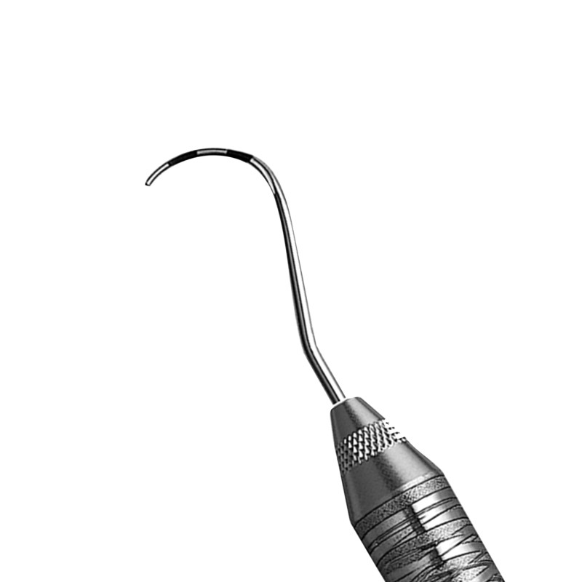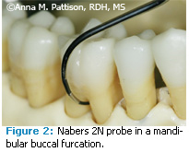

– bs nest3melo benfwto bel furcation area horizontally metel el soora –

Note : feeh kman grade 4 elha 3alaqa bel soft tissue evaluation , y3ni el 3 grades eli 7akena 3nhom ma elhom 3alaqa be sho sayer bel tissue , homeh bs be2eeso adeeh el nabers probe 3m yfoot bs grade 4 elha 3alaqa bel tissue , el doctor ma kan 7aki 3nha bel awal ^_^

- You must be wondering now where to put your probe , lets take upper 6 an example , if we want to check on the buccal furcation we check it from the buccal side .. Mesial furcation is best checked from the Palatal side .. Distal furcation can be examined from buccal or palatal .
So again it’s Buccal furcation from Buccal side
Mesial furcation from Palatal side
Distal furcation from Buccal or Palatal side
-Lower molar have two roots which means we have one space between them but it has two sides “ buccal and lingual “ , so we say we have two furcations , which means that we have to examine buccal furcation and lingual furcation .

4)Mobility examination :
We usually examine it either by the back side of dental instruments or by our fingers .
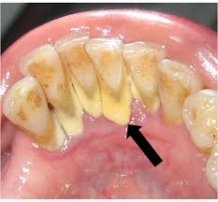
- Presence of Calculus :
Next step we need to evaluate the presence of Calculus ,
by visual inspection in some cases “ as seen in the inserted picture”
-in the cases we can detect it by our eyes its called supragengival –

- Subgingival calculus we have to use tactile sensation , which
Means that we have to check subgingival for the presence
Of calculus with perio probe but the doctor said that its better to use periodontal explorer or dental explorer “ cons probe “ .

^_^ By now we almost did all the needed examination , and then we need to fill periodontal chart ..

- Periodontal charting: is a representation of the teeth both upper and lower , we will find blocks that represent the buccal side and the lingual side and we will find some circles in these blocks that represent the circumference of the tooth and in the center we will find a square that represent the occlusal surface ..

- Regarding the occlusal surface ; we have different systems , sometimes you will find the square colored with blue that indicates restoration on that tooth , if there is caries It will be colored with red .
- And regarding the circles we talked about that represent the circumferences ; they represent mesial , distal , mesio-occlusal “ MO “ , and disto-occlusal “ DO “ .. w feeh kman da2era kbeereh represents the root , 7awlt ala2i soora bs ma feeh
- When there is a missing tooth we have to delete it “ same way as we do in diagnosis clinics , the first thing we do is deleting the missing teeth from the chart , bnktob law feeh bridge aw crown w law el sen m3mollo RCT “
So basically we do the same as we learned before in diagnosis but the difference here what’s coming next ; we measure six sides per tooth , three on the facial side and three on the lingual side , we start with probing measurements “ yofaddal ykoon m3na assistant 3shan e7na 7nbda n2ees el depth w nna22el el assistant el depth eli tele3 m3na , y3ni msln bnbda bucally bne7ki Distobuccal 3 w buccal 5 w mesiobuccal 4 w bs n5alles el buccal bne3ml nfs el eshi m3 el lingual w heeek “
- Gingival recession ; we measure from Cemento-enamel junction CEJ to the gingival margin , usually the gingival margin existed coronally to the CEJ
- We write if there Is bleeding or we put a tiny circle on the side that bleeds .
“ el doctor 7aka eno bs ne3ml heek ben7ot el probe w benw2ef benshoof law feeh bleeding w benkammel msh n7ot el probe w ndal nemshi feeh 3kol el snan bala ma nw2ef “
- Plaque index “ we need to re-study them from Dr.Nicola’s lecture “
- What differentiate between gingivitis and periodontitis is the attachment loss , so it’s the most thing we care about to diagnose a disease , then we have to know how to detect if there is attachment loss or not “ if we don’t have gingival recession we measure it from CEJ to the base of the sulcus “ , if we have recession we can detect it sometimes by looking at it according to how much of the root is exposed ^_^
If we have gingival recession Attachment loss = probing depth + recession
- Radiographic examination :
Its very important because it shows us if we have bone loss .. sometimes after therapy ; healing happens specially with vertical bone loss .
Xrays can also help us in detecting the furcation areas .
Usually what we should do in perio is taking full mouth series , if we couldn’t get it we have to get anteriors periapicals and vertical bitewings not horizontal , plus panorama .

**At the end of this lecture the doctor said again that we have to keep in our mind the difference between gingivitis and periodontitis are three main things attachment loss ,
local factors such as plaque and calculus , and Inflammation “ bleeding and swelling “.

Note : recession due to aggressive tooth brushing is also called attachment loss but its usually only on buccal side , while periodontitis is usually seen in proximal areas .
ـــــــــــــــــــــــــــــــــــــــــــــــــــــــــــــــــــــــــــــــــــــــــــــــــــــــــــــــــــــــــــــــــ Believe you can & you’re half way there !! ♥

