**Non-parametric statistics**

When we use non-parametric statistics?

1. Non-continous variables; eg. Nominal variables
2. Not normally distiputed data

In this lecture, we will talk about 3 types of NP statics: chi square test, Mann-Whitney test and Kruskal Wallis test and the way to use them is summerized in this table

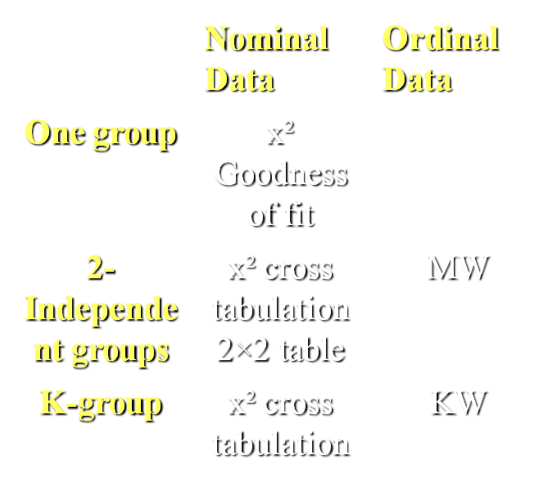K-groups: categorial groups ( more than 2 groups)

* **Chi square test**

If we want to compare independent variables on a nominal data eg, gender with the dependent variable being purely nominal we use ‘’Chi square cross tabulation’’ and the table is determined according to the number of cells 2X2 or 2X3,.. depending on the variables benig dichotomous or categorical

Ex.

The incidence of having a coronary artery disease btw males and females

The Dependent variable which is having the disease is nominal dichotomous meaning you either have it or not and the independent variable wich is gender is nominal dichotomous as well . According to that we use ‘’Chi square cross tabulation 2x2 table’’

In the ex, if we want to compare the incidence of having the disease with marital status, then the independent variable will still be nominal but not dichotomous (marital status: single, married, divorced) in this case we still ‘’Chi square cross tabulation test’’ but the table is not 2x2 it will be determined according to number of possibilities and variables and here 2x3 table

Ex. In the slides

Pressure ulcer incedence btw males and females

We set the null hypothesis : There is no significant statistical difference in PU incidence between males and females.

α= 0.05

Dependent variable: ulcer incedence 🡪 nominal dichotomous

Independent variale: gender 🡪 nominal dichotomous

So we use ’Chi square cross tabulation 2x2 table’



Here is a table of the test outcomes. We have the P value which is the ((asymp. sig. (2-sided) in the first row) ~0.4

P>α= 0.4>0.05

So we accept null

# There is no significant statistical difference in PU incidence between males and females.

** Note: If we used a statistical test that is not right (using MW test instead of chi square) we will get type 1 research error

Ex.

The association between anticoagulants intake and hematoma post breast reduction (mammoplasty)

Set the null: there’s no relationship between anticoagulant intake and hematoma development post mammoplasty

α = 0.05

dependent variable : hematoma formation 🡪 nominal dichotomous

independent variable: anticoagulant intake 🡪nominal dichotomous

So we use ’Chi square cross tabulation 2x2 table’

And the P value that resulted was 0.03

P<α

We reject the null

# there’s a relationship between anticoagulant intake and hematoma development post mammoplasty

**Key note: we can never use chi square when any of the variables; dependent or independent; are in an ordinal level, instead we use one of the two tests below

* **Mann-Whitney test**

We use it when the dependent or independent variables are in ordinal level and we want to compare only between 2 groups

Ex of ordinal variables: degree of satisfaction of sth, pain intensity, age groups,..

Ex.

The relation btw The degree of satisfaction of students in a subject and gender

The dependent variable here is ordinal and the we want to compare only between 2 groups (males or females)

So we use Mann-Whitney test

Ex.

Regarding the previous ex about pressure ulcers, we want to compare between Age groups and the incidence of having pressure ulcers

Null: no relation

α = 0.05

Dependent variable: incedence 🡪 nominal

Independent variables: age group 🡪 ordinal

So we will use MW test

**Note: normally what determine the test is the dependent variables. Although here the dependent value in nominal(incidence), we can’t use chi square because the independent variables are ordinal (age groups), else we will end up with type 1 error



P = 0.001

P<α

Reject H0

#There is a relation

* **Kruskal Wallis test**

We use it when the dependent or independent variables are ordinal and we want to compare btw more than 2 groups

Ex.

Degree of satisfaction of students in 3rd, 4th, and 5th year in the education program

Here we have an ordinal dependent variable (degree of satisfaction) and 3 groups of independent variables(3rd, 4th, 5th year students) so we use Kruskal Wallis test

Ex.

Regarding the previous ex about pressure ulcers, we want to compare age groups with group of patients A, B and C (A and B are groups of pts who had different intervinsions and C is control grp)

Set H0: no relation

The test to utilize

Depndent variable: grps A, B, C; >2 grps

Independent variables: age grps 🡪 ordinal

So we use KW test



P<0.001

P<α

Reject H0

#There is a relation

***\*\* Conclusion:***

* If we are dealing with nominal data we always use chi square regardless of the number of groups; yet the number of groups will determine the number of cells in the table 2X2, 2X3 and so on
* If we are dealing with ordinal data, then we look at the number of groups of the variables:
* If they are= 2 groups; then we use MW tests
* If they are >2; then we use KW test

*The last 5 min i didn’t get what the doctor was talking about

**Done by: Eman Sameer**