Title of Lecture: ANS

Date of Lecture:14-11-2014

Sheet no: 11

Refer to slide no. : 6

Written by: Haneen Al-khateeb

♥we have talked about the synthetic machinery , essential substances are produced & then stored cause they are essential , such like hormones, its synthesis starts from DNA & chromosomes then complete the processes to transcription →translation→proteins →stored→ & then released . we have releasable pool & storage pool , the importance of these pools are a lot, whats available in the synapse is the release pool & there is a limited amount existed in this pool , when this amount ends ,it takes from the store then released, release is very quick , but synthesis takes time as in stressful conditions for ex. Cortisol will be released immedietly but if we want to make a combination btw storing & releasing at the same time, there won't be a quick response . So in cases of a disorder, we manipulate with the release more than synthesis cause it won't take much time, so when there is an increase in a substance → inhibition of synthesis could be applied but it takes time , on the other hand, the best thing to happen is to decrease the release in these cases of overproduction, & the same concept is applied to decreased production

♥Ex. NE :
In case of decreased production | In case of overproduction
-the uptake will be increased by targets  -We have to increase synthesis ,storage & release  -give an agonist  -inhibiting the deactivation mechanism of NE  -inhibiting MAO | -inhibit uptake by targets  -inhibit synthesis, storage & release  -inhibiting tyrosine hydroxylase (the rate limiting step of making NE), metyrosine helps in inhibiting.  -damage stores  (reserpine is a mjor depletor for all neurotransmitters)  - Using an antagonist

♥Note:
- after producing an effect by NE , its deactivated by high specific uptake mechanism , this process has a value in management of cases related to decreased NE levels , meaning that when inhibiting the high specific uptake , we increase the drug.
-NE could be metabolized also by MAO (monoamine oxidase) in the liver , peripheral tissues or neuronal mitochondria. By inhibiting MAO, NE levels increases.
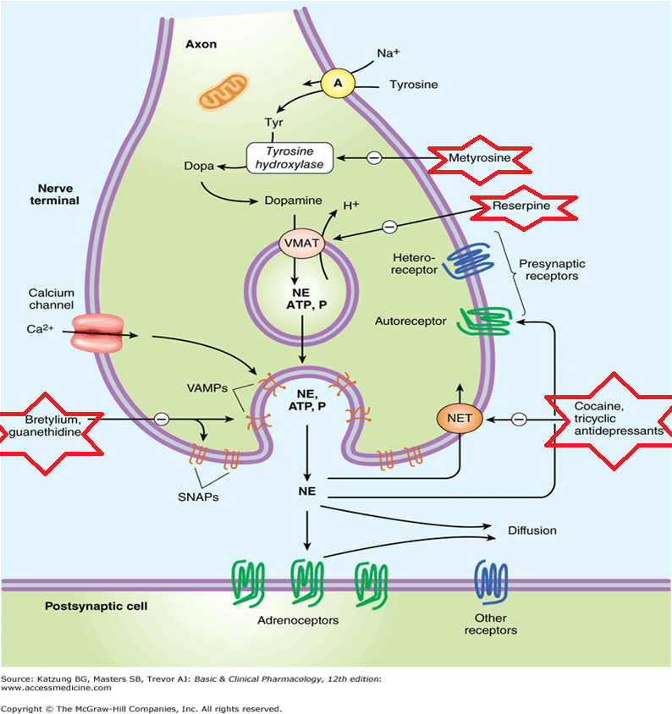

♥Excess vs. depletion of NE
-Excess: such in hypertension . all drugs mentioned that could inhibit NE in synapse, could inhibit also the case of hypertension . drugs used are:
Reserpine (making depletion) – guanethidine (inhibits the release) – specific antagonist (alpha 1, Beta blockers)

-Depletion: such in depression . biochemical effect is that there is no NE in the CNS of patients . the drug used in this case is: Tricyclic antidepressant
♥NOTE: drugs that tolerate hypertention have several side effects that would lead to depression , & the same is applied to drugs that tolerate depression which its side effects would be hypertension & something else called orthostatic hypotention caused by alpha 1 receptor blocking effect . as we know, alpha 1 makes vasoconstriction & increase the blood pressure, so in this system only we could control the hypertension ,there is lots of drugs related in management of hypertension through alpha 1 receptor we will talk about them.

What types of drugs could we take to treat….?
hypertension | depression
-tyrosine uptake inhibitors > theoretically, when there is no tyrosine, there will be no NE  - inhibitors at any level state of synthesis NE  -guanethedine > inhibits NE release  -antagonist > when NE is released into the synapse, none of any drugs could help in controlling hypertension now except the antagonist  -reserpine > this drug is not preferred to be used cause its not only affects NE, but also Serotonin as well, so reserpine depletes stores for all neurotransmitters leading to depression & Other side effects | -Drugs that: increase release, storage & synthesis of NE  - specific agonist  -alpha 2 antagonist  -inhibitors for the reuptake of NE >the most impotant point , by inhibiting the metabolism , NE will increase  - MAO inhibitors > MAO here exists in mitochondria
Major side effect : is decreased the amount of NE leading to depression

♥Metabolism of E & NE is sympathetic system
-effect are mediated through different receptors: alpha 1, alpha 2, beta 1, beta 2
-after producing the effect , action has to be terminated . termination happens by high specific uptake , also we have element of metabolism in periphery , liver, GI & in neuron
- we have 2 pathways of inactivation: MAO (oxidation) & COMT (methylation)
NOTE: we don’t have to know the intermediates of metabolism.
-Both E & NE are metabolite by MAO & COMT
- the final end product & major metabolite is: VMA (vanyllil mandilec acid) or named as methoxy hydroxyl mandilec acid. (an exam question)
-VMA could be measured in urine , it’s a diagnostic test to cases associated to excess production of E & NE.
♥Adrenal pheochromocytoma
- Adrenal pheochromocytoma > it’s a tumor in the adrenal medulla characterized by excess in E& NE . when E & NE ↑, the metabolism also ↑ by MAO & COMT so as a result, VMA is excreted in the urine with excess. Patients of pheochromocytoma suffer from hypertension
- solution : is difficult , the 2 glands have to be removed if it’s a bilateral condition

♥Sympathomimetic drugs: have direct or indirect acting:
-Direct acting: direct means that they are synthesized then released , or giving an agonist that interact with alpha 1 or 2 or beta 1 or 2 receptors. EX : E & NE
-indirectly acting: it means that these drugs don’t interact with the receptors, instead, the drug will cause a release of NE to interact with a receptor. EX: Ephedrine & Amphetamine( an addictive drug).

♥About NE:
-it’s a catecholamine > this words means catechol (that has a benzene ring with 2 hydroxyl groups ) + amine group.
♥-Action of NE : the main & obvious action for NE is vasoconstriction. Vasoconstriction → increase in peripheral resistance → increase blood pressure.
NOTE that NE don’t have Beta 2 receptor ,just alpha 1(mainly) & beta 1 .
When we talk about sympathetic system , the main thing that comes in mind is that all systems in the body are going to increase , as blood pressure , heart rate & etc , but according to NE, it may increase the heart rate little bit but its main effect is vasoconstriction & bradycardia . the bradycardia that happens here is explained by:
- the opposed & over activity of parasympathetic system that companies the use of NE according to what we know that sympathetic & parasympathetic system compensates each others .PS system overacting the action of NE on Beta 1 receptor leading to bradycardia . the evidence of the action of parasympathetic system is when we give an antagonist for the parasympathetic (Atropine) & the result is increasing the heart rate.
- Bradycardia happens as a reflex for vasoconstriction (physiologically), for more understanding, when there is peripheral vasodilatation & a drop in blood pressure the reflex will be in this case tachycardia to counter act the drug in blood pressure.

♥Clinical uses of NE:
-for shock & drop in blood pressure
-local anaesthetics . ( through making a vasoconstriction )
-could be given subcutaneously & as IV infusion … infusion means in the drip with glucose

♥Side effects of NE:
-headache , tremors, increase in blood pressure, bradycardia, palpitation & cardiac arrhythmias.

♥Mechanism of action of catecholamine:
As a refreshment , we have taken 4 types of receptors: G protein couples receptor, enzyme coupled, ion channel coupled & catecholamines acting intracellulary in transcription & translation . according to catecholamines, we have alpha & beta receptors that we are going to talk about .
-Beta receptors : beta adrenergic receptors are G protein coupled receptor to adenylyl cyclase. The first messenger is catecholamine. Catecholamine + beta adrenergic receptor → G protein transfer signal from the receptor to an enzyme (adenylyl cyclase)→ stimulation to adenylyl cyclase will inhace production of cAMP (second messenger) from ATP . Not only that , but also there is connections enhances openenig little Ca+ channels→ Ca+ bind calmodulin → then phosphorylation of different proteins & kinases in the cell that will mediate catecholamine action on beta adrenergic receptors. Note: cAMP is broken down by phosphodiesterase enzyme .there are 2 ways to increase levels of cAMP in the cell, & they are:
1- stimulation of adenylyl cyclase
2-Or inhibit phosphodiesterase enzyme
NOTE: when cAMP* related to Beta receptors * increase → heart rate will increase & also the contractility , positive chronotropic & positive ionotropic.

♥Alpha adrenergic receptor: has G protein coupled receptor to phospholipase c → activation of phospholipase c increases levels of IP3 & DAG→ these makes phosphorylation to different proteins that mediate the effect of alpha receptor.

As a conclusion , the main differences btw alpha & beta adrenergic receptors :
Alpha adrenergic receptor | Beta adrenergic receptor
Second messenger: IP3 & DAG | cAMP
The enzyme: phospholipase C | Adenylyl cyclase

♥About Epinephrine :
-it has alpha 1 & 2 , beta 1 & 2
-because there is alpha 2 receptor , so any elevation wouldn’t be severe as in NE.

♥-its effects:
- ↑ heart rate and contractility and ↑ CO
- ↑ systolic BP
- Bronchodilatation
- ↑ blood sugar
- ↓ GIT motility
- Dilatation of pupils
- ↓ salivary secretions

♥-clinical uses:
- Anaphylactic shock ( drop in blood pressure)
- Open angle glaucoma (↑ drainage of eye fluid)
- + local anaesthetic
E is ineffective orally; given SC or IM
IV→ administration is contraindicated → fatal ventricular fibrillation
Metabolized by MAO & COMT
NOTE: we couldn’t give the patient E as an IV infusion , but we could give NE as an IV infusion , this is because NE has an opposing system for the sympathetic effect on the heart leading to bradycardia , but E don’t has this although it has alpha 2 receptors , but it doesn’t have that much effect , so the heart will be affected & this will be a fatal condition.

♥E side effects:
- Anxiety
- Nervousness
- Sweating
- Headache
- Palpitations
- Cardiac arrhythmias
- ↑BP

♥NOTE:
- when a diabetes patient feels nausea or a little sweating, we order him or her to eat a chocolate . all these side effects will disappear quickly after controlling the blood sugar .
- patient with hyperthyroidism are characterized by over activity of sympathetic system , mainly by increase level of cAMP in the heart.
-beta blockers drugs are the solution to control the manifestation of hyperthyroidism .

♥About Isoprenaline:
-A catecholamine; β1 & β2 stimulant
- A good bronchodilator
- ↑ heart rate; contractility and CO
-No change or little ↑ in BP (due to ↑ in CO) (beta 1)
♥Clinical uses:
- Bronchial asthma given by inhalation
- Shock & cardiac arrest given by an IV infusion
♥About Dopamine :
-it’s a unique drug,it’s a neurotransmitter & a hormone, & A catecholamine; precursor to NE
- Present in adrenergic neurons, adrenal medulla and dopaminergic neurons and in the CNS
-following release of dopamine, it interacts with 5 receptors, D1 to D5
-it presents in nervous system mainly
-excess dopamine makes schizophrenia , & deficiency of it is related to Parkinson disease
-to prevent the excess we use dopamine antagonist , & the major side effect of this is Parkinson disease
-it’s the major hormone that regulates prolactin synthesis & release , if we want prolactine, we have to inhibit dopamine
-prolactine is involved in breast development & lactation .
- at the end of pregnancy , dopamine levels decreases ,& after delivery there will be no dopamine exists .
- best inotropic agent in the management of shock
♥Dopamine:
- ↑ release of NE
- Interacting with α and β1-receptors
- Interacting with specific dopaminergic receptors
-the action of alpha receptors could be blocked by alpha antagonist,& beta receptors could be blocked by beta antagonist of dopamine
♥Doses:
-low dose: increases renal blood flow . (renal blood flow is dependent on dopamine)
-intermediate dose: stimulate Beta 1 receptor
-high dose : activates alpha 1 receptor
So easy lecture
Enjoy ^^

