>>We talked last lecture about smoking that lead to COPD (chronic obstructed pulmonary disease )
-chronic bronchitis : the problem is inside airways >>chronic inflammation , productive cough daily in the morning with huge amount of sputum ,yellowish in color . it lasts for 3 months especially in winter , for 2 successive years.
so chronic bronchitis is easily diagnosed.
emphysema : needs biopsy , and it's not easy to have it.-
- asthma: the patient usually have sensitive mast cells , that respond to irritants that usually come from outside & sometime the so called "Exercise induced asthma (after doing exercises)" .
*Mast cells screte few substances like histamine , leukotrienes , these are called (( slow active substance of anaphylaxis )) ,
*Because of broncho constriction , excessive production of mucus from goblet cells , and inflammatory process of epithelium , All These 3 changes will induce sever broncho constriction .(narrowing of the small airways) ,
- If The patient inhale something from outside like olive pollen , that will initiate cascade of reactions that end up by making histamine , leukotrines and all kind of chemical reaction that will do the following :
- 1-induce inflammation >> so we will give patient anti-inflammatory drug cortisone
- 2-induce broncho constriction>> so we will give patient bronchodilators (adrenaline) ,,adrenalines is used for emergency cases.
But for maintainance you can give β₂-adrenergic agonists, (you have β 1 in heart β₂ in bronchioles ) , we can use epinephrine but it will NOT act as broncho dilator only … epinephrine will rise heart rate 130-140 and rising blood pressure doing hypertension ending with tachycardia.
-so we need drug that select the β₂-adrenergic receptors that present in the bronchioles not anywhere else , so this drug will dilate the bronchiole without increasing the HR or blood pressure. E.g salmutamol , albuterol .
- β₂-adrenergic agonists they work sympatho-like drug .
- we know that bronchiole are surrounded by smooth muscle , and we also know that sympathetic make contraction of arterioles' smooth muscles . norepinephrine increases cAMP and Ca in arterioles and decrease them in bronchioles .( so here sympathetic do dilatation)
-There is no sympathetic fibers directly to the smooth muscle but to the neighboring area like to the gland, arteriole, so this norepinephrine can escape and go to the beta receptor stimulating them.
-parasympathetic in contrary will case broncho constriction.
"it makes sense, that when you do exercise you need to increase your blood pressure and HR , but also to dilate your bronchioles , and that's the job of sympathetic "
-So again , Asthma is a pure obstructive disease unlike emphysema and chronic bronchitis (chronic inflammatory processes).
*We have 2 types of asthma ; one that start at childhood and the second type that start at adulthood
95% of childhood cases asthma , will resolve spontaneously ,,-
-when patient fighting for air, Bluish face(cyanosis) , sever dyspnea , he might die, once he come to you you give him subcutaneous adrenaline injection , cortisone or mucolytic (to lyse the mucus) . BUT if you give him cough suppressor you will kill him , because if sputum is kept inside , it will be a good medium for bacterial growth ending up with pneumonia .
-The asthma patient either has reversible asthma (in early stages) or irreversible (so it is considered with COPD ) – that's why we said plus minus bronchiole asthma -So we should test the patient , see if the patient has obstruction (COPD) ,how much is it reversible?? Is he going respond to treatment?
*First, we will start to test obstructive pattern, and as we said that obstruction manifested during expiration. So our pulmonary function test is going to be during expiratory process (expiration).
* We will study normal person:
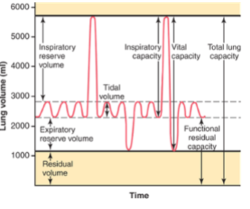
-Normal person inhale 0.5 L and exhale 0. 5L during breathing (this 0.5L called tidal volume ; TV).
-Also normal person don’t breath from zero volume (the lung contain already FRV(functional residual volume) = 2.2L)
2.2(already in lung) + 0.5(tidal volume) = 2.7L
Additional to tidal volume every one can inhale 3L extra-
2.7L +3L = 5.7L
From 2.7 to 5.7 called IRV (Inspiratory Reserve Volume )-
> Inspiratory: occur during inspiration.
>Reserve: because we don’t use it all the time (may use it during do exercise)
> Volume : because it is volume!
>>So IRV :the volume of the air that you can inhale in top of tidal volume .
-Also normal person can exhale forcefully around 1.1L (forcefully using your expiratory muscles)
[we said before that expiration normally is passive, it takes just relaxation of the inspiratory muscles (diaphragm or external intercostal muscles), Internal intercostal muscles, when they contract they push the thorax to inside, and abdominal muscles, when they contract they rise the diaphragm to up, so the vertical diameter will decrease and anterior-posterior diameter will decrease also .And normally we don't use expiratory muscles , but we use them voluntary durin exercise].
-So from 2.2 to 1.1 we call it ERV (Expiratory Reserve Volume)
- There is some volume remain in the lung called residual volume (RV), RV mean: that you can empty your lungs even if you do your best there is a 1 L will remain, so RV defined as: volume of air remains in lung (do your best to empty your lung you cant!!)

Till now we have 4 volumes :-
- TV
- IRV
- ERV
- RV
-When you put two volumes together you end up with new volume, but the new volume we don’t call it volume we call it capacity, ( capacity is volume).
-ERV with RV called FRC (Functional Residual Capacity)
- vital capacity (VC) : volume of air which you can exhale forcefully following forced inspiration . first to fill your lung to the maximum and empty it to the maximum we will exhale 3 volumes ( IRV + TV + ERV).
-total lung capacity (TLC): ,maximum volume of air both lungs can take.
TLC=IRV + VC +ERV + RV = VC + RV -
Inspiratory Capacity(IC) = IRV + VC السعة الشهيقية-
*You can't test RV , and anything related to it also can't be tested ( e.g FRC , TLC )
-So how to test it:
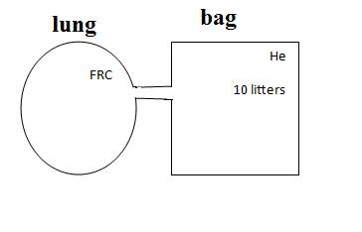
-The lung has FRC volume , and We make the person breath through a closed bag that is filled with 10L of helium which is non- absorbable gas .
So while the person is breathing there will be equilibrium between the air in the bag and the air in the lung because the helium is distributed .
-Total amount of helium is not changed (conservation of mass, because the blood didn’t take the helium and the blood didn’t add helium ) so the total amount is the same before and after.
-After equilibrium C₁*V₁=C₂*V₂
C₁=initial (known)helium concentration
C₂=final helium concentration measured by taking a sample .
V₁=volume of gas in spirometer
V₂=V₁+FRC
-So RV can only be measured by this dilutional method / conservation of mass
>> so Spirometry measures all volume and capacity exept RV that we use dilutional methods to measure it .
*VC is different from person to person according to weight and length .
-Let's talk about airway obstruction ,
Let's say , a Normal person , 6L needed to completely fill the lung ,
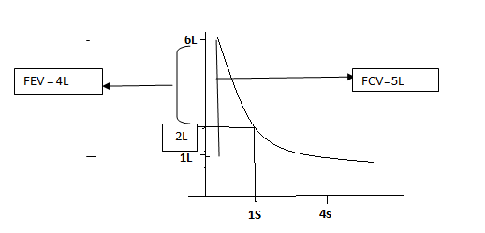
- we ask the patient to fill his lungs completely and then to empty it forcefully , in 4s , a normal person can reach the RV , and this is called FVC (forced vital capacity ) and here it’s equal to 5L .
- In the 1st second , 4L were exhaled , and we call it FEV(forced expiratory volume).
-what we care about is FEV/FVC*100%. , and it's 80% for a normal person .
>>so each normal person can exhale 80% of the VC in the first second .
-BUT for a patient with an obstruction disease , it will be totally different , the FEV might be 3L , and FEV/FVC might be 60% instead . So I give him a broncho dilater , and retest him , if the percentage increase to 75% that means it's reversible , but if it increases to 65% it’s irreversible. [ So if it 12% or above it is reversible , but if less then 12% it's irreversible ].
-Another example , If we completely fill the lungs , for another person , (5 L for this person needed to fill the lung ) ,
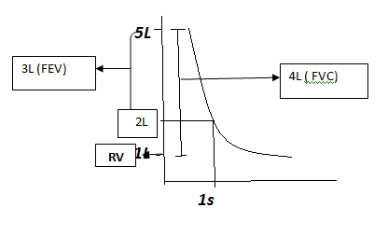
-The FVC = 4 L , and during the first second he exhaled 3 L ( FEV ) ,, so FEV1/FVC =75% "not so far away from the normal value".
- Another person , 4L is needed to fill the lungs , let's say RV = 0.5L , so the VC = 3.5 , during the first second he exhaled 3L (FEV) , so it's approximately 80% ,Normal.
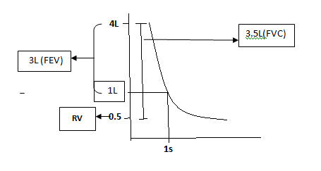
FEV1/FVC= 80% normal..
= 60-79% mild COPD
= 40-59% moderate COPD
< 40% severe COPD
>>So the pulmonary function test helps in diagnosis if there is pulmonary obstruction or not , and if it reversible or irreversible , and if the patient going to respond to our treatment or not by following up ( I make several tests , give him some medications , and after 2 weeks I retest him ) .
-Another example for obstruction,
patient

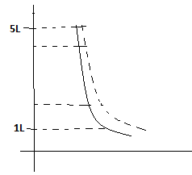
Middle portion (25%-75%) , 1/2VC

Last 25%
100% (the VC)
75%
25% first

-Like we are doing dilution for the results , the first 25% is easy for both normal person and the patient , and the last 25% both forcedly exhaled it –almost the same slope- , so ignore the first and the last quarters and take the middle portion (25%-75%) , this middle portion has the advantage to cancel both ends ,, here , if we take the FEV1/FVC it won’t be accurate here .
-so instead we take the mid respiratory flow rate ( how much time is needed to exhale half of the vital capacity) , normally it's 3.5L/second , but if 1.7L/second for the patient (too much obstruction) , so it's very sensitive test .
[keep in mind that pulmonary function tests are not diagnostic, they HELP in diagnosis .]

The Lung :-
-Is a balloon and this balloon is elastic ,and because that it have tendency to callapse.
-So how we can hold the lung at FRC 2.2L while the lung is not collapsing ??
The lung has (-ve) interpleural pressure to hold the lung inflated

-How much (-ve)interpleural pressure do we need ??
it's depend on how much collapsing forces the lungs are facing ,(too much collapsing forces = too much (–ve) pressure )

why the lung is tending to collapse ?? what makes the lung elastic??
The elastic forces of the lung are divided into
1)surface tension 2/3 2)elastic fiber (elastin) 1/3

TO UNDERSTAND MORE LET'S TALK ABOUT ;-

e.g Air Bubble ;
-The diameter=100micrometer(we choose this because the diameter of alveolus at FRC is 100).
-This air bubble consists of ;
1)wall (water)
2)air inside
It’s air-water interface .
-Water is a polar molecule. (H-bond between O & H , so the water ,molecule attract to come closer to each other)
-We have surface tension (intermolecular attraction between water molecule ), so air bubble is going to collapse toward inside .

-HOW can we prevent this collapse ?
By apply expanding force equal to collapsing force .

-How much expanding force(pressure) do we need ?
P=2T/r
T surface tension
rradius
P pressure we need
less( r) more (P) > we need more surface tension-
In this situation , and we apply the rule here and according to water T value , so we need inflation Pressure approximately =23 mmHg , but usually in intrapleural pressure we don’t have 23mmHg (it is 5 times more). And this number is high because of the polarity of water and the high surface tension.

- If the bubble is covered with inert substance (non polar / fat), so no intermolecular attraction , so T decreases , thus P decreases . so we need just 4-5 mmHg instead of 23mmhg

-So the lungs have the tendency to collapse due to the surface tension.
>>The idea is that the alveolus is lined with lipid fatty materials SURFACTANT (surf=surface ,act = active , ant = agent ) (glycolipoproteins but mainly lipid), to reduce the surface tension and the expanding pressure .

Special thanks to my friends , :')
Batool Hiari , sorry for being late

