بسم الله الرحمن الرحيم

Glomerular Filtration, Renal Blood Flow and Their Control

AS we've known from the previous lecture:
Excretion=what's filtered-what's reabsorbed +what's secreted.-
Filtration fraction (FF) =20% of renal plasma flow.-
-The ways that the kidney uses in handling different substances:
1- Some substances are only filtered, not secreted and not reabsorbed these substances can be used to measure GFR.
2-some substances are filtered and reabsorbed partially
3-some substances are filtered not reabsorbed but secreted
4-some substances are filtrated and completely reabsorbed
Water is filtered and reabsorbed except for 1L/day which is excreted –
-Na is filtered and reabsorbed what's secreted is 150 mmol/day
-glucose is filtered and completely reabsorbed unless in case of diabetes when blood sugar is high and exceeds Tmax (transport maximum) so the excess appears in urine
-creatinine is a substance that is filtered not reabsorbed and somewhat secreted but what's excreted is almost the same as what is filtered
GFR
Since renal blood flow =1200ml/min
Hematocrit (PCV) =50%
Then renal plasma flow =50% *1200=600 ml/min
And knowing that the filtration fraction =20%
Then GFR = 20%*600 is almost 125 ml/min or 180L/day
- Since the plasma volume=3L then this volume is going to be filtered 60 times/day (180/3 =60)
-the composition of the glomerular filtered is almost the same as plasma except that it doesn’t contain proteins such as globulin and albumin (normally)
NOTE: Amino acids might pass (filtered) but it's usually completely reabsorbed exactly like glucose
Blood comes through afferent arteriole and is filtered through what's called Filtration membrane which consists of:
1- The epithelium of Bowman's capsule
2- The basement membrane
3- Endothelium of glomerulus
The glomerular capillaries are fenestrated these fenestri are called Slits and they are permeable for all the contents of the plasma except for large proteins (normally)
But in some cases when you have a glomerulonephritis these slits might be abnormal and allow proteins to pass through them and then appear in urine and that’s what's called Proteinuria.

Effects of size and electrical charge of dextran on filterability by glomerular capillaries
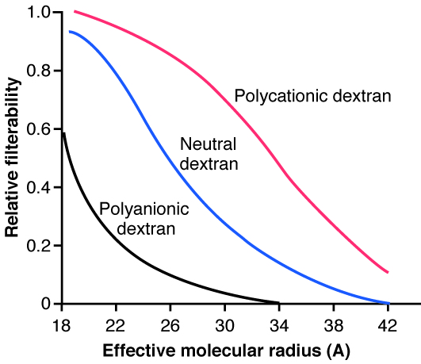
At any molecular radius the relative filterability is higher for polycataionic dextran than that of both the neutral and the polyanionic dextrans which means that positively charged molecules can pass(filtered) easier than negatively charged ones .

Conclusion: what really determines the filtered beside the size is the charge.
Proteinuria
in some diseases which affect capillaries such as : glomerulonephritis ,diabetes and hypertension we might observe proteinuria which could be Macro or Microscopic
Microalbuminuria is when : urine excretion of albumin is > 30 but < 150 mg/day
It might be caused by early diabetes, hypertension or glomerular hyper filtration.
Note:
Microalbuminuria might be a prognostic sign for diabetes which means that some diabetics may develop proteinuria from Microalbuminuria. But not all diabetics will suffer from this.
Determinants of GFR
There's something special about afferent and efferent arterioles in the kidney which is the high hydrostatic pressure compared to the hydrostatic pressure of the systemic arterioles.
Afferent arterioles hydrostatic pressure =60mmHg (in the Efferent arteriole it's slightly lower to allow the flow of filtrate from afferent arterioles toward the efferent ones).
Systemic arterioles hydrostatic pressure =35 mmHg.
Forces that drive filtration or the movement of fluids from a place to another through membranes are called starling forces and these are:
1- Hydrostatic pressure of the glomerulus.
2-colloid osmotic pressure (Oncotic pressure) of the glomerulus which is mainly (75%) due to albumin
Why is that?
It's because of the Mw of albumin. 1g of albumin has more # of molecules than any of the other plasma proteins such as globulin and osmotic pressure depends on the # of molecules and not the concentration.
3- Hydrostatic pressure of the Bowman's capsule.
4- Oncotic pressure of the Bowman's capsule. But since proteins don’t pass the capsule it's expected to be zero (normally).
So the principle of the starling forces tells us that what's going to be filtered =net filtration pressure * K_{f}
-net filtration pressure = forces that cause filtration-forces that cause reabsorption
Filtration force is mainly the glomerular hydrostatic pressure =60mmHg
Reabsorption forces are:
1-hydrostatic pressure of the Bowman's capsule.
2- The oncotic pressure of the glomerulus.
The net filtration pressure is 10 mmHg as it's shown in the following figure.
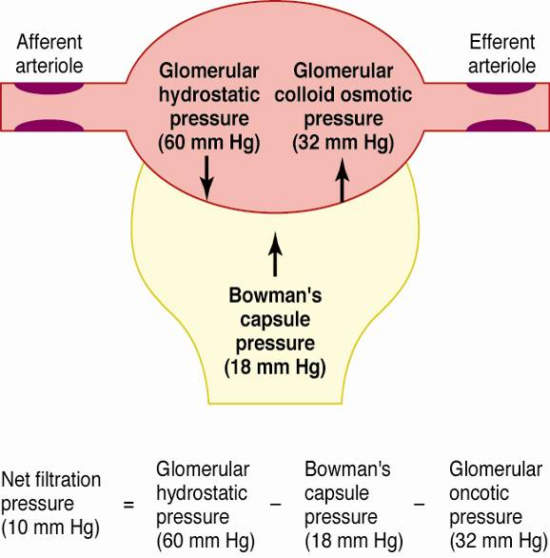

Glomerular capillary filtration coefficient K_{f}
K_{f} is a measurement of hydraulic conductivity multiplied by the capillary surface area. It depends on the size of pores (slits) and the permeability and it's not normally highly variable.
K_{f} = GFR/net.filtration.p
=125ml/min / 10mmHg =12.5ml/min/mmHg
This is also calculated per 100g tissue and it =4.2ml/min/mmHg/100g
Which is 400 times greater than in other tissues or than that of systemic arterioles and this high value of the coefficient results in great net filtration pressure (higher than that in the rest of the circulation).
Diseases that can reduce K_{f} and GFR:
Chronic hypertension-
Obesity / diabetes mellitus-
Glomerulonephritis -
Note:
All these diseases might lead to renal failure. -
-90% of the causes of secondary hypertension results from kidney diseases. And hypertension may also lead to a kidney disease.
-In diabetes the problem is usually in the vessels and in glomerulonephritis the problem could be in any part of the filtration membrane (the basement membrane, the epithelium of the capsule or the endothelium of the glomerular capillary).

Bowman’s Capsule hydrostatic Pressure (P_{B})
Normally changes as a function of GFR. -
Not a physiological regulator of GFR. -
The pressure in any space depends on the amount of fluid in that space so how much is filtered is going to affect the hydrostatic pressure in the Bowman's capsule.
So when filtration increases the hydrostatic pressure in the capsule increases as a negative feedback in order to reduce that filtration.
Conclusion: Bowman's capsule hydrostatic pressure depends on how much is filtered (GFR). When GFR increases Bowman's capsule hydrostatic pressure increases and when GFR decreases the Bowman's capsule hydrostatic pressure decreases as well.
A tubular obstruction will increase the Bowman's capsule hydrostatic pressure and reduces GFR which may lead to renal failure.
A tubular obstruction might be caused by kidney stones or tubular necrosis. Kidney stones might be in kidneys, ureter or in calyx these stones exerts a pressure on the tubule which will increase hydrostatic pressure in the capsule and thus reducing GFR.
Kidney stones could be silent (causes no pain) especially these in the kidneys themselves, but they can still be harmful and damage the kidney causing tubular necrosis.
On the other hand the stones might be really painful especially those in ureter, that the patient will seek medical care because of a
Renal colic (contraction of the smooth muscle). مغص كلوي
Urinary tract obstruction might be due to prostate hypertrophy or cancer.

Factors Influencing Glomerular Capillary Oncotic Pressure (π_{G})
1- AN increase or a decrease in the plasma proteins due to a disease.
2- Filtration fraction
An increase of the filtration fraction (how much is filtered is higher) means that how much protein is found in the filter is higher relative to how much fluid is found so that means an increase of the glomerular oncotic pressure which favors reabsorption ! (Doesn’t favor filtration) which will reduce GFR.
Remember that filtration fraction =GFR/RPF (20% normally).
Increase in oncotic pressure in plasma flowing through the glomerular capillary
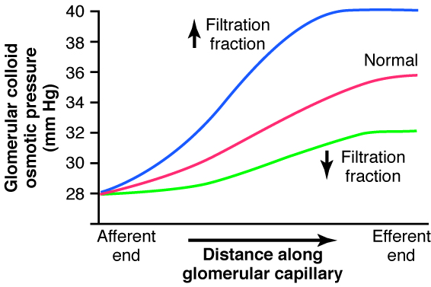
With low filtration fraction the oncotic pressure increases but not that much, but at high filtration fraction the increase in the oncotic pressure is even higher because now at a farther distance from the arteriole the amount of protein relative to the amount of fluid is higher because filtration took a place .
Conclusion:
What happens to the oncotic pressure of the glomerulus when moving from afferent to efferent arterioles is that it increases and the amount of the increase will be even higher when the filtration fraction is high and the increase will be less at lower filtration fraction.
NOTICE that net filtration pressure decreases as we go from afferent to efferent arterioles because of increasing of the glomerular oncotic pressure. At the afferent side the net filtration pressure was 14 mmHg and it reached 6 mmHg at the efferent end.
Glomerular Hydrostatic Pressure (P_{G})
Is the determinant of GFR it’s the most subjected pressure to physiological control.
Factors that influence P_{G}
₁₋ Arterial pressure (when it increases it increases the P_{G} )
A change of the arterial pressure from (60-180) mmHg will not cause a change in GFR because of what's called Autoregulation by the tubuloglomerular feedback mechanism (seen also in the regulation of blood flow to tissues which is constant by autoregulation).
2-afferent arteriole resistance
When afferent arterioles resistance decreases blood flow will increase then filtration fraction will increase and GFR increases.
When afferent arterioles resistance increase blood flow will be decreased and GFR will be also decreased.

3- Efferent arteriole resistance
Decreasing efferent arteriole resistance will decrease the blood flow and GFR.
While increasing efferent arteriole resistance will initially increases GFR then GFR will be decreased because of decreased renal blood flow.
Conclusion: GFR isn’t much affected by a change in the arterial hydrostatic pressure because of the autoregulation mechanism but it's affected more by the afferent and efferent arterioles resistances.
Renal Autoregulation
Between the glomerulus and the tubule a feedback control mechanism takes a place to keep GFR almost constant (tubuloglomerular feedback) by controlling the glomerular hydrostatic pressure which when is constant the GFR is also constant.
GFR and RBF are almost constant with varying blood pressure because they are autoregulated.
Autoregulation of GFR and RBF is done by:
1-local control
By hydrogen, potassium, CO2, prostaglandin and kallikrein-kinin system.
2-myogenic mechanism
When the arterial pressure increases the wall of the vessel (artery) will be stretched which will increase the permeability of smooth muscles to Calcium which is responsible for the excitation-contraction coupling so Ca increases intracellularly causing the contraction of the smooth muscles wall and thus vasoconstriction of the vessel which will decrease the blood flow back to normal.
In contrast, when the arterial pressure decreases there is a less stretching on the vessel this causes vasodilation , decreased resistance and increased flow back to normal.

3- Tubuloglomerular feedback (Macula densa mechanism)
In the juxtamedullary apparatus cell between the afferent, efferent and the distal tubule and specifically in the distal tubule there is a type of cells called macula densa which can sense the amount of Nacl in the filtrate and regulates GFR as following:
1) When GFR decreases less Na comes to the distal tubules so macula densa cells sense the decrease and secret Nitric oxide (NO) which acts as a vasodilator that will increase blood flow and increase GFR back to normal.
2) When GFR increases a lot of filtrate and more Nacl reaches the macula cells which will decrease the secretion of NO and secrets Endothelin which works as a vasoconstrictor that will decrease blood flow and decreases GFR back to normal.
There is another mediator of the tubuloglomerular feedback which is AngiotensinII.
It's known that AngII is secreted when afferent arteriole pressure decreases which will decrease GFR. BUT AngII preferably is an efferent arteriole vasoconstrictor (leads to increasing the GFR)

Pressure natriuresis or diuresis curves show that an increase in mean arterial pressure causes more urine formation. And that’s why patient with hypertension suffer from polyuria (more urine formation)
The curves also show that GFR and RBF are autoregulated by local and myogenic factors within the pressure ranges (60-100)mmHg that’s why a change in the arterial pressure doesn’t change GFR or RBF.

A question has been asked about How increasing the mean arterial pressure will increase the urine output when it doesn’t affect GFR?
The urine output is something different from GFR and its (urine output) controlled by reabsorption ( not related to filtration) so it increases when reabsorption is less( more urine is excreted).
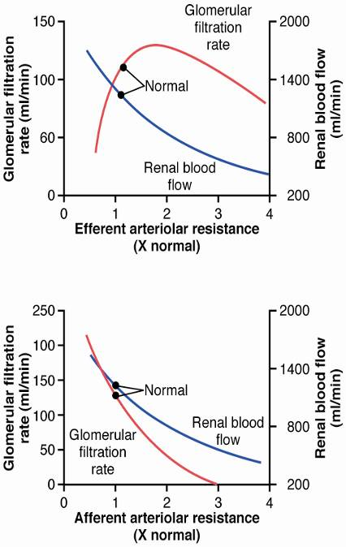

Summary of afferent and efferent arterioles resistance:
Ra increases so GFR and RBF decreases.
Re increases so GFR increases (initially till a limit ) and RBF decreases.
What determines oncotic pressure of Bowman’s capsule ? Filtration fraction
Best wishes

